**DEPARTMENT OF ELECTRONICS AND COMMUNICATION ENGINEERING**

**R.M.K.ENGINEERING COLLEGE**

(An Autonomous Institution)

**R.S.M. Nagar, Kavaraipettai-601 206**

**PROJECT BASED EXPERIENTIAL LEARNING PROGRAM (NALAIYA**

**THIRAN)**

**Global data sales analytics**

**A PROJECT REPORT**

**Submitted by**

**Yeshwanth Lakkalapudi (111719106083)**

**Chandu Konduru (111719106081)**

**Yeshwanth Kuntrapakam**

**(111719106081)**

**Dinesh N (111719106096)**

# TEAM ID : PNT2022TMID16071

**Contents :**

1. **INTRODUCTION** 
   1. Project Overview
   2. Purpose
2. **LITERATURE SURVEY**
   1. Existing problem
   2. References
   3. Problem Statement Definition
3. **IDEATION & PROPOSED SOLUTION**
   1. Empathy Map Canvas
   2. Ideation & Brainstorming
   3. Proposed Solution
   4. Problem Solution Fit
4. **REQUIREMENT ANALYSIS**
   1. Functional Requirements
   2. Non-functional Requirements
5. **PROJECT DESIGN**
   1. Data Flow Diagrams
   2. Solution & Technical Architecture
   3. User Stories
6. **PROJECT PLANNING & SCHEDULING**
   1. Sprint Planning & Estimation
   2. Sprint Delivery Schedule
   3. Reports From JIRA
7. **CODING & SOLUTION**
   1. Feature 1
   2. Feature 2
   3. Feature 3
   4. Feature 4
8. **TESTING**
   1. Test Cases
   2. User Acceptance Testing
9. **RESULTS**
10. **ADVANTAGES & DISADVANTAGES**
11. **CONCLUTION**
12. **FUTURE SCOPE**
13. **APPENDIX**
    1. Source Code
    2. Github & Project Demo Link

**1. INTRODUCTION**

**1.1 Project Overview**

Shopping online is currently the need of the hour. Because of this COVID, it is not easy to walk in a store randomly and buy anything you want. So, try to understand a few things like, Customer Analysis and Product Analysis of this Global Super Store. Global Sales covers all activities involved in selling a product or service to a consumer or business. It is important for sales and marketing teams to review their strategies and performance in order to make improvements. Understanding performance with sales data analytics helps sales and marketing teams to review their strategies and performance in order to make improvements. Sales analytics provides valuable information like Customer Analysis and Product Analysis to improve sales methodologies. Users create multiple analytical graphs/charts/Visualizations. One way to measure performance is with sales analytics.

**1.2 Purpose**

Global Sales covers all activities involved in selling a product or service to a consumer or business. It is important for sales and marketing teams to review their strategies and performance in order to make improvements. One way to measure performance is with sales analytics. Sales data analytics refers to the use of technology to collect and use sales data to identify actionable insights. It is used to identify, optimize, and increase sales. An efficient sales model that generates higher revenue for the business.

**2.** **LITERATURE SURVEY**

|  |  |  |  |
| --- | --- | --- | --- |
| **Title & Author(s)** | **Year** | **Technique** | **Findings** |
| Big Data Analytics and Deep Learning Based Sentiment Analysis System for Sales Prediction - Khatiwada, Aamod and Kadariya, Pradeep and Agrahari, Sandip and Dhakal, Rabin. | 2019 | Big data analytics (BDA) applications in e-commerce. | Merits: Used to understand complex datasets in a matter of time with beautiful visual representations.  Demerits: Lack of security since large data processed simultaneously |
| COVID-19 pandemic in the new era of big data analytics: Methodological innovations and future research directions - Sheng, Jie and Amankwah-Amoah, Joseph and Khan, Zaheer and Wang, Xiaojun | 2021 | Descriptive and diagnostic analytics, Predictive analytics | Merits: By comparing with machine learning models, we find that the proposed model is superior to others. Demerits: The experiment only considers the features of the product and does not consider external influences, such as the impact of regulations on sales. It uses only small dataset. |
| Sales Forecasting Based on CatBoost - Jingyi Ding, Ziqing Chen. | 2020 | CatBoost algorithm. | Merits: The search stops when no improvements over the current best solution have been found in 300 iterations. Demerits: Dataset is limited |
| Developing and Implementing Big Data Analytics in Marketing - Dina Darwish | 2020 | Big data analytics, R tool. | Merits: The proposed method is based on similarity measurement without complex training so that forecast can be completed in a short time, and performs well in small-scale data Demerits: The experiment only considers the features of the product and does not consider external influences, such as the impact of regulations on sales. It uses only small dataset. |
| Social media big data analytics for demand forecasting: development and case implementation of an innovative framework-Iftikhar, Rehan and Khan, Mohammad Saud | 2020 | Definitional aspects of big data analytics (BDA) in e-commerce | Merits: Captured linearity and non linearity better than ARIMA and ARNN gave the best result of 565 RMSE. Demerits: Hybrid Technique can fail if nonlinear model fails to capture residue patterns |

**2.1 Existing problem**

1. Lack of security since large data processed simultaneously
2. Hybrid Technique can fail if nonlinear model fails to capture residue patterns
3. The experiment only considers the features of the product and does not consider external influences, such as the impact of regulations on sales. It uses only small dataset.
4. Dataset is limited
5. The experiment only considers the features of the product and does not consider external influences, such as the impact of regulations on sales. It uses only small dataset.

**2.2 References**

1. Big Data Analytics and Deep Learning Based Sentiment Analysis System for Sales Prediction - Khatiwada, Aamod and Kadariya, Pradeep and Agrahari, Sandip and Dhakal, Rabin.
2. COVID-19 pandemic in the new era of big data analytics: Methodological innovations and future research directions - Sheng, Jie and Amankwah-Amoah, Joseph and Khan, Zaheer and Wang, Xiaojun
3. Sales Forecasting Based on CatBoost - Jingyi Ding, Ziqing Chen.
4. 2020 2nd International Conference on Broadband Communications, Wireless Sensors and Powering (BCWSP)-Wisesa, Oryza and Adriansyah, Andi and Khalaf, Osamah Ibrahim.
5. Developing and Implementing Big Data Analytics in Marketing - Dina Darwish
6. Social media big data analytics for demand forecasting: development and case implementation of an innovative framework-Iftikhar, Rehan and Khan, Mohammad Saud

**2.3 Problem Statement Definition**

1. Structured data focuses on demographic data including name, age, gender, date of birth, address, and preferences, unstructured data includes clicks, likes, links, tweets, voices, etc.
2. The methodological innovations in studying big data analytics and. We provide insights on methods in descriptive/diagnostic, predictive and prescriptive analytics, and how they can be leveraged to study ‘black swan’ events such as the COVID-19-related global crisis.
3. It proposed a sales forecasting system based on CatBoosting. The algorithm is trained on the Walmart sales dataset, by far the largest dataset in this field. We performed effective feature engineering to boost prediction accuracy and speed.
4. The results of this analysis are expected to generate reliable, accurate and effective forecasting data, a valuable resource for sales predictions. It shows good accuracy in forecasting.
5. Companies take informative business decisions in different fields, such as, health care, banking, manufacturing, media and entertainment, education and transportation and many others.
6. Social media big data offers insights that can be used to make predictions of products' future demand and add value to the supply chain performance

**3.** **IDEATION & PROPOSED SOLUTION**

**3.1 Empathy Map Canvas**

An empathy map is a simple, easy-to-digest visual that captures knowledge about a user’s behaviors and attitudes. It is a useful tool to help teams better understand their users. Creating an effective solution requires understanding the true problem and the person who is experiencing it. The exercise of creating the map helps participants consider things from the user’s perspective along with his or her goals and challenges.

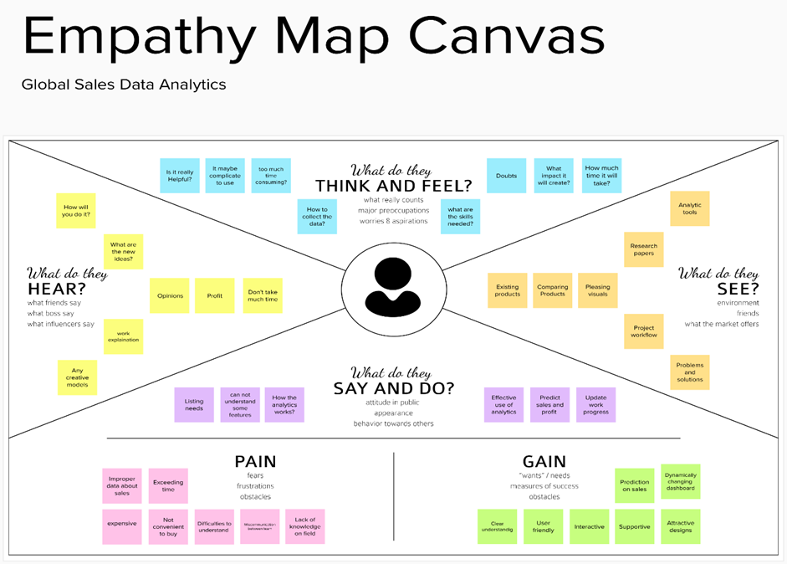

**3.2** **Ideation & Brainstorming**

Brainstorming provides a free and open environment that encourages everyone within a team to participate in the creative thinking process that leads to problem solving. Prioritizing volume over value, out-of-the-box ideas are welcome and built upon, and all participants are encouraged to collaborate, helping each other develop a rich amount of creative solutions.

**Step-1: Team Gathering, Collaboration and Select the Problem Statement**

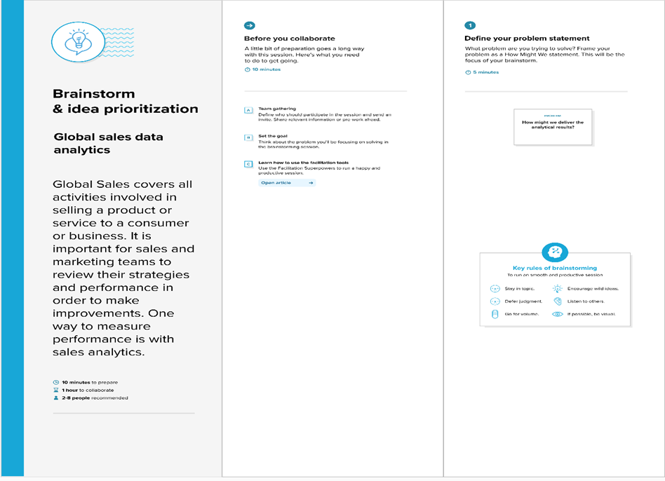

**Step-2: Brainstorm, Idea Listing and Grouping**

**Step-3: Idea Prioritization**

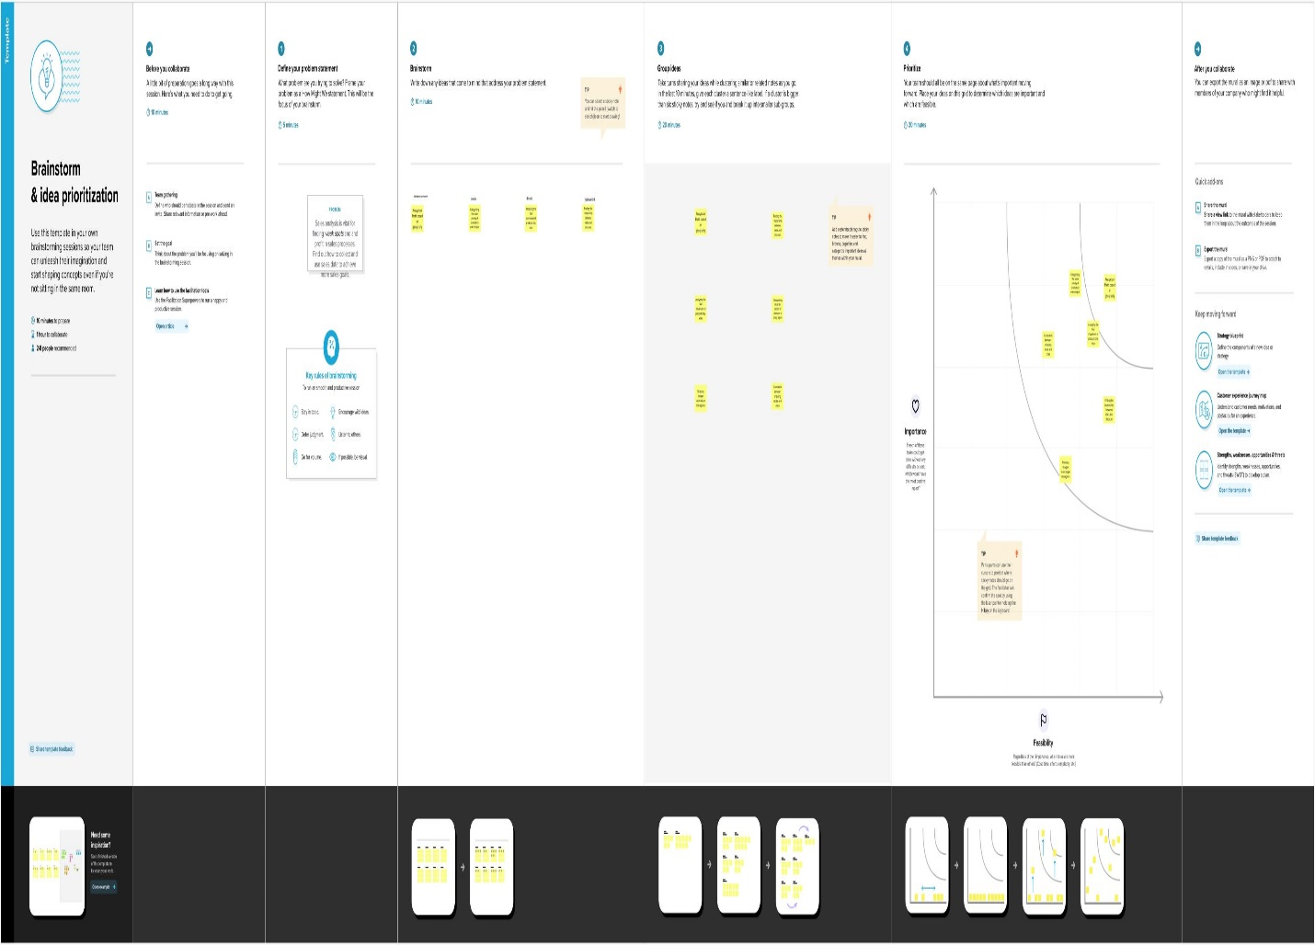

**3.3 Proposed Solution**

|  |  |  |
| --- | --- | --- |
| **S.No.** | **Parameter** | **Description** |
| 01 | Problem Statement (Problem to be solved) | Global Sales covers all activities involved in selling a product or service to a consumer or business. It is important for sales and marketing teams to review their strategies and performance in order to make improvements. One way to measure performance is with sales analytics. Sales data analytics refers to the use of technology to collect and use sales data to identify actionable insights. It is used to identify, optimize, and increase sales. An efficient sales model that generates higher revenue for the business. |
| 02 | Idea / Solution description | Use the technology to collect and use sales data to derive actionable insights. It is used to identify, optimize, and forecast sales. It uses sales data to plan an efficient sales model that generates higher revenue for the business. Users can create multiple Analytical Visualizations and can build the required Dashboards. |
| 03 | Novelty / Uniqueness | Understanding performance with sales data analytics helps sales and marketing teams to review their strategies and performance in order to make improvements. Sales analytics provides valuable information like Customer Analysis and Product Analysis to improve sales methodologies. Users create multiple analytical graphs/charts/Visualizations. |
| 04 | Social Impact / Customer Satisfaction | Analyzing sales helps businesses in understanding their most profitable products and the ones that are not moving, most profitable customers, and potential sales opportunities thereby providing sales which match customer needs and meets their satisfaction. It helps in the perception of profit about particular product and perception of sales in different locations and times. |
| 05 | Business Model (Revenue Model) | Global sales analytics can use the sales data and provide actionable insights for selling a product or service to a consumer or business. Improve the decision-making process oriented at analyzing scales trends, reducing costs and increasing business revenue. |
| 06 | Scalability of the Solution | This solution can be used from small stores to multinational companies. This solution can be processed with less memory and quickly. The solution can be used as user specified so it is easy to customer. |

**3.4 Problem Solution Fit**

The problem solution fit simply means that you have found a problem with your customer and that the solution you have realized for it actually solves the customer’s problem. It helps to identify behavioral patterns and recognize on sales.

**Purpose:**

* Solve complex problems in a way that fits the state of your customers. •
* Succeed faster and increase your solution adoption by tapping into existing mediums and channels of behavior. •
* Sharpen your communication and marketing strategy with the right triggers and messaging. •
* Increase touch-points with your company by finding the right problem-behavior fit and building trust by solving frequent annoyances, or urgent or costly problems. •
* Understand the existing situation in order to improve it for your target group.

**Solution fit:**

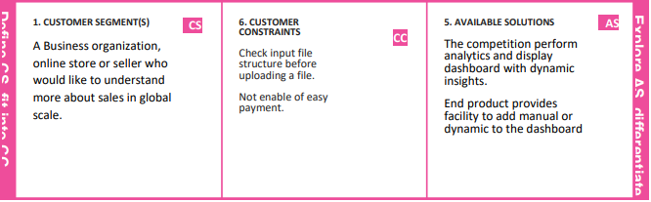

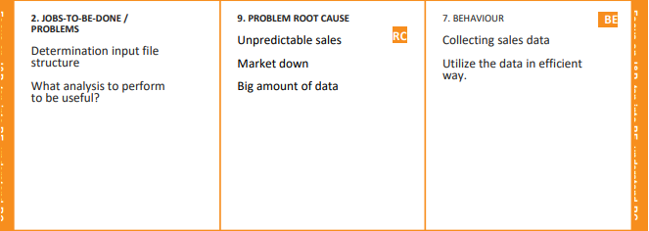

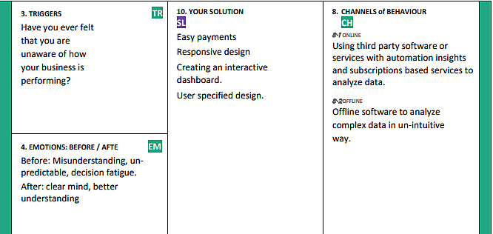

**4.** **REQUIREMENT ANALYSIS**

**4.1** **Functional Requirements**

|  |  |  |
| --- | --- | --- |
| **FR No.** | **Functional Requirement (Epic)** | **Sub Requirement (Story / Sub-Task)** |
| FR-1 | User Registration | Registration through Website Registration through Gmail |
| FR-2 | User Confirmation | Confirmation via Email |
| FR-3 | User Login | Login via Gmail and Password |
| FR-4 | Generating Report | User can view the product details |

**4.2** **Non-functional Requirements**

|  |  |  |
| --- | --- | --- |
| **FR No.** | **Non-Functional Requirement** | **Description** |
| NFR-1 | Usability | This service will have a simple and user-friendly graphical interface. Users will be able to understand and use all the features easily. |
| NFR-2 | Security | The main security concern is for users login information is end to end encryption should be used to avoid hacking. |
| NFR-3 | Reliability | It has high reliability because when the system is disconnected or internet connection lost, it should save all the process of the users made. |
| NFR-4 | Performance | A good internet speed while browsing the product it had high performance with efficiency. |
| NFR-5 | Availability | It will be available 24 hours a day and seven days a week. User access anywhere at any time . |
| NFR-6 | Scalability | A Many users can access the website simultaneously. |

**5.** **PROJECT DESIGN**

**5.1** **Data Flow Diagrams**

A Data Flow Diagram (DFD) is a traditional visual representation of the information flows within a system. A neat and clear DFD can depict the right amount of the system requirement graphically. It shows how data enters and leaves the system, what changes the information, and where data is stored.

**DFD level 0**

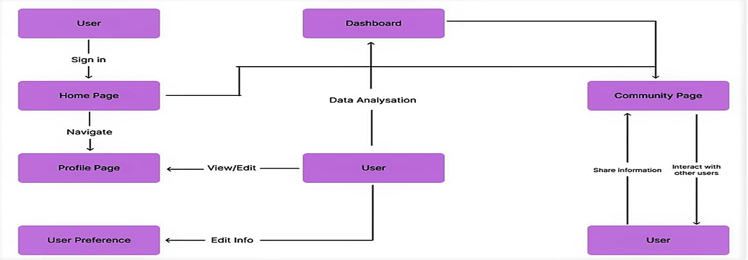

**5.2** **Solution & Technical Architecture**

Solution architecture is a complex process – with many sub-processes – that bridges the gap between business problems and technology solutions. Its goals are to:

* Find the best tech solution to solve existing business problems.
* Describe the structure, characteristics, behavior, and other aspects of the software to project stakeholders.
* Define features, development phases, and solution requirements.
* Provide specifications according to which the solution is defined, managed, and delivered.

**Solution Architecture Diagram:**

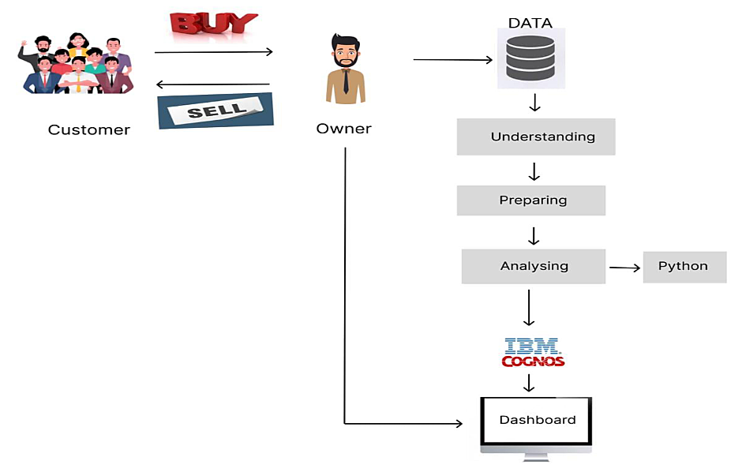

**5.3** **User Stories**

|  |  |  |  |  |  |  |
| --- | --- | --- | --- | --- | --- | --- |
| **User Type** | **Functional Requirement (Epic)** | **User Story Number** | **User Story / Task** | **Acceptance criteria** | **Priority** | **Release** |
|  | Collecting dataset | USN-1 | As a user, I need to gather the data in the form of CSV/XLS and clean the data. |  | low | Sprint-1 |
|  | Data preparation | USN-2 | As a user, I need to filter it for Data visualization. |  | Medium | Sprint-1 |
|  | Data visualization | USN-3 | As a user, I need to filter it for Data visualization. |  | Medium | Sprint-1 |
|  | Dashboard | USN-4 | Access dashboard in website | Dashboard | medium | Sprint-2 |
|  | Report and story | USN-5 | As a user, I can view the list of categorized products and their details as a report and story. | Report and Story |  | Sprint-2 |
| Customer  (web user) | Registration | USN-6 | As a user, I can register for the application by entering my email, password, and confirming my password. | I can access my account / dashboard | High | Sprint-3 |
|  | Login | USN-7 | As a user, I need valid credentials to log to my application. | I can receive confirmation email and click confirm. | High | Sprint-3 |
|  |  | USN-8 | As a user, I can register for the application through Gmail | I can register and access the dashboard with Login | Low | Sprint-3 |
|  |  | USN-9 | As a user, I can log into the application by entering email and password |  | High | Sprint-4 |
| Administrator |  | USN-10 | It can be easily accessible and responsible. | I can access it easily through application. | High | Sprint-4 |

**6.** **PROJECT PLANNING & SCHEDULING**

**6.1** **Sprint Planning & Estimation**

|  |  |  |  |  |  |  |
| --- | --- | --- | --- | --- | --- | --- |
| **Sprint** | **Functional Requirement (Epic)** | **User Story Number** | **User Story / Task** | **Story Points** | **Priority** | **Team Members** |
| Sprint -1 | Registration | USN-1 | As a user, I can register for the application by entering my email, password, and confirming my password. | 5 | High | Yeshwanth L  Chandu K  Yeshwanth K  Dinesh N |
| Sprint -1 | Login | USN-2 | As a user, I need valid credentials to log to my application. | 5 | High | Yeshwanth L  Chandu K  Yeshwanth K  Dinesh N |
| Sprint -1 | Data collection | USN-3 | As a user, I need to gather the data in the form of CSV/XLS and clean the data. | 5 | High | Yeshwanth L  Chandu K  Yeshwanth K  Dinesh N |
| Sprint -1 | Upload dataset | USN-4 | As a user, I can view the data of the products. | 5 | High | Yeshwanth L  Chandu K |
| Sprint -2 | Data preparation | USN-5 | As a user, I need to filter it for Data visualization. | 5 | High | Dharmeshprasad R, Tamilvanan N |
| Sprint -2 | Data visualization | USN-6 | As a user, I need to filter it for Data visualization. | 5 |  | Yeshwanth L  Chandu K  Yeshwanth K  Dinesh N |
| Sprint -2 | Dashboard | USN-7 | As a user, I need to filter it for Data visualization. | 10 | High | Yeshwanth L  Chandu K  Yeshwanth K  Dinesh N |
| Sprint -3 | Dashboard | USN-8 | As a user, I must plan visualizations in a way that I’m able to gain insights regarding the sales based upon the category of sales and the respective region. | 4 | High | Yeshwanth L  Chandu K  Yeshwanth K  Dinesh N |
| Sprint -3 | Dashboard | USN-9 | As a user, I must be able to gain insights from the charts/graphs through a variety of relationships established on the dashboard. | 10 | Medium | Yeshwanth L  Chandu K  Yeshwanth K  Dinesh N |
| Sprint -4 | Prediction | USN-10 | As a user, I see the prediction of the specific product’s future sales expectation. | 10 | Medium | Yeshwanth L  Chandu K  Yeshwanth K  Dinesh N |
| Sprint -4 | Report | USN-11 | As a user, I can view the list of categorized products and their details as a report. | 10 | High | Yeshwanth L  Chandu K  Yeshwanth K  Dinesh N |
| Sprint -4 | Story | USN-12 | As a user, I can view the product and customer description and more additional information as a story. | 10 | High | Yeshwanth L  Chandu K  Yeshwanth K  Dinesh N |

**6.2** **Sprint Delivery Schedule**

|  |  |  |  |  |  |  |
| --- | --- | --- | --- | --- | --- | --- |
| **Sprint** | **Total Story Points** | **Duration** | **Sprint Start Date** | **Sprint End Date (Planned)** | **Story Points Completed (as on Planned End Date)** | **Sprint Release Date (Actual)** |
| Sprint-1 | 20 | 6 Days | 24 Oct 2022 | 29 Oct 2022 | 20 | 29 Oct 2022 |
| Sprint-2 | 20 | 6 Days | 31 Oct 2022 | 05 Nov 2022 | 20 | 05 Nov 2022 |
| Sprint-3 | 20 | 6 Days | 07 Nov 2022 | 12 Nov 2022 | 20 | 12 Nov 2022 |
| Sprint-4 | 20 | 6 Days | 14 Nov 2022 | 19 Nov 2022 | 20 | 19 Nov 2022 |

**6.3** **Reports From JIRA**

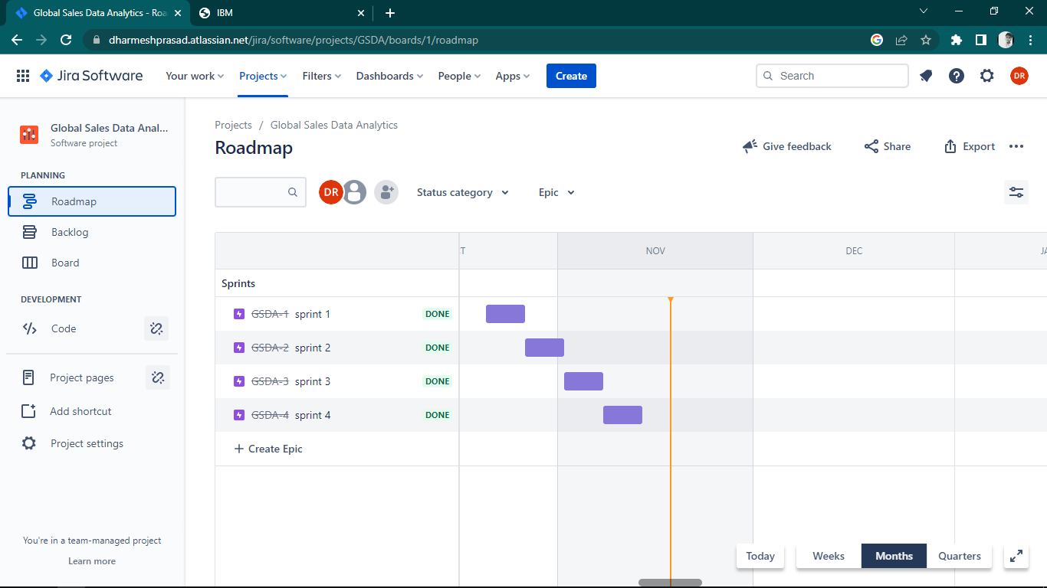

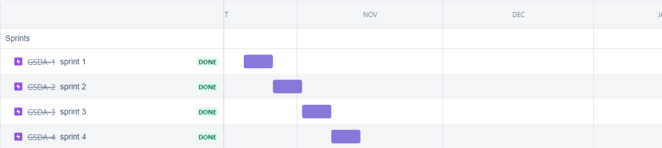

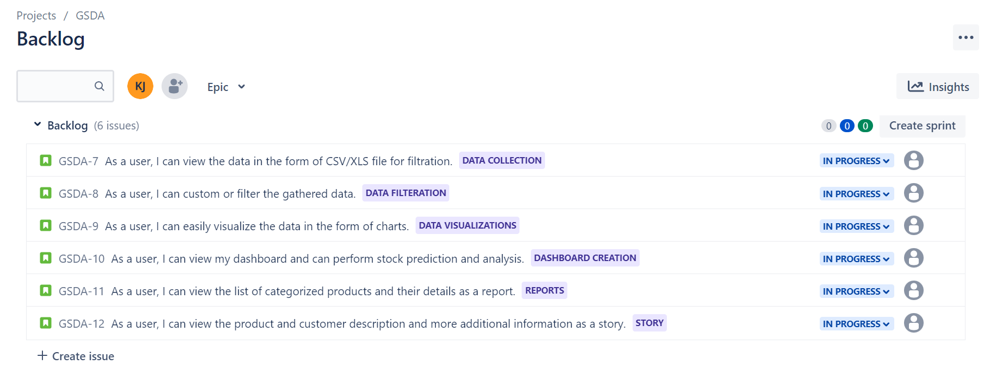

**7.CODING & SOLUTION**

**Feature 1 -** **Login page:**

1. <!DOCTYPE html>
2. <html lang="en">
3. <head>
4. <meta charset="utf-8" />
5. <meta name="author" content="Kodinger" />
6. <meta name="viewport" content="width=device-width,initial-scale=1" />
7. <title>Global Sales Data Analytics</title>
8. <link rel="stylesheet" type="text/css" href="assets/css/my-login.css" />
9. </head>
10. <body class="my-login-page">
11. <section class="h-100">
12. <div class="container h-100">
13. <div class="row justify-content-md-center h-100">
14. <div class="card-wrapper">
15. <div class="brand">
16. <img src="assets/img/logo123.png" alt="logo" />
17. </div>
18. <div class="card fat">
19. <div class="card-body">
20. <h4 class="card-title">Login</h4>
21. <form method="POST" class="my-login-validation" novalidate="">
22. <div class="form-group">
23. <label for="email">E-Mail Address</label>
24. <input
25. id="email"
26. type="email"
27. class="form-control"
28. name="email"
29. value=""
30. required
31. autofocus
32. />
33. <div class="invalid-feedback">Email is invalid</div>
34. </div>
35. <div class="form-group">
36. <label for="password"
37. >Password
38. <a href="forgot.html" class="float-right">
39. Forgot Password?
40. </a>
41. </label>
42. <input
43. id="password"
44. type="password"
45. class="form-control"
46. name="password"
47. required
48. data-eye
49. />
50. <div class="invalid-feedback">Password is required</div>
51. </div>
52. <div class="form-group">
53. <div class="custom-checkbox custom-control">
54. <input
55. type="checkbox"
56. name="remember"
57. id="remember"
58. class="custom-control-input"
59. />
60. <label for="remember" class="custom-control-label"
61. >Remember Me</label
62. >
63. </div>
64. </div>
65. <div class="form-group m-0">
66. <button
67. type="submit"
68. id="mybutton"
69. class="btn btn-primary btn-block"
70. >
71. Login
72. </button>
73. </div>
74. <div class="mt-4 text-center">
75. Don't have an account?
76. <a href="register.html">Create One</a>
77. </div>
78. </form>
79. </div>
80. </div>
81. <div class="footer">
82. Copyright &copy; 2022 &mdash; PNT2022TMID41225
83. </div>
84. </div>
85. </div>
86. </div>
87. </section>
88. <script src="https://cdnjs.cloudflare.com/ajax/libs/popper.js/1.14.7/umd/popper.min.js" integrity="sha384-UO2eT0CpHqdSJQ6hJty5KVphtPhzWj9WO1clHTMGa3JDZwrnQq4sF86dIHNDz0W1" crossorigin="anonymous"></script>
89. <script src="https://stackpath.bootstrapcdn.com/bootstrap/4.3.1/js/bootstrap.min.js" integrity="sha384-JjSmVgyd0p3pXB1rRibZUAYoIIy6OrQ6VrjIEaFf/nJGzIxFDsf4x0xIM+B07jRM" crossorigin="anonymous"></script> -->
90. <script src="assets/js/my-login.js"></script>
91. </body>
92. </html>

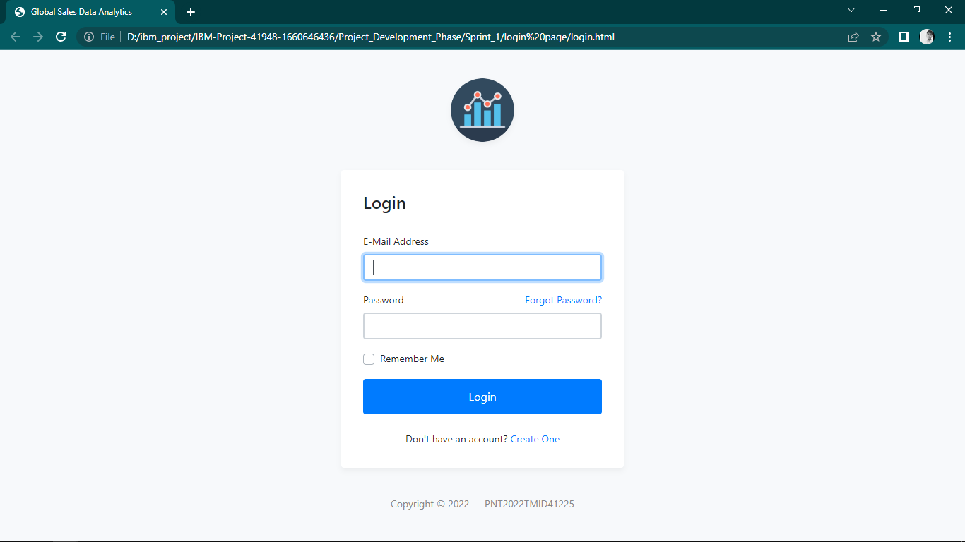



**Feature 2 - Embedding dashboard to web app:**

1. <iframe src="https://us1.ca.analytics.ibm.com/bi/?perspective=dashboard&amp;pathRef=.my_folders%2Fglobalsale%2FGlobalsales_Dashboard&amp;closeWindowOnLastView=true&amp;ui_appbar=false&amp;ui_navbar=false&amp;shareMode=embedded&amp;action=view&amp;mode=dashboard&amp;subView=model000001847746ca80_00000000" width="1200" height="1000" frameborder="0" gesture="media" allow="encrypted-media" allowfullscreen=""></iframe>

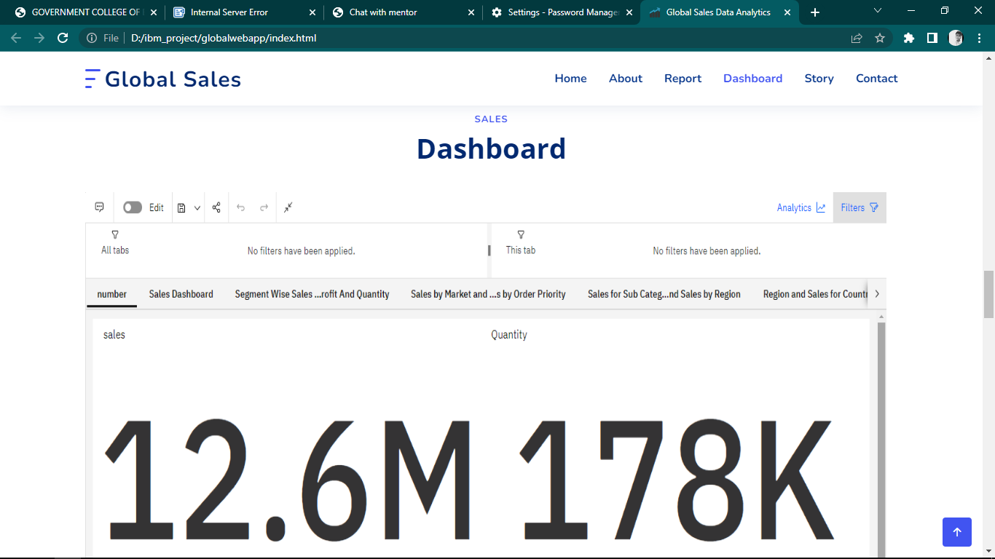

**Feature 3 - Embedding report to web app:**

1. <iframe src="https://us1.ca.analytics.ibm.com/bi/?pathRef=.my_folders%2Fglobalsale%2FGlobalsales_Report&amp;closeWindowOnLastView=true&amp;ui_appbar=false&amp;ui_navbar=false&amp;shareMode=embedded&amp;action=edit" width="1300" height="1000" frameborder="0" gesture="media" allow="encrypted-media" allowfullscreen=""></iframe>

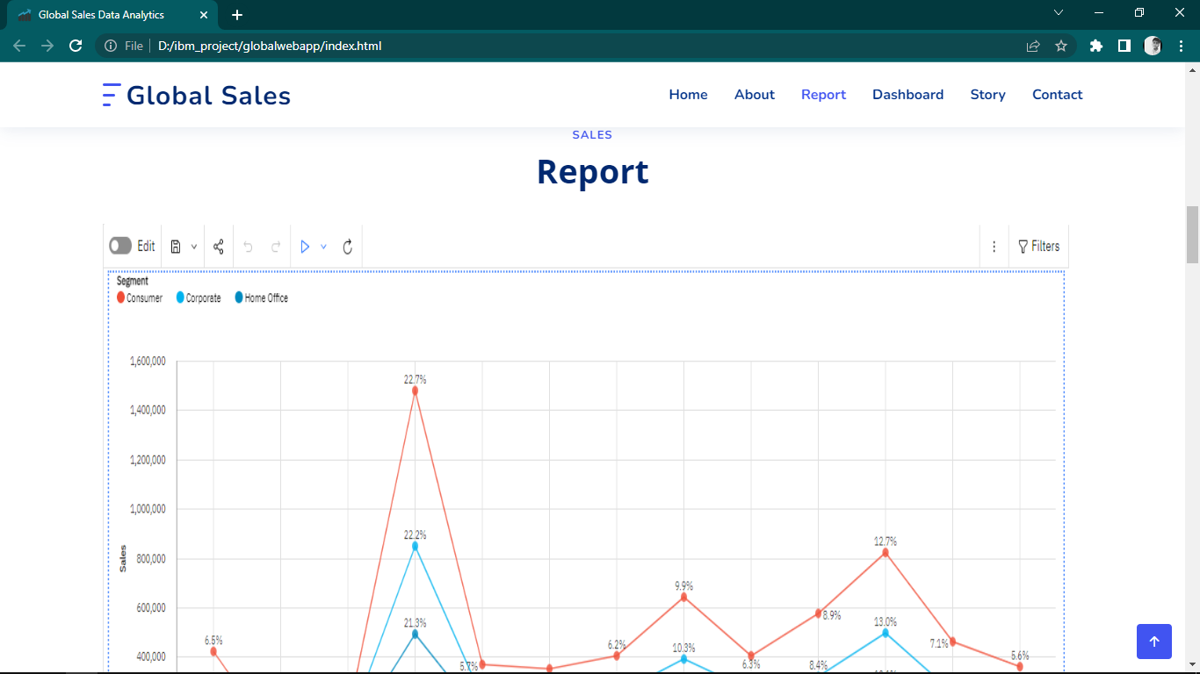

**Feature 4 - Embedding story to web app:**

1. <iframe src="https://us1.ca.analytics.ibm.com/bi/?perspective=story&amp;pathRef=.my_folders%2Fglobalsale%2FNew%2Bstory&amp;closeWindowOnLastView=true&amp;ui_appbar=false&amp;ui_navbar=false&amp;shareMode=embedded&amp;action=view&amp;sceneId=model000001847a103dc5_00000000&amp;sceneTime=600" width="1300" height="1000" frameborder="0" gesture="media" allow="encrypted-media" allowfullscreen=""></iframe>

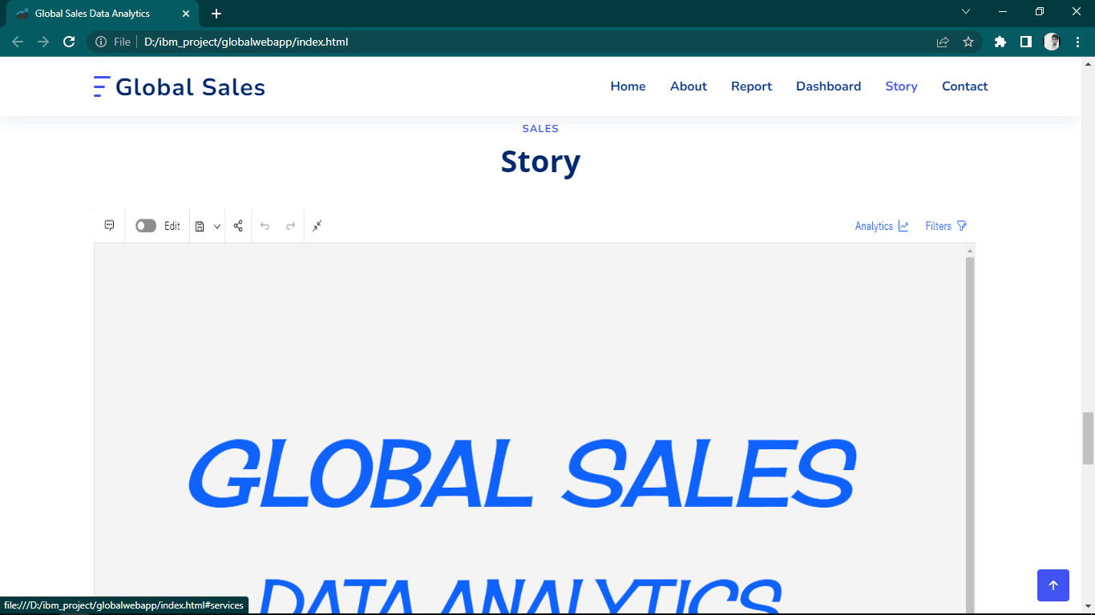

**8.** **TESTING**

**8.1** **Test Cases**

**Test Scenarios**

* Verify user able to see login page
* Verify user able to login to application or not?
* Verify user able to navigate to create your account page?
* Verify user able to recovery password
* Verify login page elements

**Access visualizations**

* User able to see dashboard
* User able to see report
* User able to see stories

**8.2** **User Acceptance Testing**

**Defect Analysis:**

|  |  |  |  |  |  |
| --- | --- | --- | --- | --- | --- |
| **Resolution** | **Severity 1** | **Severity 2** | **Severity 3** | **Severity 4** | **Subtotal** |
| By Design | 5 | 2 | 1 | 1 | 9 |
| Duplicate | 0 | 0 | 0 | 0 | 0 |
| External | 2 | 3 | 0 | 1 | 6 |
| Fixed | 4 | 1 | 2 | 2 | 9 |
| Not Reproduced | 0 | 0 | 0 | 0 | 0 |
| Skipped | 0 | 0 | 0 | 0 | 0 |
| Won't Fix | 0 | 0 | 0 | 0 | 0 |
| Totals | 11 | 6 | 3 | 4 | 24 |

**Test Case Analysis:**

|  |  |  |  |  |
| --- | --- | --- | --- | --- |
| **Section** | **Total Cases** | **Not Tested** | **Fail** | **Pass** |
| Print Engine | 0 | 0 | 0 | 0 |
| Client Application | 6 | 0 | 0 | 6 |
| Security | 0 | 0 | 0 | 0 |
| Outsource Shipping | 0 | 0 | 0 | 0 |
| Exception Reporting | 7 | 0 | 0 | 7 |
| Final ReportOutput | 0 | 0 | 0 | 0 |
| Version Control | 0 | 0 | 0 | 0 |

**9. RESULTS**

**Screenshots of web application:**

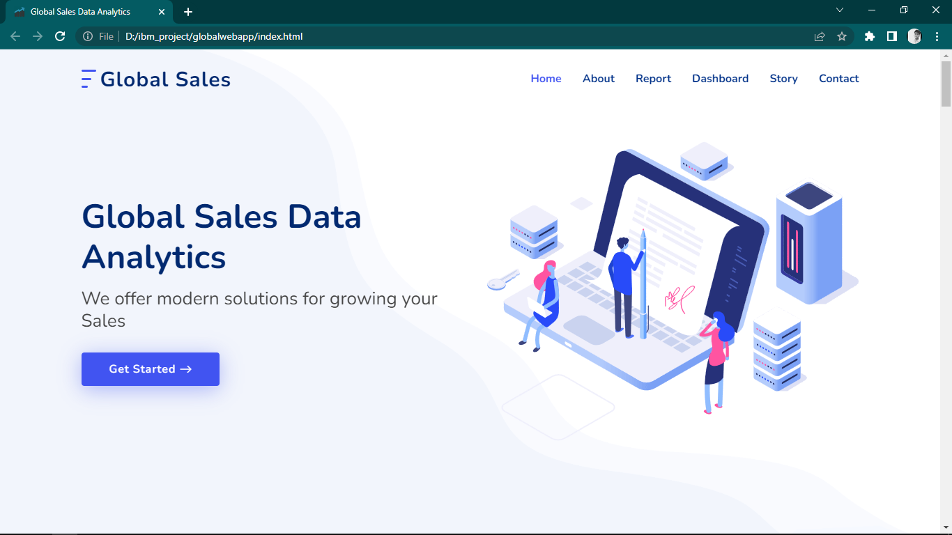

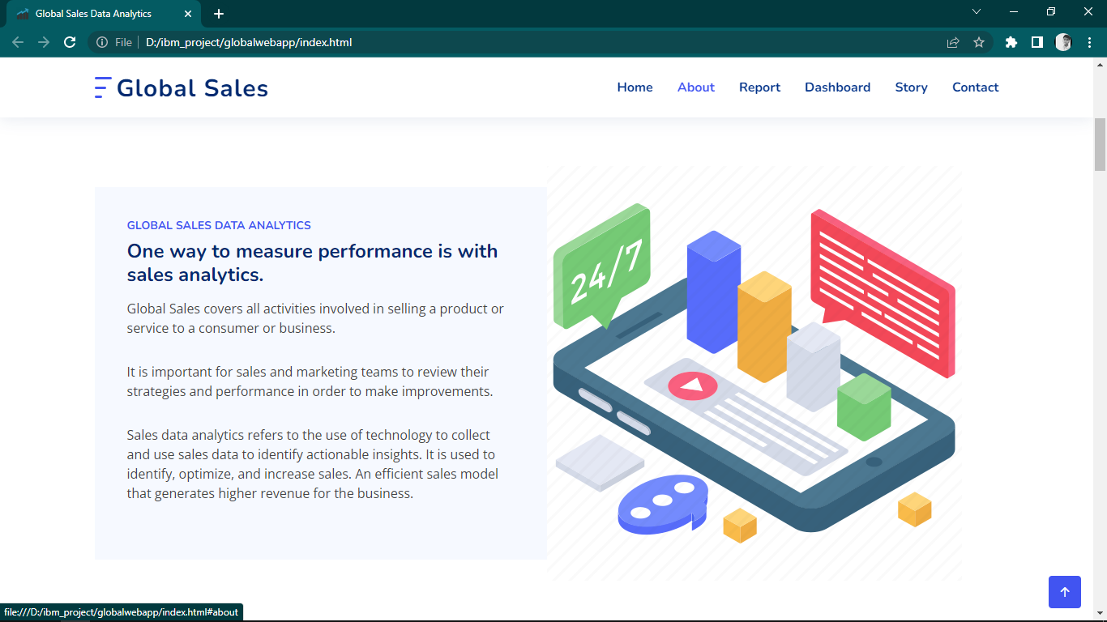

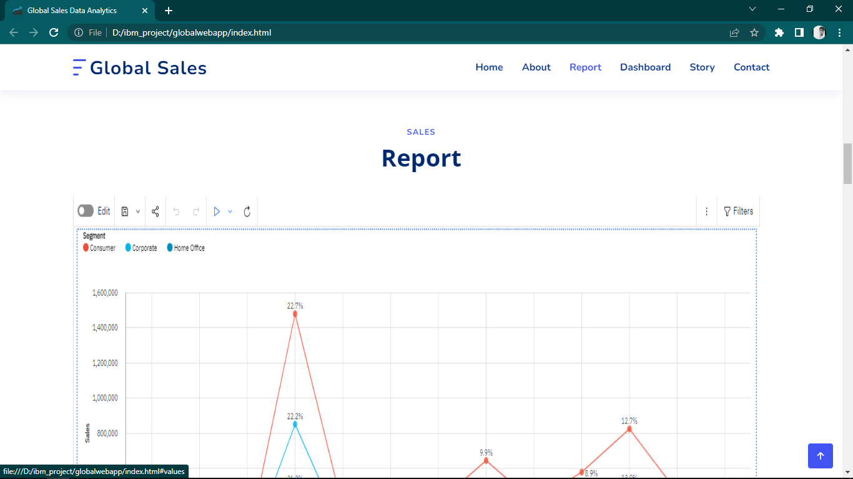

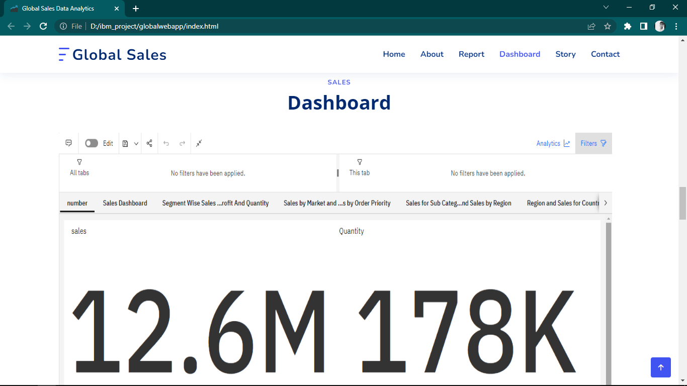

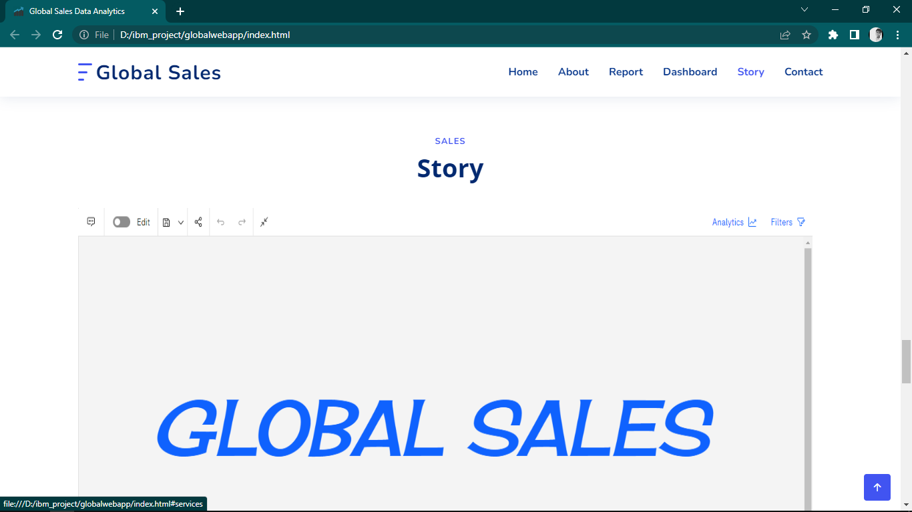

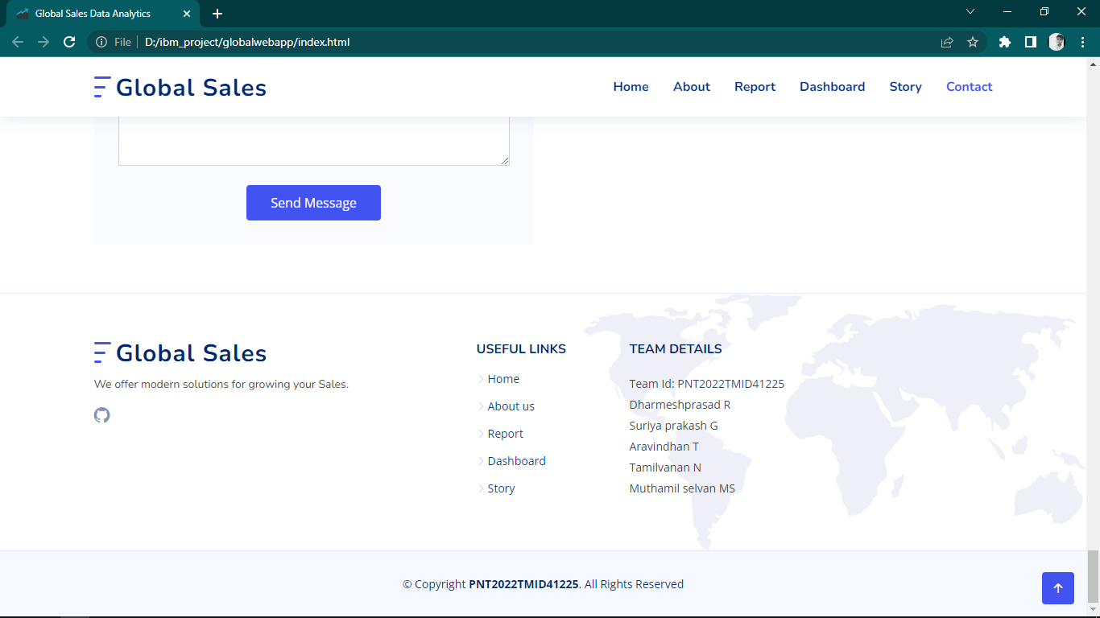



**10. ADVANTAGES & DISADVANTAGES**

**Advantages:**

* It is used to identify, optimize, and forecast sales.
* Sales data will help a company to take a future decision in terms of inventory management, marketing activities, schemes or offers to be rolled and changes in manufacturing processes if applicable.
* An efficient sales model that generates higher revenue for the business.
* Better prediction, Profit function performance.
* Helps to review their strategies and performance in order to make improvements.

**Disadvantages:**

* Sales pattern can be changed
* insufficient data may lead to wrong path.
* data may have been collected for historical reasons may not be suitable to answer the questions that we ask today.
* business users do not see results immediately

**11. CONCLUTION**

Analyzing sales helps businesses in understanding their most profitable products and the ones that are not moving, most profitable customers, and potential sales opportunities thereby providing sales which match customer needs and meets their satisfaction. An efficient sales model that generates higher revenue for the business. It helps in the perception of profit about particular product and perception of sales in different locations and times.

**12. FUTURE SCOPE**

Use the technology to collect and use sales data to derive actionable insights. It is used to identify, optimize, and forecast sales. An efficient sales model that generates higher revenue for the business. An efficient sales model that generates higher revenue for the business.

**13. APPENDIX**

**13.1 Source Code**

**kaggle api to gather the dataset**

1. !pip install -q kaggle
2. !mkdir ~/.kaggle
3. !cp kaggle.json ~/.kaggle/
4. !kaggle datasets download -d mrhatrider/glabalsales
5. !unzip /content/glabalsales.zip

**index.html**

1. <!DOCTYPE html>
2. <html lang="en">
3. <head>
4. <meta charset="utf-8" />
5. <meta content="width=device-width, initial-scale=1.0" name="viewport" />
6. <title>Global Sales Data Analytics</title>
7. <meta content="" name="description" />
8. <meta content="" name="keywords" />
9. <!-- Favicons -->
10. <link href="assets/img/favicon.png" rel="icon" />
11. <link href="assets/img/apple-touch-icon.png" rel="apple-touch-icon" />
12. <!-- Google Fonts -->
13. <link
14. href="https://fonts.googleapis.com/css?family=Open+Sans:300,300i,400,400i,600,600i,700,700i|Nunito:300,300i,400,400i,600,600i,700,700i|Poppins:300,300i,400,400i,500,500i,600,600i,700,700i"
15. rel="stylesheet"
16. />
17. <!-- Vendor CSS Files -->
18. <link href="assets/vendor/aos/aos.css" rel="stylesheet" />
19. <link
20. href="assets/vendor/bootstrap/css/bootstrap.min.css"
21. rel="stylesheet"
22. />
23. <link
24. href="assets/vendor/bootstrap-icons/bootstrap-icons.css"
25. rel="stylesheet"
26. />
27. <link
28. href="assets/vendor/glightbox/css/glightbox.min.css"
29. rel="stylesheet"
30. />
31. <link href="assets/vendor/remixicon/remixicon.css" rel="stylesheet" />
32. <link href="assets/vendor/swiper/swiper-bundle.min.css" rel="stylesheet" />
33. <!-- Main CSS File -->
34. <link href="assets/css/style.css" rel="stylesheet" />
35. </head>
36. <body>
37. <!-- ======= Header ======= -->
38. <header id="header" class="header fixed-top">
39. <div
40. class="container-fluid container-xl d-flex align-items-center justify-content-between"
41. >
42. <a href="index.html" class="logo d-flex align-items-center">
43. <img src="assets/img/logo.png" alt="" />
44. <span>Global Sales</span>
45. </a>
46. <nav id="navbar" class="navbar">
47. <ul>
48. <li><a class="nav-link scrollto active" href="#hero">Home</a></li>
49. <li><a class="nav-link scrollto" href="#about">About</a></li>
50. <li><a class="nav-link scrollto" href="#values">Report</a></li>
51. <li><a class="nav-link scrollto" href="#features">Dashboard</a></li>
52. <li><a class="nav-link scrollto" href="#services">Story</a></li>
53. <li><a class="nav-link scrollto" href="#contact">Contact</a></li>
54. </ul>
55. <i class="bi bi-list mobile-nav-toggle"></i>
56. </nav>
57. <!-- .navbar -->
58. </div>
59. </header>
60. <!-- End Header -->
61. <!-- ======= Hero Section ======= -->
62. <section id="hero" class="hero d-flex align-items-center">
63. <div class="container">
64. <div class="row">
65. <div class="col-lg-6 d-flex flex-column justify-content-center">
66. <h1 data-aos="fade-up">Global Sales Data Analytics</h1>
67. <h2 data-aos="fade-up" data-aos-delay="400">
68. We offer modern solutions for growing your Sales
69. </h2>
70. <div data-aos="fade-up" data-aos-delay="600">
71. <div class="text-center text-lg-start">
72. <a
73. href="#about"
74. class="btn-get-started scrollto d-inline-flex align-items-center justify-content-center align-self-center"
75. >
76. <span>Get Started</span>
77. <i class="bi bi-arrow-right"></i>
78. </a>
79. </div>
80. </div>
81. </div>
82. <div
83. class="col-lg-6 hero-img"
84. data-aos="zoom-out"
85. data-aos-delay="200"
86. >
87. <img src="assets/img/hero-img.png" class="img-fluid" alt="" />
88. </div>
89. </div>
90. </div>
91. </section>
92. <!-- End Hero -->
93. <main id="main">
94. <!-- ======= About Section ======= -->
95. <section id="about" class="about">
96. <div class="container" data-aos="fade-up">
97. <div class="row gx-0">
98. <div
99. class="col-lg-6 d-flex flex-column justify-content-center"
100. data-aos="fade-up"
101. data-aos-delay="200"
102. >
103. <div class="content">
104. <h3>Global Sales Data Analytics</h3>
105. <h2>One way to measure performance is with sales analytics.</h2>
106. <p>
107. Global Sales covers all activities involved in selling a
108. product or service to a consumer or business.
109. </p>
110. <p>
111. It is important for sales and marketing teams to review their
112. strategies and performance in order to make improvements.
113. </p>
114. <p>
115. Sales data analytics refers to the use of technology to
116. collect and use sales data to identify actionable insights. It
117. is used to identify, optimize, and increase sales. An
118. efficient sales model that generates higher revenue for the
119. business.
120. </p>
121. </div>
122. </div>
123. <div
124. class="col-lg-6 d-flex align-items-center"
125. data-aos="zoom-out"
126. data-aos-delay="200"
127. >
128. <img src="assets/img/32-512.webp" class="img-fluid" alt="" />
129. </div>
130. </div>
131. </div>
132. </section>
133. <!-- End About Section -->
134. <!-- ======= Counts Section ======= -->
135. <section id="counts" class="counts">
136. <div class="container" data-aos="fade-up">
137. <div class="row gy-4">
138. <div class="col-lg-3 col-md-6">
139. <div class="count-box">
140. <i class="bi bi-star-fill"></i>
141. <div>
142. <span
143. data-purecounter-start="0"
144. data-purecounter-end="12.6"
145. data-purecounter-duration="1"
146. class="purecounter"
147. ></span>
148. <p>Sales(millions)</p>
149. </div>
150. </div>
151. </div>
152. <div class="col-lg-3 col-md-6">
153. <div class="count-box">
154. <i class="bi bi-star-fill"></i>
155. <div>
156. <span
157. data-purecounter-start="0"
158. data-purecounter-end="1.6"
159. data-purecounter-duration="1"
160. class="purecounter"
161. ></span>
162. <p>Profit (millions)</p>
163. </div>
164. </div>
165. </div>
166. <div class="col-lg-3 col-md-6">
167. <div class="count-box">
168. <i class="bi bi-star-fill"></i>
169. <div>
170. <span
171. data-purecounter-start="0"
172. data-purecounter-end="17.86"
173. data-purecounter-duration="1"
174. class="purecounter"
175. ></span>
176. <p>Quantity (millions)</p>
177. </div>
178. </div>
179. </div>
180. <div class="col-lg-3 col-md-6">
181. <div class="count-box">
182. <i class="bi bi-star-fill"></i>
183. <div>
184. <span
185. data-purecounter-start="0"
186. data-purecounter-end="1.6"
187. data-purecounter-duration="1"
188. class="purecounter"
189. ></span>
190. <p>Sales cost (millions)</p>
191. </div>
192. </div>
193. </div>
194. </div>
195. </div>
196. </section>
197. <!-- End Counts Section -->
198. <!-- ======= Values Section ======= -->
199. <section id="values" class="values">
200. <div class="container" data-aos="fade-up">
201. <header class="section-header">
202. <h2>Sales</h2>
203. <p>Report</p>
204. </header>
205. <iframe
206. src="https://us1.ca.analytics.ibm.com/bi/?pathRef=.my_folders%2Fglobalsale%2FGlobalsales_Report&amp;closeWindowOnLastView=true&amp;ui_appbar=false&amp;ui_navbar=false&amp;shareMode=embedded&amp;action=edit"
207. width="1300"
208. height="1000"
209. frameborder="0"
210. gesture="media"
211. allow="encrypted-media"
212. allowfullscreen=""
213. ></iframe>
214. <div class="row">
215. <div class="col-lg-4" data-aos="fade-up" data-aos-delay="200">
216. <div class="box">
217. <img src="assets/img/values-1.png" class="img-fluid" alt="" />
218. <h3>Report</h3>
219. <p>
220. sorting and organization of data, while analytics derive
221. insights from that data and often influence business
222. decisions.
223. </p>
224. </div>
225. </div>
226. <div
227. class="col-lg-4 mt-4 mt-lg-0"
228. data-aos="fade-up"
229. data-aos-delay="400"
230. >
231. <div class="box">
232. <img src="assets/img/values-2.png" class="img-fluid" alt="" />
233. <h3>Stroy</h3>
234. <p>
235. a methodology for communicating information, tailored to a
236. specific audience, with a compelling narrative.
237. </p>
238. </div>
239. </div>
240. <div
241. class="col-lg-4 mt-4 mt-lg-0"
242. data-aos="fade-up"
243. data-aos-delay="600"
244. >
245. <div class="box">
246. <img src="assets/img/values-3.png" class="img-fluid" alt="" />
247. <h3>Dashboard</h3>
248. <p>
249. a tool used to multi-task, organize, visualize, analyze, and
250. track data.View automatically updated data with interactive
251. charts, graphs and tables.
252. </p>
253. </div>
254. </div>
255. </div>
256. </div>
257. </section>
258. <!-- End Values Section -->
259. <!-- ======= Features Section ======= -->
260. <section id="features" class="features">
261. <div class="container" data-aos="fade-up">
262. <header class="section-header">
263. <h2>Sales</h2>
264. <p>Dashboard</p>
265. </header>
266. <iframe
267. src="https://us1.ca.analytics.ibm.com/bi/?perspective=dashboard&amp;pathRef=.my_folders%2Fglobalsale%2FGlobalsales_Dashboard&amp;closeWindowOnLastView=true&amp;ui_appbar=false&amp;ui_navbar=false&amp;shareMode=embedded&amp;action=view&amp;mode=dashboard&amp;subView=model000001847746ca80_00000000"
268. width="1200"
269. height="1000"
270. frameborder="0"
271. gesture="media"
272. allow="encrypted-media"
273. allowfullscreen=""
274. ></iframe>
275. <div class="row">
276. <div class="col-lg-6 mt-5 mt-lg-0 d-flex">
277. <div class="row align-self-center gy-4">
278. <div class="col-md-6" data-aos="zoom-out" data-aos-delay="200">
279. <div class="feature-box d-flex align-items-center">
280. <i class="bi bi-check"></i>
281. <h3>Segment Wise Sales , Profit And Quantity</h3>
282. </div>
283. </div>
284. <div class="col-md-6" data-aos="zoom-out" data-aos-delay="300">
285. <div class="feature-box d-flex align-items-center">
286. <i class="bi bi-check"></i>
287. <h3>Sales By Market</h3>
288. </div>
289. </div>
290. <div class="col-md-6" data-aos="zoom-out" data-aos-delay="400">
291. <div class="feature-box d-flex align-items-center">
292. <i class="bi bi-check"></i>
293. <h3>Sales By Sub Category And Sales By Region</h3>
294. </div>
295. </div>
296. <div class="col-md-6" data-aos="zoom-out" data-aos-delay="500">
297. <div class="feature-box d-flex align-items-center">
298. <i class="bi bi-check"></i>
299. <h3>Country Wise Sales Using Map Points</h3>
300. </div>
301. </div>
302. <div class="col-md-6" data-aos="zoom-out" data-aos-delay="600">
303. <div class="feature-box d-flex align-items-center">
304. <i class="bi bi-check"></i>
305. <h3>
306. Sub Category Wise Sales And Profits Using Line And Bar
307. Chart
308. </h3>
309. </div>
310. </div>
311. <div class="col-md-6" data-aos="zoom-out" data-aos-delay="700">
312. <div class="feature-box d-flex align-items-center">
313. <i class="bi bi-check"></i>
314. <h3>
315. Sales Vs Profit Scatter Plot With Sub Categories And
316. Regions
317. </h3>
318. </div>
319. </div>
320. <div class="col-md-6" data-aos="zoom-out" data-aos-delay="700">
321. <div class="feature-box d-flex align-items-center">
322. <i class="bi bi-check"></i>
323. <h3>Sales Dashboard</h3>
324. </div>
325. </div>
326. </div>
327. </div>
328. <div class="col-lg-6 mt-5 mt-lg-0 d-flex">
329. <div class="row align-self-center gy-4">
330. <div class="col-md-6" data-aos="zoom-out" data-aos-delay="200">
331. <div class="feature-box d-flex align-items-center">
332. <i class="bi bi-check"></i>
333. <h3>Regional Sales And Profit Forecast</h3>
334. </div>
335. </div>
336. <div class="col-md-6" data-aos="zoom-out" data-aos-delay="300">
337. <div class="feature-box d-flex align-items-center">
338. <i class="bi bi-check"></i>
339. <h3>Sales Forecast By Order Priority</h3>
340. </div>
341. </div>
342. <div class="col-md-6" data-aos="zoom-out" data-aos-delay="400">
343. <div class="feature-box d-flex align-items-center">
344. <i class="bi bi-check"></i>
345. <h3>Sales By Sub Category Analytics</h3>
346. </div>
347. </div>
348. <div class="col-md-6" data-aos="zoom-out" data-aos-delay="500">
349. <div class="feature-box d-flex align-items-center">
350. <i class="bi bi-check"></i>
351. <h3>Regional Quantity using Radar Chart</h3>
352. </div>
353. </div>
354. <div class="col-md-6" data-aos="zoom-out" data-aos-delay="500">
355. <div class="feature-box d-flex align-items-center">
356. <i class="bi bi-check"></i>
357. <h3>profit Forecast using Radar Chart</h3>
358. </div>
359. </div>
360. <div class="col-md-6" data-aos="zoom-out" data-aos-delay="600">
361. <div class="feature-box d-flex align-items-center">
362. <i class="bi bi-check"></i>
363. <h3>Sales Vs Profit By Countries</h3>
364. </div>
365. </div>
366. <div class="col-md-6" data-aos="zoom-out" data-aos-delay="700">
367. <div class="feature-box d-flex align-items-center">
368. <i class="bi bi-check"></i>
369. <h3>Country Wise Sales Vs Profit Using Word Cloud</h3>
370. </div>
371. </div>
372. </div>
373. </div>
374. </div>
375. <!-- / row -->
376. </div>
377. </section>
378. <!-- End Features Section -->
379. <!-- ======= Services Section ======= -->
380. <section id="services" class="services">
381. <div class="container" data-aos="fade-up">
382. <header class="section-header">
383. <h2>Sales</h2>
384. <p>Story</p>
385. </header>
386. <iframe
387. src="https://us1.ca.analytics.ibm.com/bi/?perspective=story&amp;pathRef=.my_folders%2Fglobalsale%2FNew%2Bstory&amp;closeWindowOnLastView=true&amp;ui_appbar=false&amp;ui_navbar=false&amp;shareMode=embedded&amp;action=view&amp;sceneId=model000001847a103dc5_00000000&amp;sceneTime=600"
388. width="1300"
389. height="1000"
390. frameborder="0"
391. gesture="media"
392. allow="encrypted-media"
393. allowfullscreen=""
394. ></iframe>
395. </div>
396. </section>
397. <!-- End Services Section -->
398. <!-- ======= F.A.Q Section ======= -->
399. <section id="faq" class="faq">
400. <div class="container" data-aos="fade-up">
401. <header class="section-header">
402. <h2>F.A.Q</h2>
403. <p>Frequently Asked Questions</p>
404. </header>
405. <div class="row">
406. <div class="col-lg-6">
407. <!-- F.A.Q List 1-->
408. <div class="accordion accordion-flush" id="faqlist1">
409. <div class="accordion-item">
410. <h2 class="accordion-header">
411. <button
412. class="accordion-button collapsed"
413. type="button"
414. data-bs-toggle="collapse"
415. data-bs-target="#faq-content-1"
416. >
417. When does the issue occur?
418. </button>
419. </h2>
420. <div
421. id="faq-content-1"
422. class="accordion-collapse collapse"
423. data-bs-parent="#faqlist1"
424. >
425. <div class="accordion-body">
426. Consumers shopping patterns have changed since the
427. pandemic, with more emphasis on e-commerce and contactless
428. payments.
429. </div>
430. </div>
431. </div>
432. <div class="accordion-item">
433. <h2 class="accordion-header">
434. <button
435. class="accordion-button collapsed"
436. type="button"
437. data-bs-toggle="collapse"
438. data-bs-target="#faq-content-2"
439. >
440. Where does the issue occur?
441. </button>
442. </h2>
443. <div
444. id="faq-content-2"
445. class="accordion-collapse collapse"
446. data-bs-parent="#faqlist1"
447. >
448. <div class="accordion-body">
449. The issue occurs on online shopping.
450. </div>
451. </div>
452. </div>
453. <div class="accordion-item">
454. <h2 class="accordion-header">
455. <button
456. class="accordion-button collapsed"
457. type="button"
458. data-bs-toggle="collapse"
459. data-bs-target="#faq-content-3"
460. >
461. Why is it important that we fix the problem?
462. </button>
463. </h2>
464. <div
465. id="faq-content-3"
466. class="accordion-collapse collapse"
467. data-bs-parent="#faqlist1"
468. >
469. <div class="accordion-body">
470. Data-driven sales organizations now operate more like
471. scientists and strategists, and the results speak for
472. themselves.
473. </div>
474. </div>
475. </div>
476. </div>
477. </div>
478. <div class="col-lg-6">
479. <!-- F.A.Q List 2-->
480. <div class="accordion accordion-flush" id="faqlist2">
481. <div class="accordion-item">
482. <h2 class="accordion-header">
483. <button
484. class="accordion-button collapsed"
485. type="button"
486. data-bs-toggle="collapse"
487. data-bs-target="#faq2-content-1"
488. >
489. Who does the problem affect??
490. </button>
491. </h2>
492. <div
493. id="faq2-content-1"
494. class="accordion-collapse collapse"
495. data-bs-parent="#faqlist2"
496. >
497. <div class="accordion-body">
498. It will affect both the customer and the store.
499. </div>
500. </div>
501. </div>
502. <div class="accordion-item">
503. <h2 class="accordion-header">
504. <button
505. class="accordion-button collapsed"
506. type="button"
507. data-bs-toggle="collapse"
508. data-bs-target="#faq2-content-2"
509. >
510. What are the boundaries of the problem?
511. </button>
512. </h2>
513. <div
514. id="faq2-content-2"
515. class="accordion-collapse collapse"
516. data-bs-parent="#faqlist2"
517. >
518. <div class="accordion-body">
519. Low data proficiency among sales will greatly limits the
520. value of analytical insights and inhibits data-driven
521. decision making.
522. </div>
523. </div>
524. </div>
525. <div class="accordion-item">
526. <h2 class="accordion-header">
527. <button
528. class="accordion-button collapsed"
529. type="button"
530. data-bs-toggle="collapse"
531. data-bs-target="#faq2-content-3"
532. >
533. What is the issue?
534. </button>
535. </h2>
536. <div
537. id="faq2-content-3"
538. class="accordion-collapse collapse"
539. data-bs-parent="#faqlist2"
540. >
541. <div class="accordion-body">
542. Cannot identify most profitable products and the ones that
543. aren't moving, most profitable customers, and potential
544. sales opportunities.
545. </div>
546. </div>
547. </div>
548. </div>
549. </div>
550. </div>
551. </div>
552. </section>
553. <!-- End F.A.Q Section -->
554. <!-- ======= Contact Section ======= -->
555. <section id="contact" class="contact">
556. <div class="container" data-aos="fade-up">
557. <header class="section-header">
558. <h2>Contact</h2>
559. <p>Contact Us</p>
560. </header>
561. <div class="row gy-4">
562. <div class="col-lg-6">
563. <form
564. action="forms/contact.php"
565. method="post"
566. class="php-email-form"
567. >
568. <div class="row gy-4">
569. <div class="col-md-6">
570. <input
571. type="text"
572. name="name"
573. class="form-control"
574. placeholder="Your Name"
575. required
576. />
577. </div>
578. <div class="col-md-6">
579. <input
580. type="email"
581. class="form-control"
582. name="email"
583. placeholder="Your Email"
584. required
585. />
586. </div>
587. <div class="col-md-12">
588. <input
589. type="text"
590. class="form-control"
591. name="subject"
592. placeholder="Subject"
593. required
594. />
595. </div>
596. <div class="col-md-12">
597. <textarea
598. class="form-control"
599. name="message"
600. rows="6"
601. placeholder="Message"
602. required
603. ></textarea>
604. </div>
605. <div class="col-md-12 text-center">
606. <div class="loading">Loading</div>
607. <div class="error-message"></div>
608. <div class="sent-message">
609. Your message has been sent. Thank you!
610. </div>
611. <button type="submit">Send Message</button>
612. </div>
613. </div>
614. </form>
615. </div>
616. </div>
617. </div>
618. </section>
619. <!-- End Contact Section -->
620. </main>
621. <!-- End #main -->
622. <!-- ======= Footer ======= -->
623. <footer id="footer" class="footer">
624. <div class="footer-top">
625. <div class="container">
626. <div class="row gy-4">
627. <div class="col-lg-5 col-md-12 footer-info">
628. <a href="index.html" class="logo d-flex align-items-center">
629. <img src="assets/img/logo.png" alt="" />
630. <span>Global Sales</span>
631. </a>
632. <p>We offer modern solutions for growing your Sales.</p>
633. <div class="social-links mt-3">
634. <a
635. href="https://github.com/IBM-EPBL/IBM-Project-41948-1660646436"
636. class="github"
637. ><i class="bi bi-github"></i
638. ></a>
639. </div>
640. </div>
641. <div class="col-lg-2 col-6 footer-links">
642. <h4>Useful Links</h4>
643. <ul>
644. <li>
645. <i class="bi bi-chevron-right"></i> <a href="#home">Home</a>
646. </li>
647. <li>
648. <i class="bi bi-chevron-right"></i>
649. <a href="#about">About us</a>
650. </li>
651. <li>
652. <i class="bi bi-chevron-right"></i>
653. <a href="#values">Report</a>
654. </li>
655. <li>
656. <i class="bi bi-chevron-right"></i>
657. <a href="#features">Dashboard</a>
658. </li>
659. <li>
660. <i class="bi bi-chevron-right"></i>
661. <a href="#services">Story</a>
662. </li>
663. </ul>
664. </div>
665. <div
666. class="col-lg-3 col-md-12 footer-contact text-center text-md-start"
667. >
668. <h4>Team Details</h4>
669. <p>
670. Team Id: PNT2022TMID41225 <br />
671. Dharmeshprasad R<br />
672. Suriya prakash G<br />
673. Aravindhan T<br />
674. Tamilvanan N<br />
675. Muthamil selvan MS<br />
676. </p>
677. </div>
678. </div>
679. </div>
680. </div>
681. <div class="container">
682. <div class="copyright">
683. &copy; Copyright <strong><span>PNT2022TMID41225</span></strong
684. >. All Rights Reserved
685. </div>
686. </div>
687. </footer>
688. <!-- End Footer -->
689. <a
690. href="#"
691. class="back-to-top d-flex align-items-center justify-content-center"
692. ><i class="bi bi-arrow-up-short"></i
693. ></a>
694. <!-- Vendor JS Files -->
695. <script src="assets/vendor/purecounter/purecounter_vanilla.js"></script>
696. <script src="assets/vendor/aos/aos.js"></script>
697. <script src="assets/vendor/bootstrap/js/bootstrap.bundle.min.js"></script>
698. <script src="assets/vendor/glightbox/js/glightbox.min.js"></script>
699. <script src="assets/vendor/isotope-layout/isotope.pkgd.min.js"></script>
700. <script src="assets/vendor/swiper/swiper-bundle.min.js"></script>
701. <script src="assets/vendor/php-email-form/validate.js"></script>
702. <!-- Main JS File -->
703. <script src="assets/js/main.js"></script>
704. </body>
705. </html>

**13.2** **Github & Project Demo Link:**

**GitHub:**

Link: [IBM-EPBL/IBM-Project-30492-1660147414: Global Sales Data Analytics (github.com)](https://github.com/IBM-EPBL/IBM-Project-30492-1660147414)

Demo link: [IBM-EPBL/IBM-Project-30492-1660147414: Global Sales Data Analytics (github.com)](https://github.com/IBM-EPBL/IBM-Project-30492-1660147414)