Selected sources J



50_Startupe.xlsx +

Q Search

Administration compared to State by R6D Spend

@ Ad ministration (Stim) @ State (CoiJnt distinc I)

##### Fields

[•_¥• 8ars •

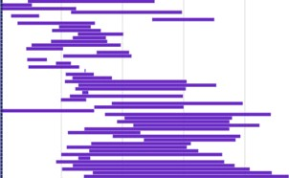:: R&D Spend



EDI Navigation paths *

* @ 50 Startups.xlsx

ljo R&D Spend

### II

@ Administration

@ Nar keting Spend

* + Q• State



J789792 440d9.9S



63005.48

o 73994.bt

 78013.11



101713.08



200000 400000 600000 800000 1000000





@ Length”

.. Administration



Marketing Spend

Required field

#### 

Mosdy clear

 



"}g

Profit



Details



### No details found



Profit by R&D Spend (Group) (3) and Marketing Spend (Group) (3) Profit \AverageJ “

78630.683 to < 157261.367 235892.050 to ‹ 314522.7J3 Z93t5J.4J7...

s than 78630.683 1S7?61.367 to < 73S892.050 314S22.733 to < 3931S3.41'/

Add *

No details were found for this visualization.

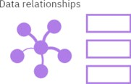@ Untidedpdf Q• Ganva.prig S8°•• •ll

## Y .fi„.., M *D*B



n0 ,0G w

## 0 ,O - a - 'â * 4* .‹u"«i»“ •



#### Upload data

Upload or drag and drop spreadsheets, csv files, and other data sources.

Recent



###### Prepare data

Use data modules to clean and connect data from multiple resources.

###### Exploration

Quickly find unbiased answers by identifying trends in your data with d...

#### Present data

Create sophisticated. multi-page, multi-query

dashboards, reports, or st...

##### Get up and running in IBM Cognos Analytics

@ Untidedpdf ^ @ Carrmpng ^

# y g. a *D* a 0 @ m y 6 0 G ¿ @ '!? •°° .



#### Explore data relationships



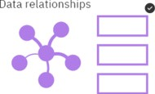50_Starl u ps. Alex

@ PFofit



Relationship diagram {T}

t0i#  t00%

Reset to original

x Edit diagram

Select a visualization

Explore visualizations related to *Profit’

Profit

# 12260566.08

Profit

Add + Profit

Show all X

Humid IN ” ” IS-GB-20M