DATA PREPARATIONS

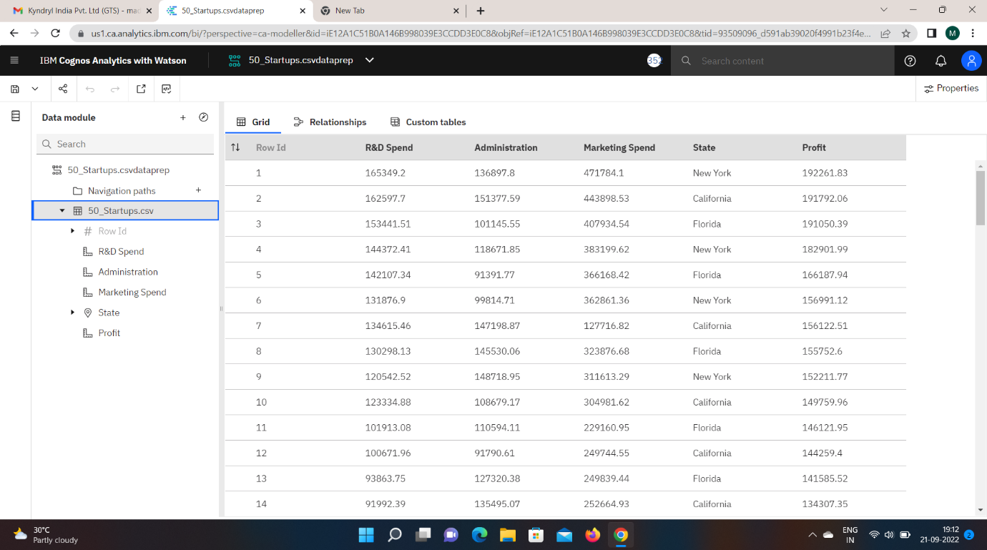

**EXPLORATIONS**

**DATA RELATIONSHIPS**

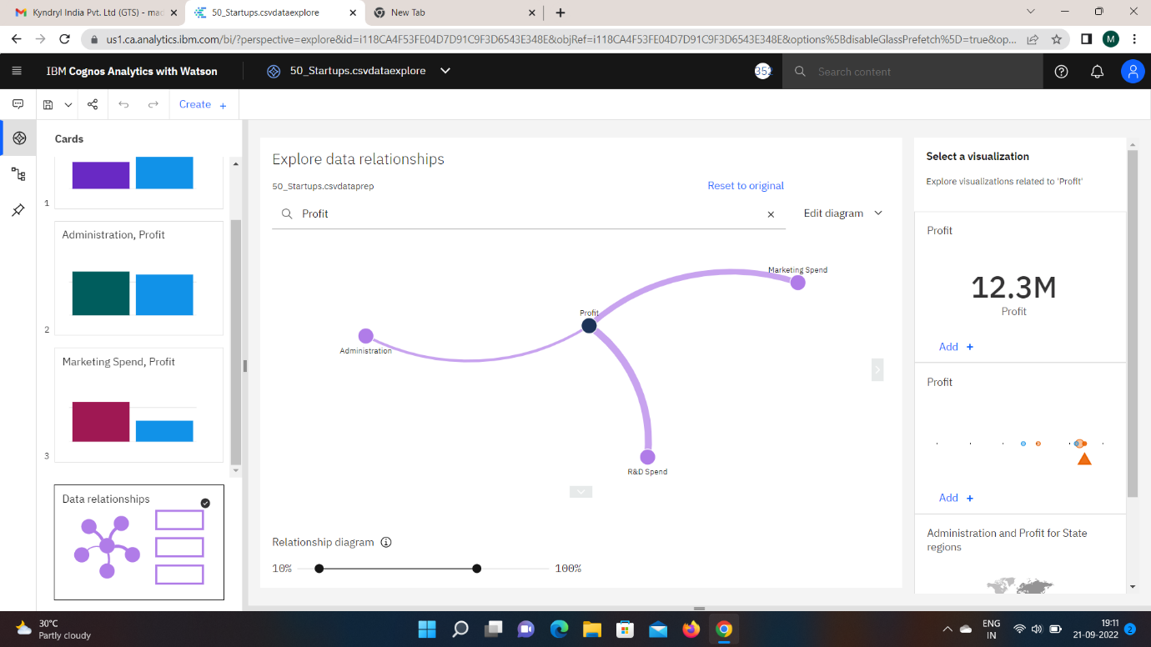

**R&D SPEND VS PROFIT**

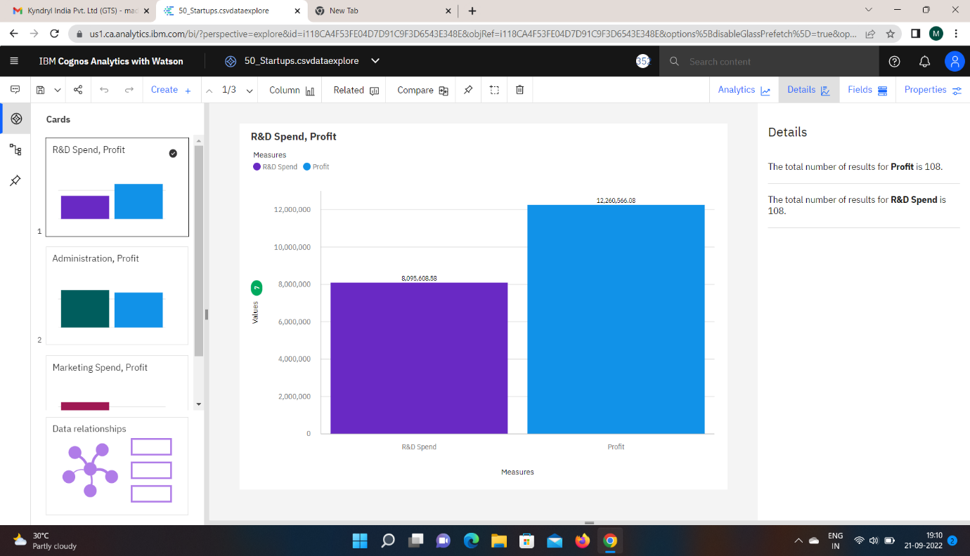

**ADMINISTRATOR VS PROFIT**

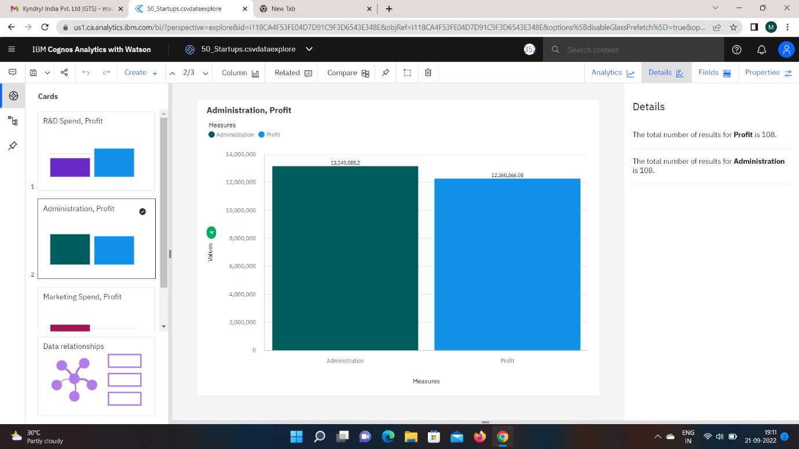

**MARKETING SPEND VS PROFIT**

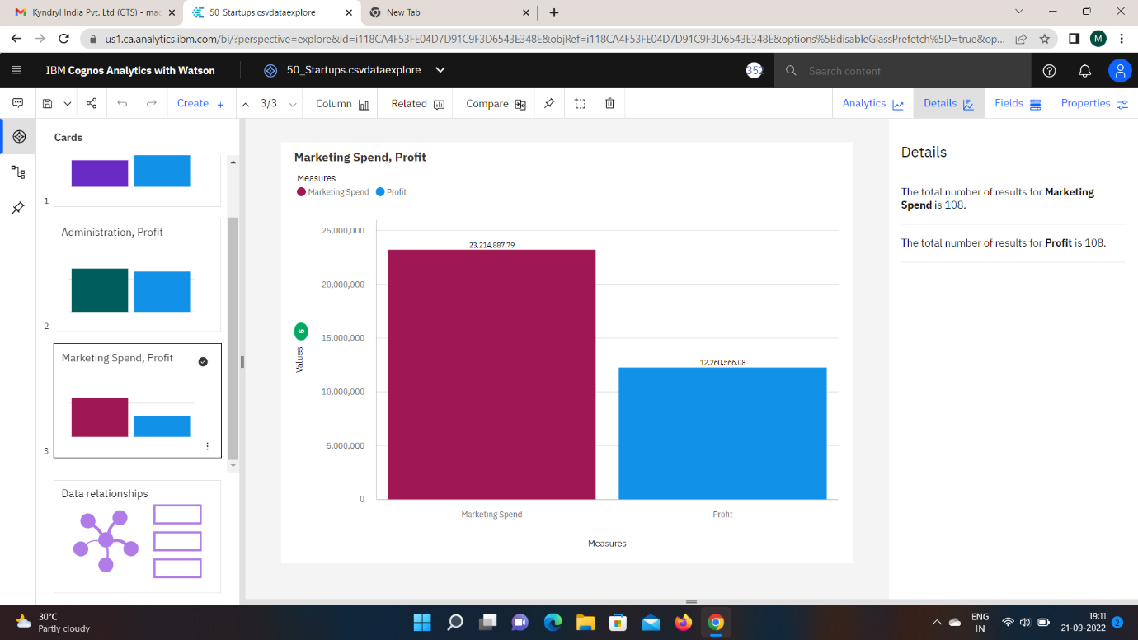

**PREPARING THE DATA**

**PROFIT BY ADMINISTRATOR**

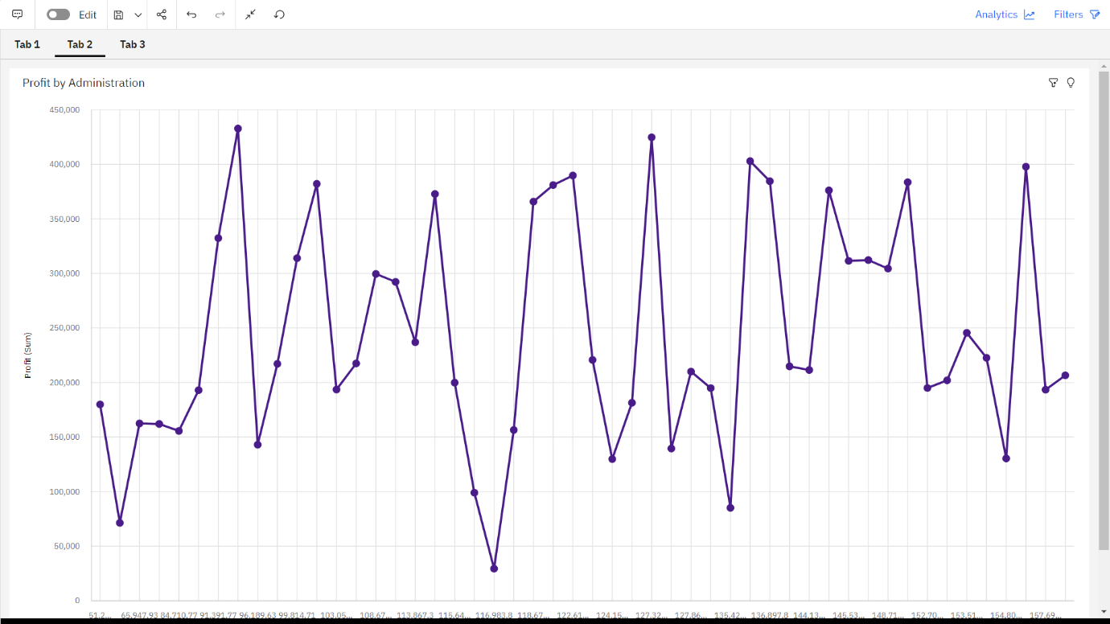

**PROFIT BY R&D SPEND**

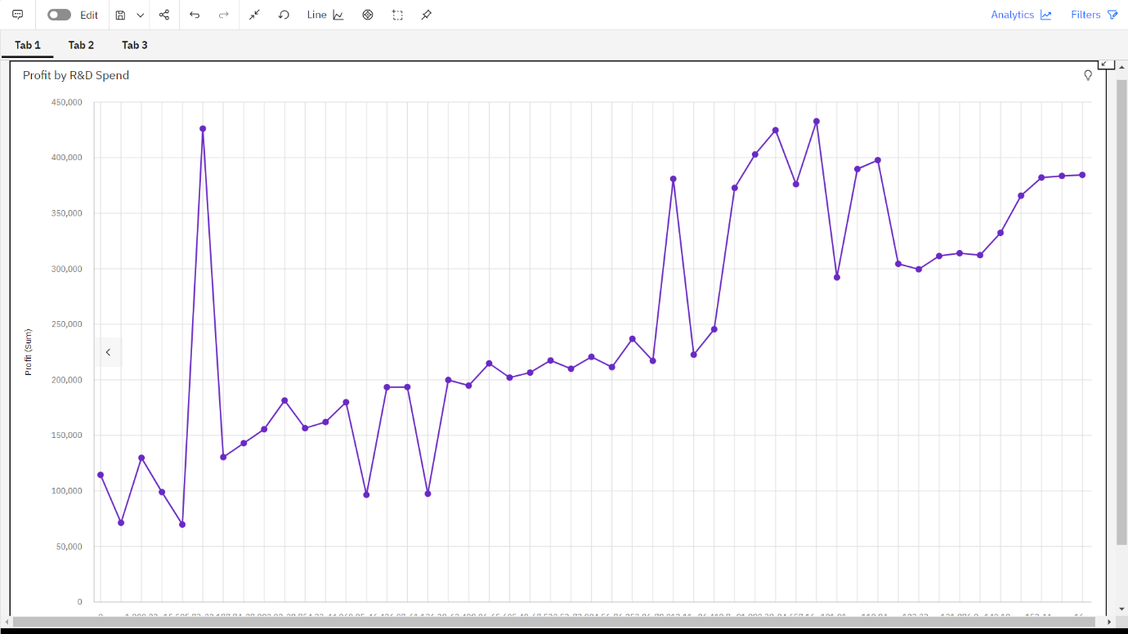

**PROFIT BY MARKETING SPEND**

