**ASSIGNMENT-4**

|  |  |
| --- | --- |
| Student name | Sivapriya N |
| Student roll number | 111519104141 |
| Maximum marks | 2 Marks |

## Download the dataset: Dataset

ANS: Data set has been downloaded.

1. Load the dataset into the tool.

ANS: **import** pandas **as**pd **import**numpy**as** np

df**=**pd**.**read_csv('Mall_Customers.csv') df**.**head()

# output:

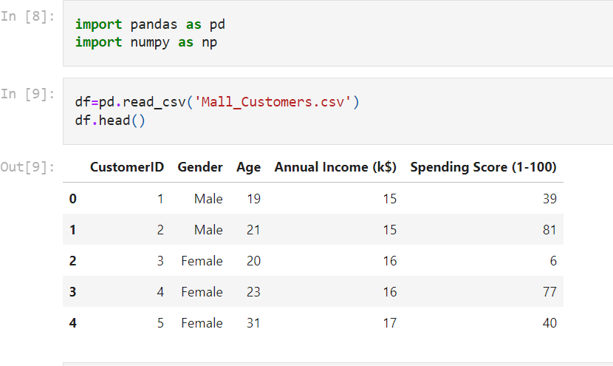

1. Perform Below Visualizations.

* Univariate Analysis
* Bi- Variate Analysis
* Multi-Variate Analysis

ANS:

.Univariate Analysis

### In [10]:

**import**matplotlib.pyplot**as**plt **import**seaborn**as**sns

**%matplotlib** inline

plt**.**plot(df['Annual Income (k$)']) plt**.**show()

data**=**np**.**array(df['Age']) plt**.**plot(data,linestyle**=** 'dotted')

# Output:

sns**.**countplot(df['Age'])

# Output:

### In [7]:

In [11]:

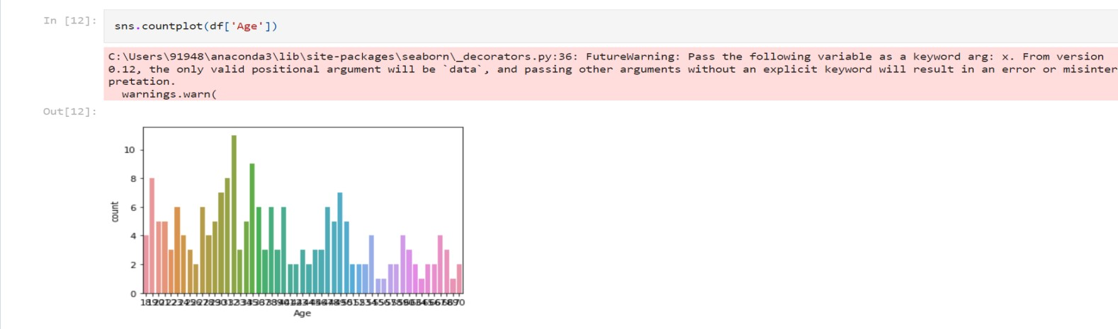

df['Annual Income (k$)']**.**plot(kind**=**'density')

# Output:

sns**.**countplot(df['Gender'])

# Output:

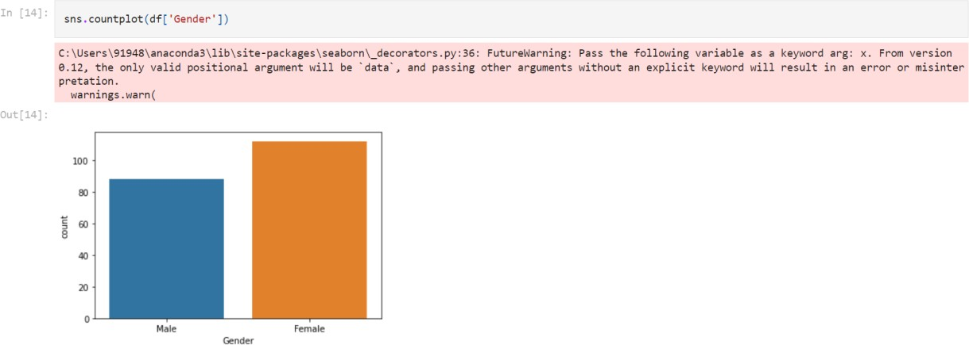

sns**.**boxplot(df['Annual Income (k$)'])

# Output:

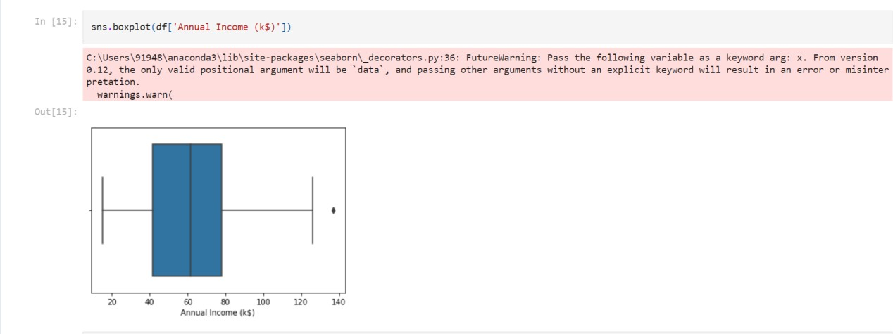

plt**.**hist(df['Annual Income (k$)'])

# Output:

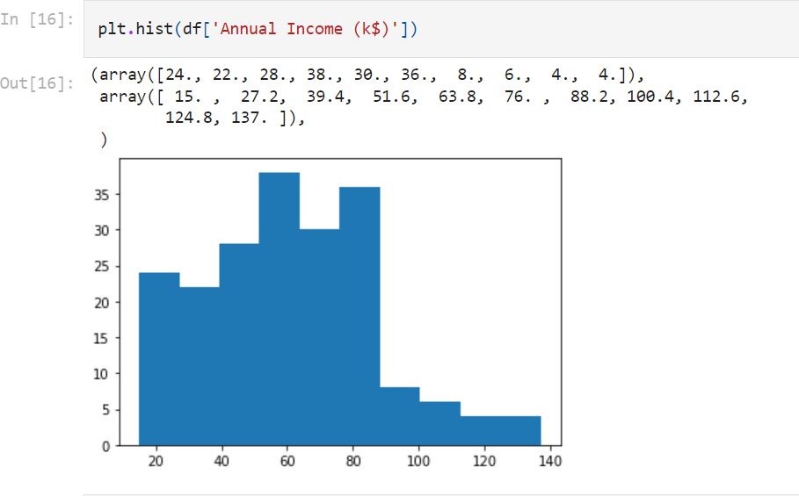

Bi-variate Analysis:

sns**.**stripplot(x**=**df['Age'],y**=**df['Annual Income (k$)'])

# Output:

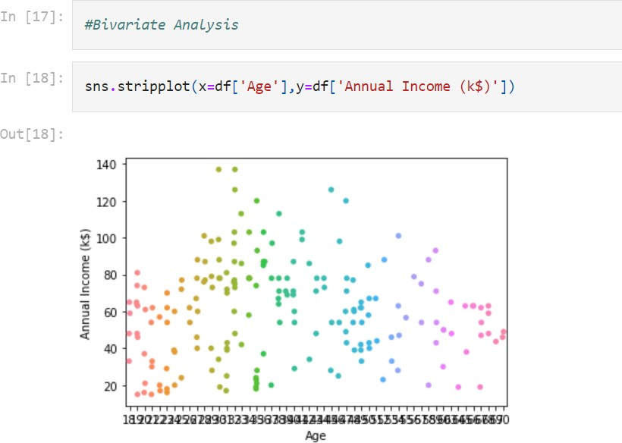

sns**.**stripplot(x**=**df['Age'],y**=**df['Spending Score (1-100)'])

# Output:

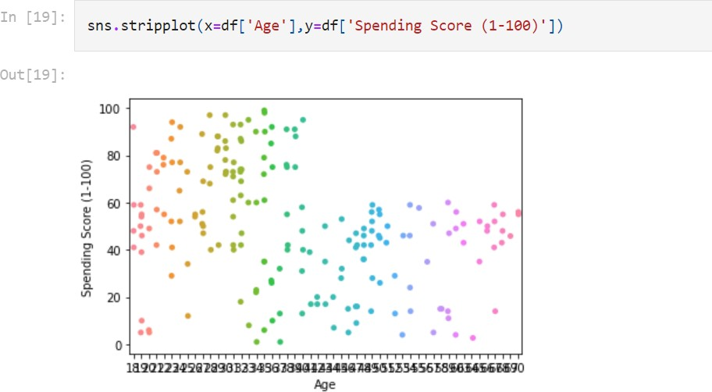

plt**.**scatter(df['Age'],df['Annual Income (k$)'],color**=**'blue') plt**.**xlabel("Age")

plt**.**ylabel("Annual Income (k$)")

# Output:

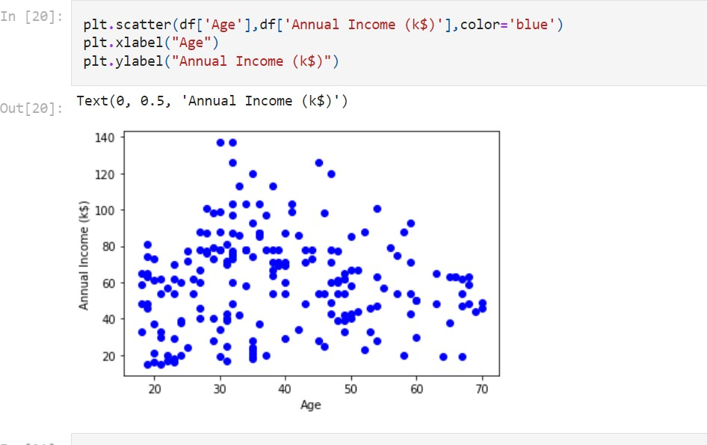

sns**.**violinplot(x**=**'Age',y**=**'Spending Score (1-100)',data**=**df)

# Output:

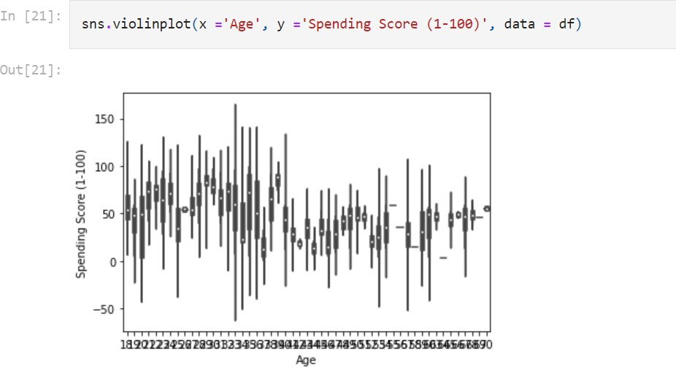

Multi-variate Analysis:

sns**.**pairplot(df)

# Output:

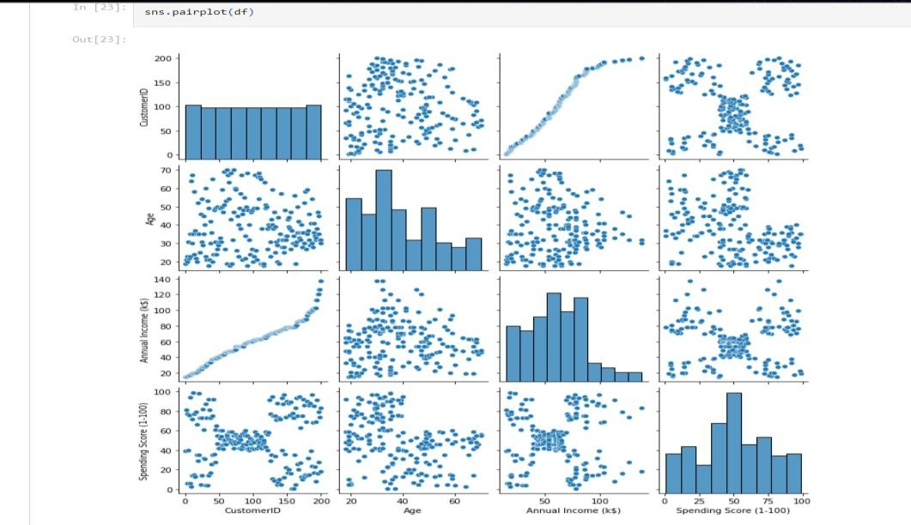

3. Perform descriptive statistics on the dataset.

ANS:

sns**.**heatmap(df**.**corr(),annot**=True**)

# Output:

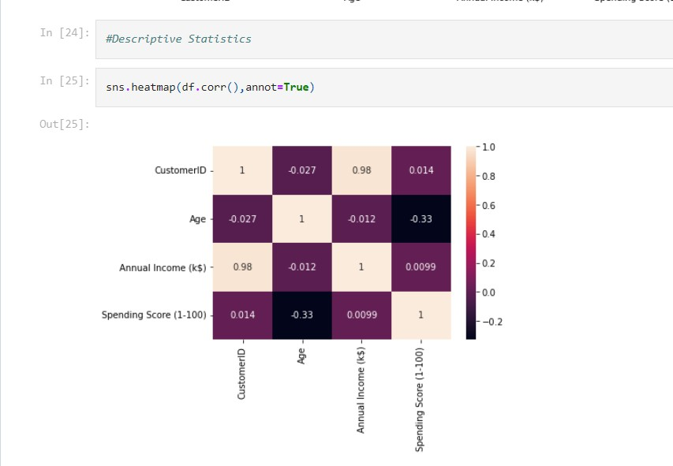

df**.**shape

# Output:

(200, 5)

df**.**isnull()**.**sum()

# Output:

CustomerID 0

Gender 0

Age 0

Annual Income (k$) 0

Spending Score (1-100) 0

dtype: int64

df**.**info()

# Output:

RangeIndex: 200 entries, 0 to 199 Data columns (total 5 columns):

# Column Non-Null Count Dtype

|  |  |  |  |  |  |  |  |
| --- | --- | --- | --- | --- | --- | --- | --- |
| 0 |  | CustomerID |  | 200 | non-null |  | int64 |
| 1 |  | Gender |  | 200 | non-null |  | object |
| 2 |  | Age |  | 200 | non-null |  | int64 |
| 3 |  | Annual Income | (k$) | 200 | non-null |  | int64 |

4 Spending Score (1-100) 200 non-null int64 dtypes: int64(4), object(1)

memory usage: 7.9+ KB

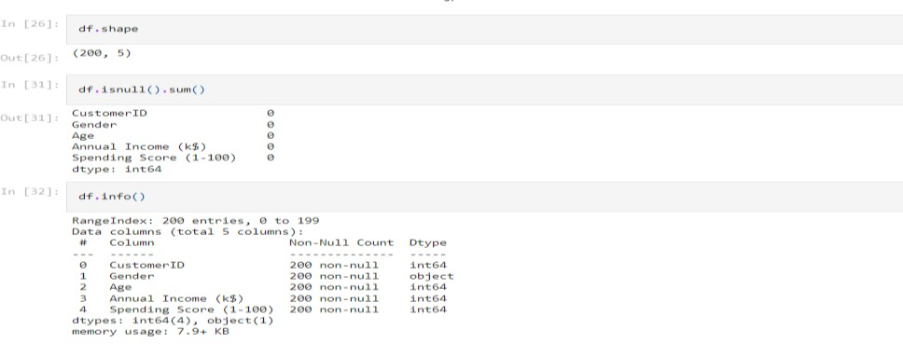

df**.**describe()

# Output:

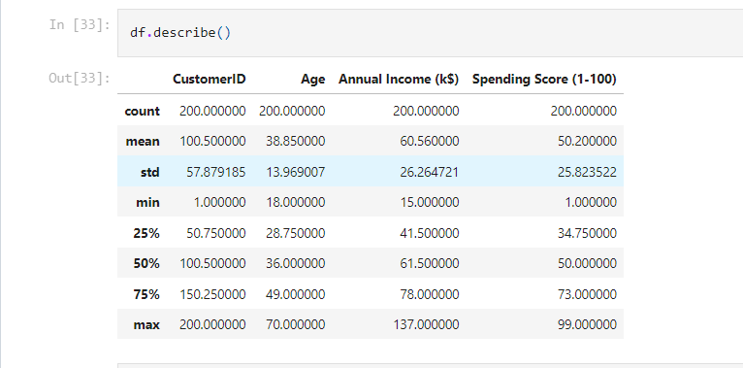

|  |  |
| --- | --- |
| df**.**mean()  Output: |  |
| CustomerID | 100.50 |
| Age | 38.85 |
| Annual Income (k$) | 60.56 |
| Spending Score (1-100) | 50.20 |
| dtype: float64 |  |
| df**.**median() |  |
| Output: |  |
| CustomerID | 100.5 |
| Age | 36.0 |
| Annual Income (k$) | 61.5 |
| Spending Score (1-100) | 50.0 |
| dtype: float64 |  |

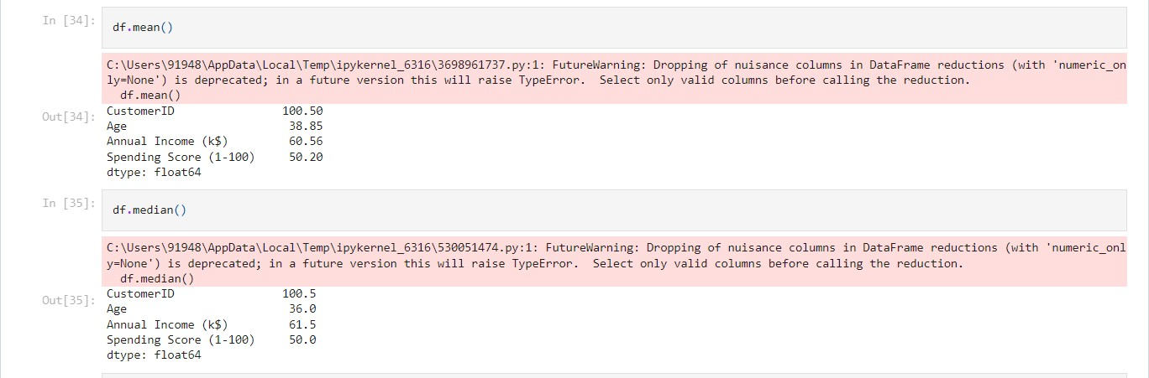

df**.**mode()

# Output:

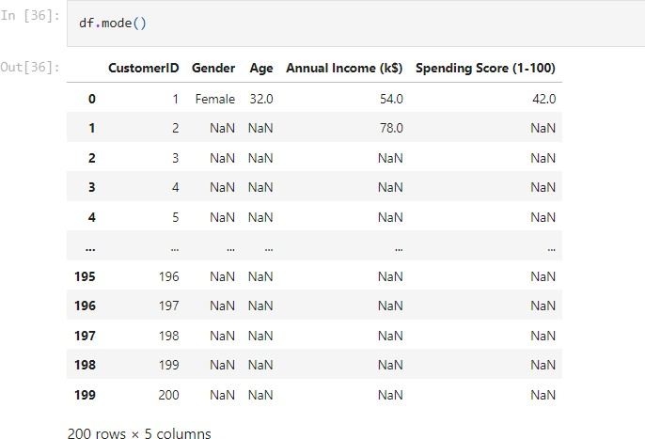

df['Gender']**.**value_counts()

# Output:

Female 112

Male 88

Name: Gender, dtype: int64



1. Check for Missing values and deal with them.

## ANS:

df**.**isna()**.**sum()

# Output:

CustomerID 0

Gender 0

Age 0

Annual Income (k$) 0

Spending Score (1-100) 0

dtype: int64

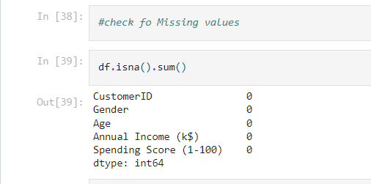

## Find the outliers and replace them outliers ANS:

sns**.**boxplot(df['Annual Income (k$)'])

# Output:

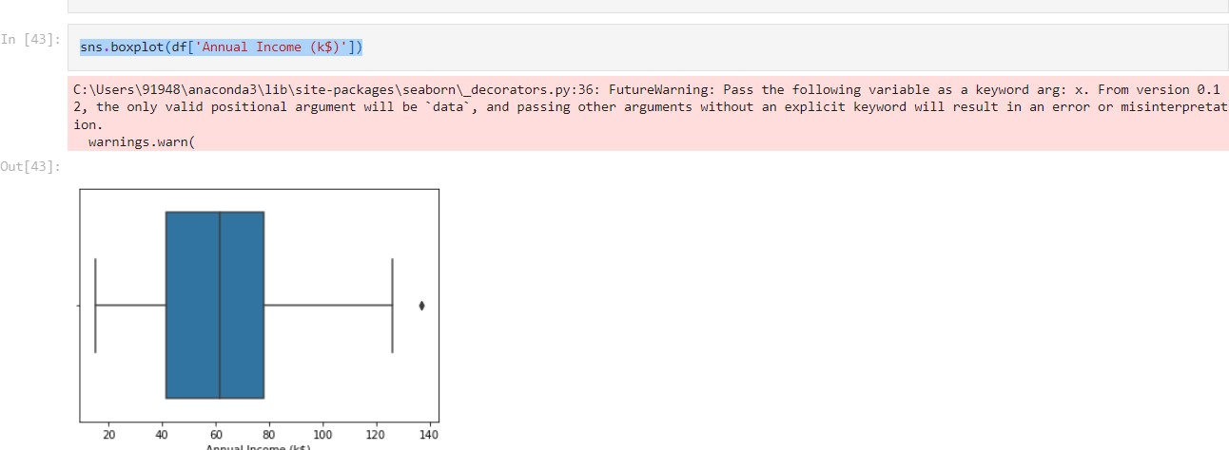

Q1 **=**df['Annual Income (k$)']**.**quantile(0.25) Q3 **=**df['Annual Income (k$)']**.**quantile(0.75)

IQR **=** Q3 **-** Q1

whisker_width**=** 1.5

lower_whisker**=** Q1 **-**(whisker_width**\***IQR) upper_whisker**=** Q3 **+**(whisker_width**\***IQR)

df['Annual Income (k$)']**=**np**.**where(df['Annual Income (k$)']**>**upper_whisker,upper_whisker,np**.**where(df['Annual Income (k$)']**<**lower_whisker,lower_whisker,df['Annual Income (k$)']))

sns**.**boxplot(df['Annual Income (k$)'])

# Output:

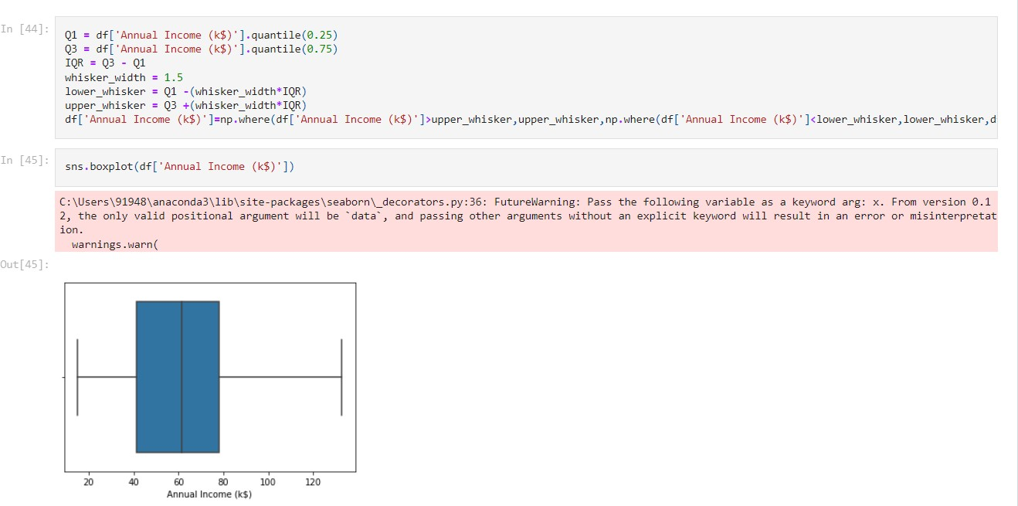

1. Check for Categorical columns and perform encoding.

# ANS:

numeric_data**=**df**.**select_dtypes(include**=**[np**.**number]) categorical_data**=**df**.**select_dtypes(exclude**=**[np**.**number]) print("Number of numerical variables: ", numeric_data**.**shape[1])

print("Number of categorical variables: ", categorical_data**.**shape[1])

Number of numerical variables: 4 Number of categorical variables: 1

print("Number of categorical variables: ", categorical_data**.**shape[1]) Categorical_variables**=**list(categorical_data**.**columns) Categorical_variables

# Output:

Number of categorical variables: 1 ['Gender']

df['Gender']**.**value_counts()

# Output:

Female 112

Male 88

Name: Gender, dtype: int64

**from**sklearn.preprocessing**import**LabelEncoder le**=**LabelEncoder() label**=**le**.**fit_transform(df['Gender']) df["Gender"] **=** label

df['Gender']**.**value_counts()

# Output:

0 112

1 88

Name: Gender, dtype: int64

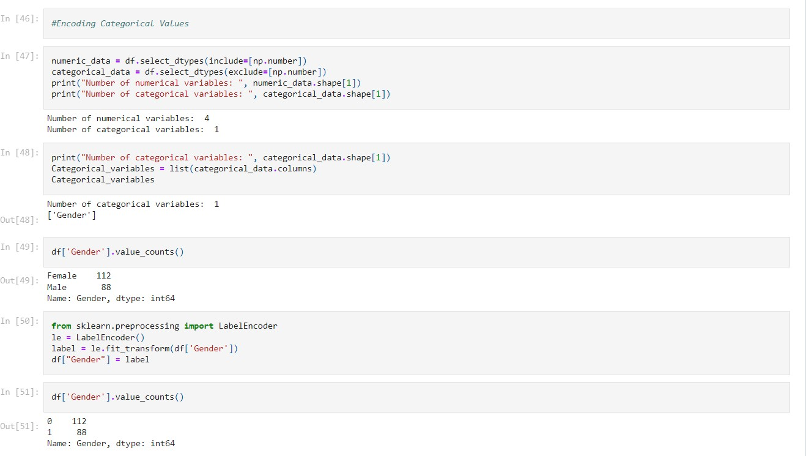

## Scaling the data

ANS:

X **=**df**.**drop("Age",axis**=**1) Y **=**df['Age']

**from**sklearn.preprocessing**import**StandardScaler object**=**StandardScaler() scale**=**object**.**fit_transform(X)

print(scale)

### In [55]:

|  |  |  |  |
| --- | --- | --- | --- |
| Output: |  | | |
| [[-1.7234121 | 1.12815215 | -1.74542941 | -0.43480148] |
| [-1.70609137 | 1.12815215 | -1.74542941 | 1.19570407] |
| [-1.68877065 | -0.88640526 | -1.70708307 | -1.71591298] |
| [-1.67144992 | -0.88640526 | -1.70708307 | 1.04041783] |
| [-1.6541292 | -0.88640526 | -1.66873673 | -0.39597992] |
| [-1.63680847 | -0.88640526 | -1.66873673 | 1.00159627] |
| [-1.61948775 | -0.88640526 | -1.6303904 | -1.71591298] |
| [-1.60216702 | -0.88640526 | -1.6303904 | 1.70038436] |
| [-1.5848463 | 1.12815215 | -1.59204406 | -1.83237767] |
| [-1.56752558 | -0.88640526 | -1.59204406 | 0.84631002] |
| [-1.55020485 | 1.12815215 | -1.59204406 | -1.4053405 ] |
| [-1.53288413 | -0.88640526 | -1.59204406 | 1.89449216] |
| [-1.5155634 | -0.88640526 | -1.55369772 | -1.36651894] |
| [-1.49824268 | -0.88640526 | -1.55369772 | 1.04041783] |
| [-1.48092195 | 1.12815215 | -1.55369772 | -1.44416206] |
| [-1.46360123 | 1.12815215 | -1.55369772 | 1.11806095] |

|  |  |  |  |
| --- | --- | --- | --- |
| [-1.4462805 | -0.88640526 | -1.51535138 | -0.59008772] |
| [-1.42895978 | 1.12815215 | -1.51535138 | 0.61338066] |
| [-1.41163905 | 1.12815215 | -1.43865871 | -0.82301709] |
| [-1.39431833 | -0.88640526 | -1.43865871 | 1.8556706 ] |
| [-1.3769976 | 1.12815215 | -1.40031237 | -0.59008772] |
| [-1.35967688 | 1.12815215 | -1.40031237 | 0.88513158] |
| [-1.34235616 | -0.88640526 | -1.36196603 | -1.75473454] |
| [-1.32503543 | 1.12815215 | -1.36196603 | 0.88513158] |
| [-1.30771471 | -0.88640526 | -1.24692702 | -1.4053405 ] |
| [-1.29039398 | 1.12815215 | -1.24692702 | 1.23452563] |
| [-1.27307326 | -0.88640526 | -1.24692702 | -0.7065524 ] |
| [-1.25575253 | 1.12815215 | -1.24692702 | 0.41927286] |
| [-1.23843181 | -0.88640526 | -1.20858069 | -0.74537397] |
| [-1.22111108 | -0.88640526 | -1.20858069 | 1.42863343] |
| [-1.20379036 | 1.12815215 | -1.17023435 | -1.7935561 ] |
| [-1.18646963 | -0.88640526 | -1.17023435 | 0.88513158] |
| [-1.16914891 | 1.12815215 | -1.05519534 | -1.7935561 ] |
| [-1.15182818 | 1.12815215 | -1.05519534 | 1.62274124] |
| [-1.13450746 | -0.88640526 | -1.05519534 | -1.4053405 ] |
| [-1.11718674 | -0.88640526 | -1.05519534 | 1.19570407] |
| [-1.09986601 | -0.88640526 | -1.016849 | -1.28887582] |
| [-1.08254529 | -0.88640526 | -1.016849 | 0.88513158] |
| [-1.06522456 | -0.88640526 | -0.90180999 | -0.93948177] |
| [-1.04790384 | -0.88640526 | -0.90180999 | 0.96277471] |
| [-1.03058311 | -0.88640526 | -0.86346365 | -0.59008772] |
| [-1.01326239 | 1.12815215 | -0.86346365 | 1.62274124] |
| [-0.99594166 | 1.12815215 | -0.82511731 | -0.55126616] |
| [-0.97862094 | -0.88640526 | -0.82511731 | 0.41927286] |
| [-0.96130021 | -0.88640526 | -0.82511731 | -0.86183865] |
| [-0.94397949 | -0.88640526 | -0.82511731 | 0.5745591 ] |
| [-0.92665877 | -0.88640526 | -0.78677098 | 0.18634349] |
| [-0.90933804 | -0.88640526 | -0.78677098 | -0.12422899] |
| [-0.89201732 | -0.88640526 | -0.78677098 | -0.3183368 ] |
| [-0.87469659 | -0.88640526 | -0.78677098 | -0.3183368 ] |
| [-0.85737587 | -0.88640526 | -0.7100783 | 0.06987881] |
| [-0.84005514 | 1.12815215 | -0.7100783 | 0.38045129] |
| [-0.82273442 | -0.88640526 | -0.67173196 | 0.14752193] |
| [-0.80541369 | 1.12815215 | -0.67173196 | 0.38045129] |
| [-0.78809297 | -0.88640526 | -0.67173196 | -0.20187212] |
| [-0.77077224 | 1.12815215 | -0.67173196 | -0.35715836] |
| [-0.75345152 | -0.88640526 | -0.63338563 | -0.00776431] |
| [-0.73613079 | 1.12815215 | -0.63338563 | -0.16305055] |
| [-0.71881007 | -0.88640526 | -0.55669295 | 0.03105725] |
| [-0.70148935 | 1.12815215 | -0.55669295 | -0.16305055] |
| [-0.68416862 | 1.12815215 | -0.55669295 | 0.22516505] |
| [-0.6668479 | 1.12815215 | -0.55669295 | 0.18634349] |
| [-0.64952717 | -0.88640526 | -0.51834661 | 0.06987881] |
| [-0.63220645 | -0.88640526 | -0.51834661 | 0.34162973] |
| [-0.61488572 | 1.12815215 | -0.48000028 | 0.03105725] |
| [-0.597565 | 1.12815215 | -0.48000028 | 0.34162973] |
| [-0.58024427 | -0.88640526 | -0.48000028 | -0.00776431] |
| [-0.56292355 | -0.88640526 | -0.48000028 | -0.08540743] |
| [-0.54560282 | 1.12815215 | -0.48000028 | 0.34162973] |
| [-0.5282821 | -0.88640526 | -0.48000028 | -0.12422899] |
| [-0.51096138 | 1.12815215 | -0.44165394 | 0.18634349] |
| [-0.49364065 | -0.88640526 | -0.44165394 | -0.3183368 ] |
| [-0.47631993 | -0.88640526 | -0.4033076 | -0.04658587] |

|  |  |  |  |
| --- | --- | --- | --- |
| [-0.4589992 | -0.88640526 | -0.4033076 | 0.22516505] |
| [-0.44167848 | 1.12815215 | -0.24992225 | -0.12422899] |
| [-0.42435775 | 1.12815215 | -0.24992225 | 0.14752193] |
| [-0.40703703 | -0.88640526 | -0.24992225 | 0.10870037] |
| [-0.3897163 | 1.12815215 | -0.24992225 | -0.08540743] |
| [-0.37239558 | -0.88640526 | -0.24992225 | 0.06987881] |
| [-0.35507485 | -0.88640526 | -0.24992225 | -0.3183368 ] |
| [-0.33775413 | 1.12815215 | -0.24992225 | 0.03105725] |
| [-0.3204334 | 1.12815215 | -0.24992225 | 0.18634349] |
| [-0.30311268 | 1.12815215 | -0.24992225 | -0.35715836] |
| [-0.28579196 | -0.88640526 | -0.24992225 | -0.24069368] |
| [-0.26847123 | -0.88640526 | -0.24992225 | 0.26398661] |
| [-0.25115051 | 1.12815215 | -0.24992225 | -0.16305055] |
| [-0.23382978 | -0.88640526 | -0.13488324 | 0.30280817] |
| [-0.21650906 | -0.88640526 | -0.13488324 | 0.18634349] |
| [-0.19918833 | -0.88640526 | -0.0965369 | 0.38045129] |
| [-0.18186761 | -0.88640526 | -0.0965369 | -0.16305055] |
| [-0.16454688 | -0.88640526 | -0.05819057 | 0.18634349] |
| [-0.14722616 | 1.12815215 | -0.05819057 | -0.35715836] |
| [-0.12990543 | 1.12815215 | -0.01984423 | -0.04658587] |
| [-0.11258471 | -0.88640526 | -0.01984423 | -0.39597992] |
| [-0.09526399 | -0.88640526 | -0.01984423 | -0.3183368 ] |
| [-0.07794326 | 1.12815215 | -0.01984423 | 0.06987881] |
| [-0.06062254 | -0.88640526 | -0.01984423 | -0.12422899] |
| [-0.04330181 | -0.88640526 | -0.01984423 | -0.00776431] |
| [-0.02598109 | 1.12815215 | 0.01850211 | -0.3183368 ] |
| [-0.00866036 | 1.12815215 | 0.01850211 | -0.04658587] |
| [ 0.00866036 | -0.88640526 | 0.05684845 | -0.35715836] |
| [ 0.02598109 | -0.88640526 | 0.05684845 | -0.08540743] |
| [ 0.04330181 | 1.12815215 | 0.05684845 | 0.34162973] |
| [ 0.06062254 | 1.12815215 | 0.05684845 | 0.18634349] |
| [ 0.07794326 | 1.12815215 | 0.05684845 | 0.22516505] |
| [ 0.09526399 | -0.88640526 | 0.05684845 | -0.3183368 ] |
| [ 0.11258471 | -0.88640526 | 0.09519478 | -0.00776431] |
| [ 0.12990543 | 1.12815215 | 0.09519478 | -0.16305055] |
| [ 0.14722616 | 1.12815215 | 0.09519478 | -0.27951524] |
| [ 0.16454688 | 1.12815215 | 0.09519478 | -0.08540743] |
| [ 0.18186761 | 1.12815215 | 0.09519478 | 0.06987881] |
| [ 0.19918833 | -0.88640526 | 0.09519478 | 0.14752193] |
| [ 0.21650906 | -0.88640526 | 0.13354112 | -0.3183368 ] |
| [ 0.23382978 | 1.12815215 | 0.13354112 | -0.16305055] |
| [ 0.25115051 | -0.88640526 | 0.17188746 | -0.08540743] |
| [ 0.26847123 | -0.88640526 | 0.17188746 | -0.00776431] |
| [ 0.28579196 | -0.88640526 | 0.17188746 | -0.27951524] |
| [ 0.30311268 | -0.88640526 | 0.17188746 | 0.34162973] |
| [ 0.3204334 | -0.88640526 | 0.24858013 | -0.27951524] |
| [ 0.33775413 | -0.88640526 | 0.24858013 | 0.26398661] |
| [ 0.35507485 | 1.12815215 | 0.24858013 | 0.22516505] |
| [ 0.37239558 | -0.88640526 | 0.24858013 | -0.39597992] |
| [ 0.3897163 | -0.88640526 | 0.32527281 | 0.30280817] |
| [ 0.40703703 | 1.12815215 | 0.32527281 | 1.58391968] |
| [ 0.42435775 | -0.88640526 | 0.36361914 | -0.82301709] |
| [ 0.44167848 | -0.88640526 | 0.36361914 | 1.04041783] |
| [ 0.4589992 | 1.12815215 | 0.40196548 | -0.59008772] |
| [ 0.47631993 | 1.12815215 | 0.40196548 | 1.73920592] |
| [ 0.49364065 | 1.12815215 | 0.40196548 | -1.52180518] |
| [ 0.51096138 | 1.12815215 | 0.40196548 | 0.96277471] |

|  |  |  |  |  |
| --- | --- | --- | --- | --- |
| [ | 0.5282821 | 1.12815215 | 0.40196548 | -1.5994483 ] |
| [ | 0.54560282 | 1.12815215 | 0.40196548 | 0.96277471] |
| [ | 0.56292355 | -0.88640526 | 0.44031182 | -0.62890928] |
| [ | 0.58024427 | -0.88640526 | 0.44031182 | 0.80748846] |
| [ | 0.597565 | 1.12815215 | 0.47865816 | -1.75473454] |
| [ | 0.61488572 | -0.88640526 | 0.47865816 | 1.46745499] |
| [ | 0.63220645 | -0.88640526 | 0.47865816 | -1.67709142] |
| [ | 0.64952717 | 1.12815215 | 0.47865816 | 0.88513158] |
| [ | 0.6668479 | 1.12815215 | 0.51700449 | -1.56062674] |
| [ | 0.68416862 | -0.88640526 | 0.51700449 | 0.84631002] |
| [ | 0.70148935 | -0.88640526 | 0.55535083 | -1.75473454] |
| [ | 0.71881007 | 1.12815215 | 0.55535083 | 1.6615628 ] |
| [ | 0.73613079 | -0.88640526 | 0.59369717 | -0.39597992] |
| [ | 0.75345152 | -0.88640526 | 0.59369717 | 1.42863343] |
| [ | 0.77077224 | 1.12815215 | 0.6320435 | -1.48298362] |
| [ | 0.78809297 | 1.12815215 | 0.6320435 | 1.81684904] |
| [ | 0.80541369 | 1.12815215 | 0.6320435 | -0.55126616] |
| [ | 0.82273442 | -0.88640526 | 0.6320435 | 0.92395314] |
| [ | 0.84005514 | -0.88640526 | 0.67038984 | -1.09476801] |
| [ | 0.85737587 | 1.12815215 | 0.67038984 | 1.54509812] |
| [ | 0.87469659 | 1.12815215 | 0.67038984 | -1.28887582] |
| [ | 0.89201732 | 1.12815215 | 0.67038984 | 1.46745499] |
| [ | 0.90933804 | -0.88640526 | 0.67038984 | -1.17241113] |
| [ | 0.92665877 | -0.88640526 | 0.67038984 | 1.00159627] |
| [ | 0.94397949 | -0.88640526 | 0.67038984 | -1.32769738] |
| [ | 0.96130021 | -0.88640526 | 0.67038984 | 1.50627656] |
| [ | 0.97862094 | 1.12815215 | 0.67038984 | -1.91002079] |
| [ | 0.99594166 | -0.88640526 | 0.67038984 | 1.07923939] |
| [ | 1.01326239 | 1.12815215 | 0.67038984 | -1.91002079] |
| [ | 1.03058311 | -0.88640526 | 0.67038984 | 0.88513158] |
| [ | 1.04790384 | -0.88640526 | 0.70873618 | -0.59008772] |
| [ | 1.06522456 | -0.88640526 | 0.70873618 | 1.27334719] |
| [ | 1.08254529 | 1.12815215 | 0.78542885 | -1.75473454] |
| [ | 1.09986601 | -0.88640526 | 0.78542885 | 1.6615628 ] |
| [ | 1.11718674 | 1.12815215 | 0.9388142 | -0.93948177] |
| [ | 1.13450746 | -0.88640526 | 0.9388142 | 0.96277471] |
| [ | 1.15182818 | 1.12815215 | 0.97716054 | -1.17241113] |
| [ | 1.16914891 | -0.88640526 | 0.97716054 | 1.73920592] |
| [ | 1.18646963 | -0.88640526 | 1.01550688 | -0.90066021] |
| [ | 1.20379036 | 1.12815215 | 1.01550688 | 0.49691598] |
| [ | 1.22111108 | 1.12815215 | 1.01550688 | -1.44416206] |
| [ | 1.23843181 | 1.12815215 | 1.01550688 | 0.96277471] |
| [ | 1.25575253 | 1.12815215 | 1.01550688 | -1.56062674] |
| [ | 1.27307326 | 1.12815215 | 1.01550688 | 1.62274124] |
| [ | 1.29039398 | -0.88640526 | 1.05385321 | -1.44416206] |
| [ | 1.30771471 | -0.88640526 | 1.05385321 | 1.38981187] |
| [ | 1.32503543 | 1.12815215 | 1.05385321 | -1.36651894] |
| [ | 1.34235616 | 1.12815215 | 1.05385321 | 0.72984534] |
| [ | 1.35967688 | 1.12815215 | 1.2455849 | -1.4053405 ] |
| [ | 1.3769976 | 1.12815215 | 1.2455849 | 1.54509812] |
| [ | 1.39431833 | -0.88640526 | 1.39897025 | -0.7065524 ] |
| [ | 1.41163905 | -0.88640526 | 1.39897025 | 1.38981187] |
| [ | 1.42895978 | 1.12815215 | 1.43731659 | -1.36651894] |
| [ | 1.4462805 | -0.88640526 | 1.43731659 | 1.46745499] |
| [ | 1.46360123 | -0.88640526 | 1.47566292 | -0.43480148] |
| [ | 1.48092195 | 1.12815215 | 1.47566292 | 1.81684904] |
| [ | 1.49824268 | -0.88640526 | 1.5523556 | -1.01712489] |

|  |  |  |  |  |
| --- | --- | --- | --- | --- |
| [ | 1.5155634 | 1.12815215 | 1.5523556 | 0.69102378] |
| [ | 1.53288413 | -0.88640526 | 1.62904827 | -1.28887582] |
| [ | 1.55020485 | -0.88640526 | 1.62904827 | 1.35099031] |
| [ | 1.56752558 | -0.88640526 | 1.62904827 | -1.05594645] |
| [ | 1.5848463 | -0.88640526 | 1.62904827 | 0.72984534] |
| [ | 1.60216702 | 1.12815215 | 2.01251165 | -1.63826986] |
| [ | 1.61948775 | -0.88640526 | 2.01251165 | 1.58391968] |
| [ | 1.63680847 | -0.88640526 | 2.28093601 | -1.32769738] |
| [ | 1.6541292 | -0.88640526 | 2.28093601 | 1.11806095] |
| [ | 1.67144992 | -0.88640526 | 2.51101403 | -0.86183865] |
| [ | 1.68877065 | 1.12815215 | 2.51101403 | 0.92395314] |
| [ | 1.70609137 | 1.12815215 | 2.76985181 | -1.25005425] |
| [ | 1.7234121 | 1.12815215 | 2.76985181 | 1.27334719]] |

X_scaled**=**pd**.**DataFrame(scale,columns**=**X**.**columns) X_scaled

# Output:

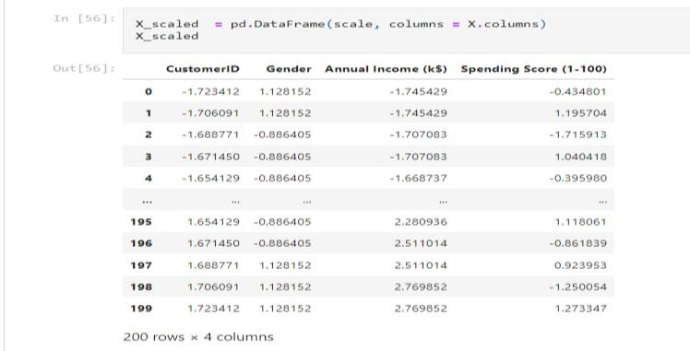

*#train test split* **from**sklearn.model_selection**import**train_test_split *# split the dataset*

X_train, X_test, Y_train, Y_test**=**train_test_split(X_scaled, Y, test_size**=**0.20, random_state**=**0)

X_train**.**shape

# Output:

(160, 4)

X_test**.**shape

### In [58]:

Output:

(40, 4)

Y_train**.**shape

# Output:

(160,)

Y_test**.**shape

# Output:

(40,)

# Perform any of the clustering algorithms

ANS:

*#Clustering Algorithm*

x **=**df**.**iloc[:, [3, 4]]**.**values

*#finding optimal number of clusters using the elbow method*

**from**sklearn.cluster**import**KMeans

wcss_list**=** [] *#Initializing the list for the values of WCSS*

*#Using for loop for iterations from 1 to 10.*

**for**i**in** range(1, 11):

kmeans**=**KMeans(n_clusters**=**i, init**=**'k-means++', random_state**=** 42) kmeans**.**fit(x)

wcss_list**.**append(kmeans**.**inertia_) plt**.**plot(range(1, 11), wcss_list) plt**.**title('The Elobw Method Graph') plt**.**xlabel('Number of clusters(k)') plt**.**ylabel('wcss_list')

plt**.**show()

# Output:

### In [63]:

In [64]:

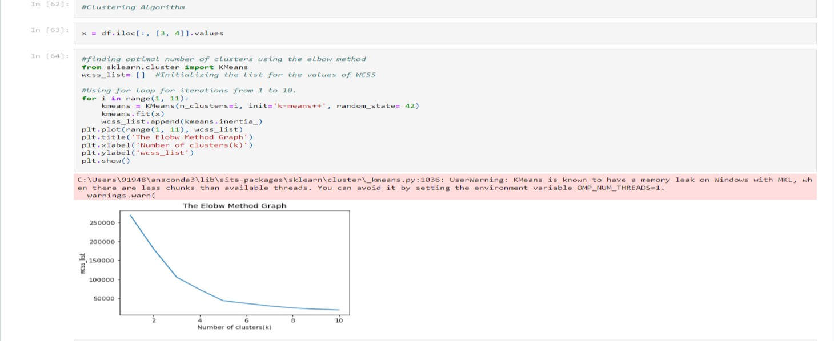

*#training the K-means model on a dataset* kmeans**=**KMeans(n_clusters**=**5, init**=**'k-means++', random_state**=** 42) y_predict**=**kmeans**.**fit_predict(x)

### In [66]:

|  |  |  |  |  |  |  |  |  |  |
| --- | --- | --- | --- | --- | --- | --- | --- | --- | --- |
| *#visulaizing the clusters*  plt**.**scatter(x[y_predict**==** | 0, 0], x[y_predict**==** | 0, | 1], | s | **=** | 100, | c | **=** | 'blue', |
| label **=** 'Cluster 1') *#for* | *first cluster* |  |  |  |  |  |  |  |  |
| plt**.**scatter(x[y_predict**==** | 1, 0], x[y_predict**==** | 1, | 1], | s | **=** | 100, | c | **=** | 'green', |
| label **=** 'Cluster 2') *#for* | *second cluster* |  |  |  |  |  |  |  |  |
| plt**.**scatter(x[y_predict**==** | 2, 0], x[y_predict**==** | 2, | 1], | s | **=** | 100, | c | **=** | 'red', |
| label **=** 'Cluster 3') *#for*  plt**.**scatter(x[y_predict**==** | *third cluster*  3, 0], x[y_predict**==** | 3, | 1], | s | **=** | 100, | c | **=** | 'cyan', |
| label **=** 'Cluster 4') *#for* | *fourth cluster* |  |  |  |  |  |  |  |  |
| plt**.**scatter(x[y_predict**==** | 4, 0], x[y_predict**==** | 4, | 1], | s | **=** | 100, | c | **=** |  |

'magenta', label **=** 'Cluster 5') *#for fifth cluster*

plt**.**scatter(kmeans**.**cluster_centers_[:, 0], kmeans**.**cluster_centers_[:, 1], s

**=** 300, c **=** 'yellow', label **=** 'Centroid') plt**.**title('Clusters of customers') plt**.**xlabel('Annual Income (k$)') plt**.**ylabel('Spending Score (1-100)') plt**.**legend()

plt**.**show()

# Output:

