# ASSIGNMENT-2

|  |  |
| --- | --- |
| Student Name | SWETHA R |
| Team ID | PNT2022TMID14780 |

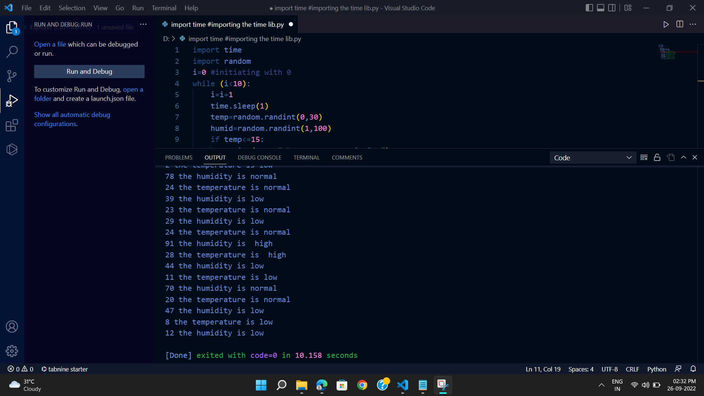

import time

import random

i=0 #initiating with 0

while (i<10):

i=i+1

time.sleep(1)

temp=random.randint(0,30)

humid=random.randint(1,100)

if temp<=15:

print(temp,"the temperature is low")

elif temp<=25:

print(temp,"the temperature is normal")

else:

print(temp,"the temperature is high")

if humid<=50:

print(humid,"the humidity is low")

elif humid<=80:

print(humid,"the humidity is normal")

else:

print(humid,"the humidity is high")