# ASSIGNMENT-3

|  |  |
| --- | --- |
| Student Name | SWETHA R |
| Team ID | PNT2022TMID14780 |

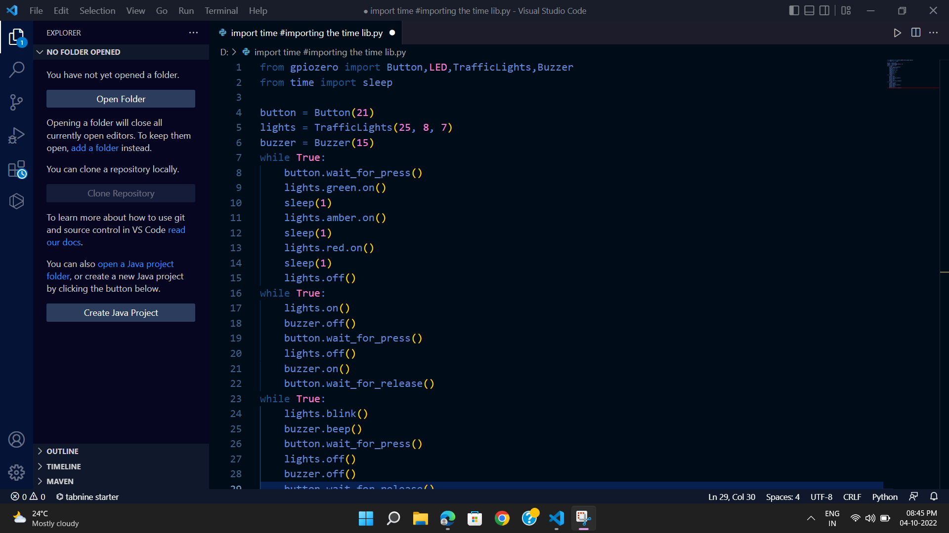

from gpiozero import Button,LED,TrafficLights,Buzzer

from time import sleep

button = Button(21)

lights = TrafficLights(25, 8, 7)

buzzer = Buzzer(15)

while True:

button.wait_for_press()

lights.green.on()

sleep(1)

lights.amber.on()

sleep(1)

lights.red.on()

sleep(1)

lights.off()

while True:

lights.on()

buzzer.off()

button.wait_for_press()

lights.off()

buzzer.on()

button.wait_for_release()

while True:

lights.blink()

buzzer.beep()

button.wait_for_press()

lights.off()

buzzer.off()

button.wait_for_release()