|  |  |
| --- | --- |
| TEAM ID | PNT2022TMID11641 |
| PROJECT NAME | Analytics for Hospitals' Health-Care Data |
| MAXIMUM MARKS | 2 Marks |

**Pharma Sales Dashboard**

**Description:-** Sales of Pharmaceutical products, which may include medicines, surgical devices, consumables of any form, machines, and equipment used in surgeries are called Pharma Sales. The target audience is doctors of any kind, chemists, and/or purchase in charge in hospitals or pharmacies.

Pharmaceutical sale is very different from regular sales of any kind right from the product to the customer to the process of selling. Of all the sales, Pharmaceutical sales are considered to be one of the most lucrative and most challenging jobs requiring a lot of learning on the salesperson’s part.

Like every sale, there is a buyer and a seller. In this case, the buyer depends on the product of the manufacturer. We will consider all of the buyer kinds.

1. A buyer for medicines of any kind – Chemist, Distributor, Hospital Pharmacies
2. A buyer for medical devices, instruments, implants – Doctor, purchase officer

**About the Pharma Dataset:**

Let’s understand the features of the dataset:

1. Month- January -December Months Data.

1. Customer- Hospitals & Organizations.

1. Period- Q1-Q4 are the four quarters which show the sales record quarterly.

1. Product- Different Tablets for diseases

1. Location-Sales in different regions,

1. Sales Rep- Sales Representative who sells pharma products.

1. Supplier-Pharmaceuticals companies are those who supply their products.

1. Warehouse Location- A warehouse location is a region where companies storing goods.

1. Actual-Actual sales for the product.

1. C.sales-Customer Sales for the product.

1. Inventory Stock: Inventory stock refers to the goods and materials that a business holds for the ultimate goal of resale.
2. L.sales-Location Wise Sales for the product.

1. M.sales-Monthly Sales for the product.
2. Received Inventory- Creating a safe, fast, and organized process for handling received inventory. Accurately track your goods from when they arrive in your warehouse to when they are shipped to your customer. 15. Rep. sales- Representative Sales for the product.

16. Target- Target sales for the product.

**Challenge:-** Upload the dataset to Cognos Analytics, prepare the data, explore and Create Interactive Dashboard.

**Task 1:Sales By**

**Customer.**

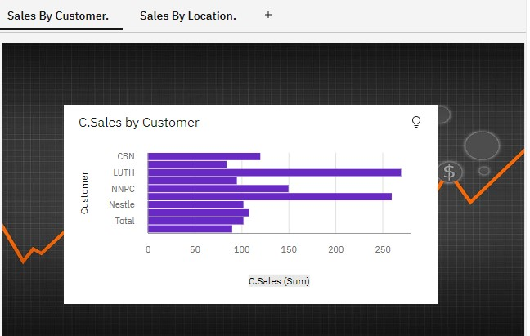

**Task 2:Sales By Location.**

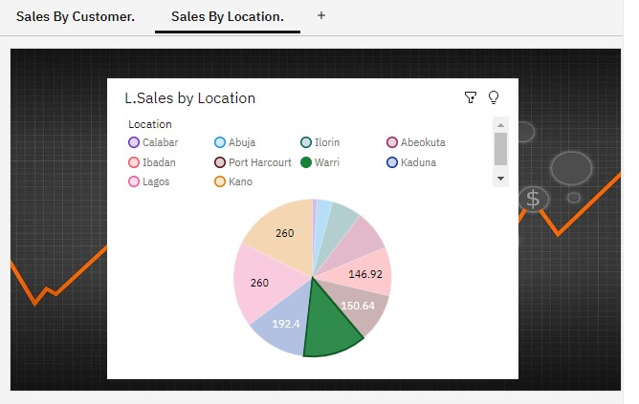

## Task 3:Sales By Sales Representative

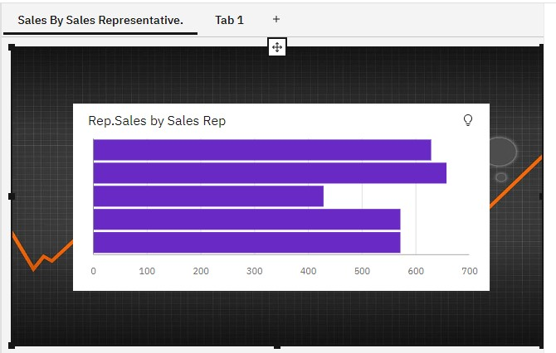

### Task 4: Received Inventory From Supplier

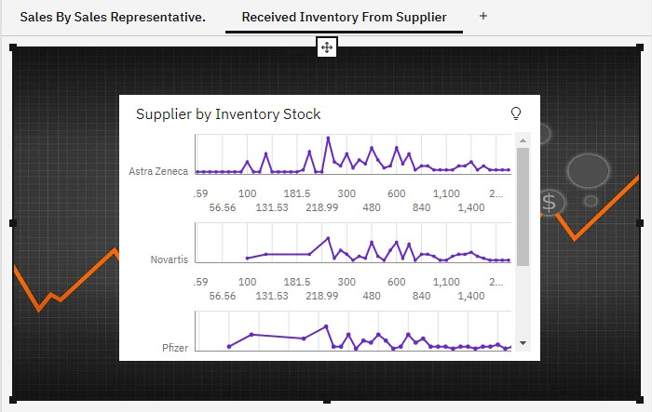

### Task 5: Inventory Stock for Warehouse Locations

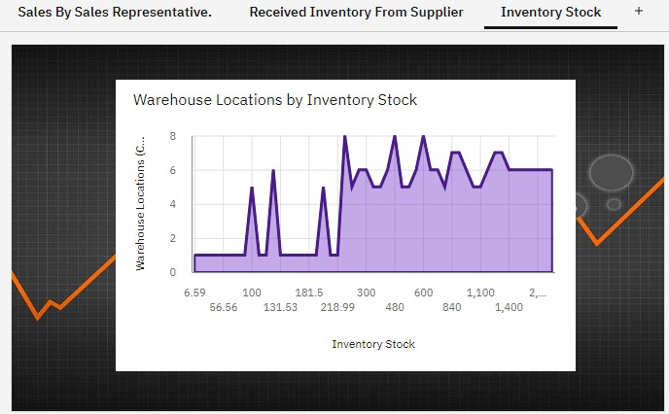

### Task 6: Sales Trend

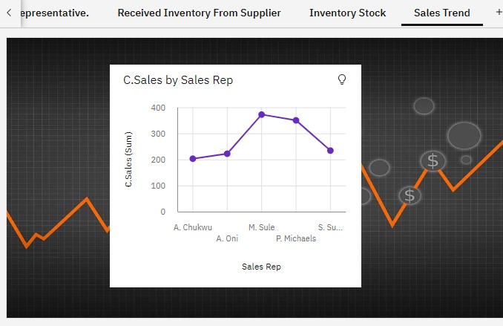

## Task 7:Monthly Sales

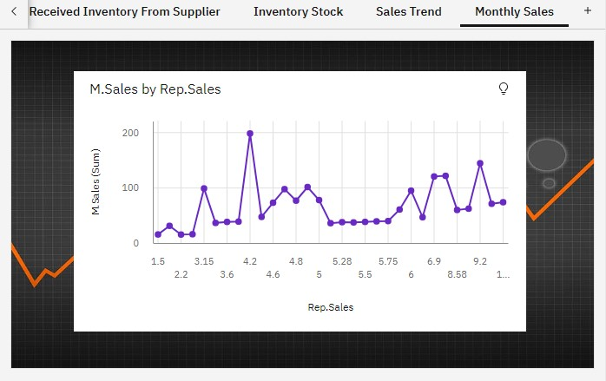

### Task 8: Actual and Received Inventory by Month

