**Done by Kamalesh.S**

**Team ID 1089**

**OBJECTIVE:**

Make a Smart Home in Tinkercad ,using 2 sensors ,LED,Buzzer in single code and circuit

**CODE:**

int trig=2;

int echo=3;

void setup()

{

pinMode(trig, OUTPUT);

pinMode(echo,INPUT);

Serial.begin(9600);

pinMode(4,OUTPUT);

pinMode(8,OUTPUT);

}

void loop()

{

digitalWrite(trig,LOW);

digitalWrite(trig,HIGH);

delayMicroseconds(10);

digitalWrite(trig,LOW);

float dur =pulseIn(echo,HIGH);

float dist=(dur*0.0343)/2;

Serial.print("distance:");

Serial.println(dist);

if(dist>=100)

{

digitalWrite(4,HIGH);

}

else

{

digitalWrite(4,LOW);

}

double a=analogRead(A2);

Serial.print("adc value");

Serial.print(a);

double v=a/1024;

double tvolt=v*5;

Serial.print("temp value voltage:");

Serial.println(tvolt);

double o=tvolt-0.5;

double t=o*100;

Serial.print("temp is:");

Serial.println(t);

if(t>=50)

{

digitalWrite(8,HIGH);

}

else

{

digitalWrite(8,LOW);

}

}

**OUTPUT**:

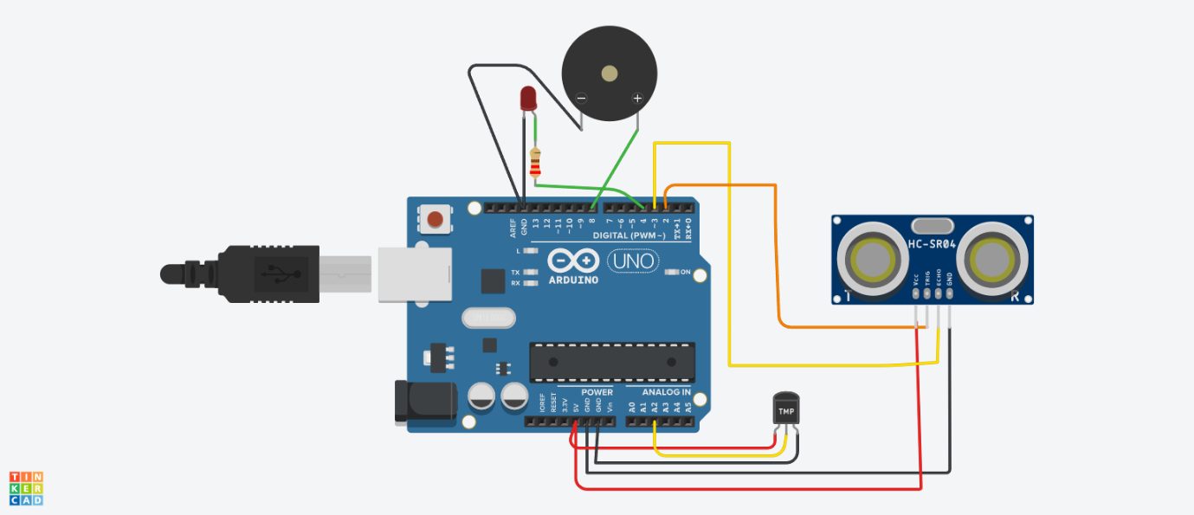

**simulation link** :https://www.tinkercad.com/things/gGagkK0sJSi-fantabulous-elzing/editel