### SKILL / JOB RECOMMENDER APPLICATION

SATHYAPRAKASH A P MENTOR:

PURUSOTHAMON V Mr. Vetri selvan.,

SILAMBARASAN B

RIYAS S

**PROBLEM DESCRIPTION:**

This comparative study is conducted concentrating on the following aspects: modeling inputs, Visualizing the data, modeling methods, and pre-processing techniques. The results provide a comparison of various evaluation metrics of these machine learning techniques and their reliability to predict rainfall by analyzing the weather data.

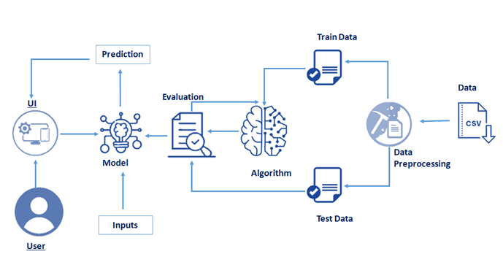

**TECHNICAL STACK:**

* Python,Python Web Frame Works,
* Python For Data Visualization,Data Preprocessing Techniques,
* Machine Learning,IBM Cloud,
* IBM Watson Studio,
* Python-Flask.