Inventory management for retail companies

Abstract:
The following are the expected project outcomes. The first one is that the project will have a system that saves time. This means that if the company has a manual inventory system, the electronic system will help to save on time. The other outcome of the project is that the inventory system adopted by the company should have accuracy such that it can reconcile the actual physical stock with the electronic records

Literature review:
Products are considered as the business resources for the organization. This includes
managing the product with appropriate way to review any time as per the requirement.
Therefore it is important to have a computer based IMS which has the ability to
generate reports, maintain the balance of the stock, details about the purchase and
sales in the organization. Before developing this application we came up with Inventory Management System existing in the market, which helps to give the knowledge for the development of our project. These application software are only used by the large organization but so we came up with the application which can be used by the small company for the management of their stock in the production houses. After analyzing the other inventory management system we decided to include some of common and key features that should be included in every inventory management system. So we decided to include those things that help the small organization in a way or other.
Introduction:
The manual inventory gives an uphill task to the inventory manager, who has to reconcile every receipt and the physical stock. A computerized point of a sale information system that updates the inventory once there is a sale simplifies the inventory management. This may involve installing bar code scanners at the point of sale scanners to mark up every item sold. The inventory should also evaluate how each product is faring in terms of sales. Besides, the systems should provide analysis of the comparison between different products as well as other competitor retails. The inventory systems should also have security measures to keep the inventory away from unauthorized persons.

Objectives:
This project will ensure that the organization saves money and time thereby reducing the cost that the company is incurring while maximizing profits.

Technical Architecture:

Predicting Out-of-Stock Using Data Analytics
Out of Stock:
Detection and Prediction Most research on the detection of OOS has been approached from the retailer’s perspective. Presented the use of zero balance walks. In this strategy, the employees walk the store periodically to check for stock outs (physical audits). Implemented an RFID system in a retailer to monitor on-shelf availability used point of sale data (POS data) obtained directly from a retailer information system to detect the occurrence of OOS. Physical audits and RFID to detect OOS have in common their high overall cost, making them barely scalable to a large number of stores, categories, and products. Alternately, the detection of OOS events based on POS data (data-driven) present important advantages such as reducing labor intensity and human error of measurement, making this method scalable and more efficient in terms of overall cost. Some of the challenges of this method are access to the historical POS data, determining which variables are related to the OOS occurrence and developing mechanisms with more efficient detection performance. Usually, the POS data used are product sales (captured by check-out scanners) and inventory records. There is a lack of research in OOS detection from a manufacturer’s perspective. In they partnered with a product manufacturer and a retail service provider to use transactional data shared by the retailer to detect OOS events and correct them with physical audits. Due to the OOS research generated in recent years, knowledge about their consequences and drivers has increased. This has led to the development of a third area of research, which addresses the detection and/or prediction of OOS occurrence, one of the most important challenges related to this problem In principle presented three methodologies for measuring OOS: manual audit method, POS sales estimation, and perpetual inventory aggregation. The first method is the traditional approach, where an auditor looks for “holes” generated by the products that are not visible on the shelf to the consumer. The second method uses point of sale data (POS data) to predict missed revenue due to OOS. Finally, the third method uses perceptual inventory data (PI), “PI systems track sales, and when sales = 0, the item is OOS” In recent times, new technologies and tools have been incorporated to measure and detect OOS, such as RFID, automated identification systems through image recognition, stochastic prediction models, and machine learning techniques. As mentioned previously, presented the zero balance walk method, where employees walk the shop floor regularly to look for stock outs. Some disadvantages of this method include that retailers often choose a small number of items and set a time for conducting these audits due to financial limitations and the lack of staff available to conduct physical audits. As a result, the expense of this approach is prohibitive for maintaining a continuous measurement, and therefore it is not scalable to a broad range of stores or products Currently, the retailer (internal audit) or the manufacturer (external audit) may start and lead the OOS measurement. The manufacturer can perform the audit either directly through their own work teams or via third-party, as retail service providers PI also has disadvantages since its accuracy is less than 50%, and it normally only detects store OOS rather than shelf OOS Reference presented a pilot project that proposed an RFID infrastructure that stored data in real-time, allowing for OSA and OOS tracking, demonstrating the advantages of inventory management in a retail store. However, some authors have stated limitations of the use of this technology.
Conclusion
For the success of the program, the managers of the retail stores must formulate a modern way of managing the inventory by instituting electronic systems to take care of the resources of the company. This ensures that they can be accounted for and there are proper records available all the time for reference to be made when the need arises. Besides, the retail management system is necessary for ensuring that there is accountability in the way the company handles its stock. It helps in saving time.

Research paper on Stock Maintenance
Abstract:
This examination work manages the part of stock administration of consumer loyalty in the paper production according to the study. The information use in the improvement of this venture work will gathered from different levels of administration in the distribution, using survey. What's more, from that we got a thought where they are missing i.e Inventory control and Bill eras. In paper presents an alarm about the information section in the bill which in view of PDF format. So that the shopkeeper will update about the remaining items in the shop . Maintaining a balance between too much and too little inventory for the future use in shop .Tracking inventory as it is transported between locations. To maintain a stock for each and every data as well as of every product’s they are dealing with. It is also used for to reduce overhead cost and Time saving application. It will give’s an Maximum profit within less cost, update Log will be maintained.
INTRODUCTION :
Stock organization writing computer programs is a PC based structure for taking after stock levels, solicitations, arrangements and transports. It can moreover be used as a piece of the amassing business to make a work organize, bill of materials and other creation related reports. A good inventory tracking system will tell you what merchandise in stock, what is on order, when it will arrive and what you've sold. With such a system, you can plan purchases intelligently and quickly recognize the fast-moving items you need to reorder and the slow-moving items you should mark down or specially promote. Some retailers track inventory using a manual tag system, which can be updated daily, weekly or even monthly. In a manual tag system, you remove price tags from the product at the point of purchase. You then cross-check the tags against physical inventory to figure out what you have sold . A key stock administration process is renewal. Its motivation is to keep your stock levels adequate to cover the interest for those items. Recharges can happen at numerous levels – from a provider to a client's focal distribution center, from the focal stockroom to littler provincial stockrooms, from territorial stockrooms to a store's back-room, and from the back space to the end-client confronting rack. Associations use stock organization programming to avoid thing over-burden and power outages. It is an instrument for sorting out stock data that before was overall secured in printed duplicate casing or in spreadsheets. We will make a desktop application for the Predefined paper publication to control their stock . To keep up a stock for each and every data and furthermore of every things they are overseeing in operations administration, coordinations and store network administration, the innovative framework and the modified programming essential for overseeing stock. In financial aspects and operations administration, the stock control issue ,which expects to decrease overhead cost without harming deals.
PURPOSED :
Stock proportionality is the objective of interest driven stock administration. The essential ideal result is to have a similar number of days' worth of stock available over all items so that the season of run out of all items would be concurrent. In such a case, there is no "overabundance stock," that is, stock that would be left over of another item when the primary item runs out. Overabundance stock is imperfect on the grounds that the cash spent to acquire it could have been used better somewhere else, i.e. to the item that just ran out.
FLOW DIAGRAM :
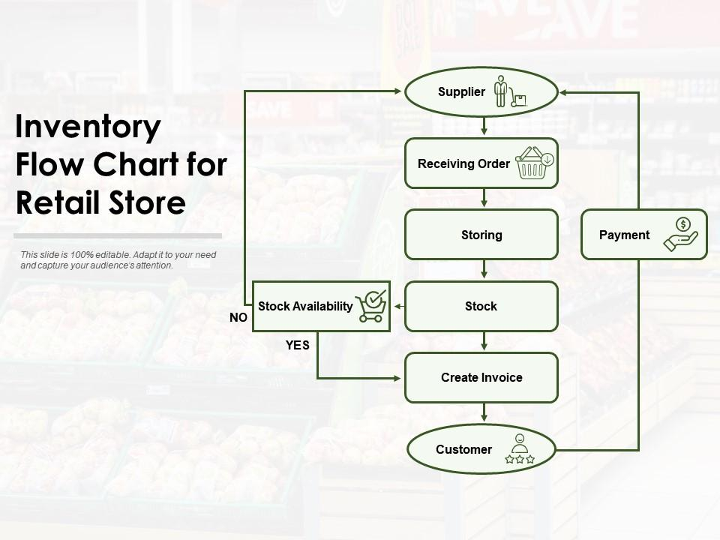

APPLICATIONS :
The procedure of stock proportionality is most fitting for inventories that stay inconspicuous by the purchaser, rather than "keep full" frameworks where a retail customer might want to see full retires of the item they are purchasing so as not to think they are purchasing something old, undesirable or stale; and separated from the "trigger point" frameworks where item is reordered when it hits a specific level; stock proportionality is utilized viably by without a moment to spare assembling procedures and retail applications where the item is escaped see.
HARDWARE AND SOFTWARE REQUIREMENTS:
Hardware:- Desktop or Laptop(2GB RAM) Windows 7
Software:- Front End:- Java (JDK 8) Netbeans 8.0.1 Jdk 1.8 (Java 8)
Back End:-SQLYOGULTIMATE(ANY VERSION)
CONCLUSIONS :
This paper presents an alarm about the information section in the bill which in view of desktop application. It's a straightforward desktop application inwhich the network to the immediate distribution center with the goal that information ought to be refreshed in store for the confirmation. It's a secure application in which the no information spillage from the stockroom. And furthermore gives the one table organization look so that after the finish of month we know about what we sold.

Inventory Management for Retail Applications Using Iot Systems
Abstract:
The retail sector has grown tremendously over the past century. Retail shopping has now become a part of our everyday life. There are two main players here: the retailers and the customers. The retailer’s main objectives are to obtain maximum sales with minimum operating costs. Customers will want to check for the availability of the product, and get to know its details beforehand. In this paper, we use Internet of Things (IoT) technology to integrate networked information systems with real world entities. It connects objects such as smartphones, sensors, etc with the cloud where the data is stored. When a product is selected for purchase, its details are displayed upon scanning its RFID tag and the product quantity is updated in the cloud once the purchase has been made. With this data, the retailers can keep track of the stock of each item, and restock items that are less in quantity. Customers can check for the availability of a particular product on the mobile application. This will save time for the customer in case a product is not available at a particular store. For the retailer, it will ensure that they never run out of stock of a particular product. This setup can be implemented in retail stores of varying sizes.
INTRODUCTION:
Internet Of Things (IOT) has gained widespread acceptance in various walks of life. In an Internet of Things (IoT) network, a number of objects are interconnected and are able to communicate with other objects in the network. It is a system of interconnected computing devices, digital machines, objects which are provided with unique id and which are capable of sending and receiving data over the IoT network without requiring any sort of interaction in either human or machine form. One of the main factors in loT devices to function properly in both physical world or in cyber world is trust. Under IoT, a number of applications are under development. Some of them include e-health, smart city, air pollution check in the city and so on. With the rapid urbanization in society over the past century, supermarkets.
RELATED WORK An Arduino
UNO can be used to develop an effective IoT system which is used to keep a check on the inventory of the store and an alert is issued in advance when the quantity of a product goes low. RFID automatically identifies the tags which are attached with the objects. The importance of RFID tags are implemented in many manufacturing industries. The production of RFID tags had a greater impact on retailers to tag each and every product with RFID tag which reads the linked information of the product and makes it easy for the customers to have a better shopping experience.Once customers step into a retail store they save their time by getting suggestions on the app about certain products of concern and where the product is located. The ultimate aim is to provide a stress free and easily accessible system of shopping for the customers. RFID technology can be used for locating, reading, computing and updating the position of each product in a store. This is done by attaching RFID tags to each item or their price tags. It can also be used to monitor the quantity of each product in a shop. Here, an RFID reader is placed on the shopping cart which helps in real-time updation of the stock of each product. Image processing is a technique that can be used to process various images and to compare the present stock of products on a shelf to the ideal (full) scenario. It notes down parameters like the occupation rate of each shelf, the rate of sale, etc. Wireless sensor network working on IoT technology can be used to track the grocery stock at homes and retail stores. This is chiefly done to watch the food consumption patterns and its levels.
Block diagram of a proposed system :
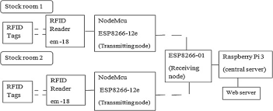

RESULTS :
The hardware components are as follows; Load cell, HX711 weight sensor, Arduino Uno, RFID reader and tag, ESP 8266-01 Wi-fi module, and a display component. The weight of the products is measured by load cell which converts force into electrical signals and also by determining the strain we can calculate the weight. These electrical signals are further amplified using weight sensor. These signals are carried towards Arduino by connecting wires and fed into it and the Wi-Fi module maintains the network access in carrying the amplified signals. RFID „Radio frequency identification‟ reads and records the incoming radio waves. RFID reader reads the products information on the tag and makes the RFID system.
CONCLUSION :
To conclude, this paper proposes a system designed to improve the retail experience of customers and retailers alike. By designing a system that helps both customers and retailers know the quantity of each product in a store, a lot of time and effort can be saved for them. Using this information, customers can search for the availability and details of a product online, through the mobile app. The retailers can monitor the sales of each product and restock if necessary, avoiding the situation where the store runs out of a particular product. By implementing this system in stores, the stores can improve their sales and profits. So it turns out to be a win-win situation for both customer and retailer.

