**CREATE A FAST TO SMS SERVICE:**

STEP 1: Type fast2sms in Google.

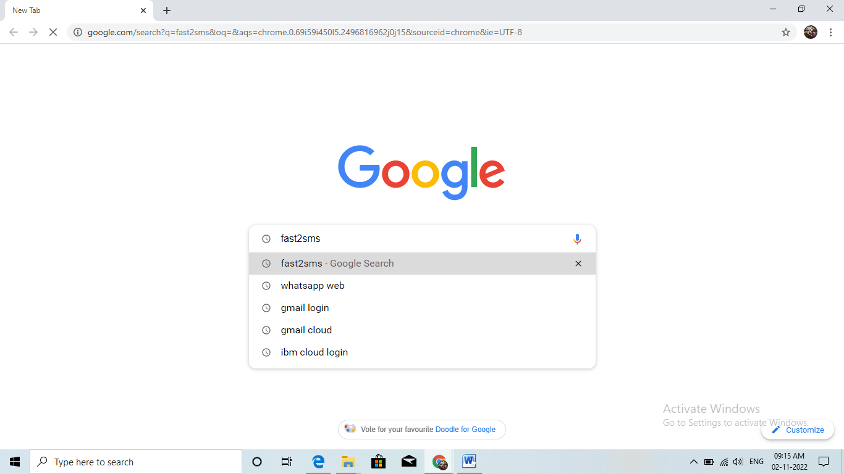

STEP 2: Click on the first link.

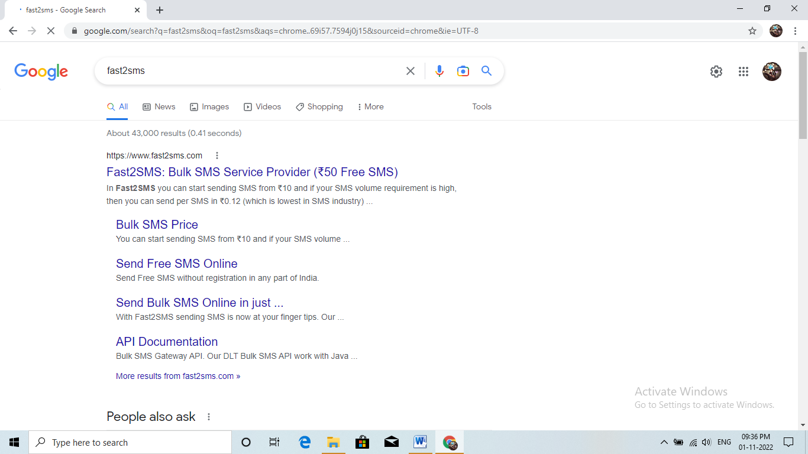

STEP 3: Click on SIGNUP NOW

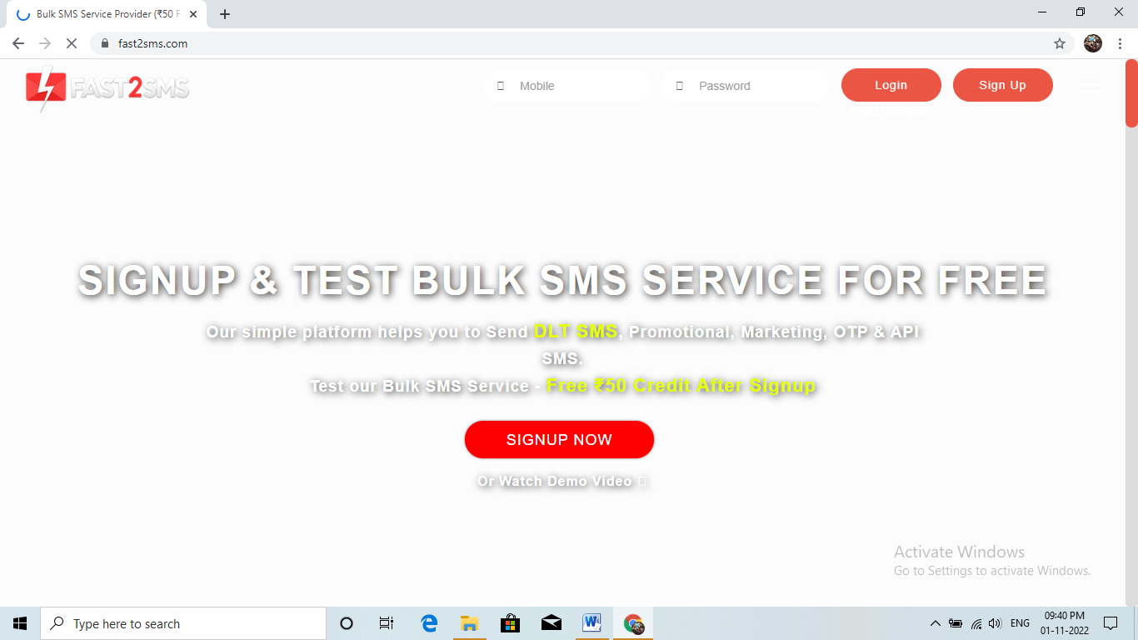

STPE 4: Give your details and click on the check box then click the submit button

STEP 5: You will get the SMS with your password. Type your mobile number and the password then click on the submit button.

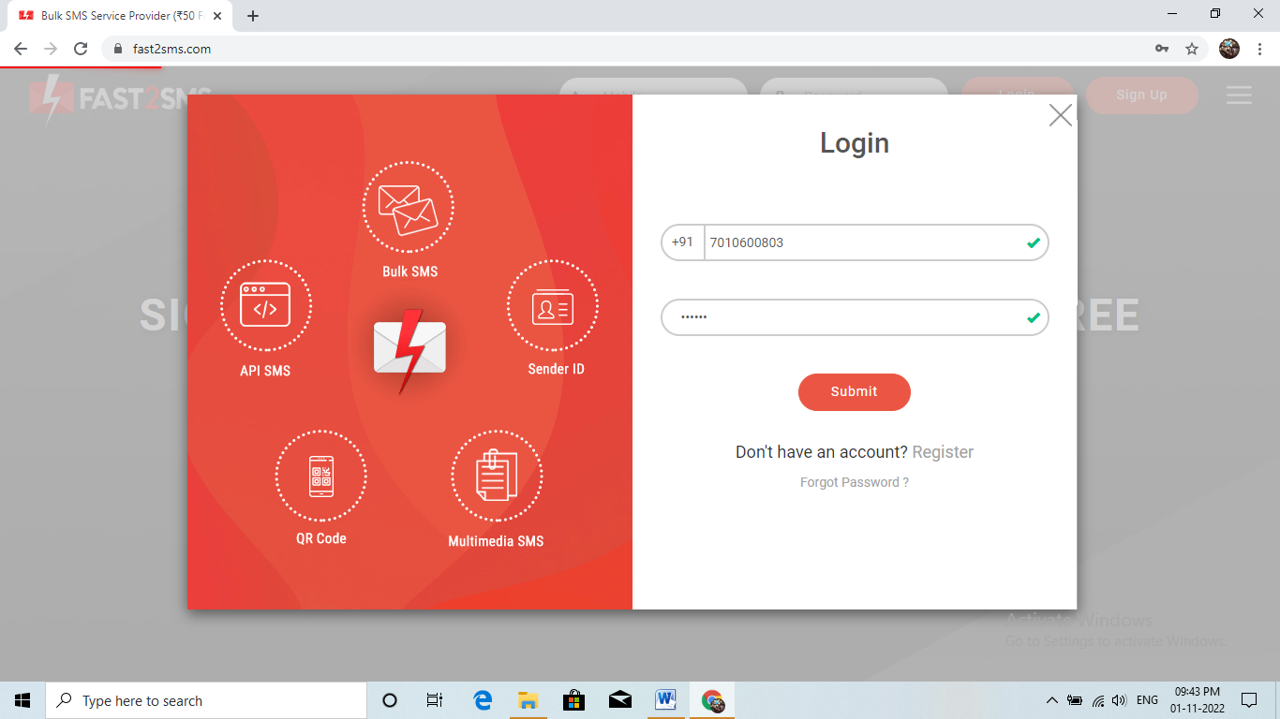

STEP 6: Type your email address and click on the VERIFY NOW button.

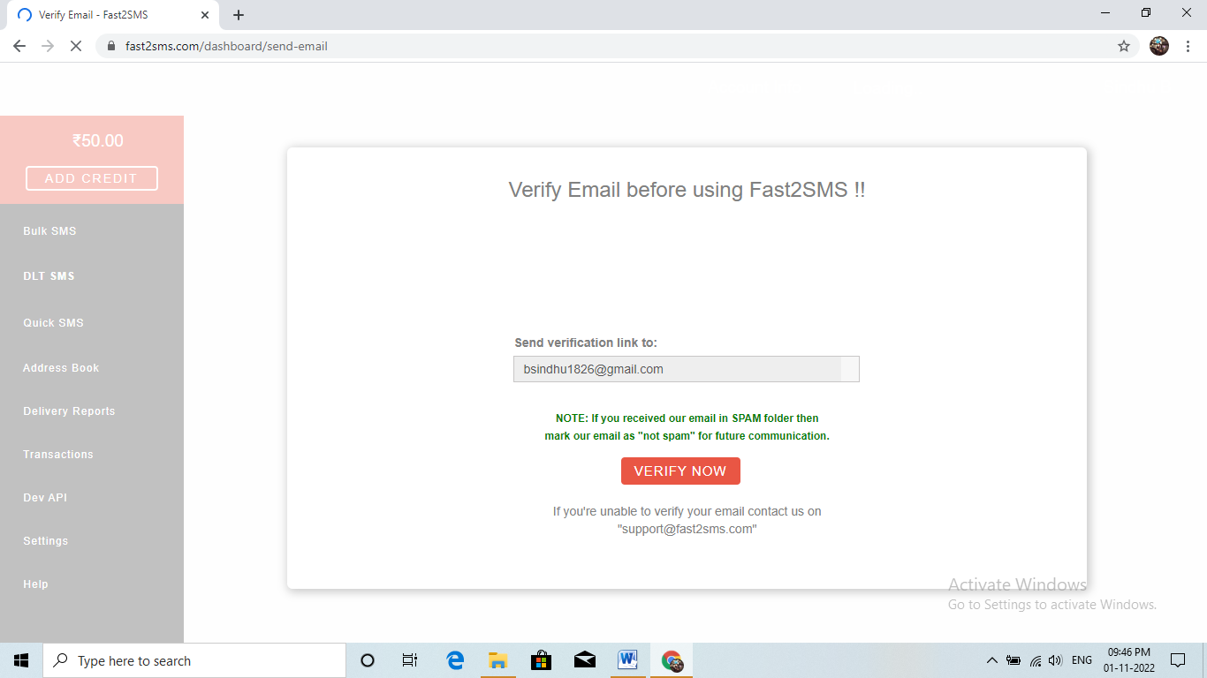

STEP 7: Click on the Dev API.

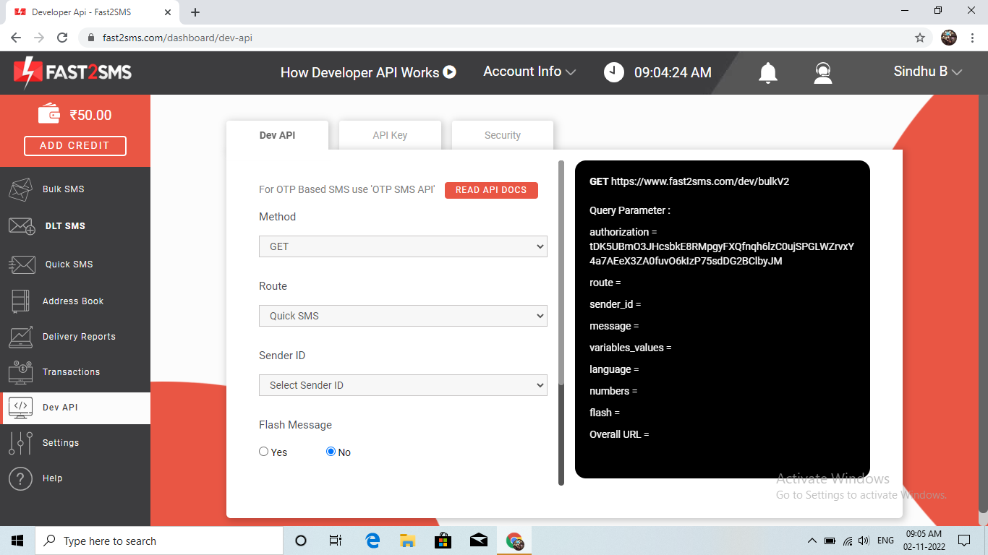

STEP 8: Select the Route as Quick SMS and type the message in Message box

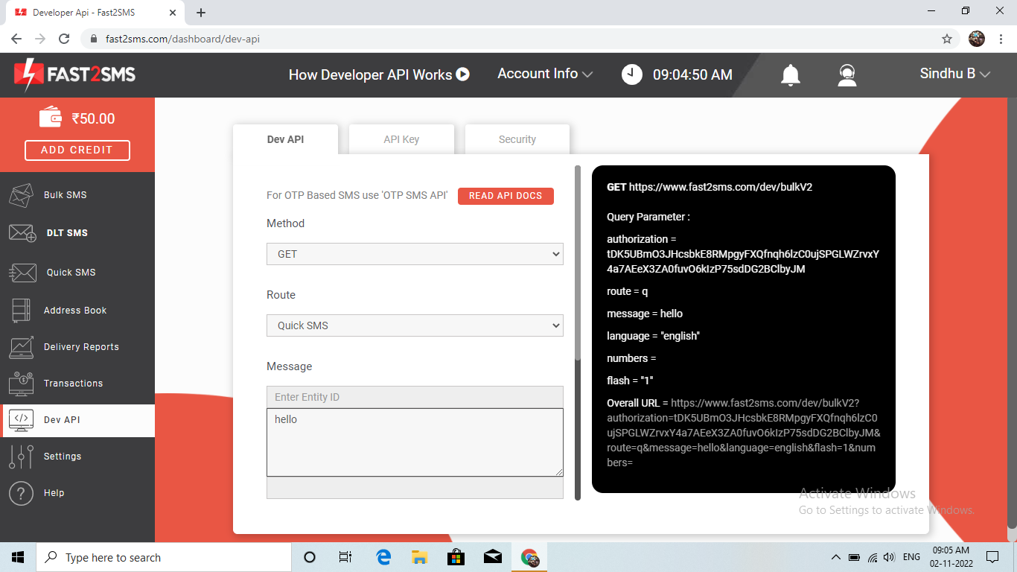

STEP 9: Select your language and type your mobile number in Contact.

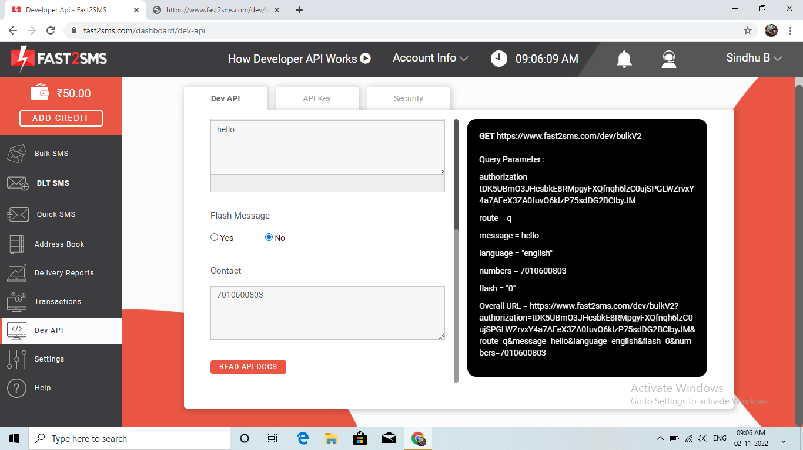

STEP 10: Copy the URL and paste it in the new tab.



STEP 11: You will get the SMS in the new tab.

