**INSTALLATION OF PYTHON 3.9.8**

|  |  |
| --- | --- |
| Date | 30 octomber 2022 |
| Team ID | PNT2022TMID50829 |
| Project Name | Project – Real-Time River Water Quality Monitoring and Control System |

# Step 1: Type python in google and click on the first link

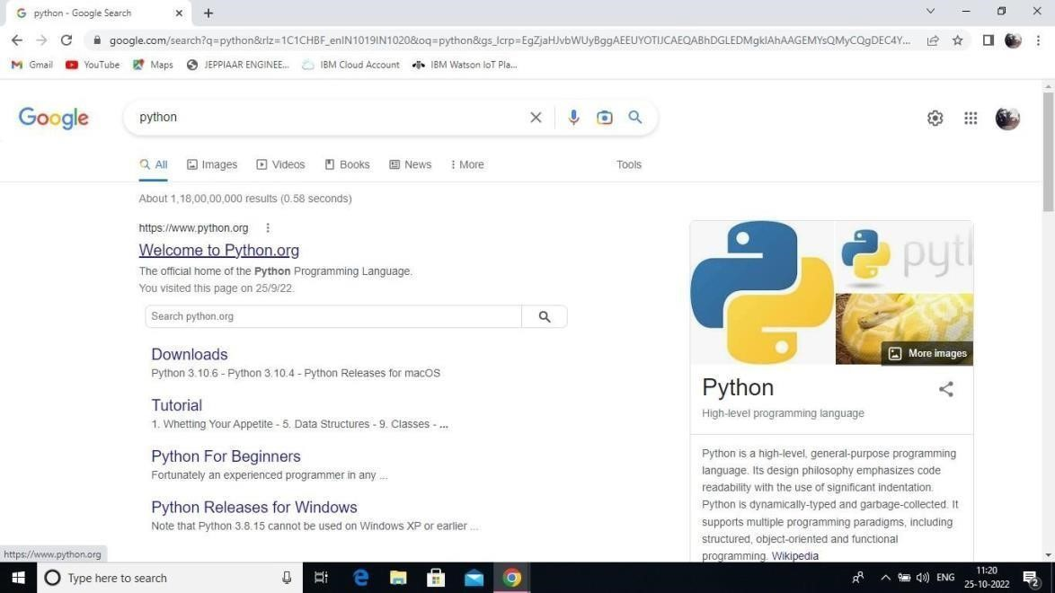

# Step 2: Click the python 3.9.8

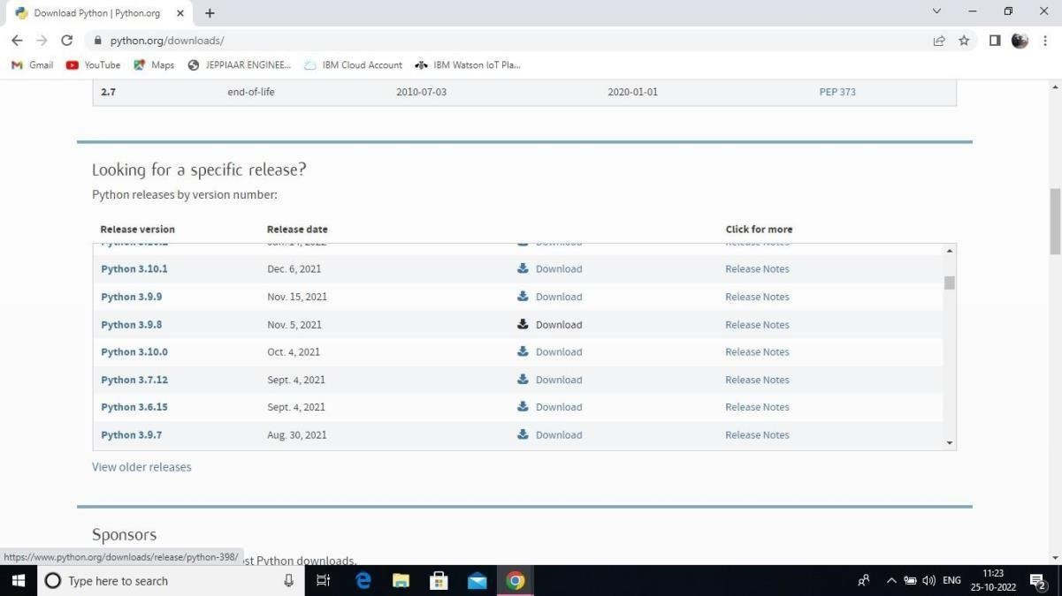

Step 3: Scroll down to reach Files and click on “Window installer (64 bit)

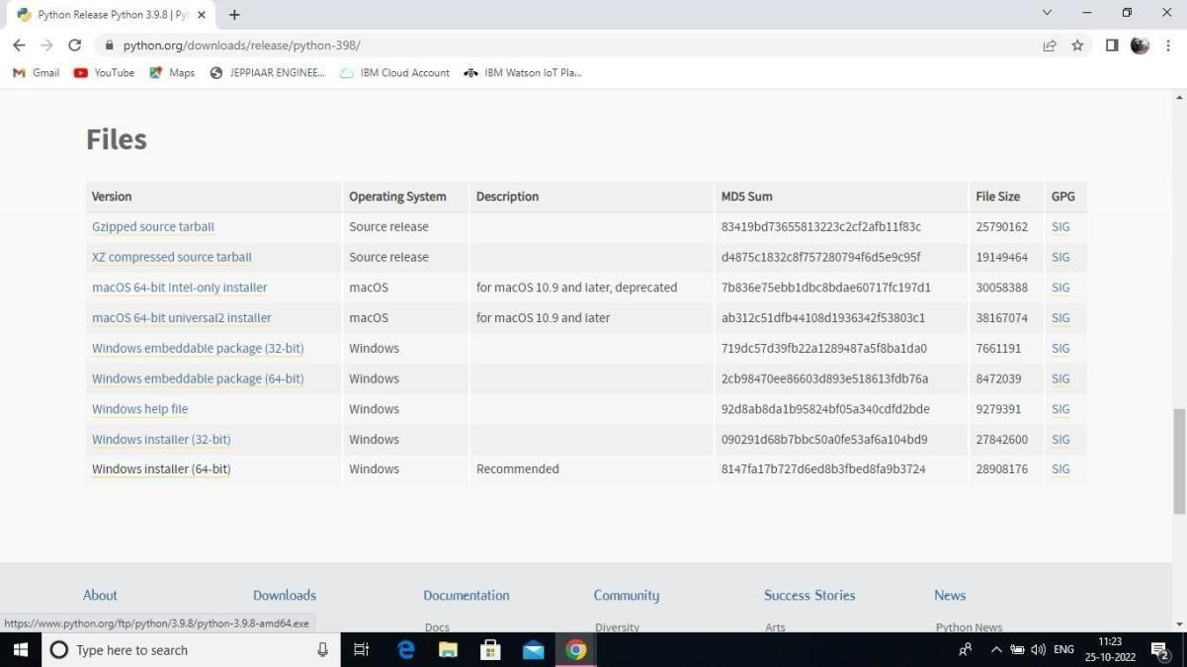

Step 4: Click on the Install button.

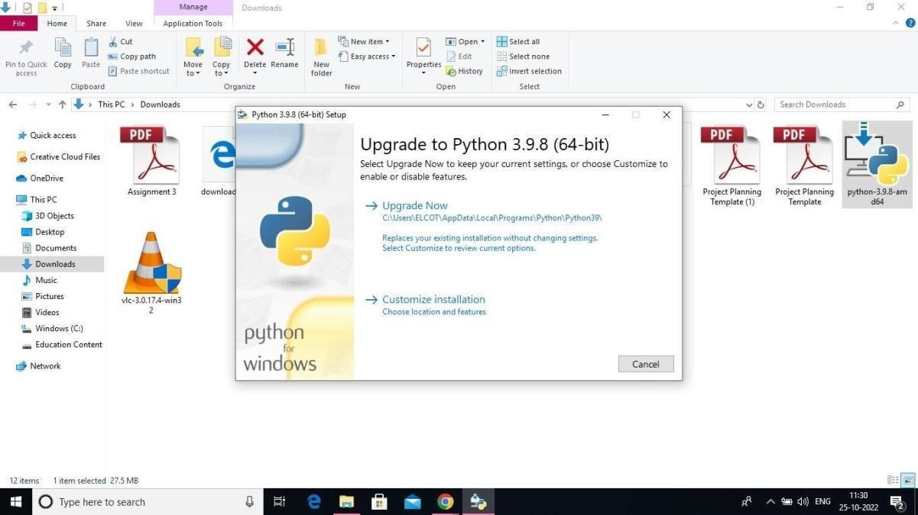

# Step 5: Installation on progress

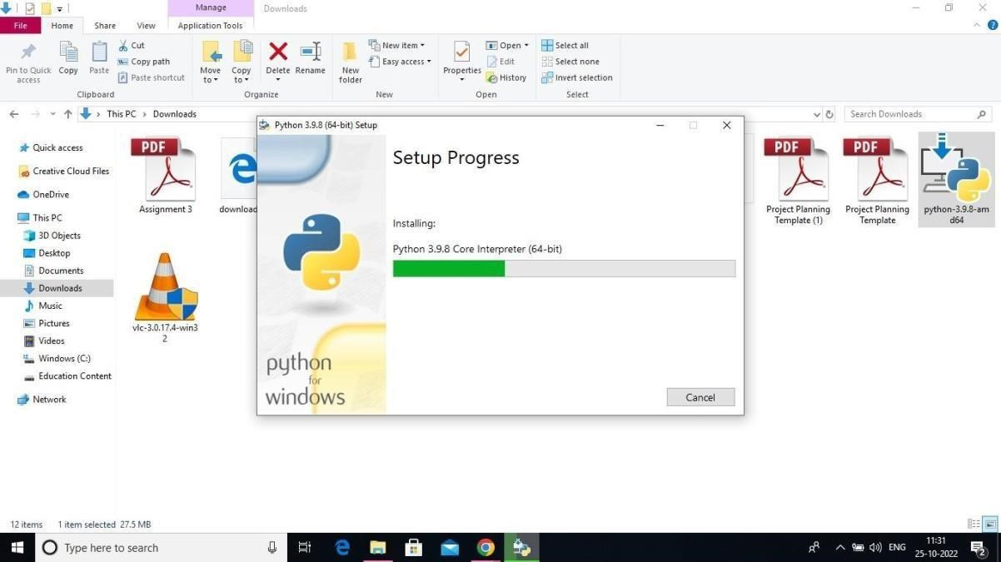

# 6:Close the button

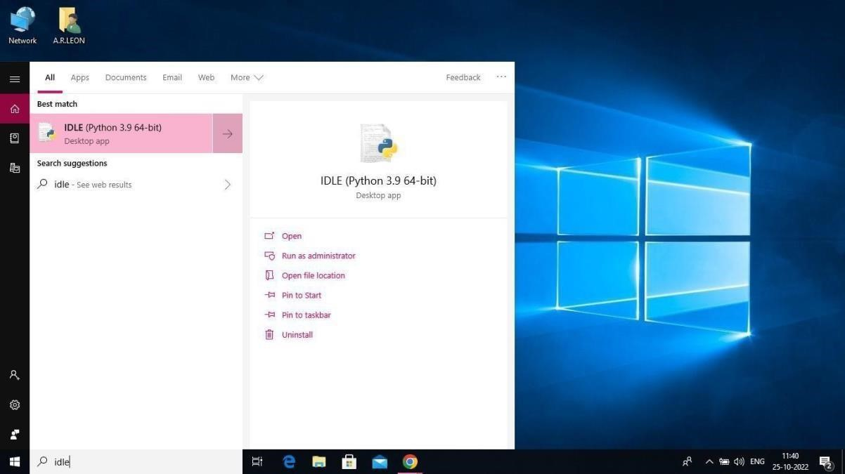

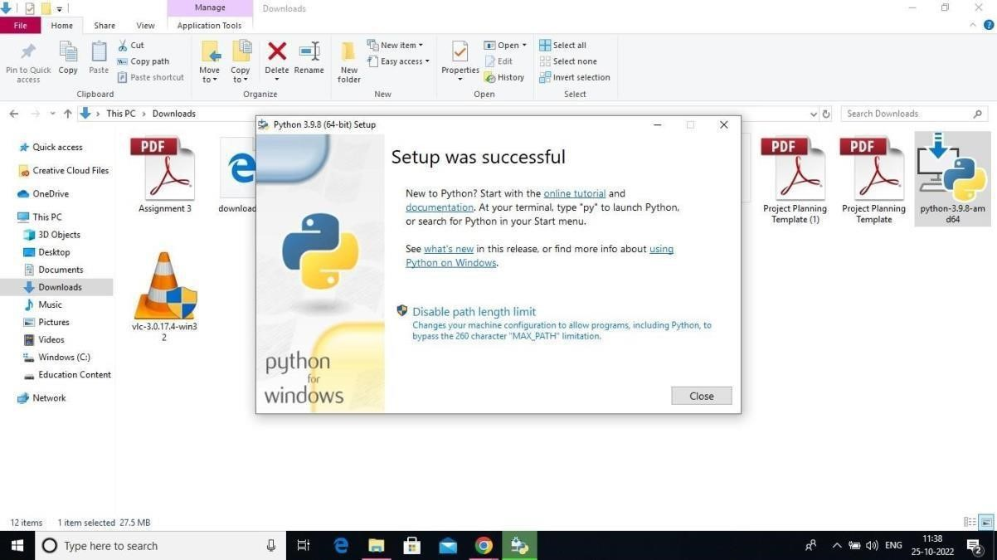

# Step 7: Search IDLE 8: Open it

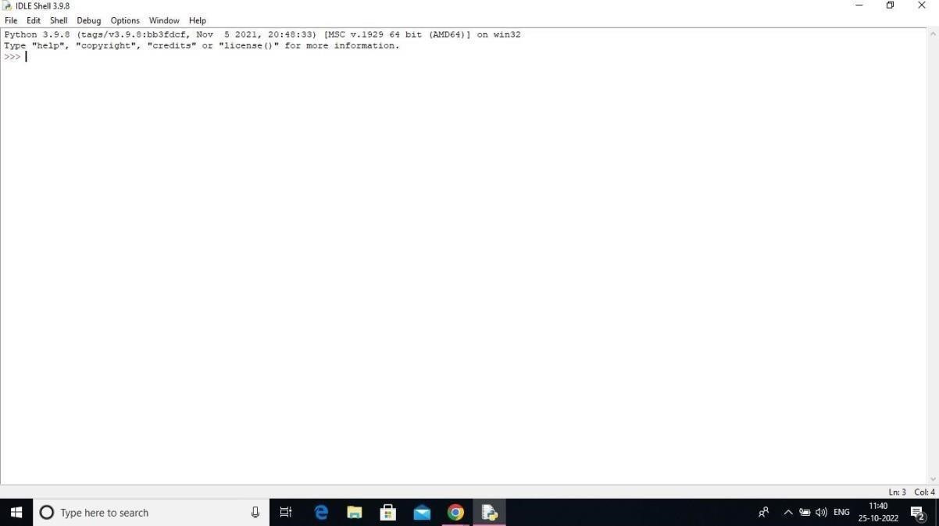

# Step 9: Go to file and click on New File

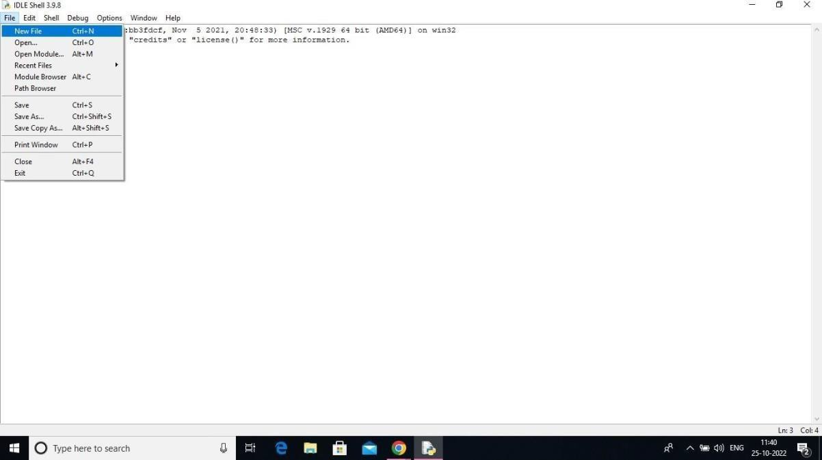

# Step 10: Open it

