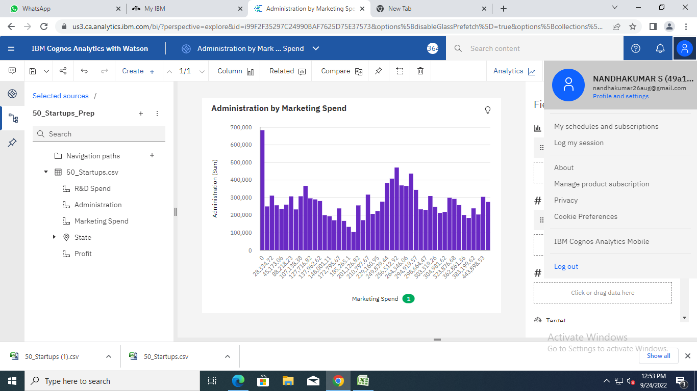

<https://us3.ca.analytics.ibm.com/bi/?perspective=explore&pathRef=.my_folders%2FAdministration%2Bby%2BMarketing%2BSpend&subView=model000001836e5f09b5_00000004>

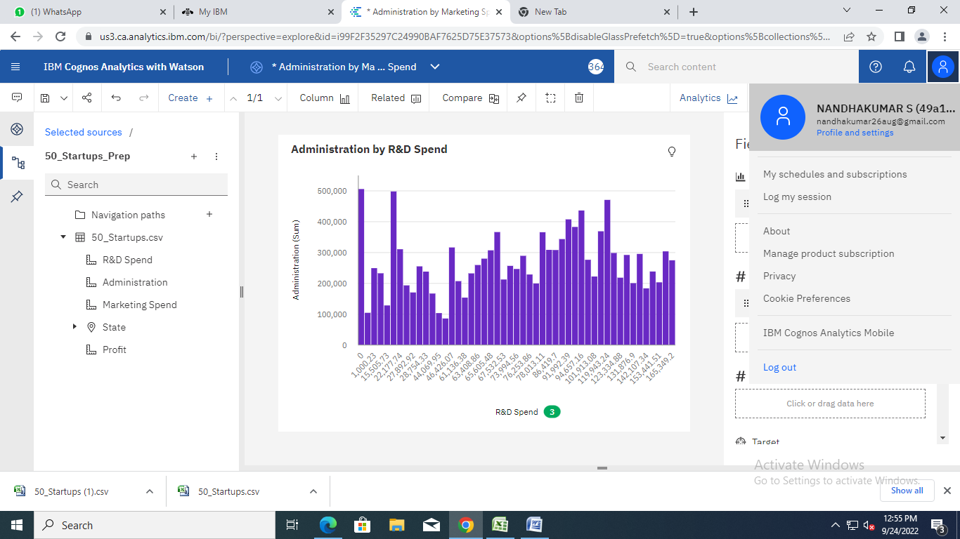

<https://us3.ca.analytics.ibm.com/bi/?perspective=explore&pathRef=.my_folders%2FAdministration%2Bby%2BMarketing%2BSpend&subView=model000001836e5f09b5_00000004>

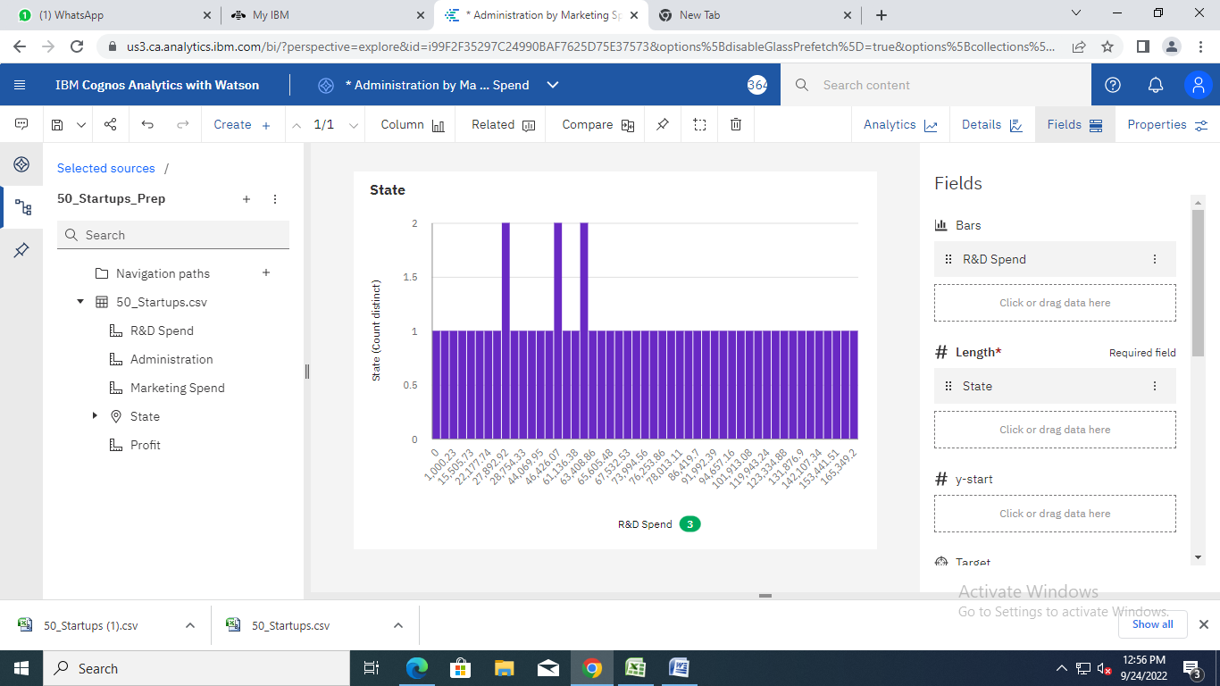

<https://us3.ca.analytics.ibm.com/bi/?perspective=explore&pathRef=.my_folders%2FAdministration%2Bby%2BMarketing%2BSpend&subView=model000001836e5f09b5_00000004>

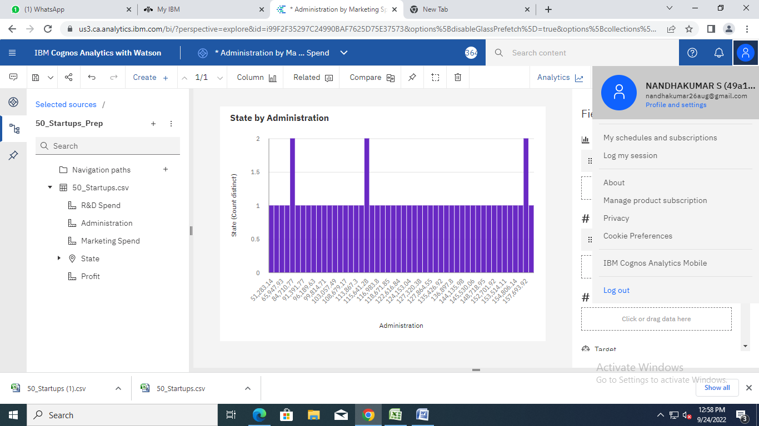

<https://us3.ca.analytics.ibm.com/bi/?perspective=explore&pathRef=.my_folders%2FAdministration%2Bby%2BMarketing%2BSpend&subView=model000001836e5f09b5_00000004>

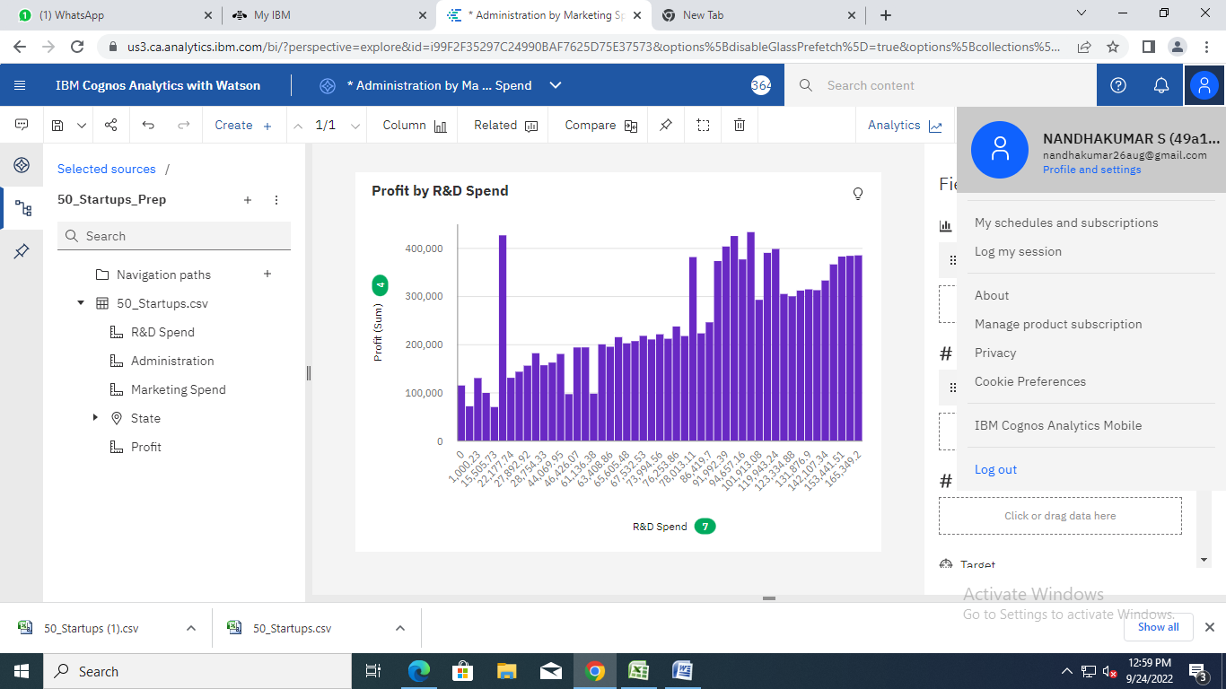

<https://us3.ca.analytics.ibm.com/bi/?perspective=explore&pathRef=.my_folders%2FAdministration%2Bby%2BMarketing%2BSpend&subView=model000001836e5f09b5_00000004>

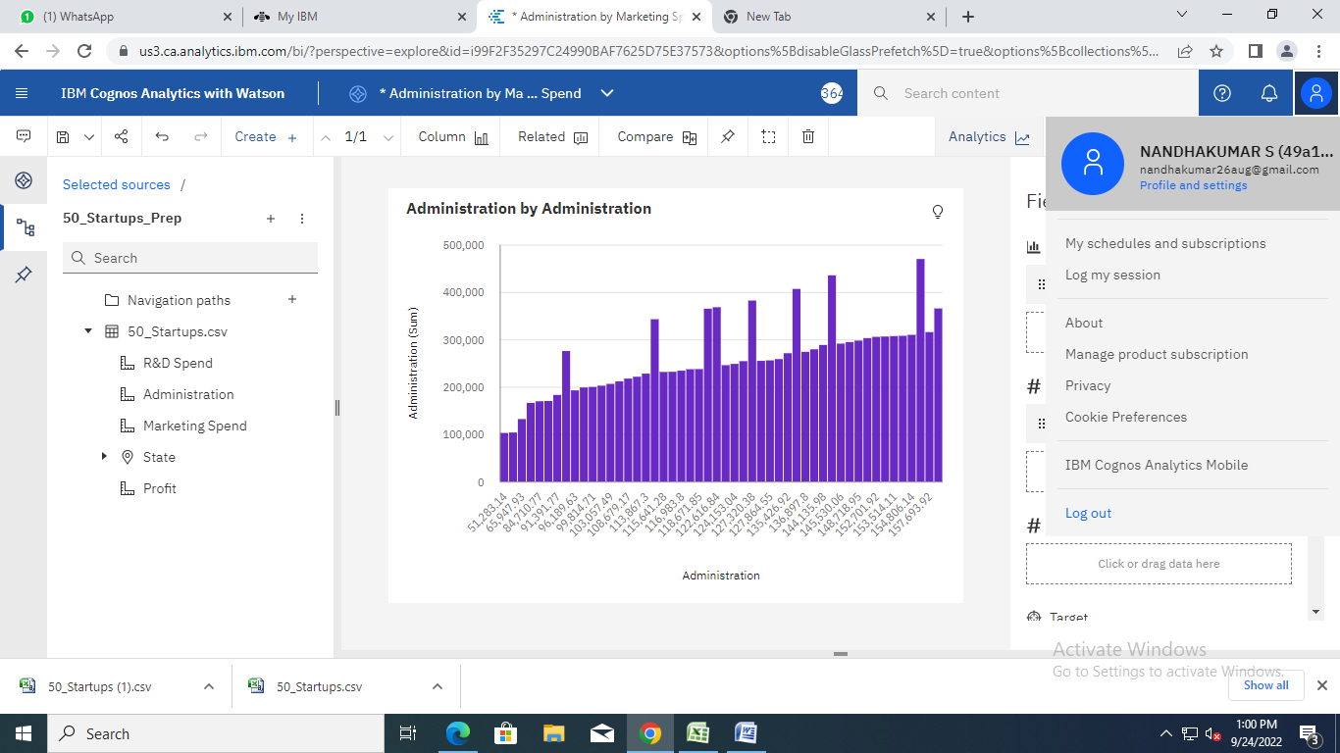

<https://us3.ca.analytics.ibm.com/bi/?perspective=explore&pathRef=.my_folders%2FAdministration%2Bby%2BMarketing%2BSpend&subView=model000001836e5f09b5_00000004>

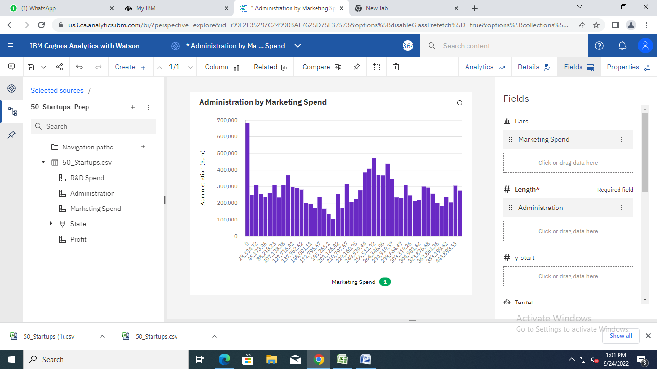

<https://us3.ca.analytics.ibm.com/bi/?perspective=explore&pathRef=.my_folders%2FAdministration%2Bby%2BMarketing%2BSpend&subView=model000001836e5f09b5_00000004>

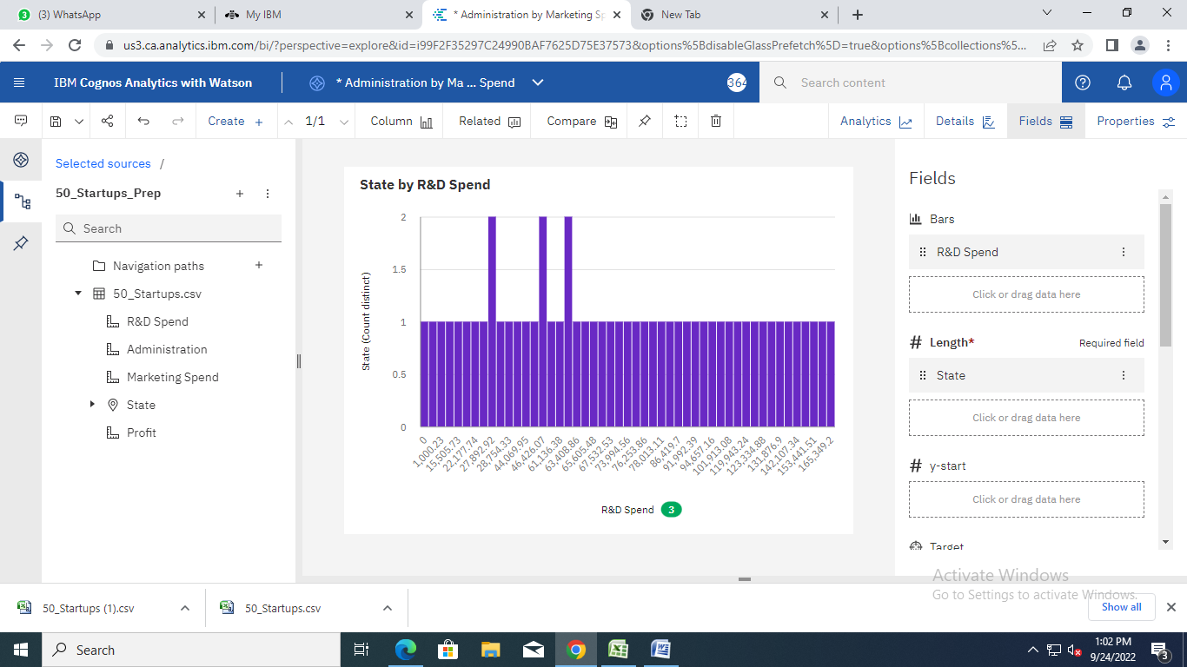

<https://us3.ca.analytics.ibm.com/bi/?perspective=explore&pathRef=.my_folders%2FAdministration%2Bby%2BMarketing%2BSpend&subView=model000001836e5f09b5_00000004>

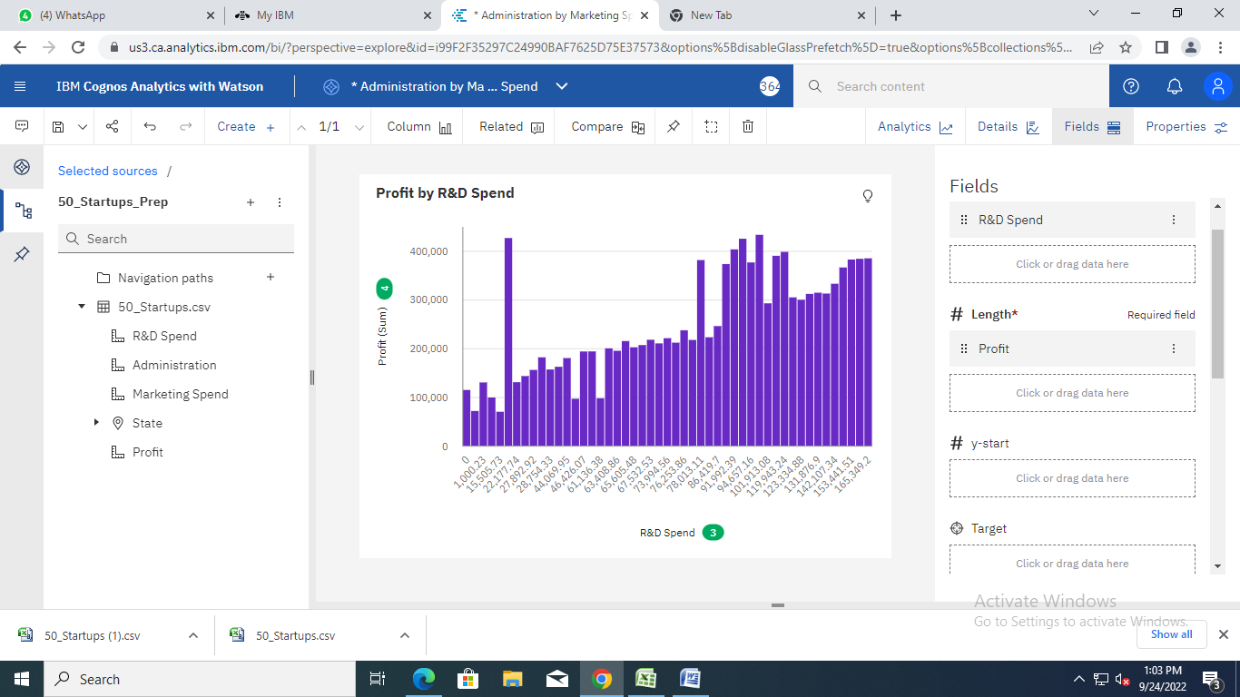

<https://us3.ca.analytics.ibm.com/bi/?perspective=explore&pathRef=.my_folders%2FAdministration%2Bby%2BMarketing%2BSpend&subView=model000001836e5f09b5_00000004>

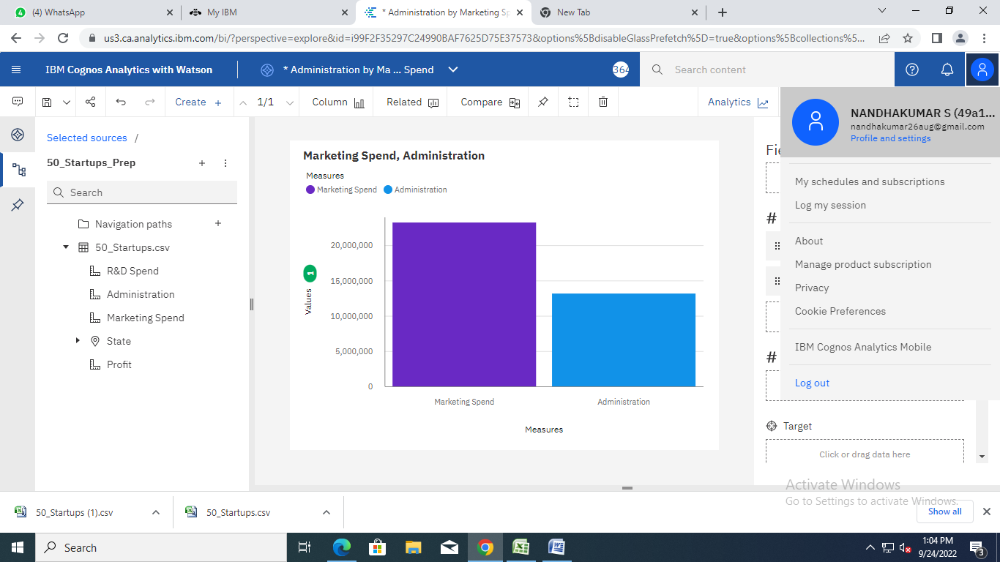

<https://us3.ca.analytics.ibm.com/bi/?perspective=explore&pathRef=.my_folders%2FAdministration%2Bby%2BMarketing%2BSpend&subView=model000001836e5f09b5_00000004>

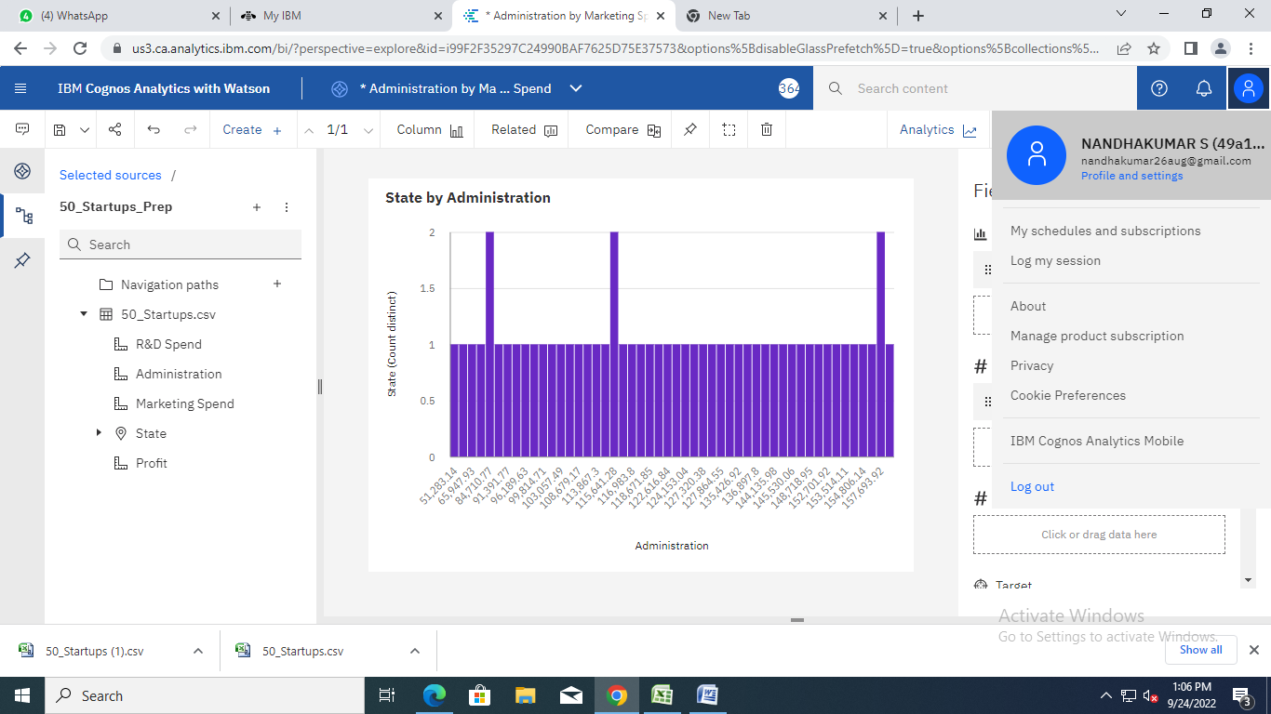

<https://us3.ca.analytics.ibm.com/bi/?perspective=explore&pathRef=.my_folders%2FAdministration%2Bby%2BMarketing%2BSpend&subView=model000001836e5f09b5_00000004>

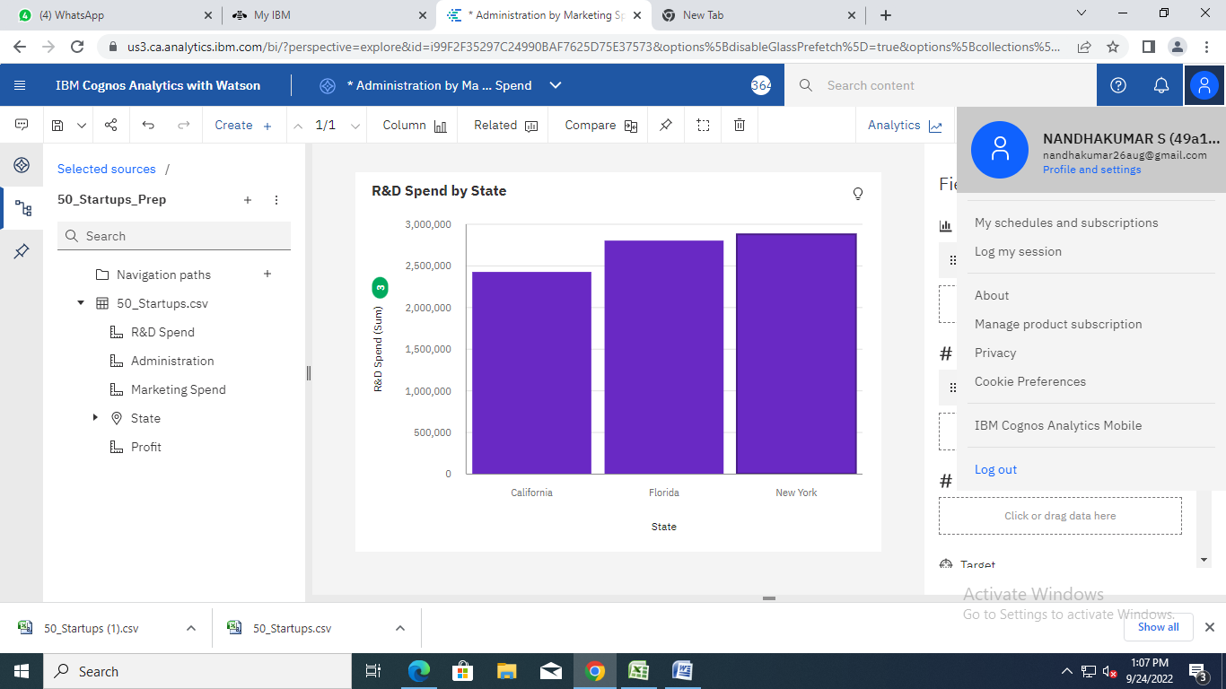

<https://us3.ca.analytics.ibm.com/bi/?perspective=explore&pathRef=.my_folders%2FAdministration%2Bby%2BMarketing%2BSpend&subView=model000001836e5f09b5_00000004>

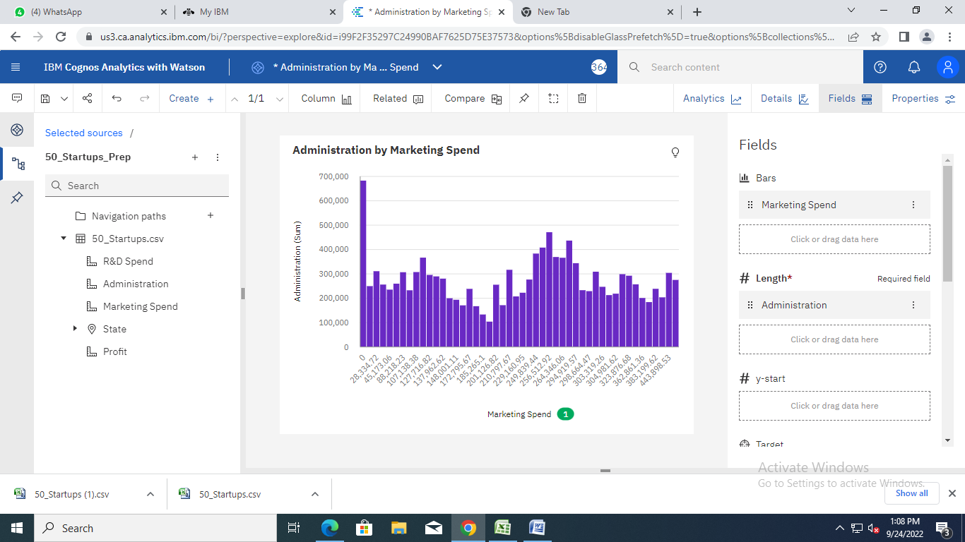

<https://us3.ca.analytics.ibm.com/bi/?perspective=explore&pathRef=.my_folders%2FAdministration%2Bby%2BMarketing%2BSpend&subView=model000001836e5f09b5_00000004>

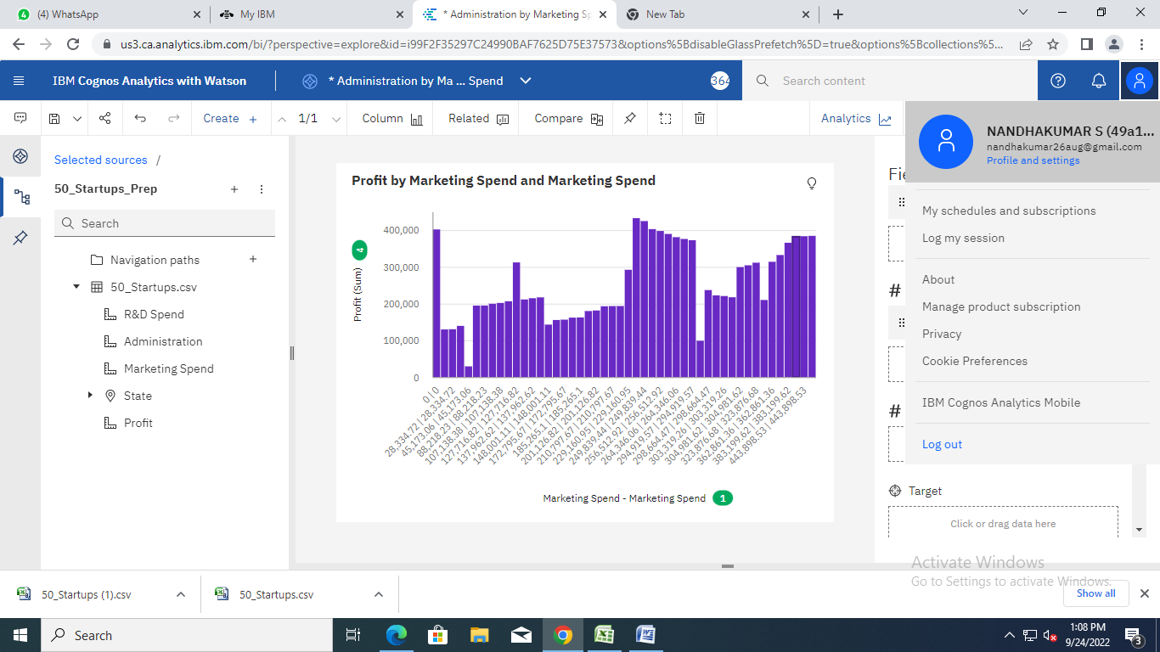

<https://us3.ca.analytics.ibm.com/bi/?perspective=explore&pathRef=.my_folders%2FAdministration%2Bby%2BMarketing%2BSpend&subView=model000001836e5f09b5_00000004>

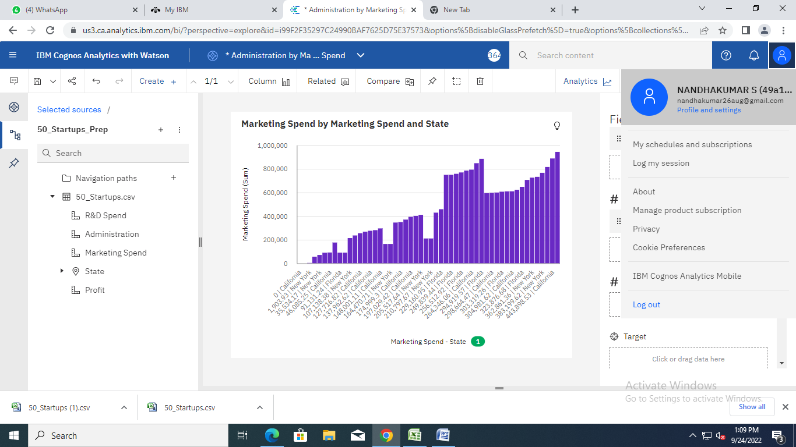

<https://us3.ca.analytics.ibm.com/bi/?perspective=explore&pathRef=.my_folders%2FAdministration%2Bby%2BMarketing%2BSpend&subView=model000001836e5f09b5_00000004>

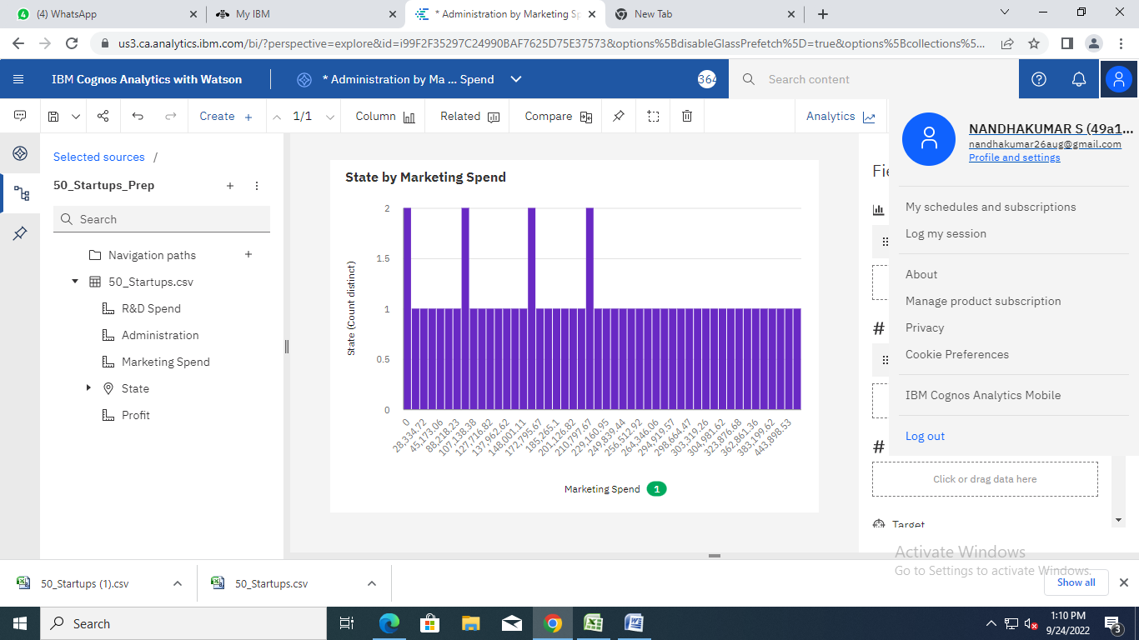

https://us3.ca.analytics.ibm.com/bi/?perspective=explore&pathRef=.my_folders%2FAdministration%2Bby%2BMarketing%2BSpend&subView=model000001836e5f09b5_00000004