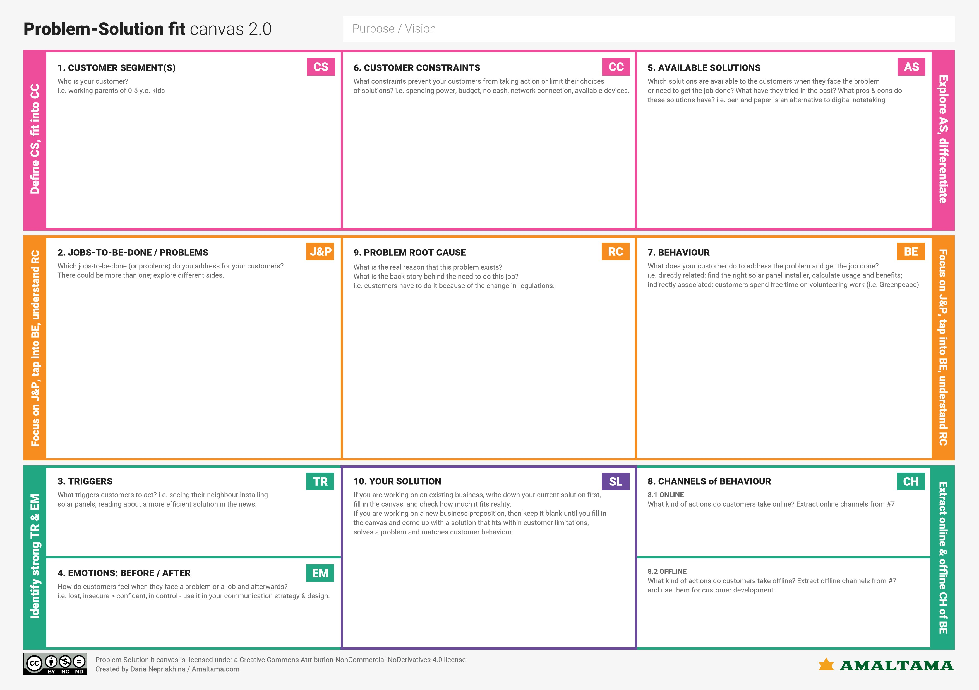

Physical counselling is an alternative to web counselling.

Spending lot of money, time and energy.

Students of 17 years + who are seeking admission in a good college.

Wants to get admission in our preferred college based on our credentials.

At last, students spend a lot of money and time to know their eligibility to that particular college.

Students are often confused about whether they are eligible or not for the college’s admission and often spend a sum of money and even their time too.

We would create an application where it will check the eligibility criteria of a student to get admission in a college by calculating cut offs, GRE and TOEFL score.

They opt for counselling or by management.

They will search about each and every college for their eligibility.

Not getting into the preferred college and not being able to adapt the surroundings.

Seeing the other students investing money and time for choosing the college.