# MANGAI ESAKKI P

**ROLLNO: 49621915039**

# Assignment:-(Module-3 Python)

**1)**

n=int(input()) list=[]

for i in range(0,n):

c=input().split() if c[0]=="insert":

list.insert(int(c[1]),int(c[2])) elif c[0]=="print":

print(list)

elif c[0]=="remove":

list.remove(int(c[1])) elif c[0]=="append":

list.append(int(c[1])) elif c[0]=="sort":

list.sort() elif c[0]=="pop":

list.pop()

### OUTPUT:-

else:

list.reverse()

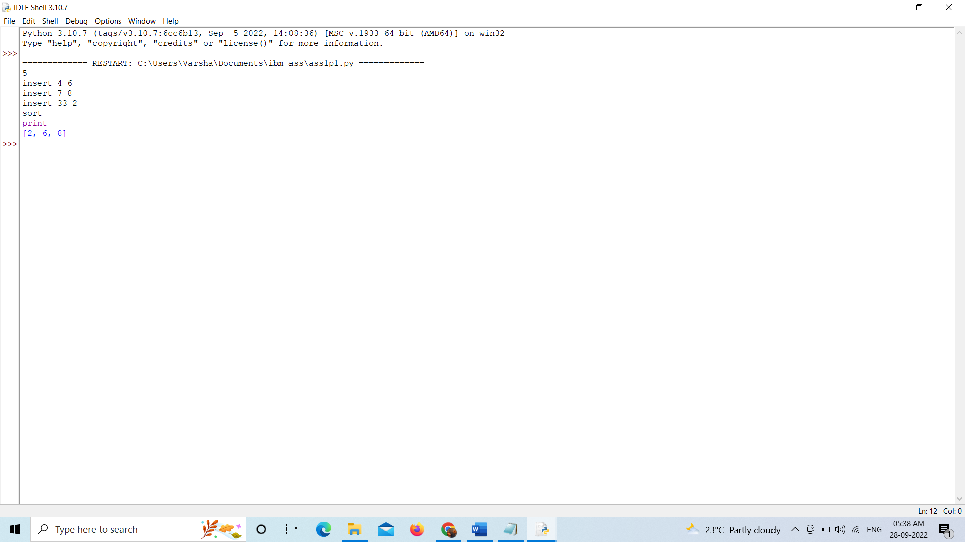

**2)**

while(True):

print("\nCalculator:\n1.Add\n2.Subtract\n3.Multiplication\n4.Division\n5.Exit") print("Enter the choice:")

n=int(input()) if(n==5):

break

n1=int(input("Enter the First number:")) n2=int(input("Enter the second number:")) if(n==1):

print("Answer:",n1+n2) elif(n==2): print("Answer:",n1-n2)

elif(n==3): print("Answer:",n1*n2) elif(n==4): print("Answer:",n1/n2) else:

break

**OUTPUT:-**

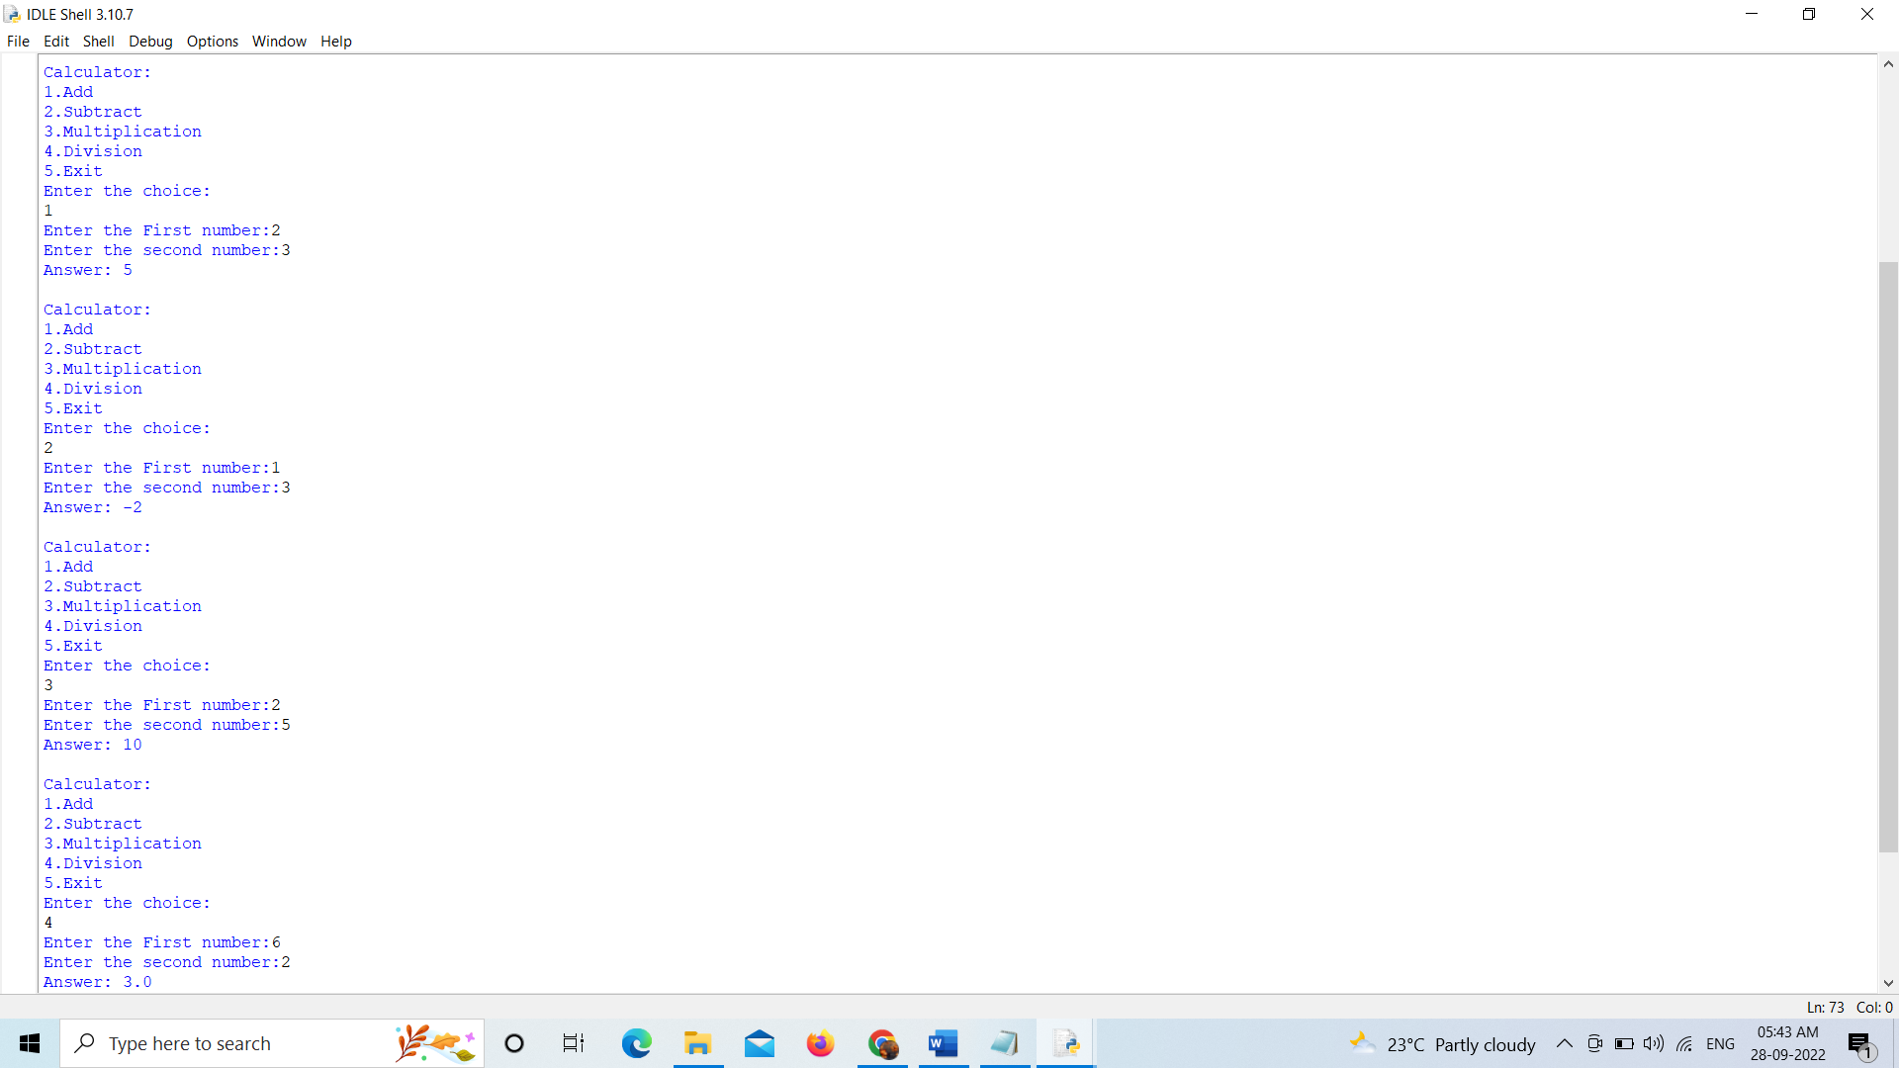

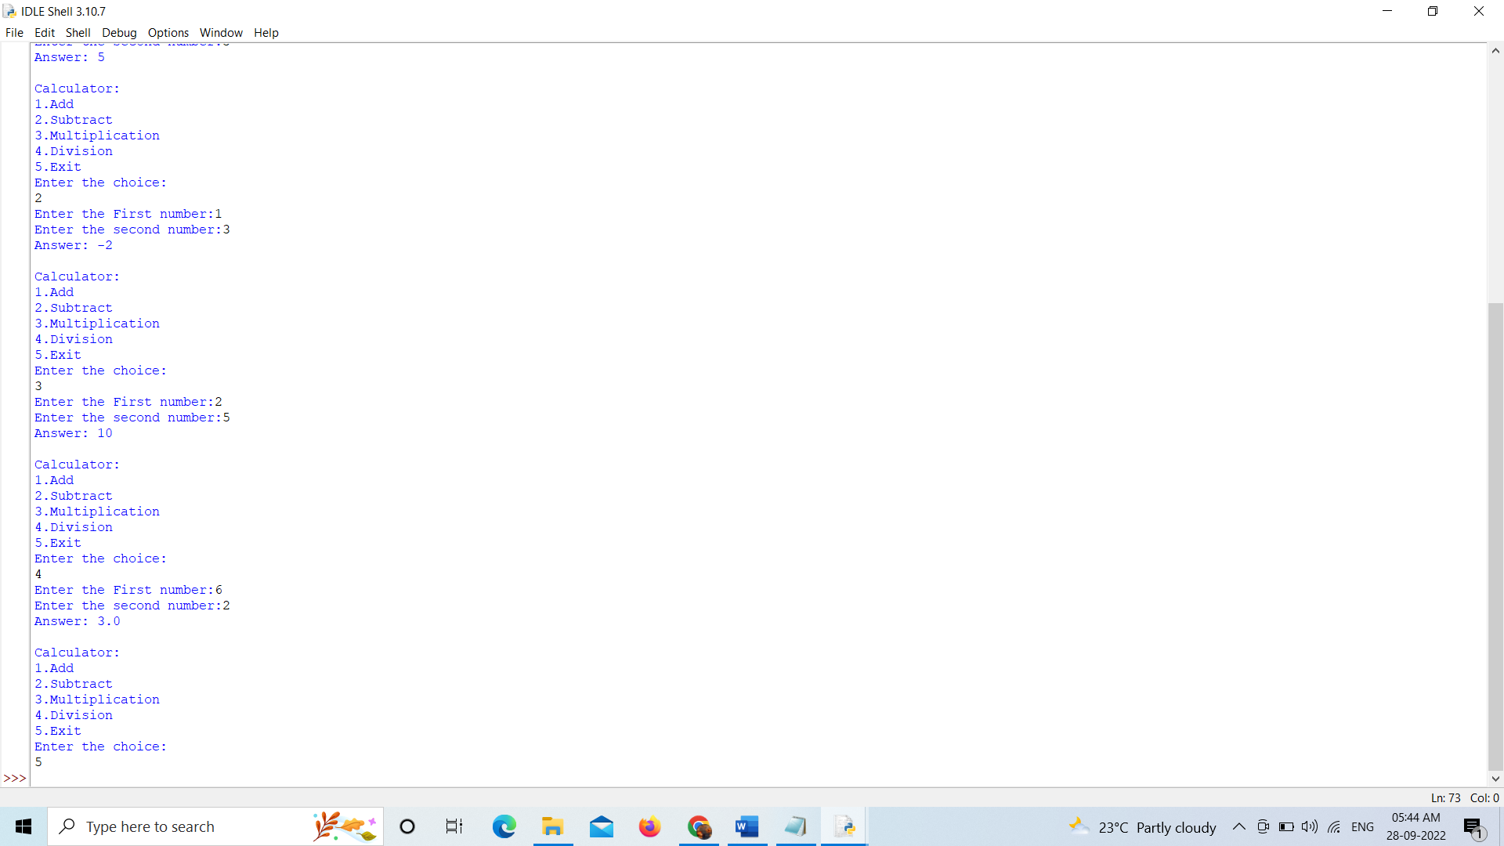

## 3)

s1="ananthi" s2="kavi" print("String-1: ",s1)

print("String-2: ",s2) print("Concatenate: ",s1+s2) print("String reverse: ",s1[::-1])

print("String Slice: ",s2[2:4])

### OUTPUT:-

