**EMPATHY MAP**

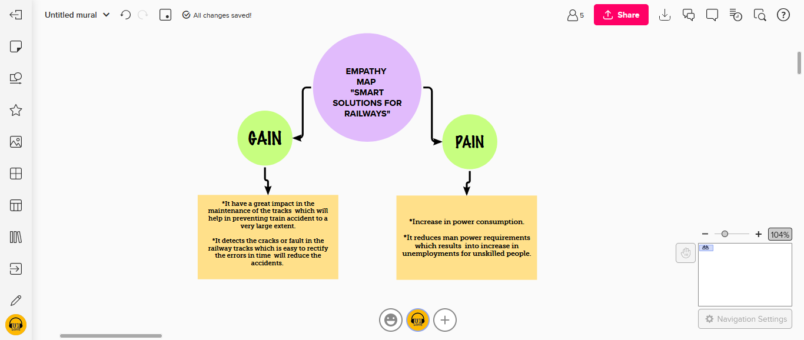

# SUBMITTED BY

DHARANI