SPRINT-1

|  |  |
| --- | --- |
| Date | 29 October 2022 |
| Team ID | PNT2022TMID47932 |
| Project Name | Smart solutions for railways |
| Maximum Marks | 20 marks |

Step-1: Creating IBM Cloud

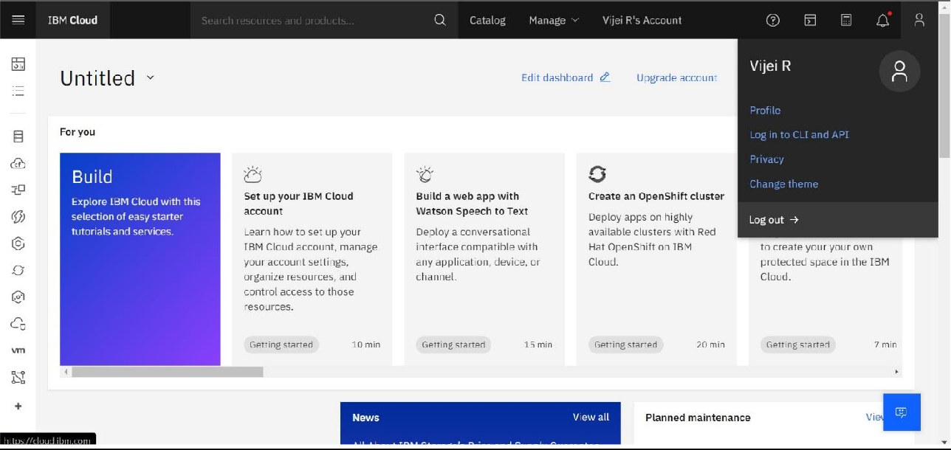

Step-2: Using IBM CLOUD services

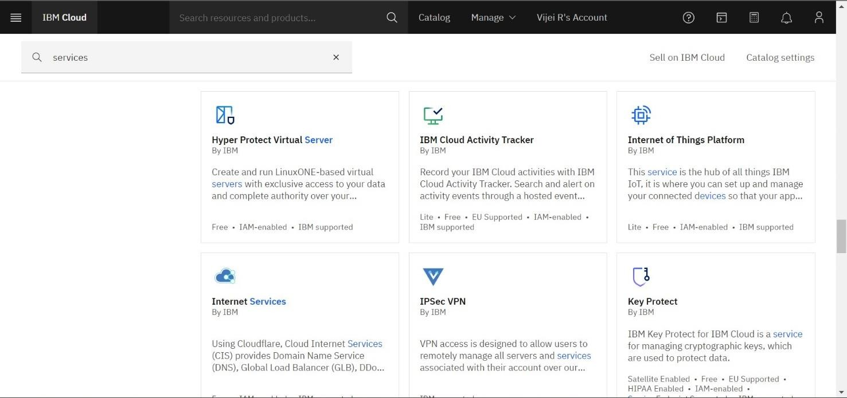

Step-3: Configure the IBM CLOUD service and creating IOT platform.

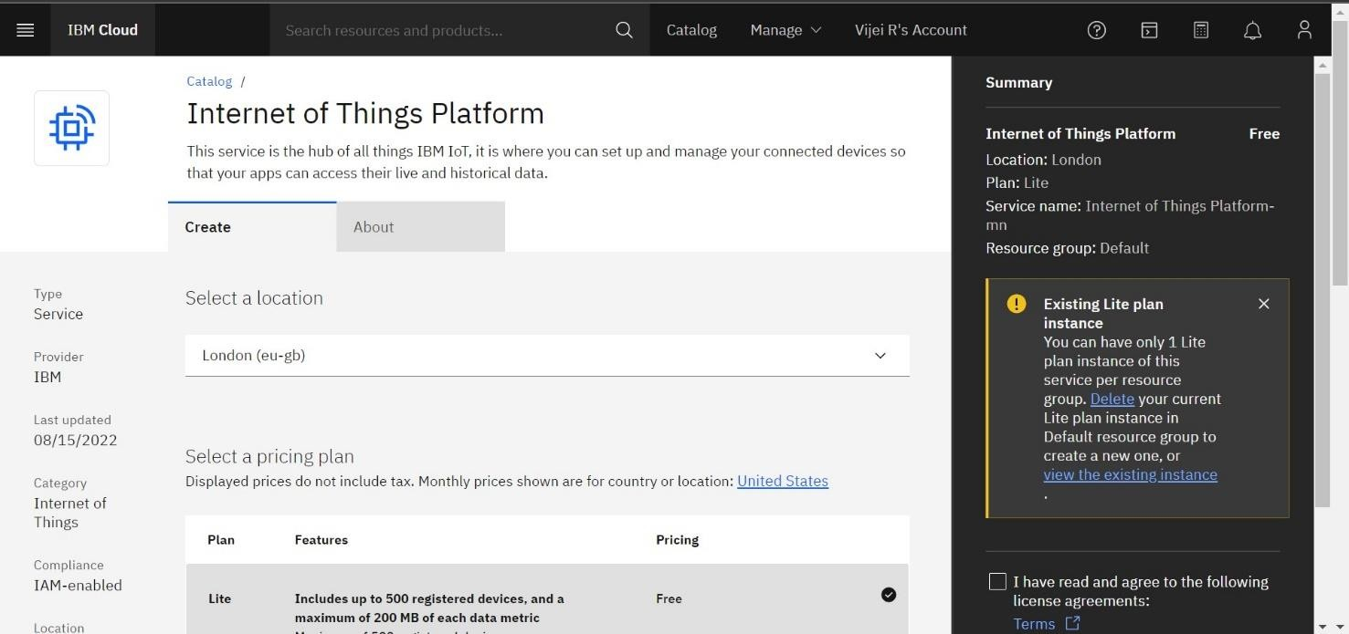

Step4: IBM Watson IOT platform acts as the mediator to connect the web application to IOT devices, hence launching IBM Watson IOT platform.

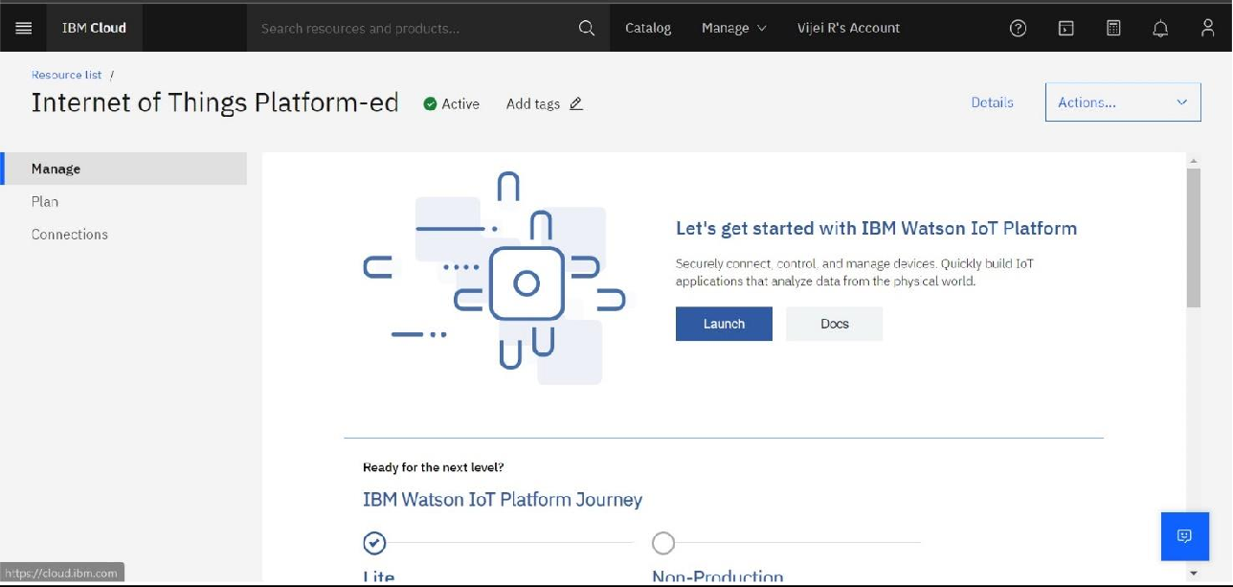

Step 5: IBM Watson IOT platform is created

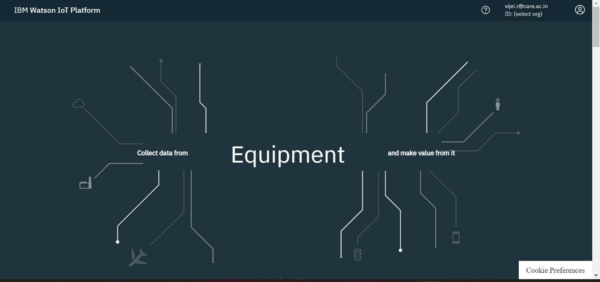

Step 6: In order to connect the IOT device to the IBM cloud, create device in the IBM Watson IOT Platform and get the device credentials.

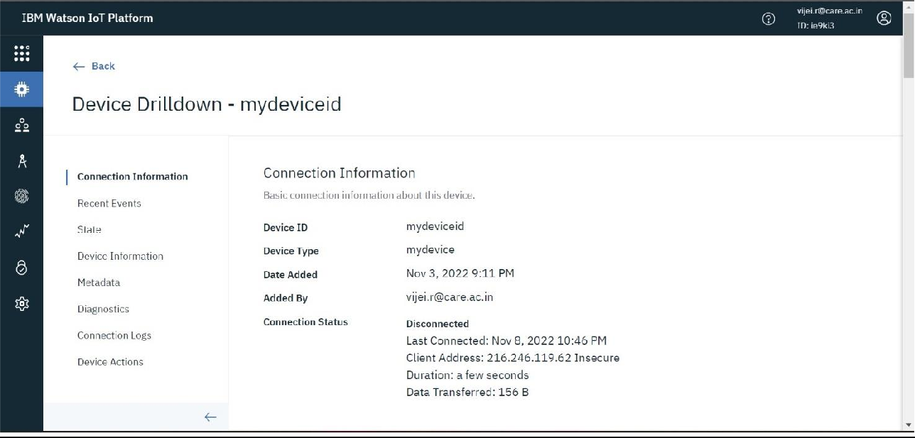

Step-7: Connect the device and start simulating.

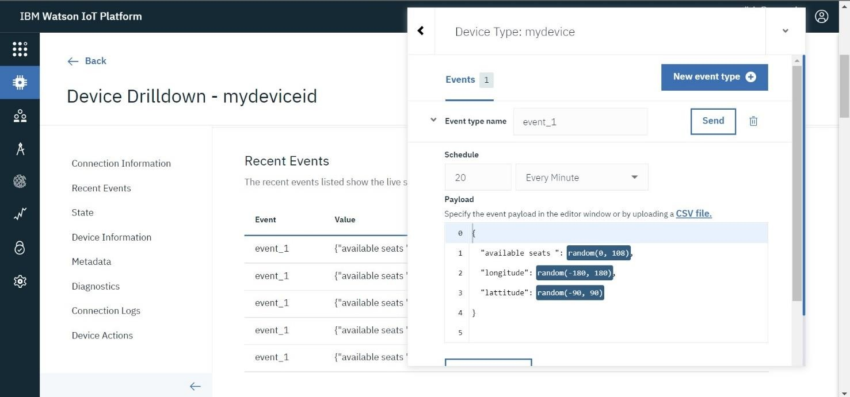

SIMULATION:

The simulation shows the available seats, longitude and latitude

