SPRINT-3

|  |  |
| --- | --- |
| Date | 12 November 2022 |
| Team ID | PNT2022TMID47932 |
| Project Name | SMART SOLUTIONS FOR RAILWAYS |

# Develop a python script for publishing the location(Latitude & Longitude) data to the IBM IOT platform.

import wiotp.sdk.device import time

# Provide your IBM Watson Device Credentials

myConfig = { "identity": { "orgId": "ie9ki3",

"typeId": "mydevice", "deviceId":"mydeviceid"},

"auth": { "token": "bW(_2O((aRG8E6fij6"}}

def myCommandCallback(cmd):

print("Message received from IBM IoT Platform: %s" % cmd.data['command']) m = cmd.data['command']

client = wiotp.sdk.device.DeviceClient(config=myConfig, logHandlers=None) client.connect()

def pub(data):

client.publishEvent(eventId="status", msgFormat="json", data=myData, qos=0, onPublish=None) print("Published data Successfully: %s", myData)

while True:

###### TRAIN ROUTE FROM MUMBAI > CHENNAI ######

myData = {'name': 'MUMBAI >CHENNAI EXPRESS', 'lat': 13.913128, 'lon': 79.360651}

pub(myData) time.sleep(3)

myData = {'name': 'MUMBAI >CHENNAI EXPRESS', 'lat': 13.729034,'lon': 79.472997}

pub(myData) time.sleep(3)

myData = {'name': 'MUMBAI >CHENNAI EXPRESS', 'lat': 13.478878, 'lon': 79.541901}

pub (myData) time.sleep (3)

myData = {'name': 'MUMBAI--->CHENNAI EXPRESS', 'lat': 13.216907,'lon': 79.592364}

pub(myData) time.sleep(3)

myData = {'name': 'MUMBAI--->CHENNAI EXPRESS', 'lat': 13.093835,'lon': 79.683645}

pub(myData) time.sleep(3)

myData = {'name': 'MUMBAI--->CHENNAI EXPRESS', 'lat': 13.128028,'lon': 79.932913}

pub(myData) time.sleep(3)

client.commandCallback = myCommandCallback client.disconnect()

**OUTPUT:**

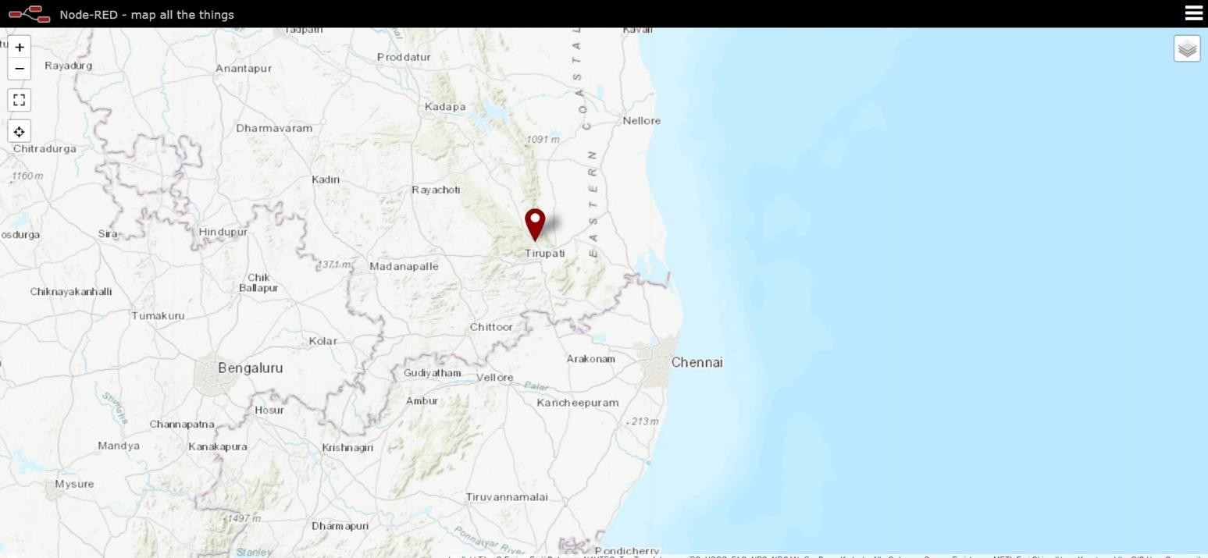

**python code to read the QR code and fetch the data from cloudant DB:**

import cv2 import time

import pyzbar.pyzbar as pyzbar

from ibmcloudant.cloudant_v1 import CloudantV1

from ibm_cloud_sdk_core.authenticators import BasicAuthenticator

authenticator = BasicAuthenticator('apikey-5fa841dab9544e31b6a1b6f9ba432422', '591f8ef66aac6f9bc779c8e7bf4a670f4058cf13')

service = CloudantV1(authenticator=authenticator)

service.set_service_url('https://c14dc572-82d6-4b8b-9e6f-01fc8aedecb0-bluemix.cloudant.com') cap= cv2.VideoCapture(0)

font = cv2.FONT_HERSHEY_PLAIN

while True:

_, frame = cap.read()

decodedObjects = pyzbar.decode(frame) for obj in decodedObjects:

# print ("Data", obj.data)

a = obj.data.decode('UTF-8')

cv2.putText(frame, "Ticket", (50, 50), font, 2, (255, 0, 0), 3) try:

response = service.get_document(db='crendentials',doc_id=a).get_result() print(response)

time.sleep(5) except Exception as e:

print("Not a Valid Ticket") time.sleep(5)

cv2.imshow("Frame",frame)

if cv2.waitKey(1) & 0xFF ==ord('q'): break

cap.release() cv2.destroyAllWindows() #client.disconnect()

**OUTPUT:**

