SPRINT-4

|  |  |
| --- | --- |
| Date | 05 November 2022 |
| Team ID | PNT2022TMID47932 |
| Project Name | SMART SOLUTIONS FOR RAILWAYS |

Develop the web application using Node-RED

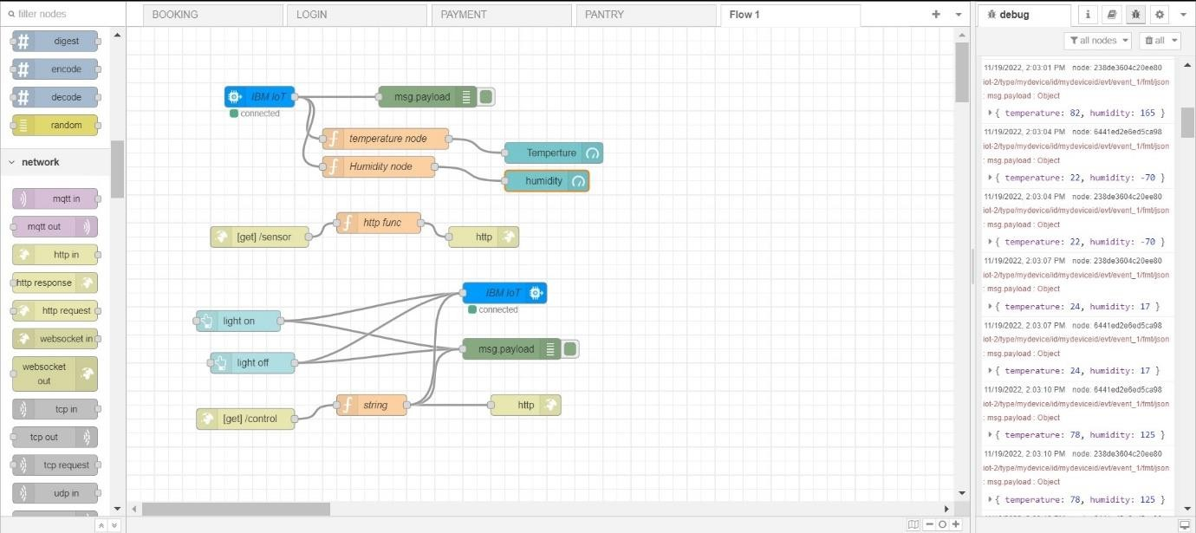

Testing the web UI by giving the required inputs

