**Assignment – 1**

1. Link: <https://us3.ca.analytics.ibm.com/bi/?perspective=explore&pathRef=.my_folders%2FMarketing%2BSpend%2Band%2BState%2Bfor%2BR%2526D%2BSpend%2Bcolored%2Bby%2BProfit&subView=model000001835e829fe5_00000004>

2.Link: <https://us3.ca.analytics.ibm.com/bi/?perspective=explore&pathRef=.my_folders%2FMarketing%2BSpend%2Band%2BState%2Bfor%2BR%2526D%2BSpend%2Bcolored%2Bby%2BProfit&subView=model000001835e8b83fc_00000003>

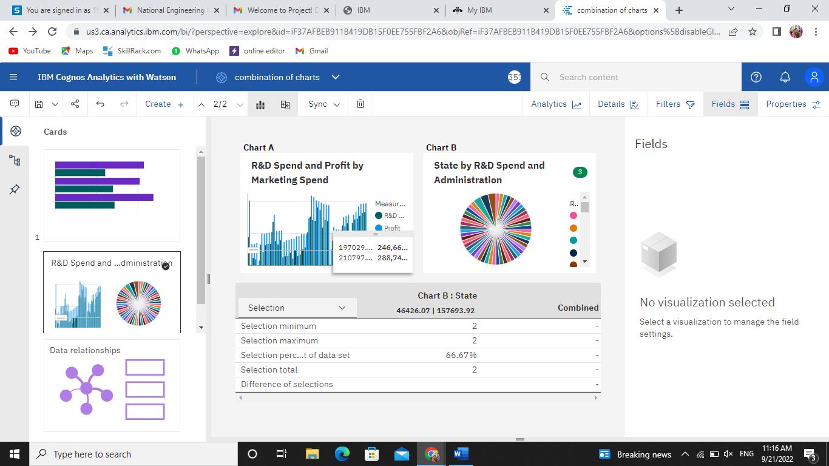

3.Link: <https://us3.ca.analytics.ibm.com/bi/?perspective=explore&pathRef=.my_folders%2FMarketing%2BSpend%2Band%2BState%2Bfor%2BR%2526D%2BSpend%2Bcolored%2Bby%2BProfit&subView=model000001835e95f329_00000000>

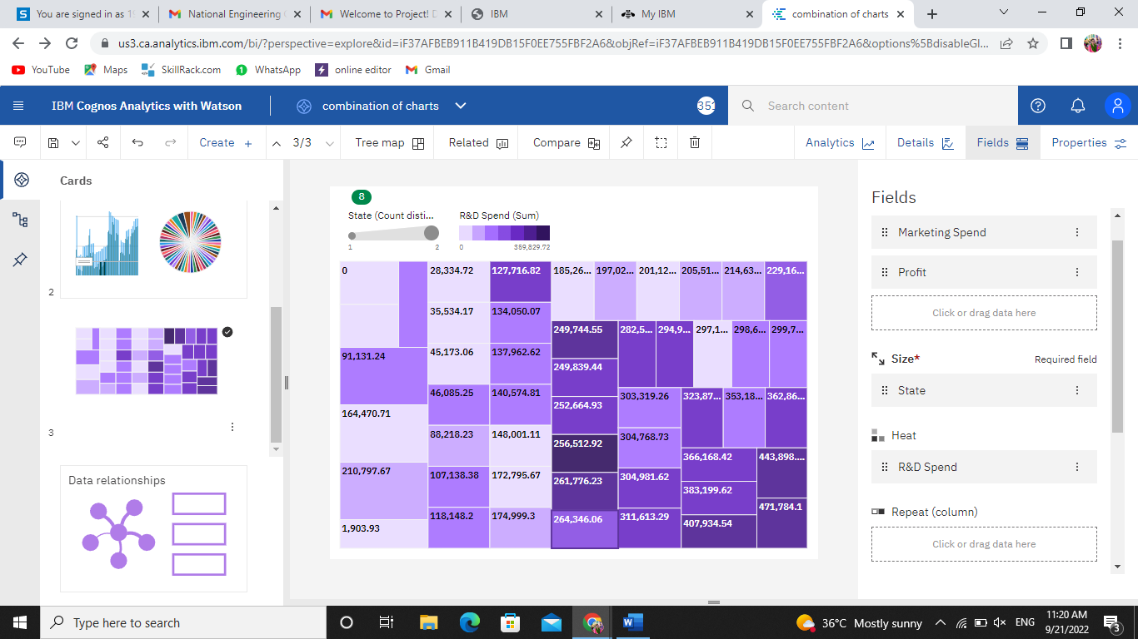

4.Link: <https://us3.ca.analytics.ibm.com/bi/?perspective=explore&pathRef=.my_folders%2FMarketing%2BSpend%2Band%2BState%2Bfor%2BR%2526D%2BSpend%2Bcolored%2Bby%2BProfit&subView=model000001835e9a5402_00000000>

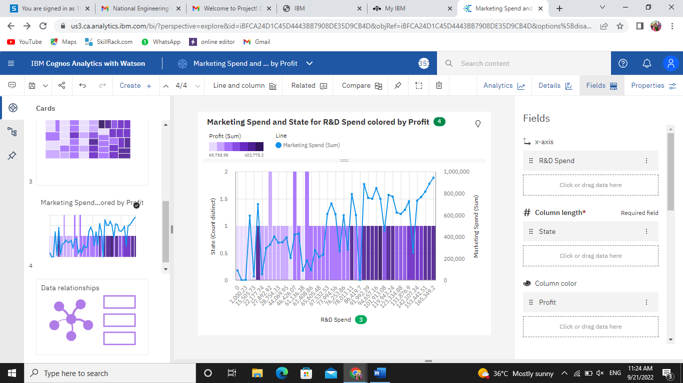

5.Link: <https://us3.ca.analytics.ibm.com/bi/?perspective=explore&pathRef=.my_folders%2FMarketing%2BSpend%2Bby%2BR%2526D%2BSpend%2Bcolored%2Bby%2BAdministration&subView=model000001835ea3de3e_00000004>

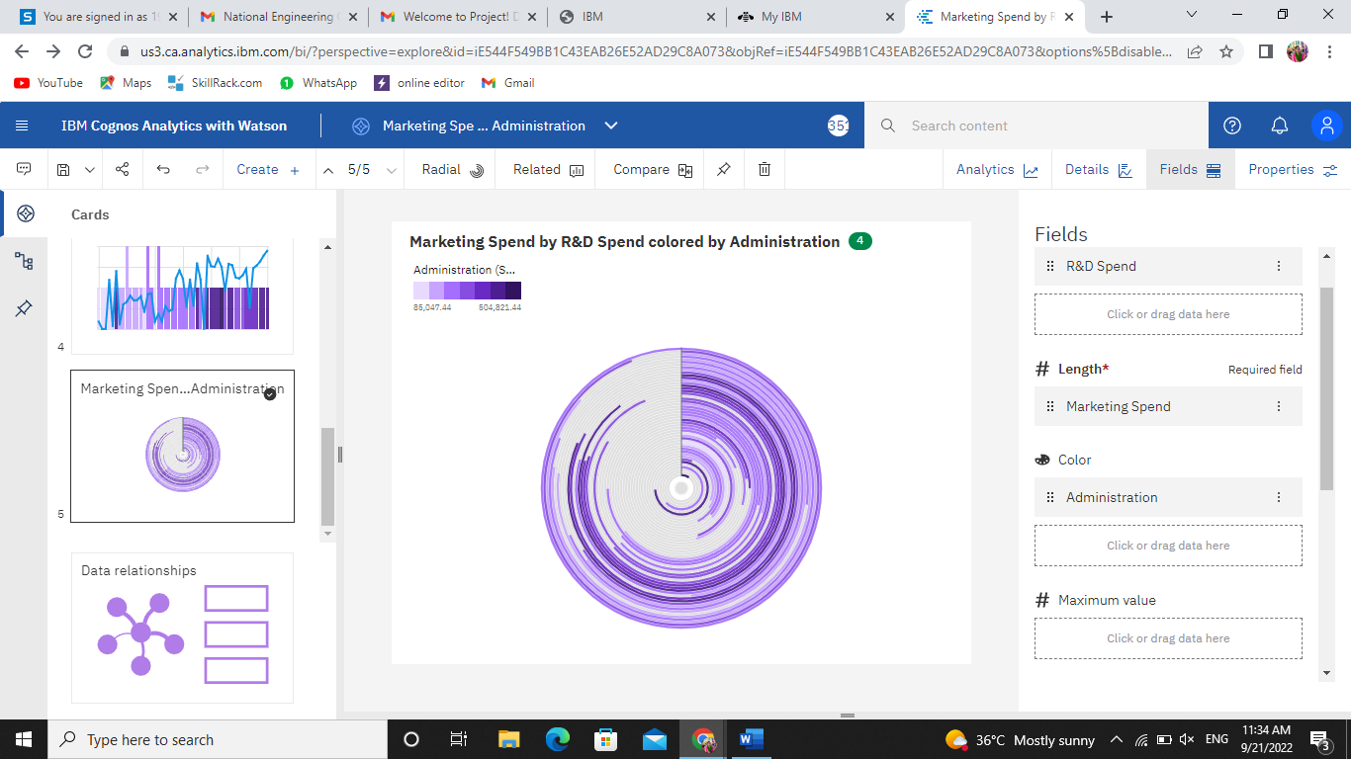

6. Link: <https://us3.ca.analytics.ibm.com/bi/?perspective=explore&pathRef=.my_folders%2FAdministration%2Band%2BState%2Bby%2BR%2526D%2BSpend%2Band%2BMarketing%2BSpend&subView=model000001835ea7828d_00000003>

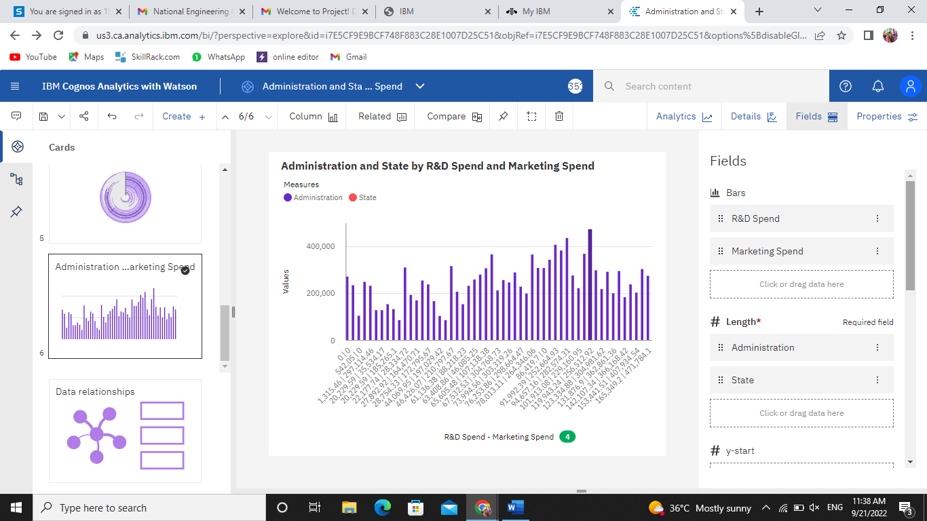

7.Link: <https://us3.ca.analytics.ibm.com/bi/?perspective=explore&pathRef=.my_folders%2FR%2526D%2BSpend%2Bcompared%2Bto%2BAdministration%2Bwith%2BMarketing%2BSpend%2Bminimum&subView=model000001835eaa8594_00000000>

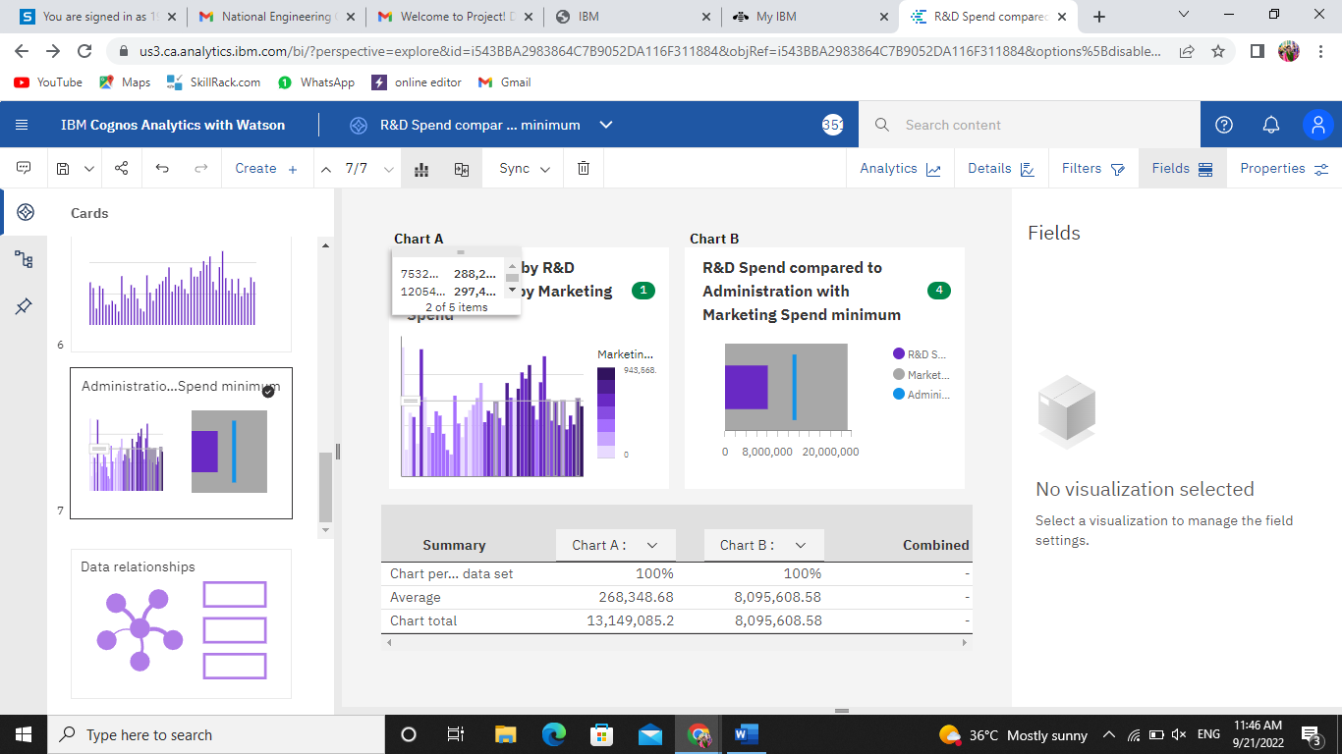

8.Link: <https://us3.ca.analytics.ibm.com/bi/?perspective=explore&pathRef=.my_folders%2FAdministration%2Bfor%2BR%2526D%2BSpend%2Band%2BMarketing%2BSpend&subView=model000001835eb274a0_00000004>

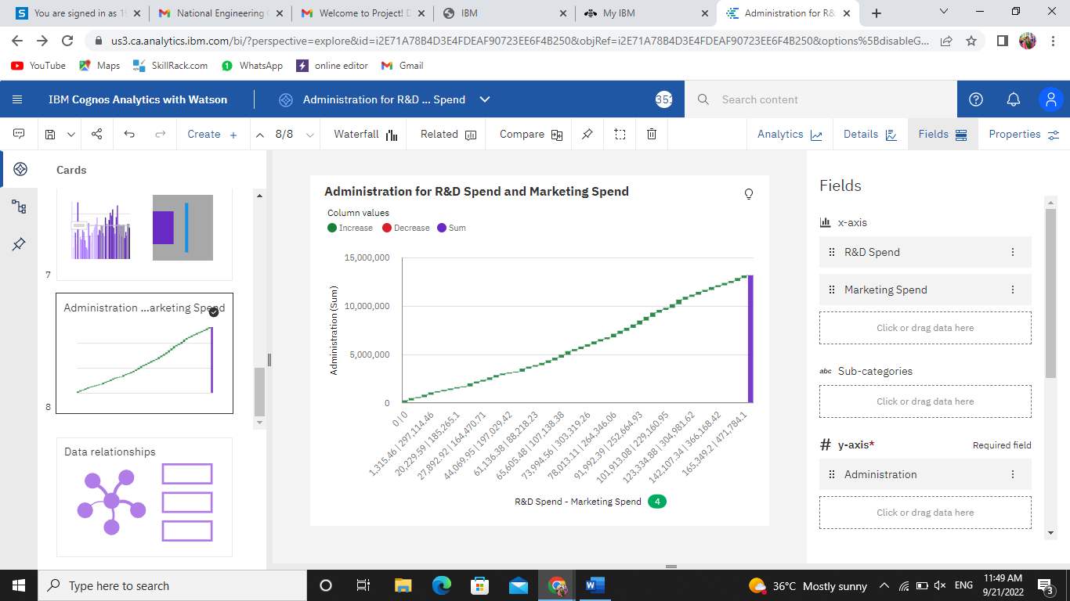

9.Link: <https://us3.ca.analytics.ibm.com/bi/?perspective=explore&pathRef=.my_folders%2FAdministration%2Bfor%2BR%2526D%2BSpend%2Band%2BMarketing%2BSpend&subView=model000001835eb53980_00000003>

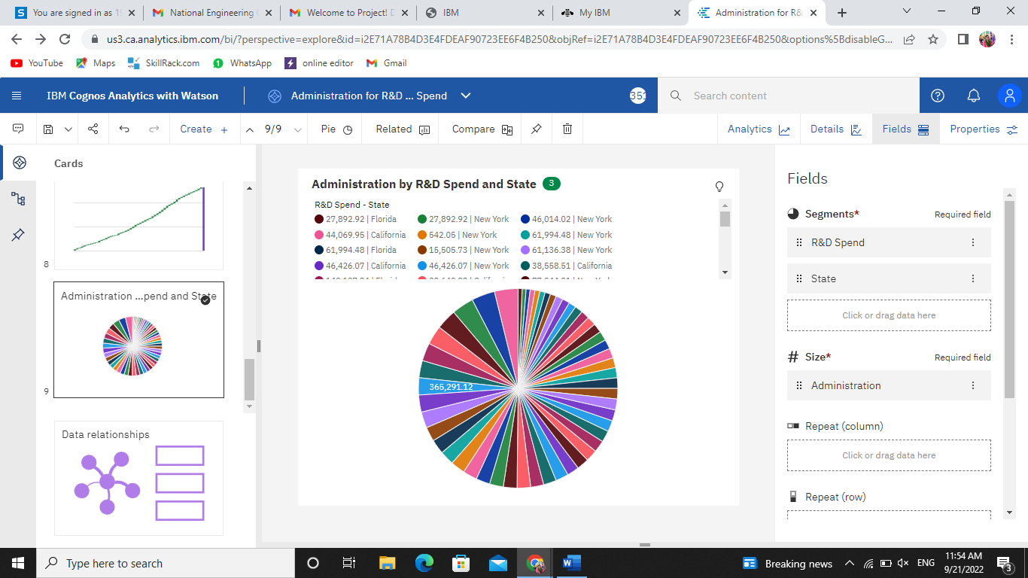

10.Link: <https://us3.ca.analytics.ibm.com/bi/?perspective=explore&pathRef=.my_folders%2FState%2Bto%2BR%2526D%2BSpend%2Bwith%2Bline%2Bwidth%2BAdministration&subView=model000001835eb9b7c3_00000002>

