**Pharma Sales Dashboard Assignment**

**Challenge**:- Upload the dataset to Cognos Analytics, prepare the data, explore and

Create Interactive Dashboard.

Task 1:Sales By Customer.

Task 2:Sales By Location.

Task 3:Sales By Sales Representative.

Task 4: Received Inventory From Supplier

Task 5: Inventory Stock for Warehouse Locations

Task 6: Sales Trend

Task 7:Monthly Sales

Task 8: Actual and Received Inventory by Month

**Dashboard:**

**Link:** <https://us3.ca.analytics.ibm.com/bi/?perspective=dashboard&pathRef=.my_folders%2Fdashboard&action=view&mode=dashboard&subView=model0000018378989704_00000002>

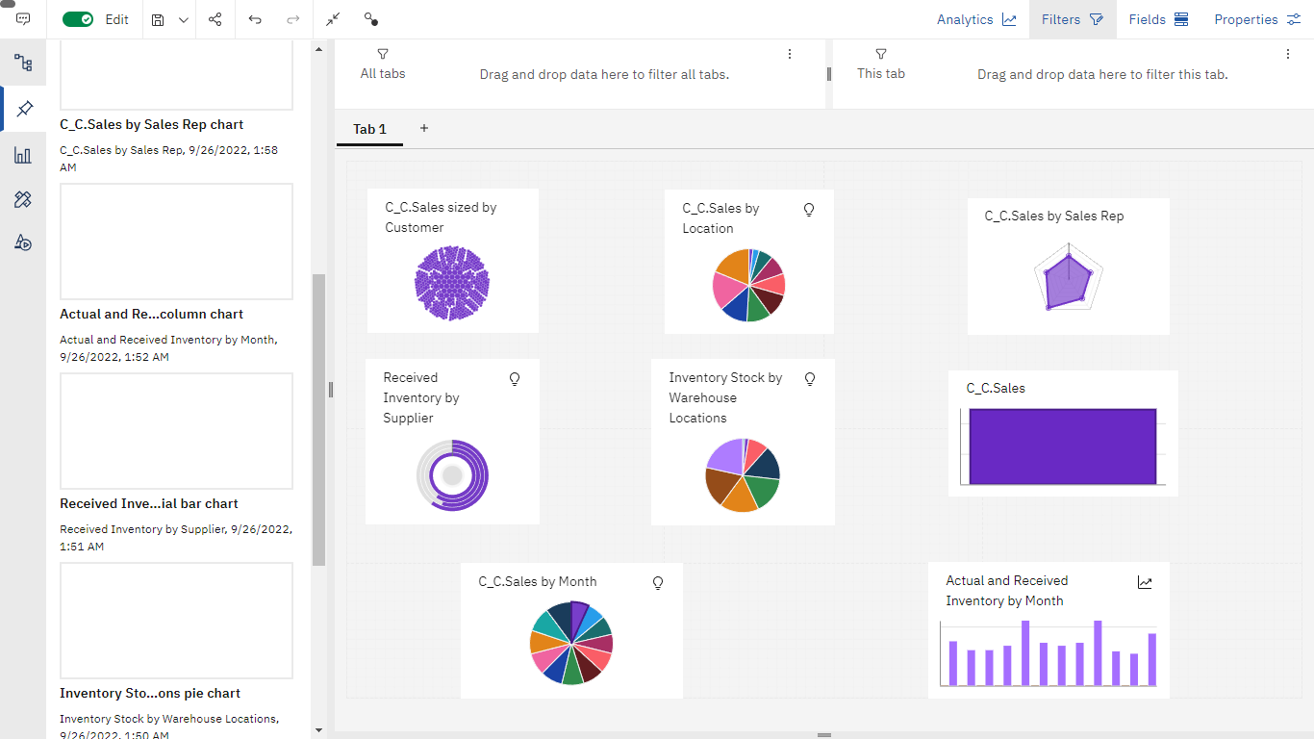

**1)Link:** <https://us3.ca.analytics.ibm.com/bi/?perspective=dashboard&pathRef=.my_folders%2FC_C.Sales%2Bsized%2Bby%2BCustomer&action=view&mode=dashboard&subView=model00000183783d2d6f_00000000>

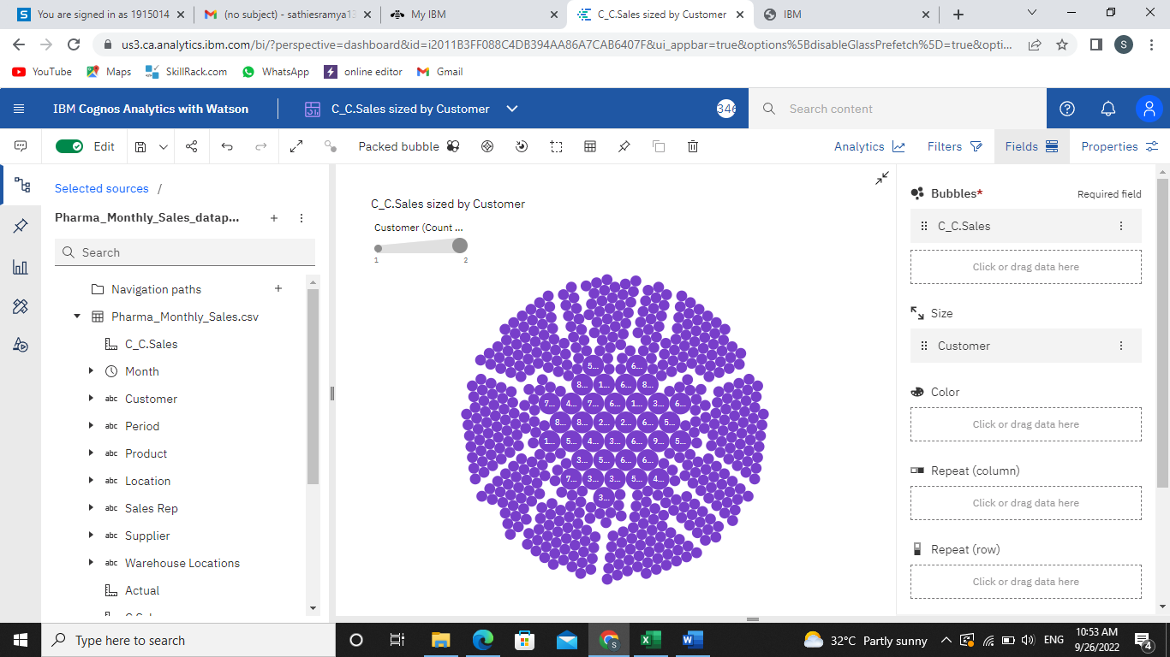

**2)Link:** <https://us3.ca.analytics.ibm.com/bi/?perspective=dashboard&pathRef=.my_folders%2FC_C.Sales%2Bby%2BLocation&action=view&mode=dashboard&subView=model0000018378423e0b_00000000>

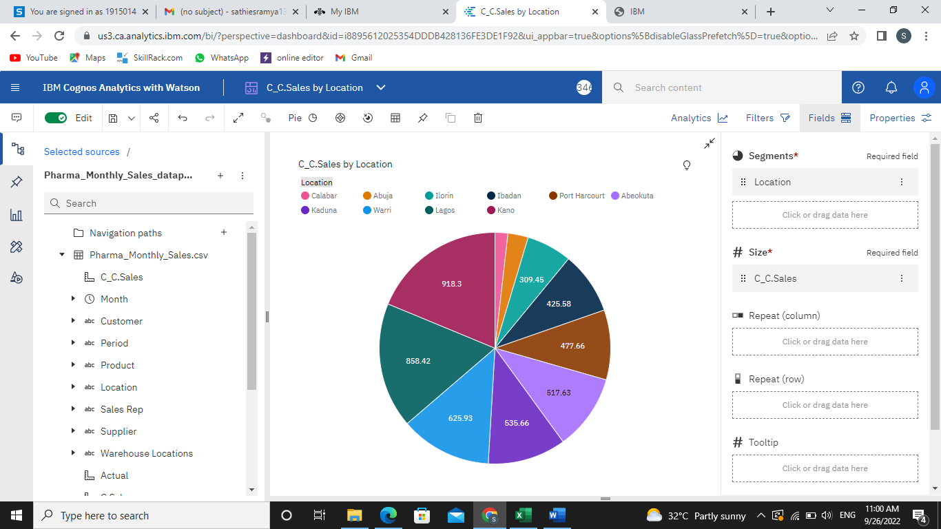

**3)Link:** <https://us3.ca.analytics.ibm.com/bi/?perspective=dashboard&pathRef=.my_folders%2FC_C.Sales%2Bby%2BSales%2BRep&action=view&mode=dashboard&subView=model000001837848d561_00000000>

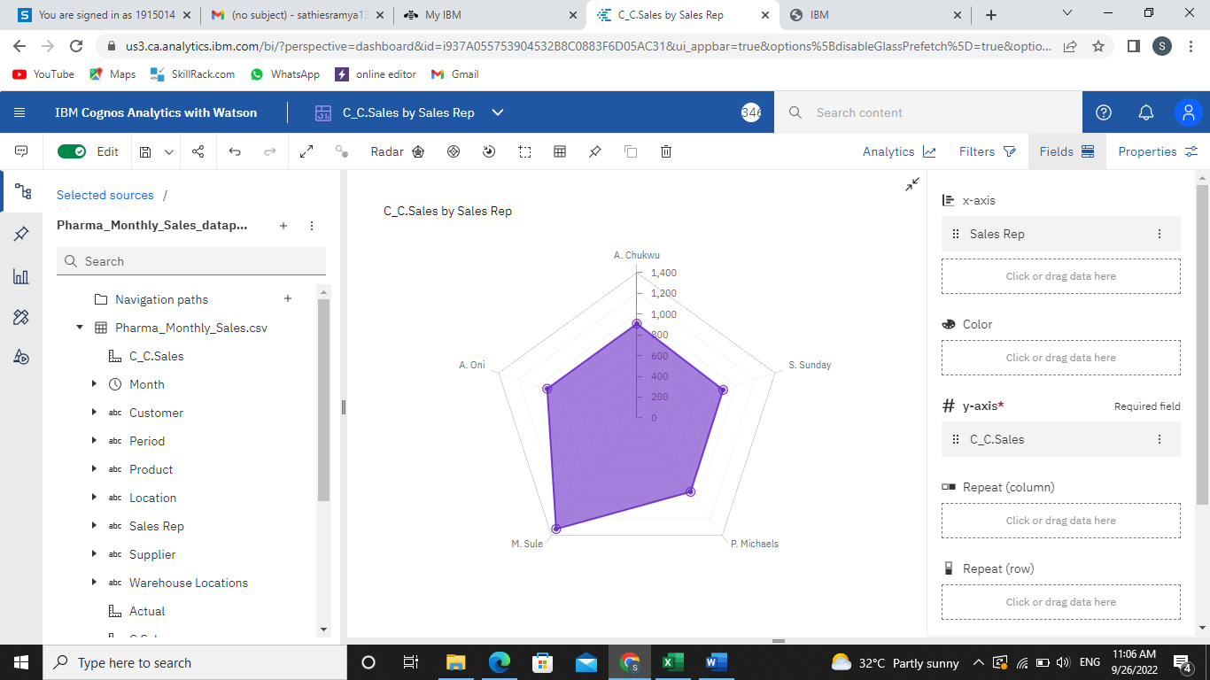

**4)Link:** <https://us3.ca.analytics.ibm.com/bi/?perspective=dashboard&pathRef=.my_folders%2FReceived%2BInventory%2Bby%2BSupplier&action=view&mode=dashboard&subView=model00000183781fb44a_00000001>

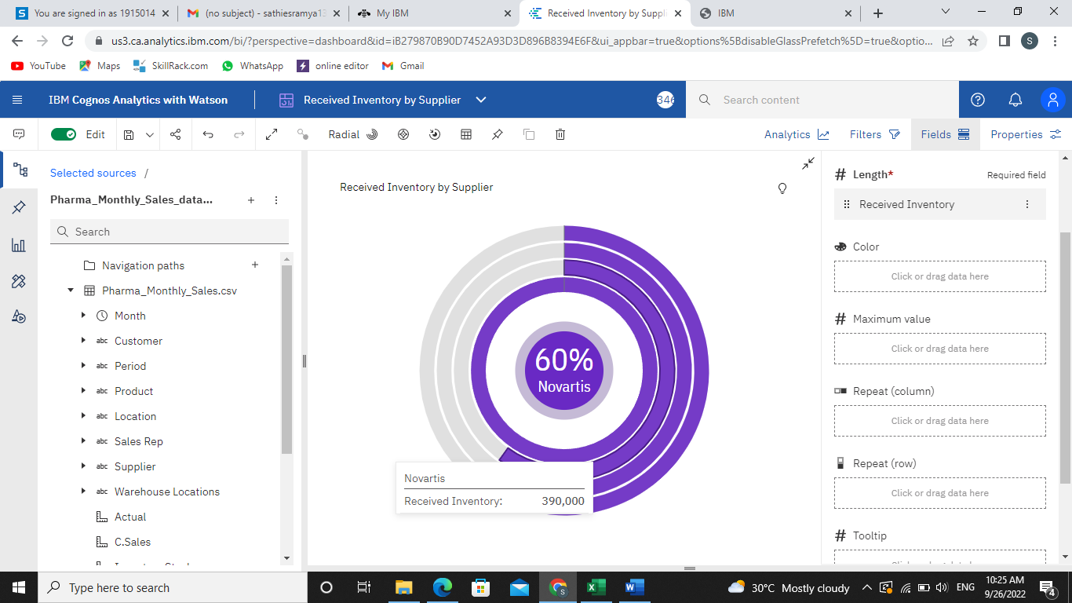

**5)Link:** <https://us3.ca.analytics.ibm.com/bi/?perspective=dashboard&pathRef=.my_folders%2FInventory%2BStock%2Bby%2BWarehouse%2BLocations&action=view&mode=dashboard&subView=model000001837814a2a8_00000000>

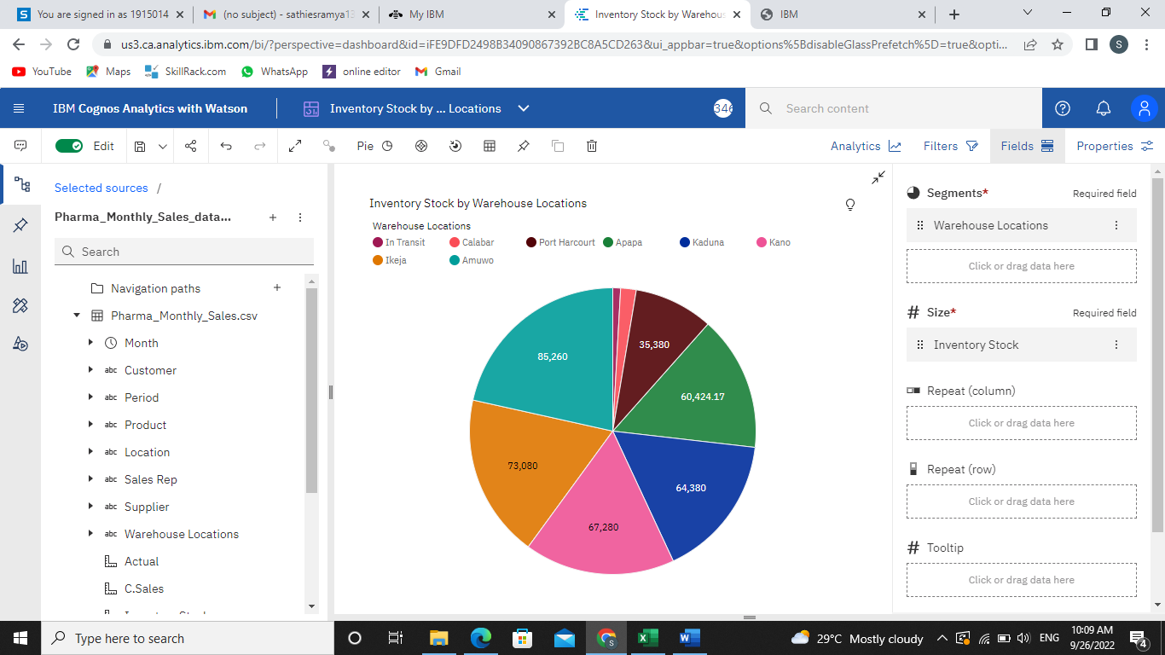

**6)Link:** <https://us3.ca.analytics.ibm.com/bi/?perspective=dashboard&pathRef=.my_folders%2FC_C.Sales%2Btrend&action=view&mode=dashboard&subView=model00000183786838a2_00000002>

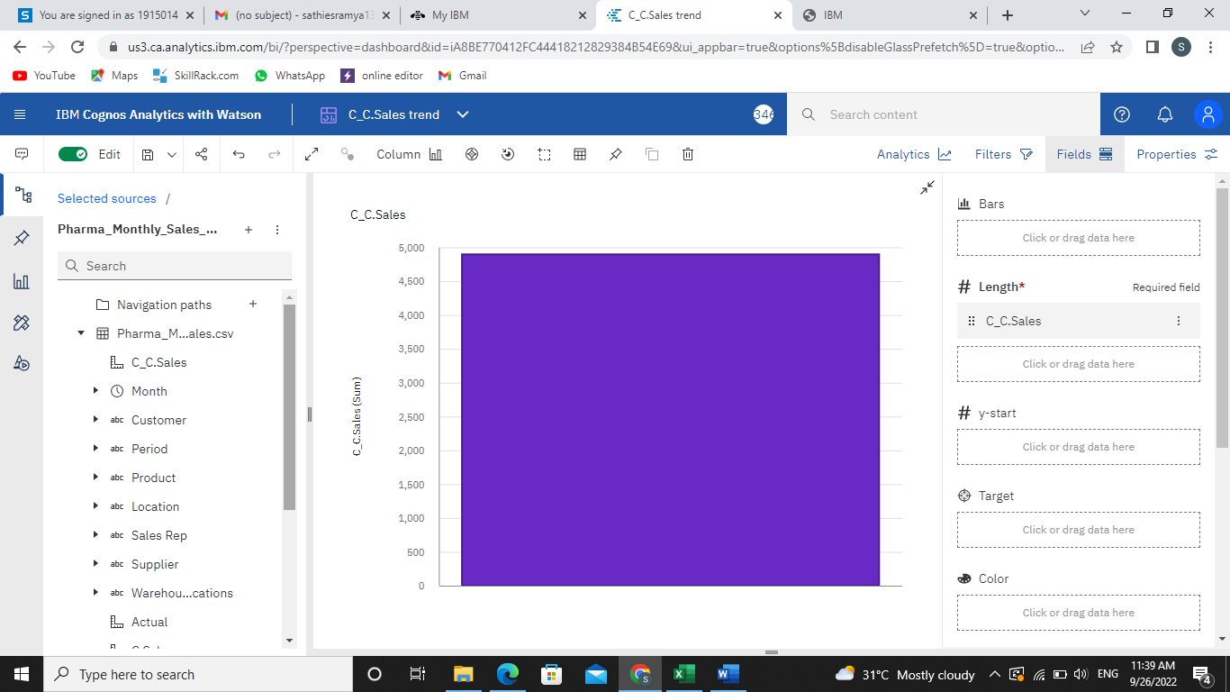

**7) Link:** <https://us3.ca.analytics.ibm.com/bi/?perspective=explore&pathRef=.my_folders%2FC_C.Sales%2Bby%2BMonth&subView=model000001837880c2a1_00000000>

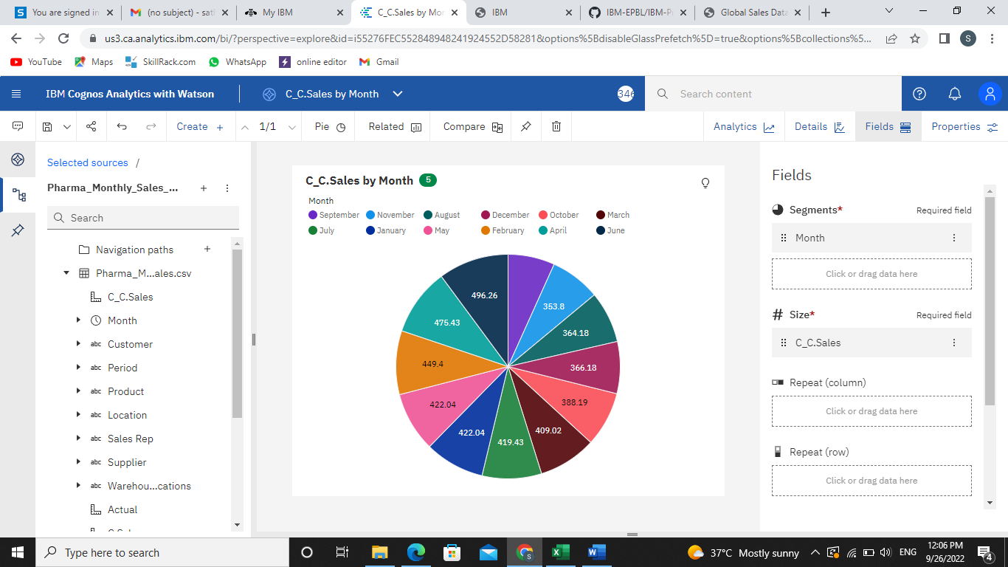

**8) Link:** <https://us3.ca.analytics.ibm.com/bi/?perspective=dashboard&pathRef=.my_folders%2FActual%2Band%2BReceived%2BInventory%2Bby%2BMonth&action=view&mode=dashboard&subView=model000001837829735c_00000002>

