|  |  |
| --- | --- |
| Date | 15 November 2022 |
| Team ID | PNT2022TMID19351 |
| Project Name | Natural disaster Intensity Analysis and Classification Using Artificial Intelligence |
| Maximum Mark | 2 marks |

**Prerequisites for Artificial Intelligence Hardware Specifications:**

* Windows (minimum 10), Mac & Linux
* Ram - 4GB ( minimum)
* Hard Disk - 100GB (minimum)
* Processor - Intel i3 (minimum), Mac M1 Software Specifications: ● Anaconda Navigator - <https://www.anaconda.com/products/distribution>● Jupyter notebook.
* Google Colab [- https://colab.research.google.com/](https://colab.research.google.com/) ● Spyder / VS Code / Pycharm IBM:
* IBM Account Creation - https://vimeo.com/742609168/1824d26a5b (Follow this video for IBM Skill Build Account Creation)
* IBM Skill Build - <https://www.ibm.com/academic/home>
* Webmail - https://sg2plmcpnl492529.prod.sin2.secureserver.net:2096/ ● IBM Cloud - https://cloud.ibm.com/login

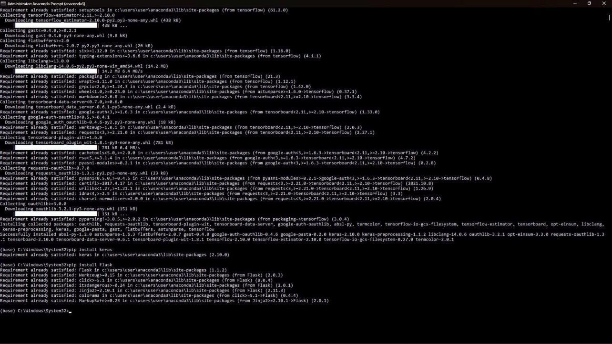

SUBMITTED BY

Pasupathikumar S (20IT502) Yaser Arabth S (19IT059)

Yuvaraj S (19IT060) Devaganeshvara C(20IT501)