2 .Build a python code,Assume you get a temperature and humidityvalues generated with random function to a variable and write a conditoin to detect alarm in case of high temperature

*ASSIGNMENT 2*

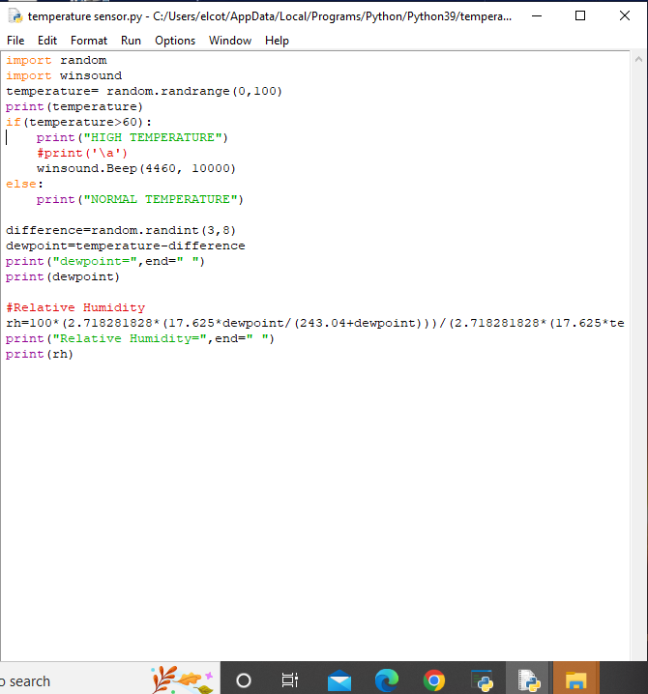

*Python code*

*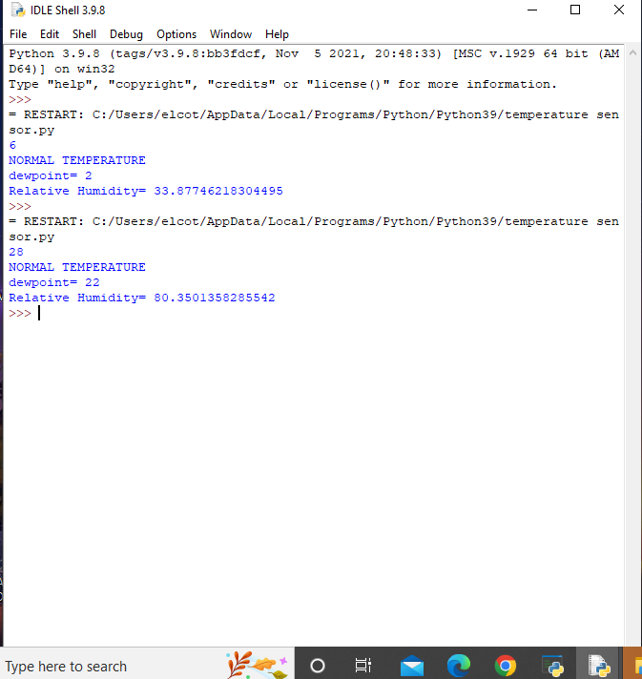*

*Output*

Drive link: https://docs.google.com/document/d/1Uco3Oe8PLtYgTNBViLWEqXnCb5ybw4vR/edit?usp=sharing&ouid=112269385202087262414&rtpof=true&sd=true