**ASSIGNMENT 1- SMART HOME**

**Circuit View**

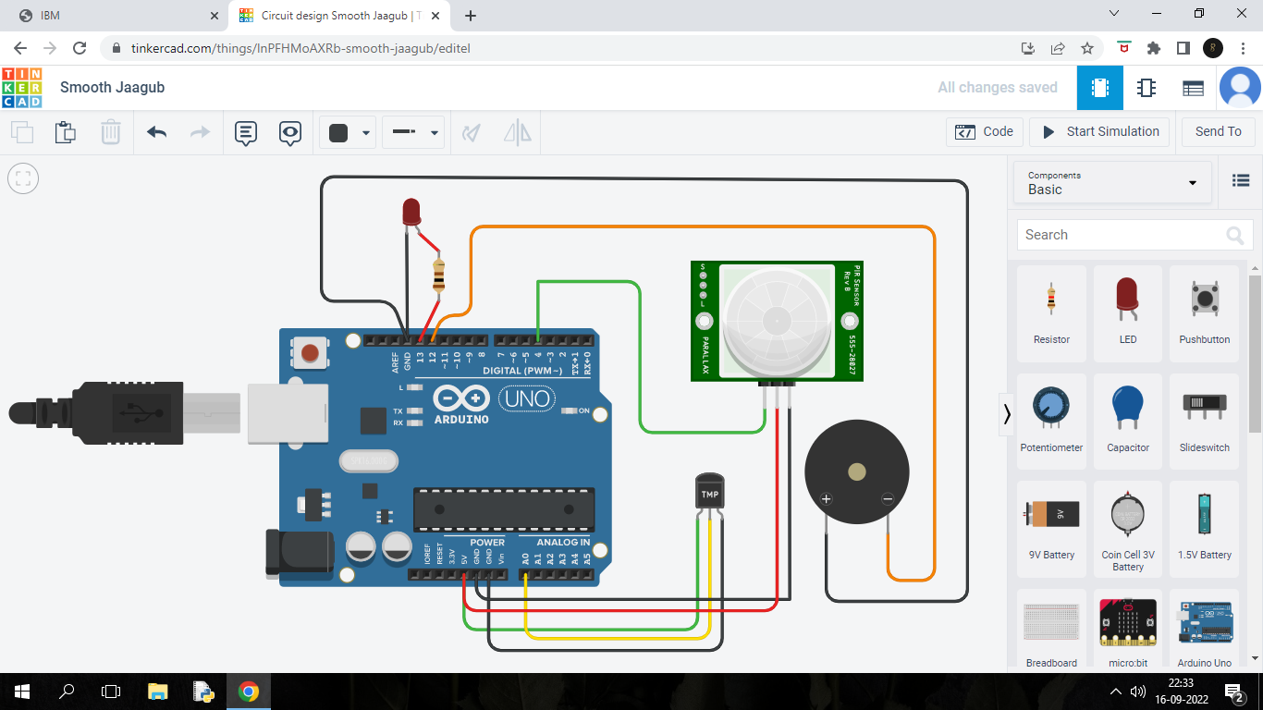

**Circuit Simulation Explanation**

In this circuit , I have used 2 sensors namely Temperature Sensor and the PIR Sensor. Execution of the circuit is follows.

When any movement is sensed through the PIR Sensor, the LED LIGHT Glows and the temperature sensor comes to an execution. I have programmed that , if the sensed movement temperature is above 37 degree Celsius , then the program delivers the temperature value and the message displays as “ HUMAN MOVEMENT IS FOUND!!!”, if the Celsius is below 37, the message displays as “SOME MOVEMENT IS FOUND!!!”. The Buzzer Sound responds only if the Human Movement is detected.

**PROGRAM EXECUTED**

//Smart Home//

//Human Detection and Movement Detection//

void setup()

{

Serial.begin(9600);

pinMode(4,INPUT);

pinMode(13,OUTPUT);

pinMode(12,OUTPUT);

}

void loop()

{

//PIR Sensor execution code//

int p=digitalRead(4);

Serial.println(p);

digitalWrite(13,LOW);

if(p)

{

double a= analogRead(A0);

double t=(((a/1024)*5)-0.5)*100;

Serial.print("Temperature Value");

Serial.println(t);

delay(1000);

//For Detecting the Human presence//

if (t>=37)

Serial.println("Human Movement is Found!!!");

if(t>=37)

tone(12,20);

delay(1000);

digitalWrite(13,HIGH);

//For any movement in the surrounding//

Serial.println("Some Movement is found!!!");

}

delay(1000);

}

**TINKERCAD LINK FOR THE ABOVE CIRCUIT IS GIVEN BELOW:**

https://www.tinkercad.com/things/lnPFHMoAXRb-smooth-jaagub

**S.PARAMESH**

961819106041

Ponjesly College of Engineering