**ASSIGNMENT-3**

**1.LED**

from machine import Pin

import utime

led=Pin(13,Pin.OUT)

while True:

  led.toggle()

  utime.sleep(1)

**OUTPUT:**

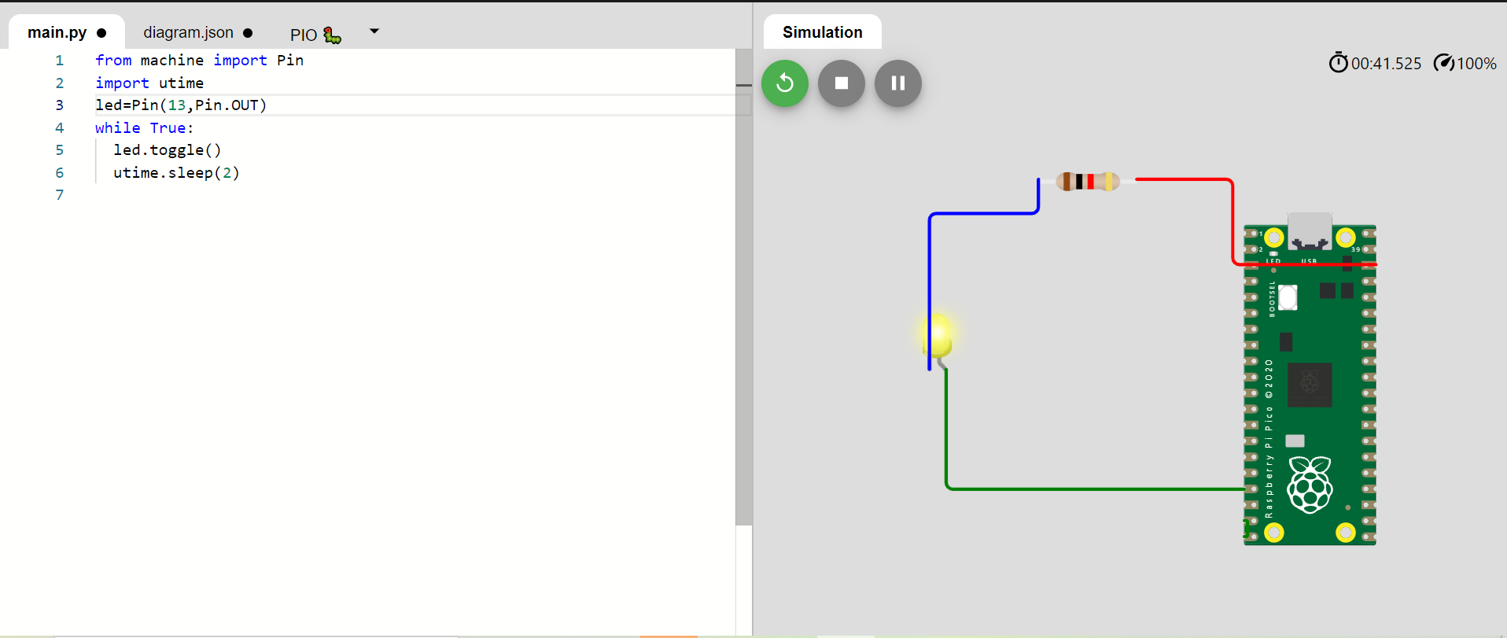

**2.LEB BLINKING:**

**Main.py**

from machine import Pin

import utime

led=Pin(9,Pin.OUT)

led1=Pin(15,Pin.OUT)

while True:

  led.toggle()

  utime.sleep(3)

  led.off()

  led1.toggle()

  utime.sleep(3)

  led1.off()

**OUTPUT:**

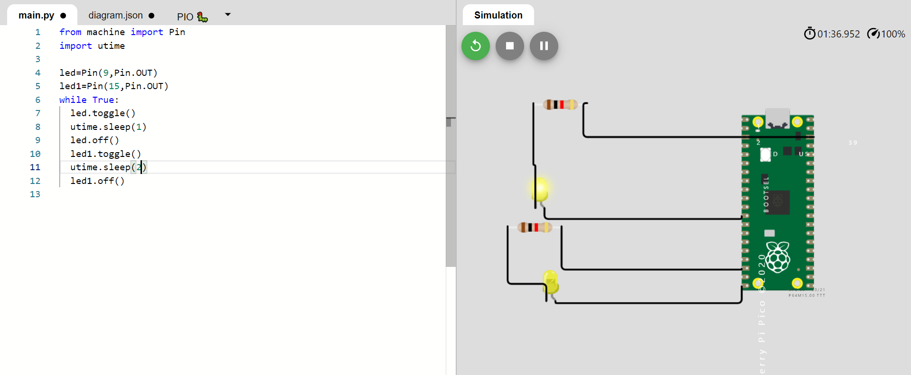

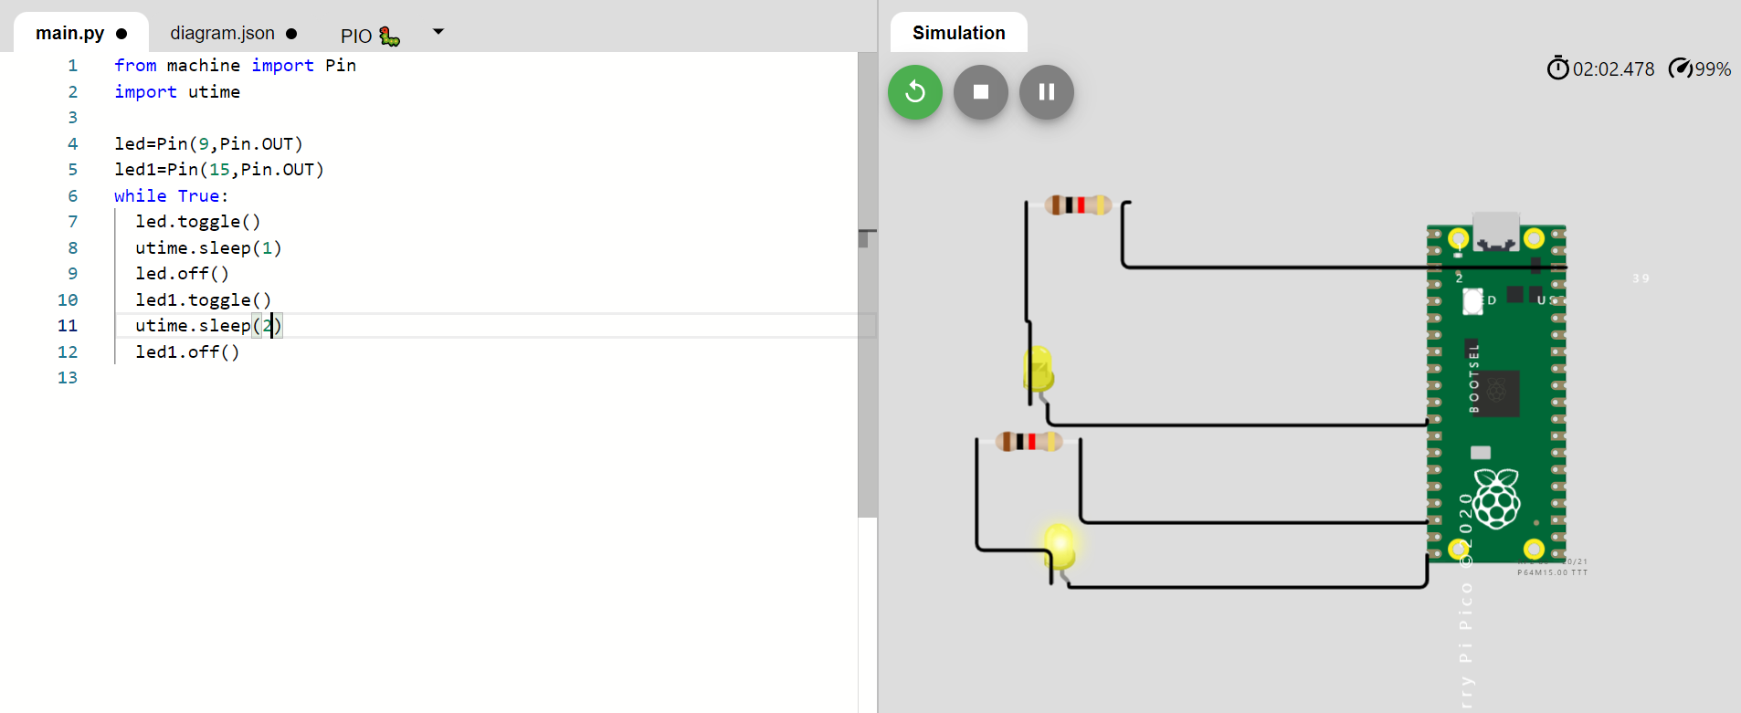**Traffic Light**

**Main.py:**

from machine import Pin

import utime

led=Pin(3,Pin.OUT)

led1=Pin(9,Pin.OUT)

led2=Pin(14,Pin.OUT)

while True:

  led.toggle()

  utime.sleep(3)

  led.off()

  led1.toggle()

  utime.sleep(3)

  led1.off()

  led2.toggle()

  utime.sleep(3)

  led1.off()

**diagram.json:**

{

  "version": 1,

  "author": "Kaneeshka Shanmugam",

  "editor": "wokwi",

  "parts": [

    {

      "type": "wokwi-pi-pico",

      "id": "pico",

      "top": 0,

      "left": 0,

      "attrs": { "env": "micropython-20220117-v1.18" }

    },

    {

      "type": "wokwi-led",

      "id": "led2",

      "top": 73.18,

      "left": -133.31,

      "attrs": { "color": "yellow" }

    },

    {

      "type": "wokwi-led",

      "id": "led3",

      "top": 143.51,

      "left": -134.98,

      "attrs": { "color": "limegreen" }

    },

    {

      "type": "wokwi-resistor",

      "id": "r1",

      "top": -24.49,

      "left": -129.65,

      "attrs": { "value": "1000" }

    },

    {

      "type": "wokwi-resistor",

      "id": "r2",

      "top": 57.85,

      "left": -139.98,

      "attrs": { "value": "1000" }

    },

    {

      "type": "wokwi-resistor",

      "id": "r3",

      "top": 126.18,

      "left": -145.65,

      "attrs": { "value": "1000" }

    },

    {

      "type": "wokwi-led",

      "id": "led1",

      "top": 4.18,

      "left": -126.98,

      "attrs": { "color": "red" }

    }

  ],

  "connections": [

    [ "undefined:undefined", "undefined:undefined", null, null ],

    [ "undefined:undefined", "undefined:undefined", null, null ],

    [ "led1:A", "pico:GP3", "green", [ "v4.4", "h105" ] ],

    [ "undefined:undefined", "undefined:undefined", null, null ],

    [ "undefined:undefined", "undefined:undefined", null, null ],

    [ "led2:A", "pico:GP9", "green", [ "v2.73", "h108" ] ],

    [ "undefined:undefined", "undefined:undefined", null, null ],

    [ "undefined:undefined", "undefined:undefined", null, null ],

    [ "led3:A", "pico:GP14", "green", [ "v-0.26", "h111" ] ]

  ]

}

**OUTPUT:**



