**CIRCUIT**

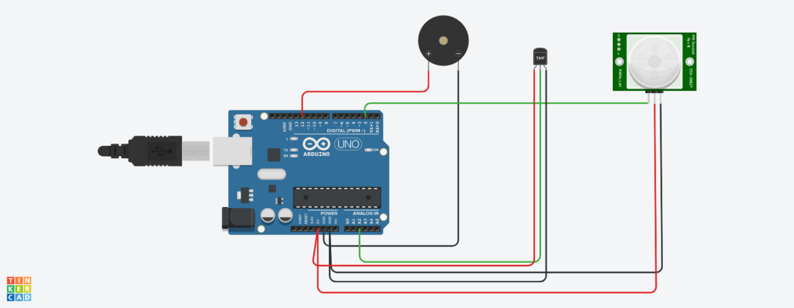

CODE:

void setup()

{

Serial.begin(9600);

pinMode(2,INPUT);

pinMode(12,OUTPUT);

}

void loop()

{

int motion=digitalRead(2);

if(motion==1)

{

Serial.println("Motion is detected !");

tone(12,10);

delay(1000);

noTone(12);

delay(3000);

}

else

{

Serial.println("No Motion !!!");

delay(1000);

}

double data=analogRead(A2);

double n=data/1024;

double voltage=n*5;

double offsetvol=voltage-0.5;

double temp=offsetvol*100;

if(temp>60)

{

Serial.println("Temperature is greater than 60 degrees !");

Serial.println(temp);

tone(12,100);

delay(1000);

noTone(12);

delay(3000);

}

else

{

Serial.println("Temperature is less than 60 degrees !!!");

Serial.println(temp);

delay(1000);

}

}

SIMULATION

