**Assignment -1**

Tinkercad Task

|  |  |
| --- | --- |
| Assignment Date | 20 September 2022 |
| Student Name | Shaik Kamiloon |
| Student Roll Number | 111519106141 |
| Maximum Marks | 2 Marks |

**Question-1:**

Build a smart home in Thinkercad with 2 sensors, an Led, buzzer and submit it.

|  |
| --- |
| **Solution:** |
|  |
|  |
|  |
|  |
|  |
|  |
|  |
|  | void setup()  {  Serial.begin(9600);  pinMode(2, INPUT);  pinMode(12, OUTPUT);  }  void loop()  {  int motion=digitalRead(2);  double temperature=analogRead(A2);  double detectedtemp=(((temperature/1024)*5)-0.5)*100;  if(motion==1)  {  tone(12,400);  delay(1000);  noTone(12);  delay(1000);  }  if(detectedtemp>60.00)  {  tone(12,300);  delay(1000);  noTone(12);  delay(1000);  }  } |
|  |  |

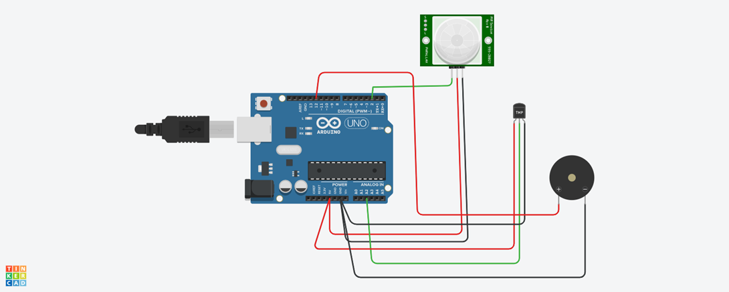

**Demo Link:**

You can follow this link to tinker the mentioned project

IBM Assignment - Temperature and PIR Sensor Project[**https://www.tinkercad.com/things/6JYWYptqIsY?sharecode=IPwBShWYZTTDAjiW3u-qDW5bzebwqtXcEUz7Lufn6xM**](https://www.tinkercad.com/things/6JYWYptqIsY?sharecode=IPwBShWYZTTDAjiW3u-qDW5bzebwqtXcEUz7Lufn6xM)