**Circuit Design using Piezo Alarm for Detection of Rise in Temperature using Temperature Sensor and Motion Detection using PIR Sensor**

**Features:**

* Alarm buzzes when temperature is detected above 60 deg C.
* Alarm buzzes another sound if motion is detected.

**Circuit Diagram:**

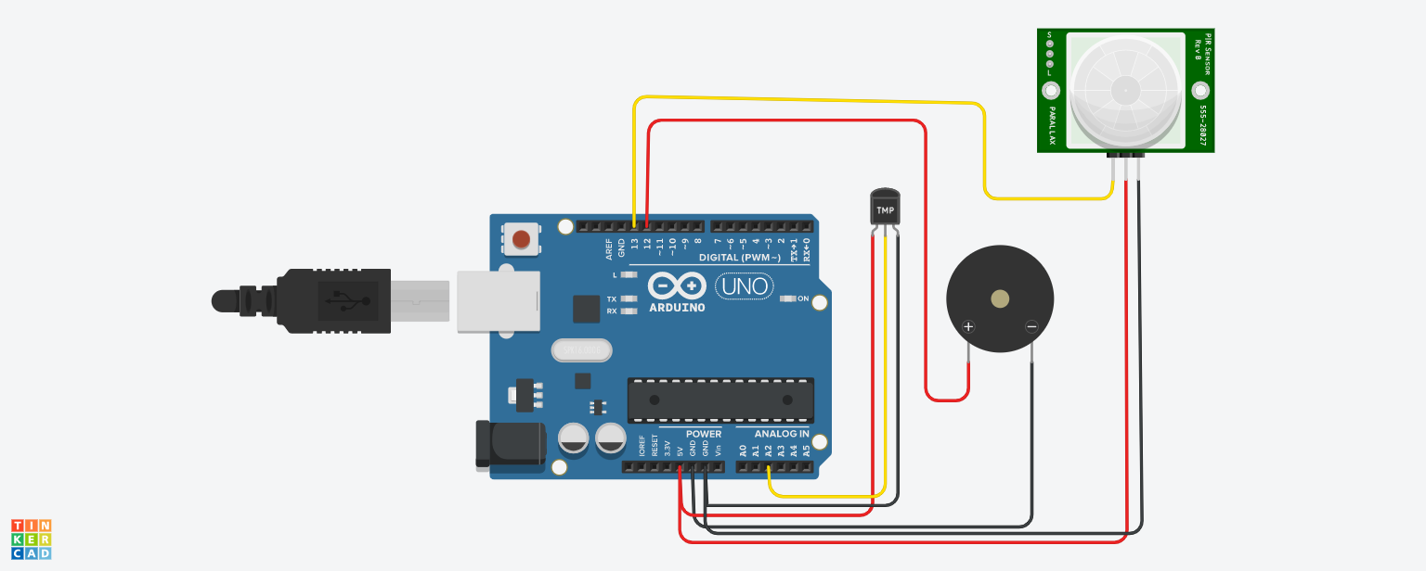

**Program:**

void setup()

{

Serial.begin(9600);

pinMode(13,INPUT);

pinMode(12,OUTPUT);

}

void loop()

{

double data=analogRead(A2);

double n=data/1024;

double volt=n*5;

double off=volt-0.5;

double temperature=off*100;

int motion=digitalRead(13);

for(int freq=49;freq<=50;freq++)

{

if(temperature>=60)

{

Serial.println("Temperature is above 60");

tone(12,freq);

delay(100);

}

else

{

Serial.println("Temperature is below 60");

noTone(12);

}

}

for(int freq=9;freq<=10;freq++)

{

if(motion==1)

{

Serial.println("Motion Detected");

tone(12,freq);

delay(200);

}

else

{

Serial.println(" No Motion");

noTone(12);

}

}

}

Outputs:

Initial Condition

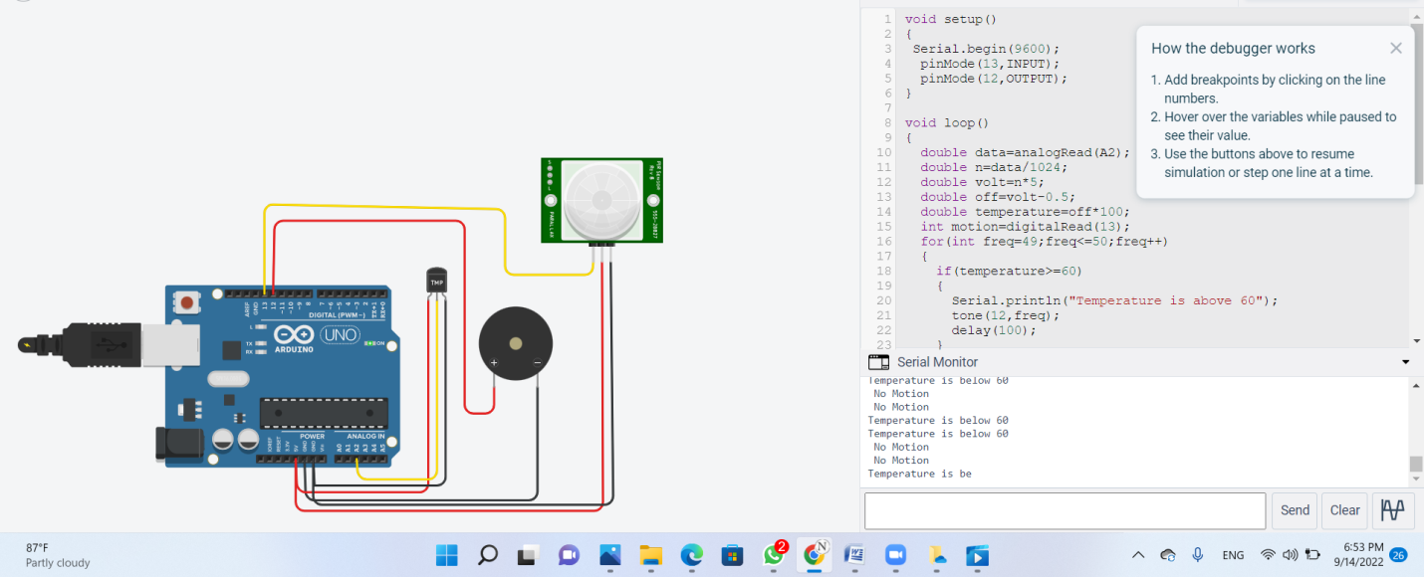

When Temperature is above 60 C

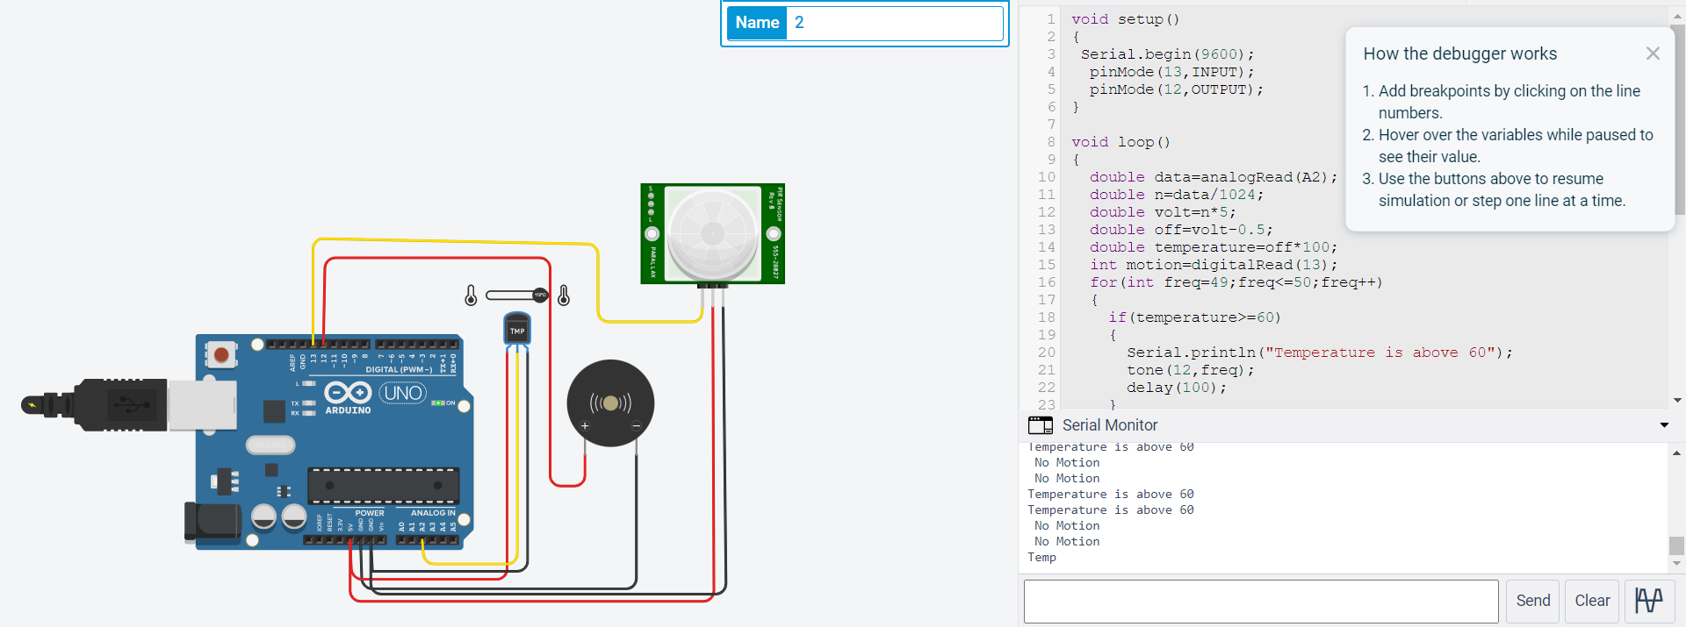

When Motion Detected

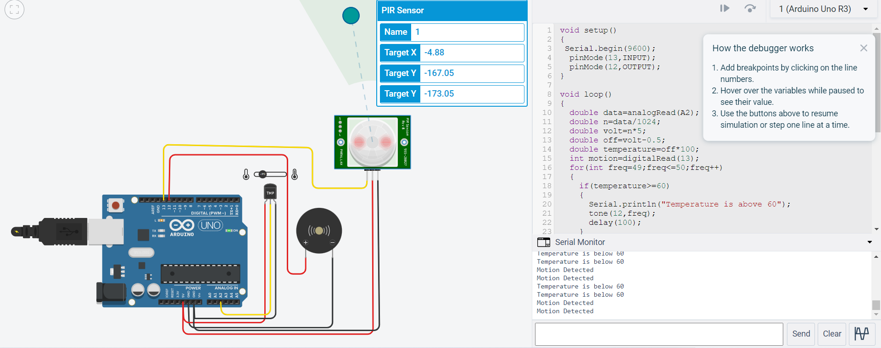

Video Link:

https://drive.google.com/file/d/1M1JwK8mYMdD1W5ztWIc3Sm5bB-8nSp-6/view?usp=sharing