Build a python code by assuming temperature and humidity values using random function. And write a condition to continuously buzz an alarm in case of high temperature.

Demolink:

https://drive.google.com/file/d/1jzBf4iU4DTOMhE5diqJ6yWbExlFGu6_F/view?usp=sharing

Program:

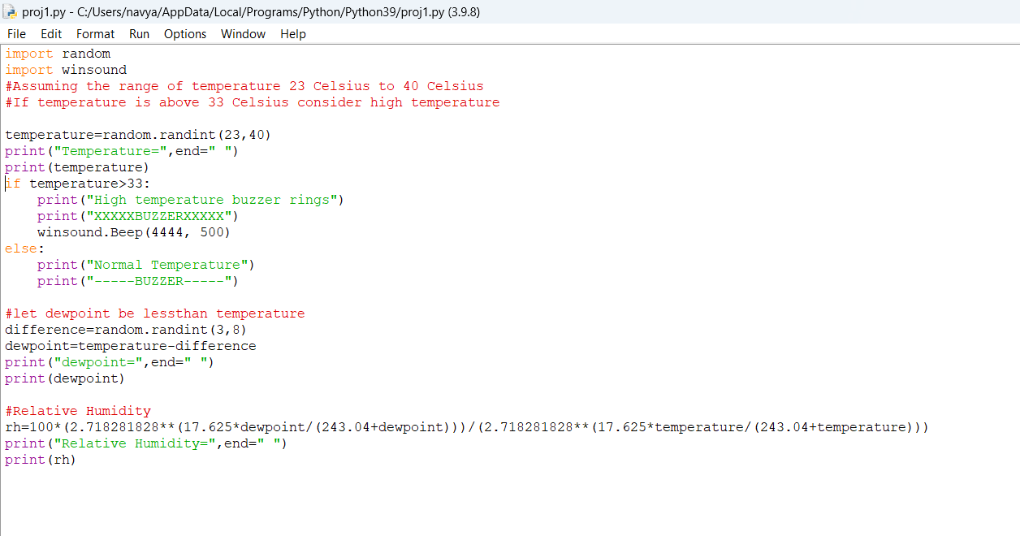

Output:

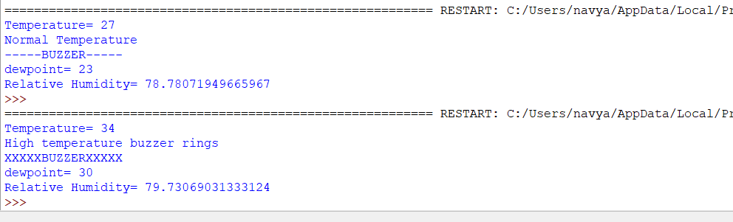

Navyasree Siram(111519106102)