|  |  |
| --- | --- |
| ASSIGNMENTDATE | 22-SEP-2022 |
| STUDENTNAME | NAVYASREE SIRAM |
| STUDENTROLLNUMBER | 111519106102 |
| MAXIMUMMARK | 2MARK |

**Question:**

**Build a python code by assuming temperature and humidity values using random function. And write a condition to continuously buzz an alarm in case of high temperature.**

Demolink:

https://drive.google.com/file/d/1jzBf4iU4DTOMhE5diqJ6yWbExlFGu6_F/view?usp=sharing

Program:

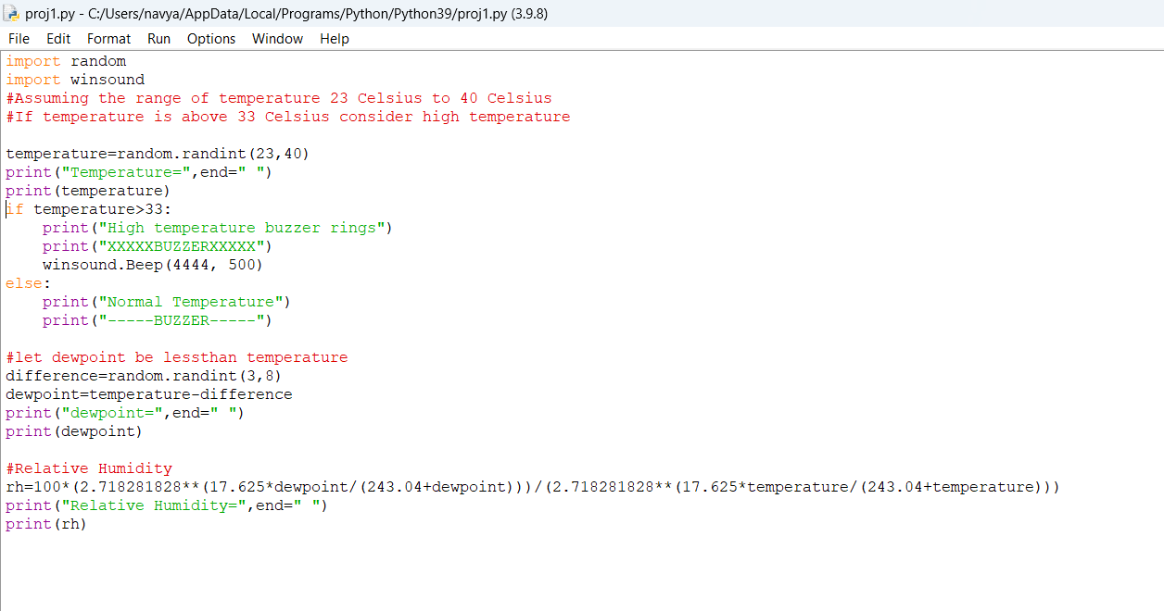

Output:

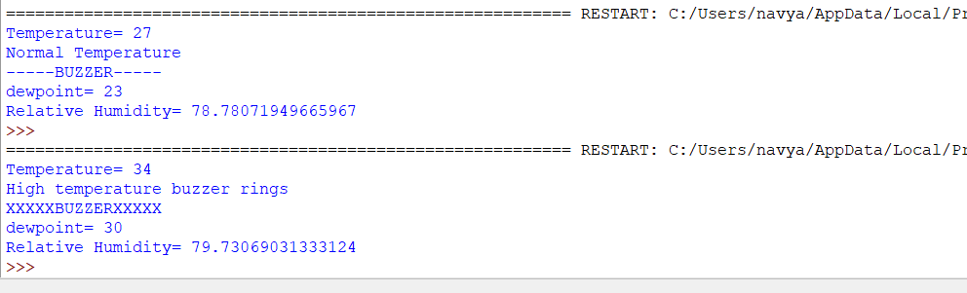

Navyasree Siram(111519106102)