PROJECT DEVELOPMENT PHASE SPRINT-3

|  |  |
| --- | --- |
| Date | 21 November 2022 |
| Team ID | PNT2022TMID15090 |
| Project Name | Hazardous Area Monitoring for Industrial Plant powered by IOT |

**Code:**

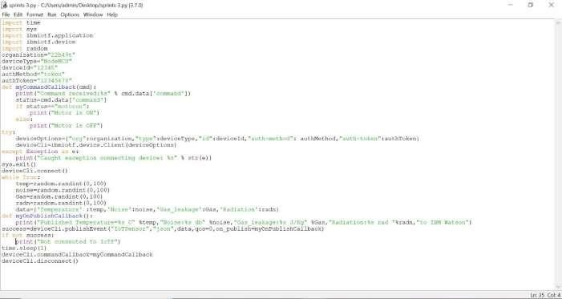

**Output:**

