ASSIGNMENT 1

EXPLORATION

Explore Data Relationships - Profit

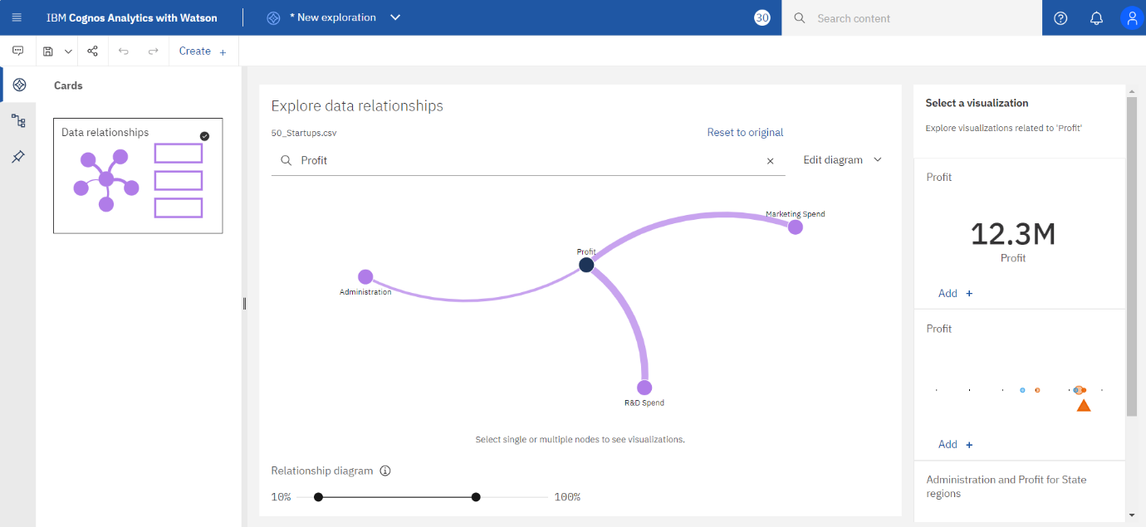

Explore Data Relationships – Marketing Spend

Explore Data Relationships – Administration

Explore Data Relationships – R & D Spend

Visualization – Bar Chart

Visualization – Pie Chart

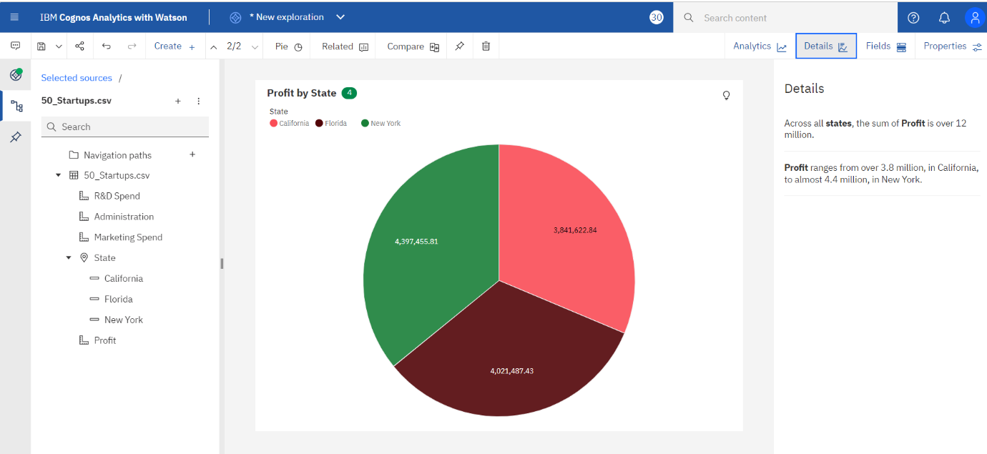

Visualization – Line

Visualization – CrossTab

