ASSIGNMENT 1

EXPLORATION

Explore Data Relationships - Profit

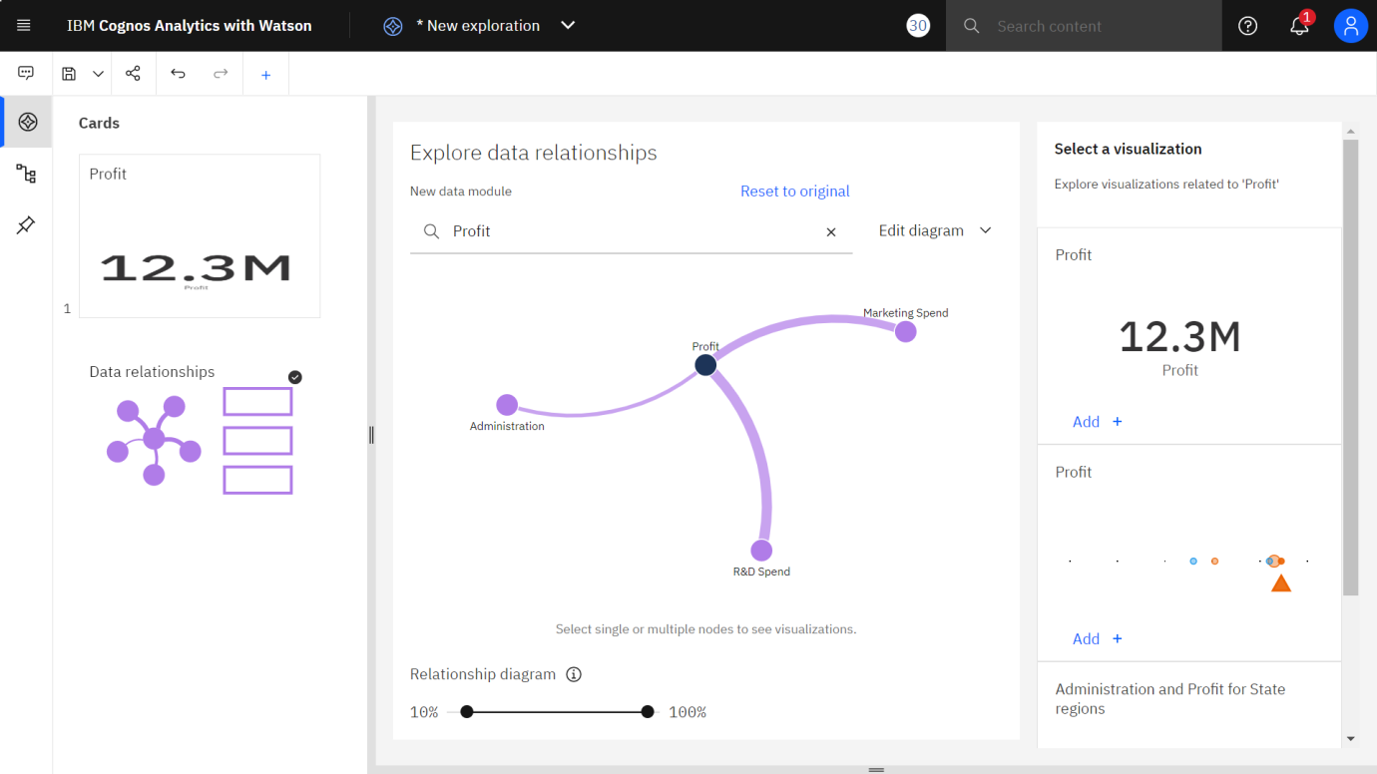

Explore Data Relationships – Marketing Spend

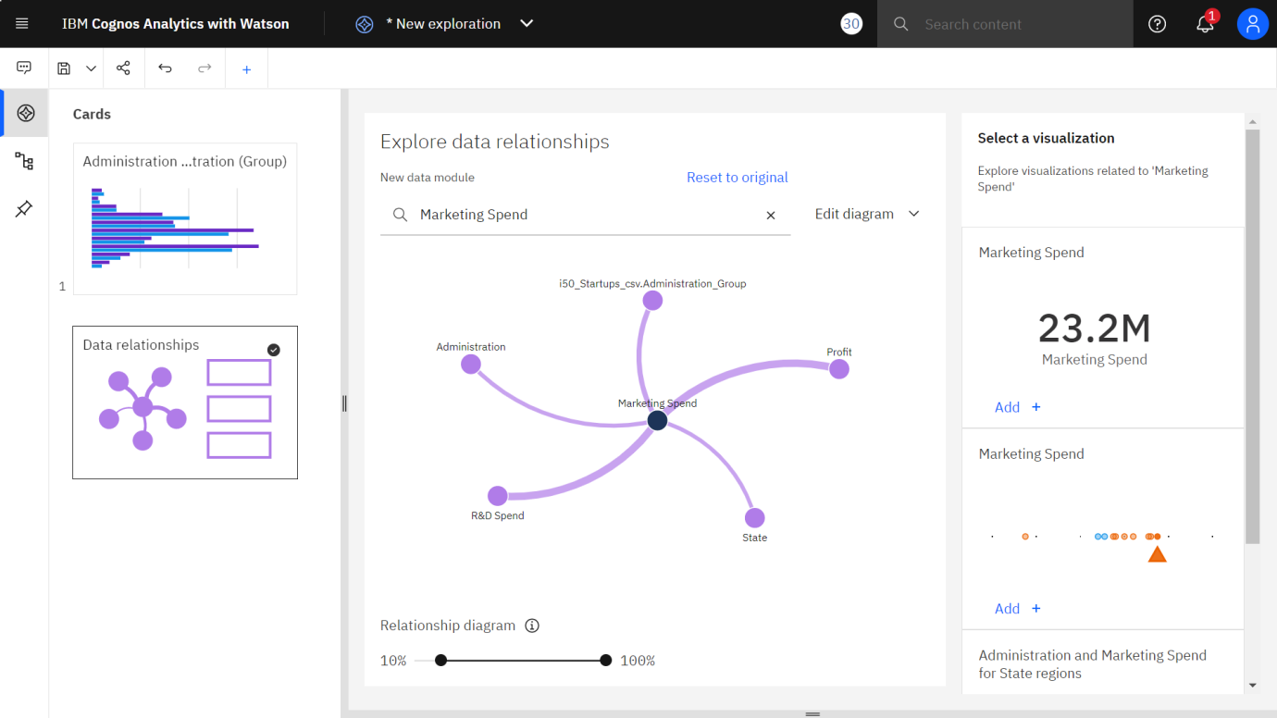

Explore Data Relationships – Administration

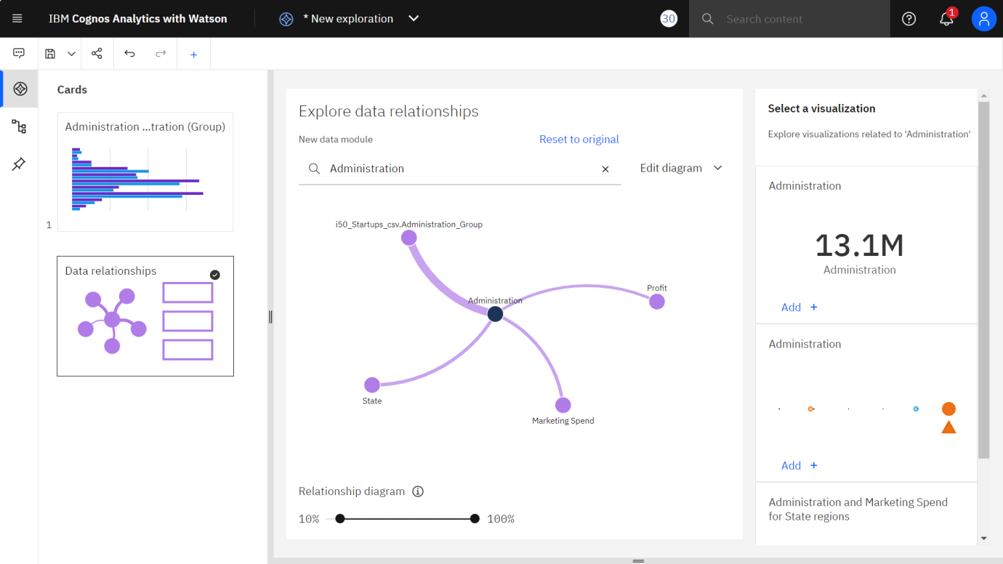

Explore Data Relationships – R & D Spend

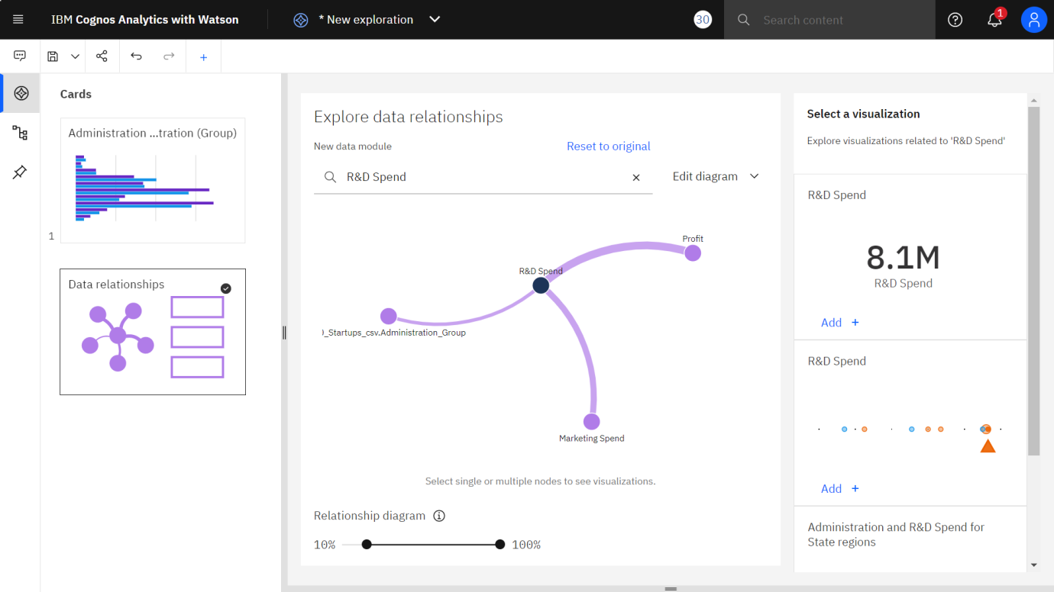

Visualization – Bar Chart

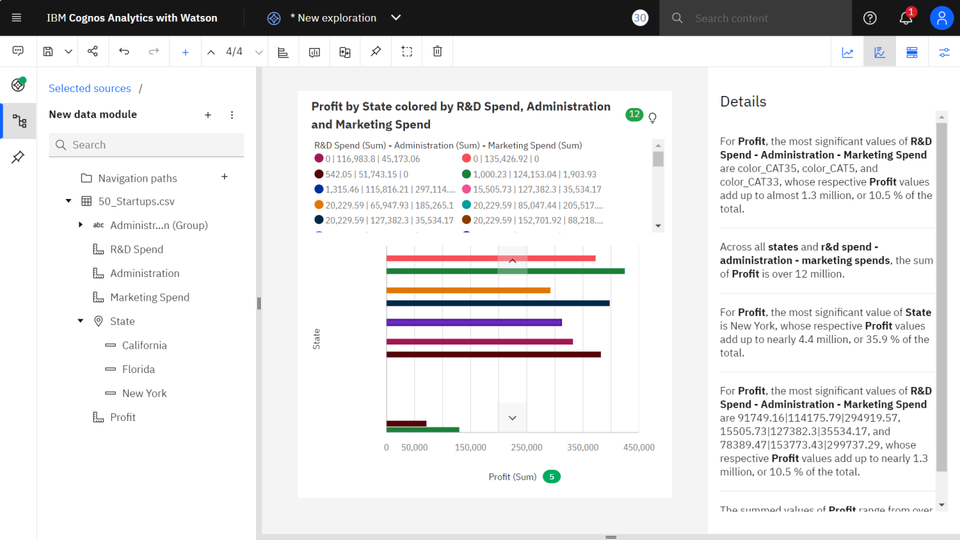

Visualization – Pie Chart

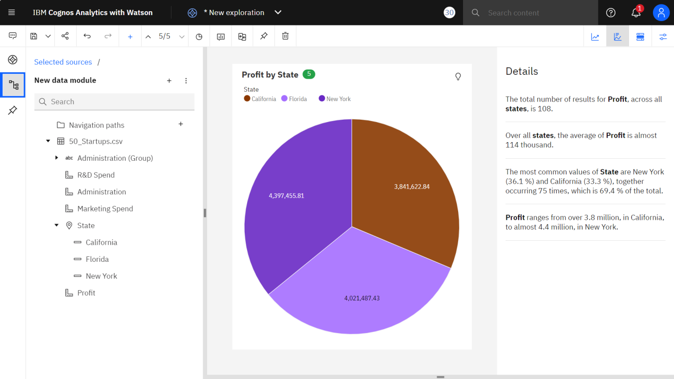

Visualization – Line

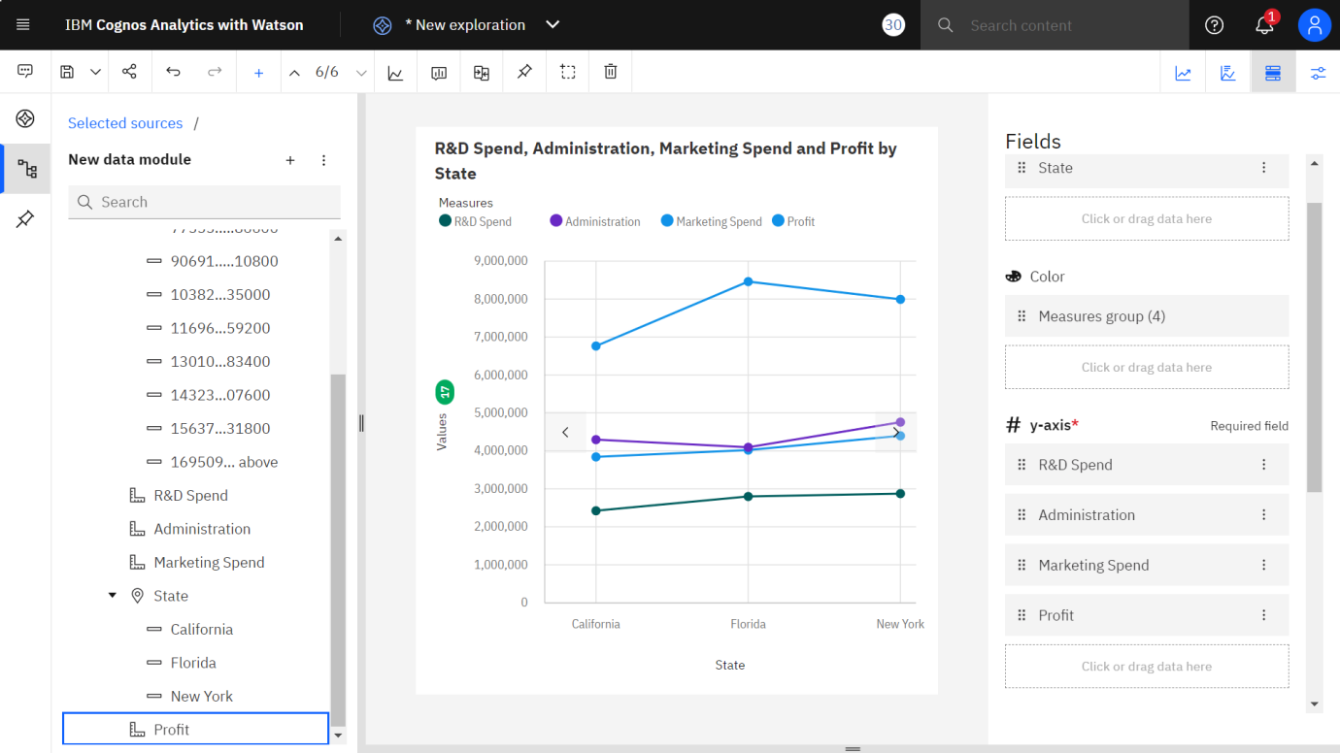

Visualization – CrossTab

