ASSIGNMENT-4

PERSONAL EXPENSE TRACKER APPLICATION

**TEAM ID : PNT2022TMID22686**

1. Pull an image from docker hub and run it in docker playground.

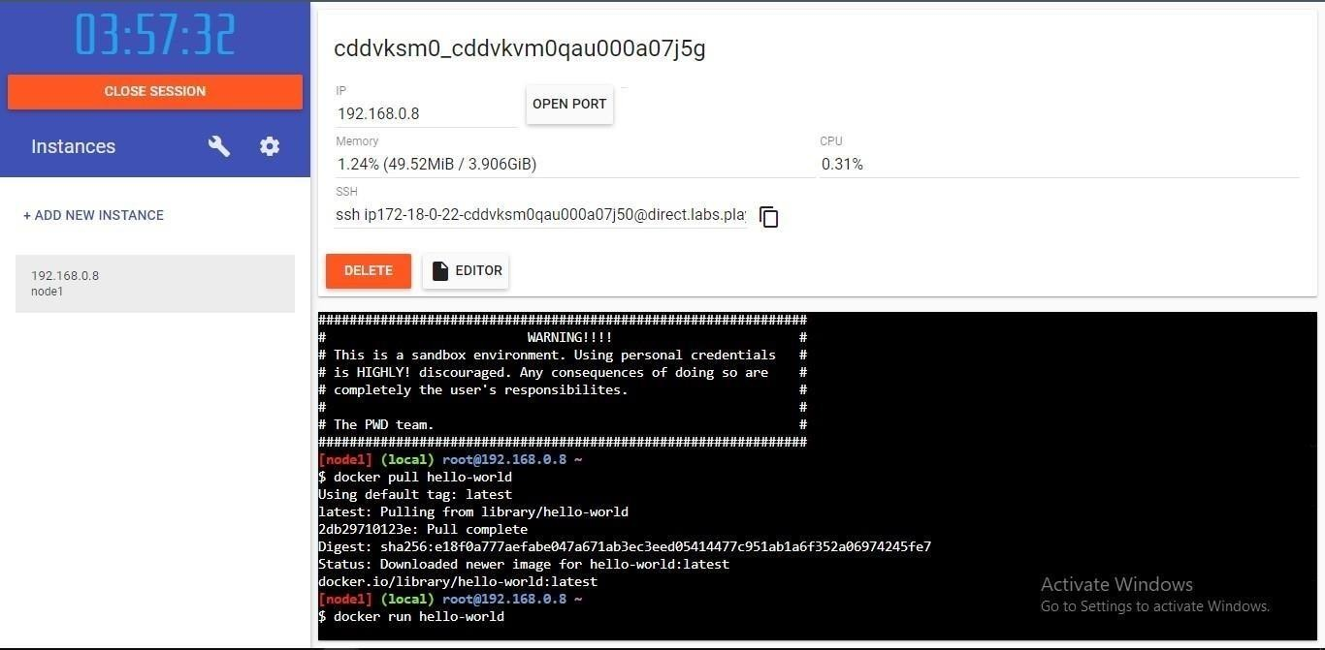

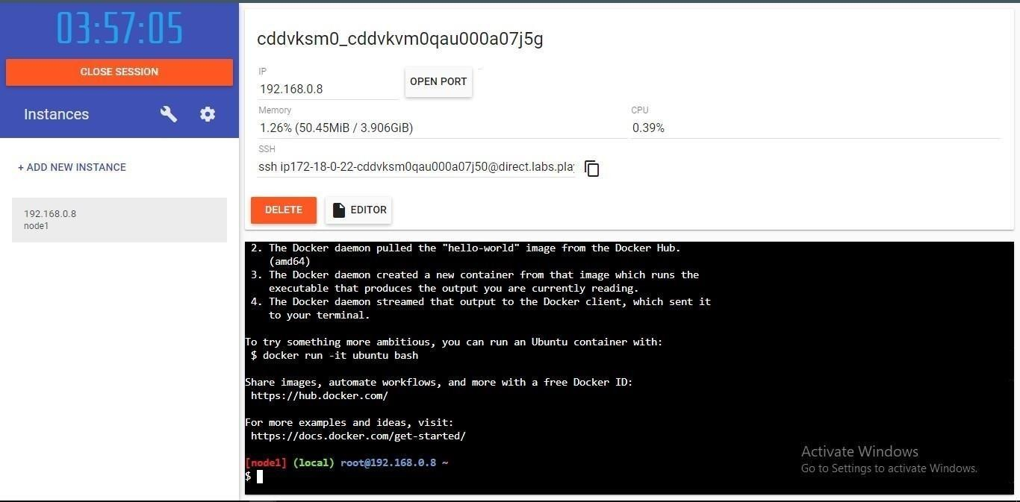

1. Create a docker file for the job portal application and deploy it in Docker desktop application.

DOCKER FILE FOR JOB PORTAL APPLICATION:

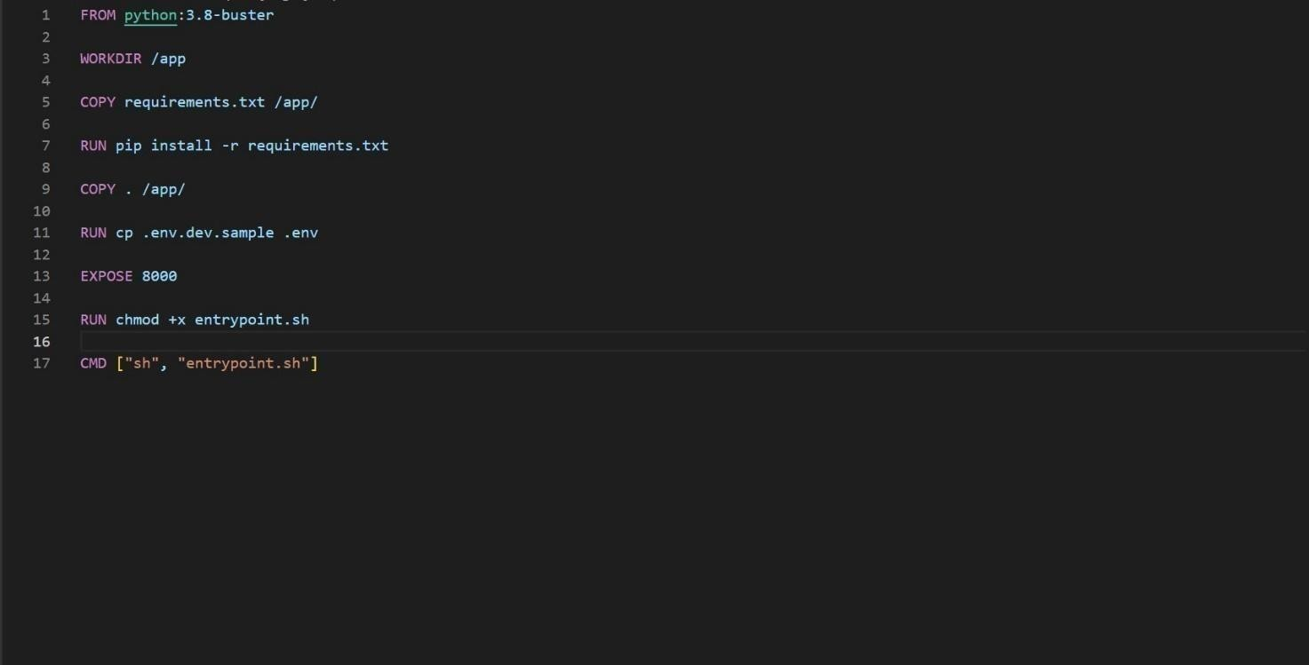

DEPLOYMENT OF DOCKER DESKTOP APPLICATION:

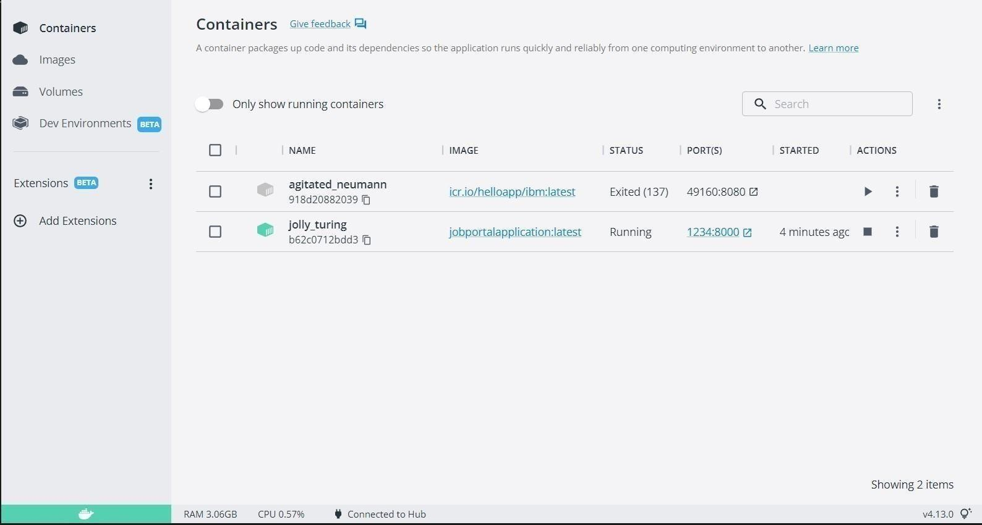

OUTPUT:

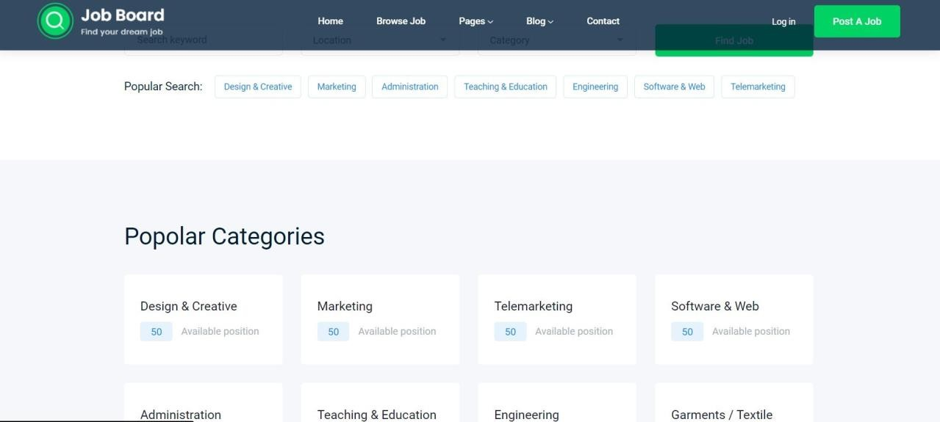

1. Create a IBM container registry and deploy hello world app or job port app.

CONTAINERREGISTRY DEPLOYMENT:

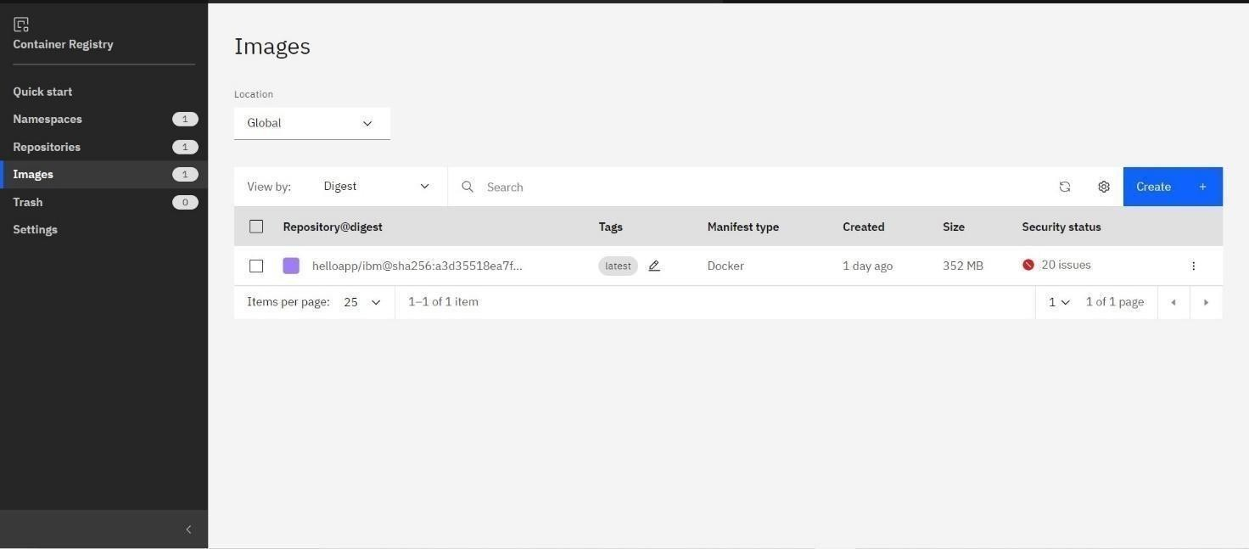

OUTPUT:



1. Create a Kubernetes cluster in IBM cloud and deploy hello world image or job portal image and also expose the same app to run in node port.

Creating Kubernetes cluster in IBM cloud and exposing node port:

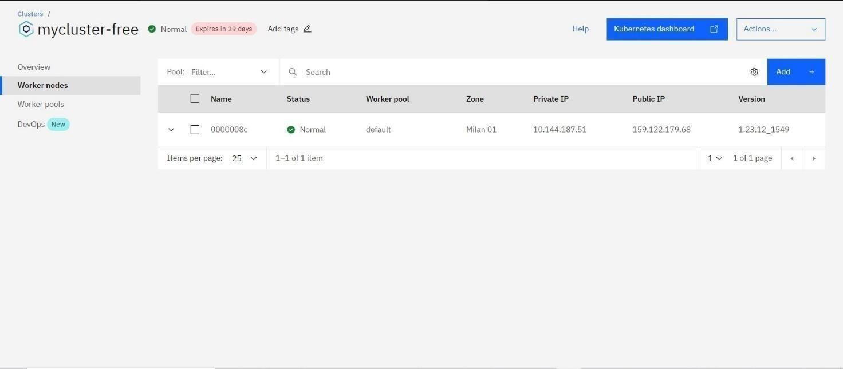

Output:

