IOT-ASSIGNMENT 1 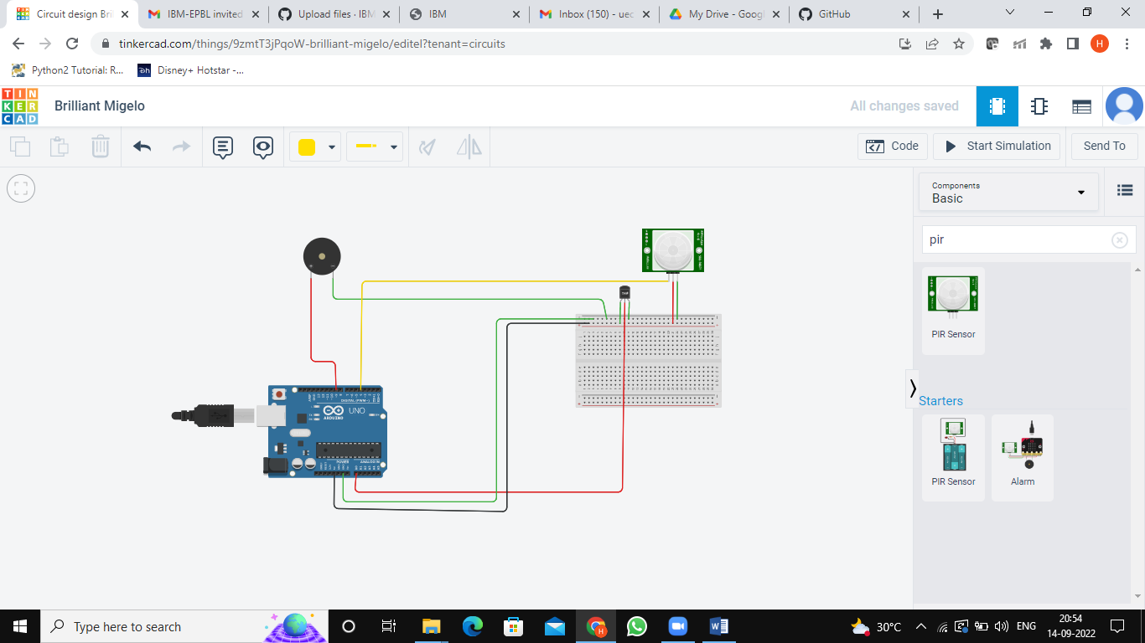

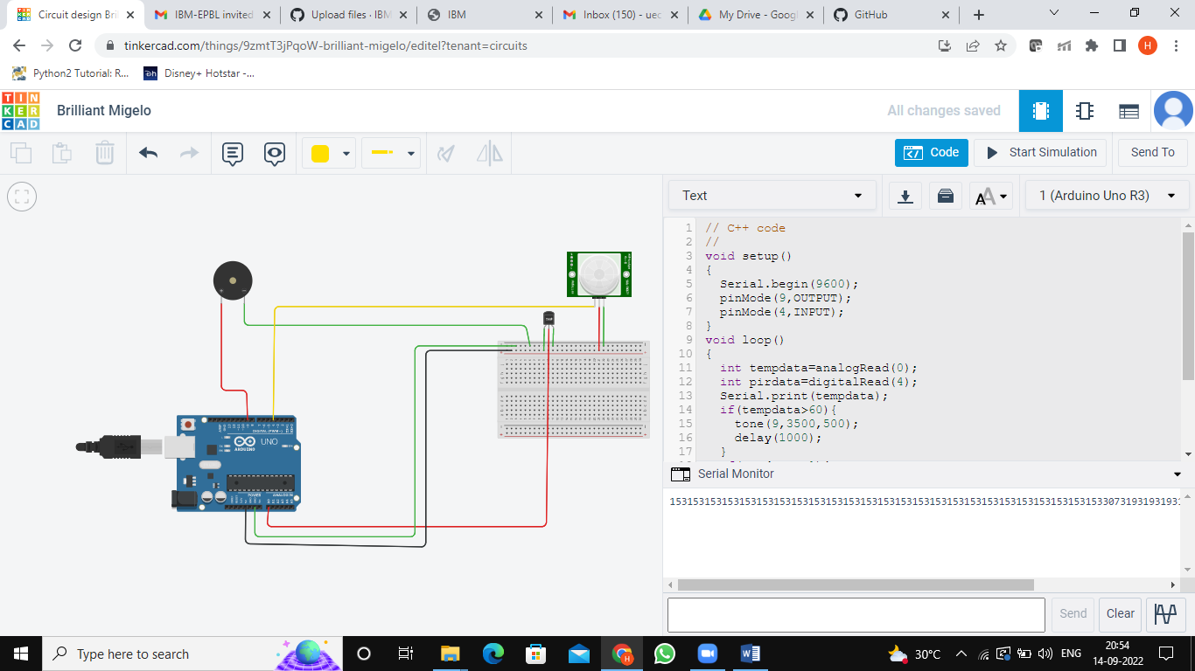

CODE:

void setup()

{

Serial.begin(9600);

pinMode(9,OUTPUT);

pinMode(4,INPUT);

}

void loop()

{

int tempdata=analogRead(0);

int pirdata=digitalRead(4);

Serial.print(tempdata);

if(tempdata>60){

tone(9,3500,500);

delay(1000);

}

if(pirdata==1){

tone(9,5000,500);

delay(1000);

}

digitalWrite(9,LOW);

}

LINK:

https://drive.google.com/file/d/1cxjpCn1WxxluuYcoSN-s13Yb9j0qADxW/view?usp=sharing