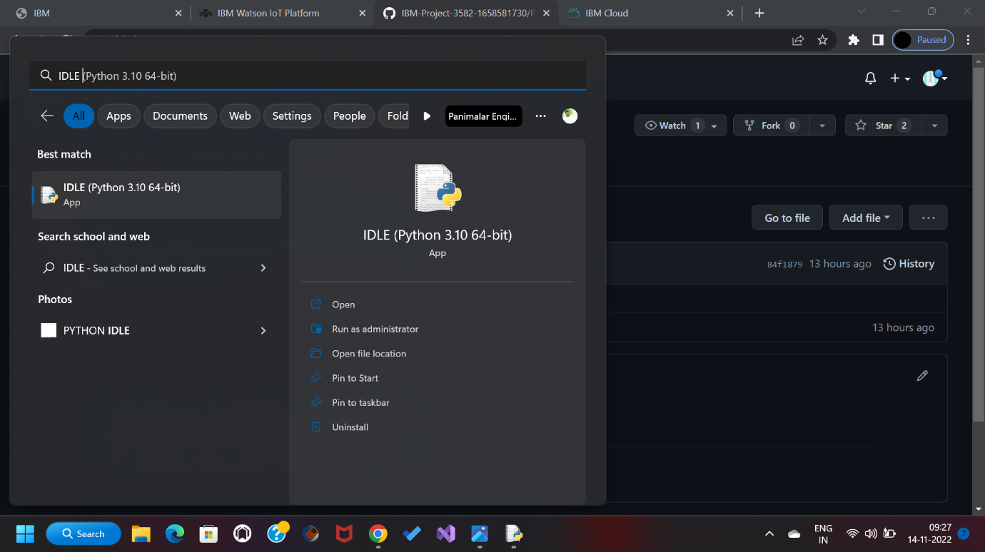

**TEAM I: PNT2022TMID01164**

**TEAM LEADER: U. SHIVA RAMAKRISHNAN**

**TEAM MEMBER: S. SRINIVASAN**

**TEAM MEMBER: G. YUVANESH**

**TEAM MEMBER: K. VISHWA**

**SOFTWARE**