Project Development Phase Model Performance Test

|  |  |
| --- | --- |
| Date | 26 November 2022 |
| Team ID | PNT2022TMID49030 |
| Project Name | Project – Car Resale Value Prediction |
| Maximum Marks | 10 Marks |

# Model Performance Testing:

Project team shall fill the following information in model performance testing template.

|  |  |  |  |
| --- | --- | --- | --- |
| **S.No.** | **Parameter** | **Values** | **Screenshot** |
| 1. | Metrics | **Regression Model:** LGBM Regressor  MAE: 1327.55  MSE: 9492244.28  RMSE: 3080.95  RMSLE: 8.03  R2 Score: 0.8668  Adjusted R2 Score: 0.8668 |  |
| 2. | Tune the Model | **Hyperparameter Tuning**   1. Learning Rate:   [0.01, 0.03, 0.05, 0.07]   1. Boosting Type: ['gbdt','dart','goss','rf'] 2. Number of Estimators: [100,200,300]   **Validation Method**: Grid Search Cross Validation  **Best Parameters:** Learning Rate – 0.07 Boosting Type – ‘gbdt’  Number of Estimators - 300 |  |

# Screenshots

1. **Metrics**

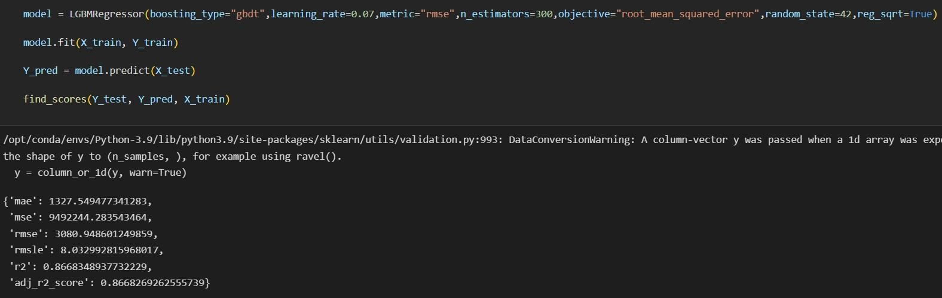

# Text Description automatically generatedTune the model

1. **Wandb sweep:**

