ASSIGNMENT NO 3

**NAME: SHANUPAUL**

**PROJECT: NUTRITION ASSISTANT APPLICATION PROJECT ID: PNT2022TMID51895**

# Create user table with user with email,username,roll number,password.

INSERT INTO TABLENO6 VALUES

('nishanthchandru@gmail.com','Nishanth',73,'Nishanth2001'), ('bharathraj@gmail.com','Bharath',20,'Bharath2000'), ('praneshraja@gmail.com','Pranesh',80,'Praneshvarshini'), ('vijaykowsi@gmail.com','Vijay',113,'Vijay@2001');

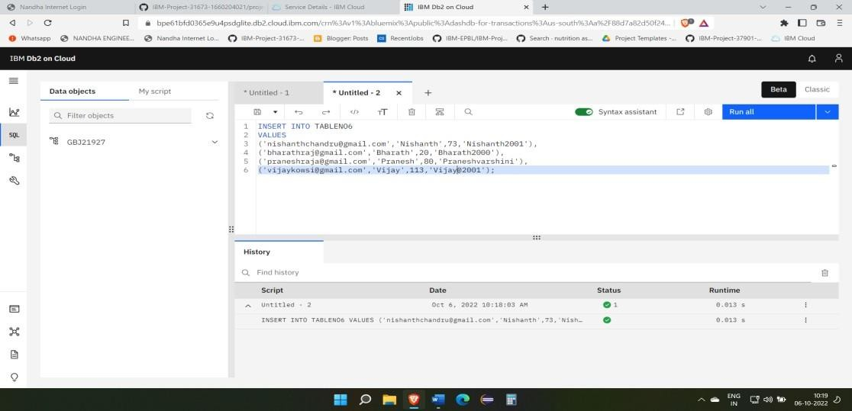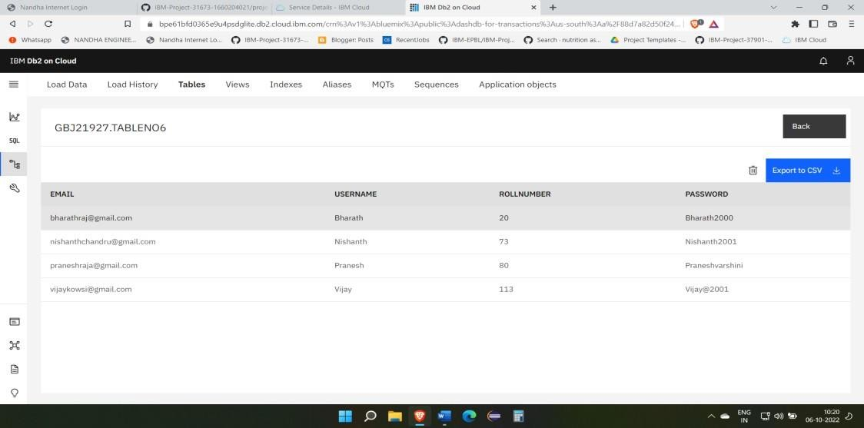

# Perform UPDATE,DELETE Queries with user table.

UPDATE TABLENO6

SET Rollnumber = 25

WHERE Username = 'Bharath'; DELETE FROM TABLENO6

WHERE Username='Vijay';

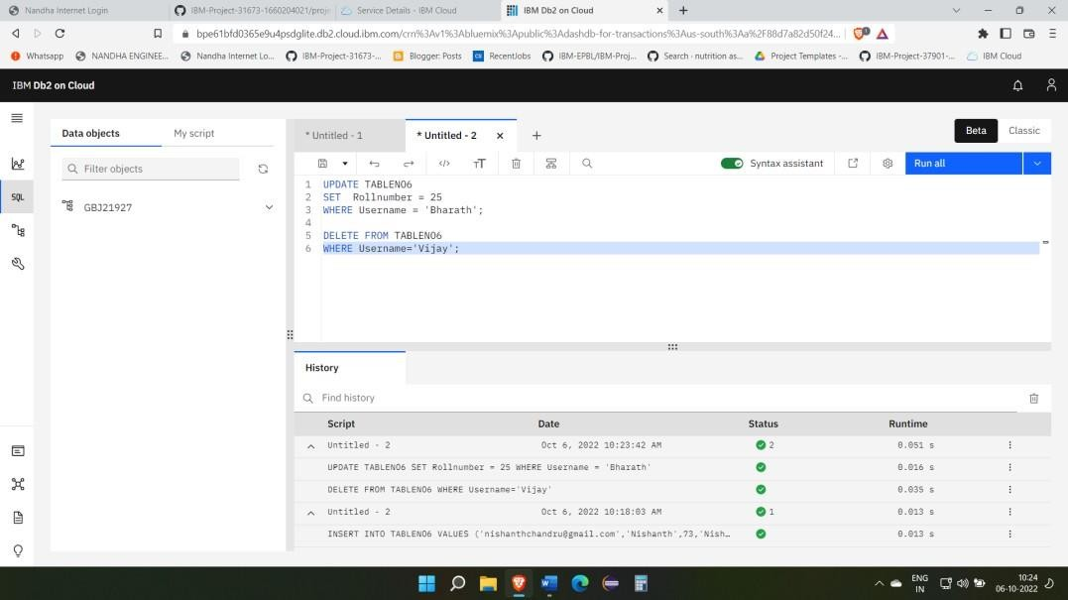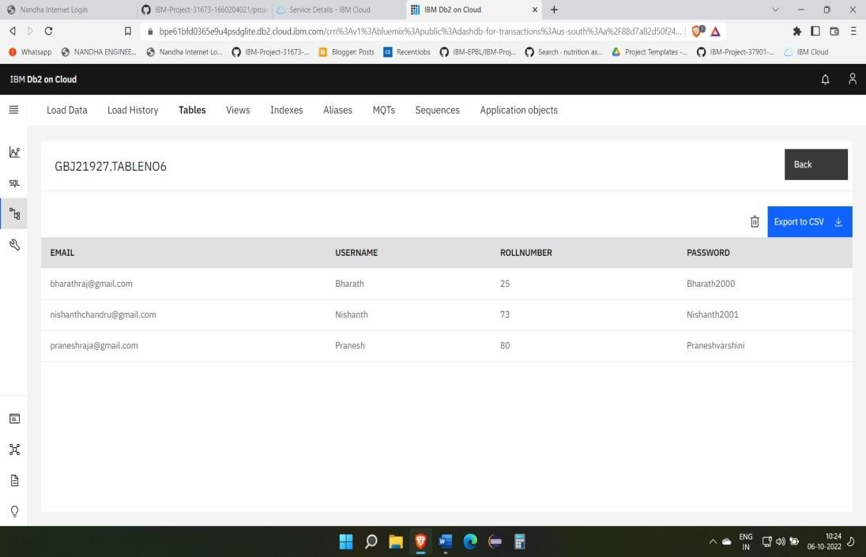

1. **CONNECT PYTHON TO DB2:**

import ibm_db

hostname = '2f3279a5-73d1-4859-88f0-a6c3e6b4b907.c3n41cmd0nqnrk39u98g.databases.appdomain.cloud' uid = 'gbj21927'

pwd = 'skRdfv9YUhrJjxeo'

driver = "{IBM DB2 ODBC DRIVER}"

db = 'bludb' port = '30756'

protocol = 'TCPIP' cert = 'CRT1.crt' dsn = (

"DATABASE = {0};",

"HOSTNAME = {1};",

"PORT = {2};",

"UID = {3};", "SECURITY = SSL;",

"SSlServerCertificate = {4};",

"PWD = {5};"

).format(db, hostname, port, uid, cert, pwd) print(dsn)

try:

db2 = ibm_db.connect(dsn, " ", " ") print("connect to database")

except:

print("unable to connect ", ibm_db.conn_errormsg())

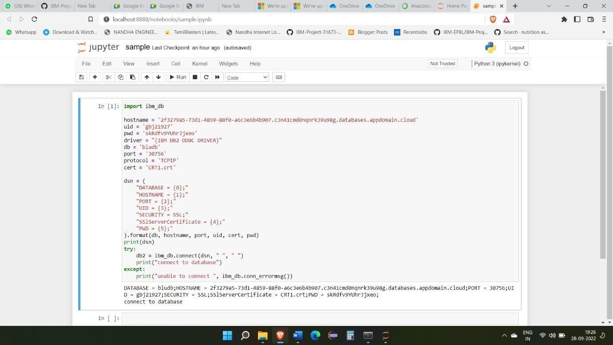

# Create a flask Application

**about.html**

<!DOCTYPE html>

<html lang="en">

<head>

<meta charset="utf-8">

<meta name="viewport" content="width=device-width,initial-scale=1">

<title>About Page</title>

<link [href="https://cdn.jsdelivr.net/npm/bootstrap@5.0.](https://cdn.jsdelivr.net/npm/bootstrap%405.0.0-)0- beta2/dist/css/bootstrap.min.css" rel="stylesheet">

</head>

<body>

<nav class="navbar navbar-expand-lg bg-light" style="background-color: #b5dbf7;">

<!-- Navbar content -->

<div class="container-fluid">

<div class="collapse navbar-collapse" id="navbarNavAltMarkup">

<div class="navbar-nav">

<a class="nav-link " href="home.html">Home</a>

<a class="nav-link active" aria-current="page" href="#">About</a>

<a class="nav-link" href="signin.html">Sign In</a>

<a class="nav-link" href="signup.html">Sign up</a>

</div>

</div>

</div>

</nav>

<br><br>

<footer>

International Business Machines Corporation is an American multinational technology corporation headquartered in Armonk, New York, with operations in over 171 countries.

</footer>

</body>

</html>

## Home.html

<!DOCTYPE html>

<html lang="en">

<head>

<meta charset="utf-8">

<meta name="viewport" content="width=device-width,initial-scale=1">

<title>Home Page</title>

<link [href="https://cdn.jsdelivr.net/npm/bootstrap@5.0.](https://cdn.jsdelivr.net/npm/bootstrap%405.0.0-)0- beta2/dist/css/bootstrap.min.css" rel="stylesheet">

</head>

<body>

<nav class="navbar navbar-expand-lg bg-light" style="background-color: #e3f2fd;">

<!-- Navbar content -->

<div class="container-fluid">

<div class="collapse navbar-collapse" id="navbarNavAltMarkup">

<div class="navbar-nav">

<a class="nav-link active" aria-current="page" href="#">Home</a>

<a class="nav-link" href="about.html">About</a>

<a class="nav-link" href="signin.html">SignIn</a>

<a class="nav-link" href="signup.html">SignUp</a>

</div>

</div>

</div>

</nav>

<br><br>

<div>

<h4>

<b>Welcome to IBM!!!</B>

</h4>

</div>

</body>

</html>

## Signin.html

<!DOCTYPE html>

<html lang="en">

<head>

<meta charset="utf-8">

<meta name="viewport" content="width=device-width,initial-scale=1">

<title>SignIn</title>

<link [href="https://cdn.jsdelivr.net/npm/bootstrap@5.0.](https://cdn.jsdelivr.net/npm/bootstrap%405.0.0-)0- beta2/dist/css/bootstrap.min.css" rel="stylesheet">

</head>

<body>

<nav class="navbar navbar-expand-lg bg-light" style="background-color: #e3f2fd;">

<!-- Navbar content -->

<div class="container-fluid">

<div class="collapse navbar-collapse" id="navbarNavAltMarkup">

<div class="navbar-nav">

<a class="nav-link " href="home.html">Home</a>

<a class="nav-link" href="about.html">About</a>

<a class="nav-link active" aria-current="page" href="#">SignIn</a>

<a class="nav-link" href="signup.html">SignUp</a>

</div>

</div>

</div>

</nav>

<div class="text-center my-5" style="background-image:

url('https://png.pngtree.com/thumb_back/fh260/background/20200714/pngtree- modern-double-color-futuristic-neon-background-image_351866.jpg'); background-repeat: no-repeat;

background-size: cover;">

<section class="h-100">

<div class="container h-100">

<div class="row justify-content-sm-center h-100">

<div class="col-xxl-4 col-xl-5 col-lg-5 col-md-7 col-sm-9">

<div class="text-center my-5"></div>

<div class="card shadow-lg">

<div class="card-body p-5">

<h1 class="fs-4 card-title fw-bold mb-4">Login</h1>

<form method="POST" class="needs-validation" novalidate="" autocomplete="off">

<div class="mb-3">

<label class="mb-2 text-muted" for="email">E-Mail Address</label>

<input id="email" type="email" class="form-control" name="email" value="" required autofocus>

<div class="invalid-feedback"> Email is invalid

</div>

</div>

<div class="mb-3">

<div class="mb-2 w-100">

<label class="text-muted" for="password">Password</label>

<a href="forgot.html" class="float-end"> Forgot Password?

</a>

</div>

<input id="password" type="password" class="form-control" name="password"

required>

<div class="invalid-feedback"> Password is required

</div>

</div>

<div class="d-flex align-items-center">

<div class="form-check">

<input type="checkbox" name="remember" id="remember" class="form-check-input">

<label for="remember" class="form-check-label">Remember Me</label>

</div>

<button type="submit" class="btn btn-primary ms-auto"> Login

</button>

</div>

</form>

</div>

<div class="card-footer py-3 border-0">

<div class="text-center">

Don't have an account? <a href="signup.html" class="text-dark">Create One</a>

</div>

</div>

</div>

</div>

</div>

</div>

</section>

</div>

</body>

</html>

## Signup.html

<!DOCTYPE html>

<html lang="en">

<head>

<meta charset="utf-8">

<meta name="viewport" content="width=device-width,initial-scale=1">

<title>SignUp</title>

<link [href="https://](https://cdn.jsdelivr.net/npm/bootstrap%405.0.0-)cdn.js[delivr.net/npm/bootstrap@5.0.0-](https://cdn.jsdelivr.net/npm/bootstrap%405.0.0-) beta2/dist/css/bootstrap.min.css" rel="stylesheet">

</head>

<body>

<nav class="navbar navbar-expand-lg bg-light" style="background-color: #e3f2fd;">

<!-- Navbar content -->

<div class="container-fluid">

<div class="collapse navbar-collapse" id="navbarNavAltMarkup">

<div class="navbar-nav">

<a class="nav-link " href="home.html">Home</a>

<a class="nav-link" href="about.html">About</a>

<a class="nav-link" href="signin.html">SignIn</a>

<a class="nav-link active" aria-current="page" href="#">SignUp</a>

</div>

</div>

</div>

</nav>

<div class="text-center my-5" style="background-image:

url('https://png.pngtree.com/thumb_back/fh260/background/20200714/pngtree- modern-double-color-futuristic-neon-background-image_351866.jpg'); background-repeat: no-repeat;

background-size: cover;">

<section class="h-100">

<div class="container h-100">

<div class="row justify-content-sm-center h-100">

<div class="col-xxl-4 col-xl-5 col-lg-5 col-md-7 col-sm-9">

<div class="text-center my-5"></div>

<div class="card shadow-lg">

<div class="card-body p-5">

<h1 class="fs-4 card-title fw-bold mb-4">Register</h1>

<form method="POST" class="needs-validation" novalidate="" autocomplete="off">

<div class="mb-3">

<label class="mb-2 text-muted" for="name">Name</label>

<input id="name" type="text" class="form-control" name="name" value="" required

autofocus>

<div class="invalid-feedback"> Name is required

</div>

</div>

<div class="mb-3">

<label class="mb-2 text-muted" for="email">E-Mail Address</label>

<input id="email" type="email" class="form-control" name="email" value="" required>

<div class="invalid-feedback"> Email is invalid

</div>

</div>

<div class="mb-3">

<label class="mb-2 text-muted" for="password">Password</label>

<input id="password" type="password" class="form-control" name="password" required>

<div class="invalid-feedback"> Password is required

</div>

</div>

<p class="form-text text-muted mb-3">

By registering you agree with our terms and condition.

</p>

<div class="align-items-center d-flex">

<button type="submit" class="btn btn-primary ms-auto"> Register

</button>

</div>

</form>

</div>

<div class="card-footer py-3 border-0">

<div class="text-center">

Already have an account? <a href="signin.html" class="text-dark">Login</a>

</div>

</div>

</div>

</div>

</div>

</div>

</section>

</div>

</body>

</html>

**app.py**

from flask import Flask, render_template app = Flask( name )

@app.route("/") @app.route("/home") def home():

return render_template("home.html") @app.route("/about")

def about():

return render_template("about.html") @app.route("/signin")

def signin():

return render_template("signin.html") @app.route("/signup")

def signup():

return render_template("signup.html")