ASSIGNMENT NO 2

**NAME: SREEJITH.S**

**PROJECT: NUTRITION ASSISTANT APPLICATION PROJECT ID: PNT2022TMID51895**

# ANSWER NO 1

**TABLE NO 1:**

INSERT INTO TABLENO1 VALUES(18,'Ram',88000,'ADMIN'),

(56,'SEETA',9000,'HELPDESK'),

(10,'MRUNAL',56000,'HR'),

(16,'PANDYA',78000,'DEVOP'),

(50,'LAXMI',88000,'TESTER');

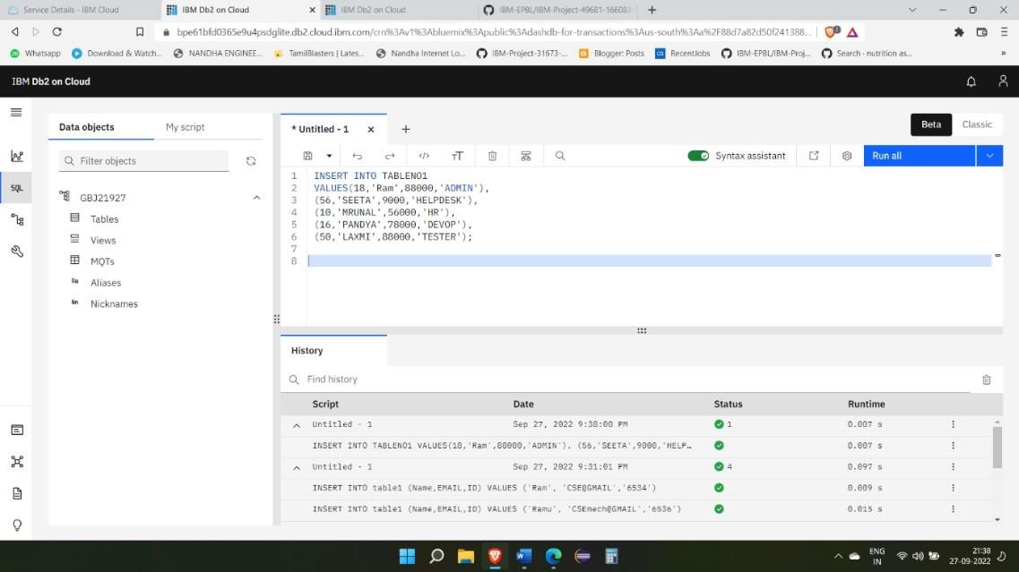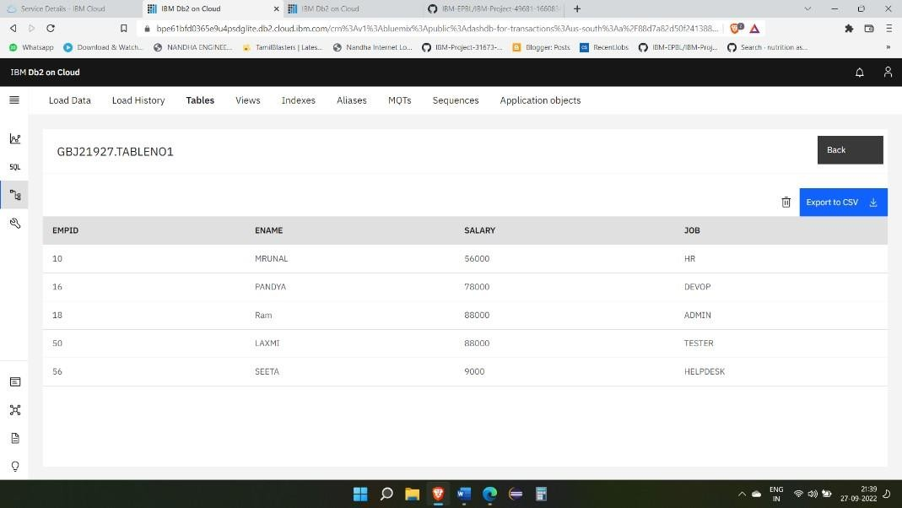

INSERT INTO TABLENO2 VALUES (167,'KUSHI',005),

(170,'ZAARA',008), (188,'ANUPAMAA',034),(100,'KANOOE',009), (190,'VIDHYA',002);

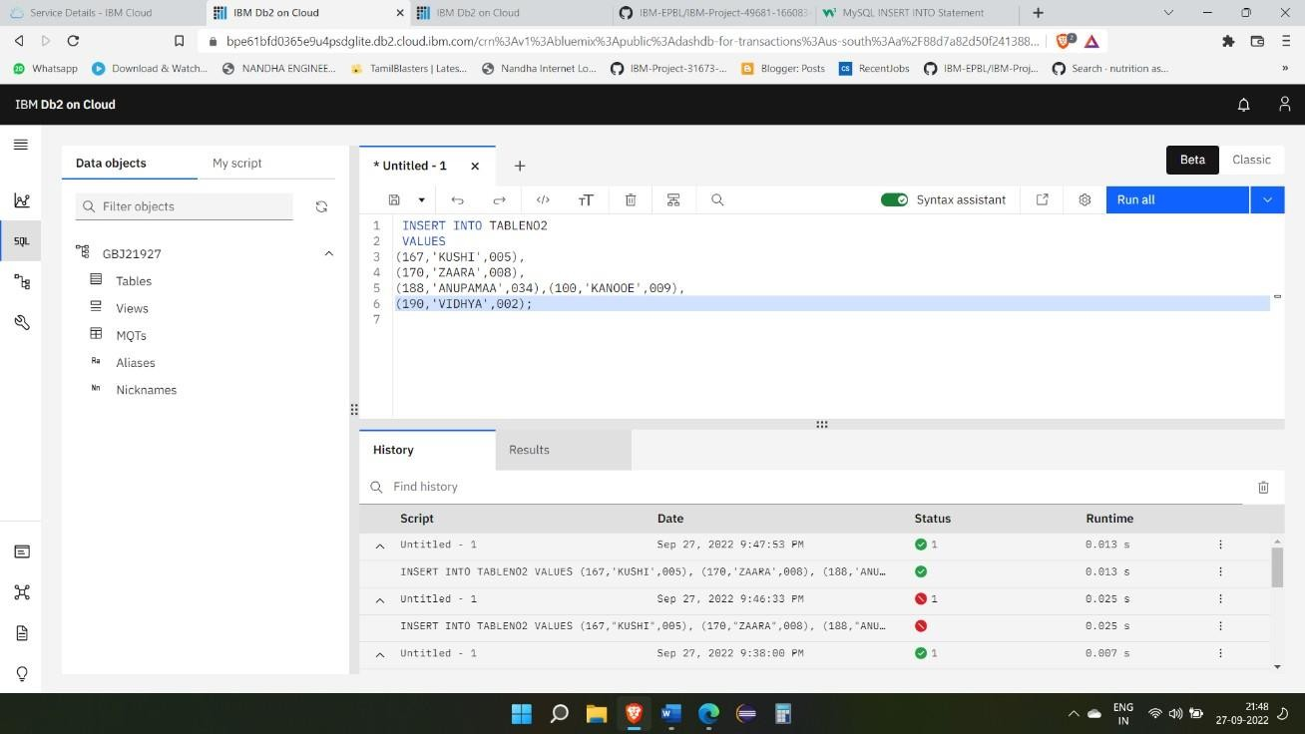

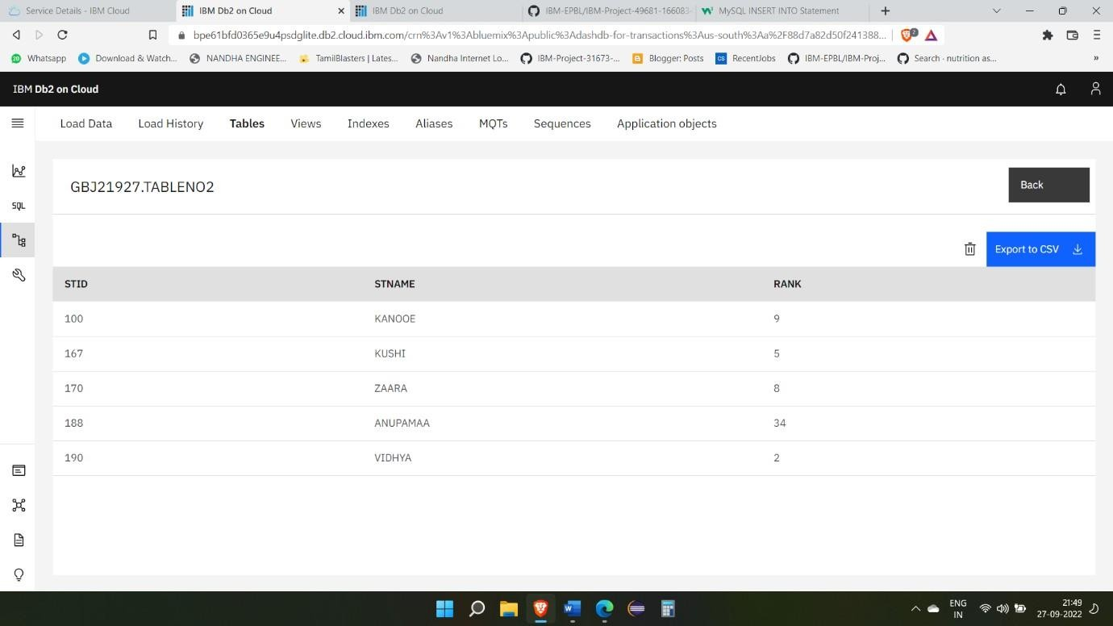

INSERT INTO TABLENO3 VALUES (12395,'RA1',9,'HINDI'),

(125456,'VIRUMAN',8,'TAMIL'),

(190345,'LIGER',7,'TELUGU'),

(167345,'KOSHI',9,'MALYALAM');

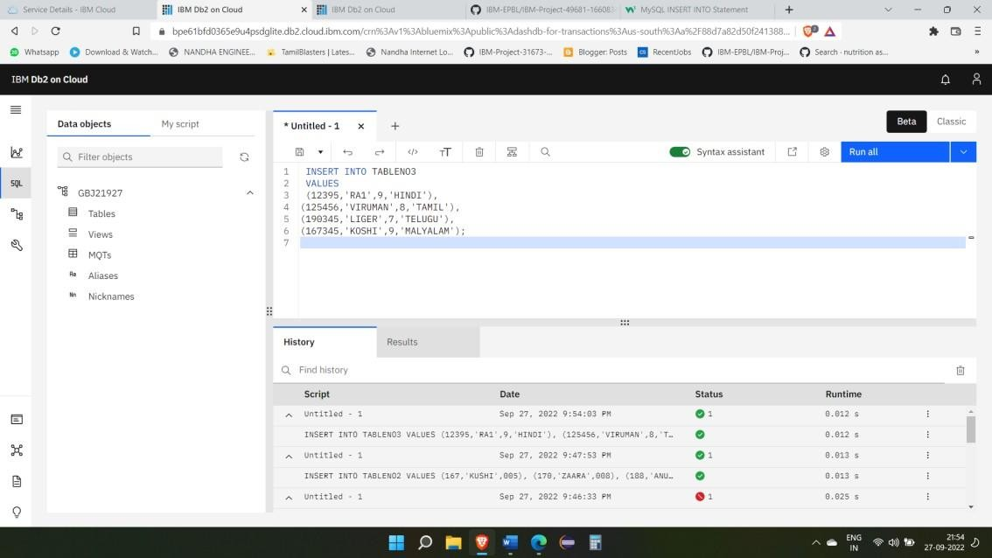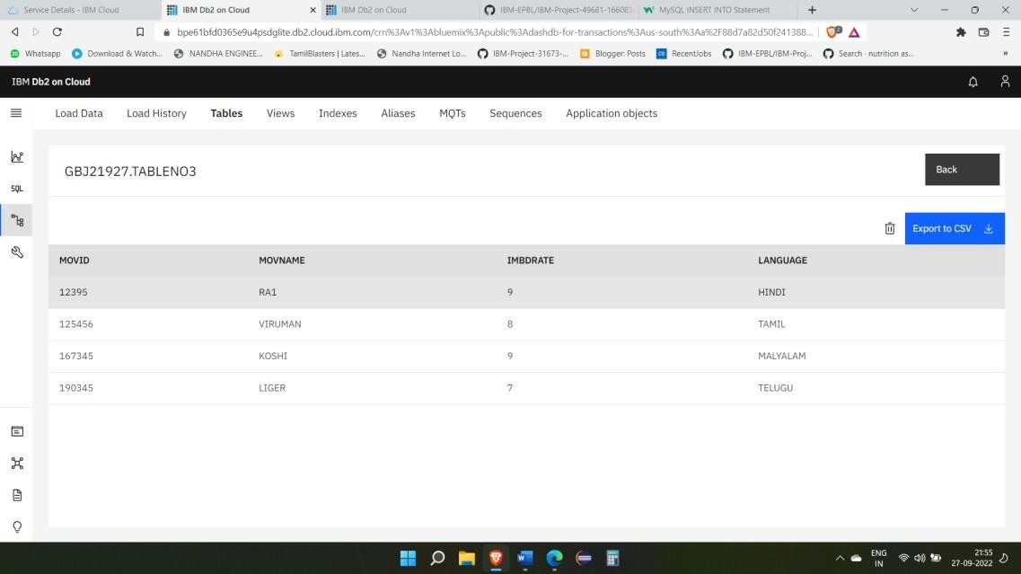

INSERT INTO TABLENO4 VALUES

(123,'PEN',12),

(189,'PENCIL',9),

(233,'SCALE',10),

(893,'RUBBER',5),

(128,'CHART',5),

(103,'COMPASS',15),

(223,'INKBOTTLE',25);

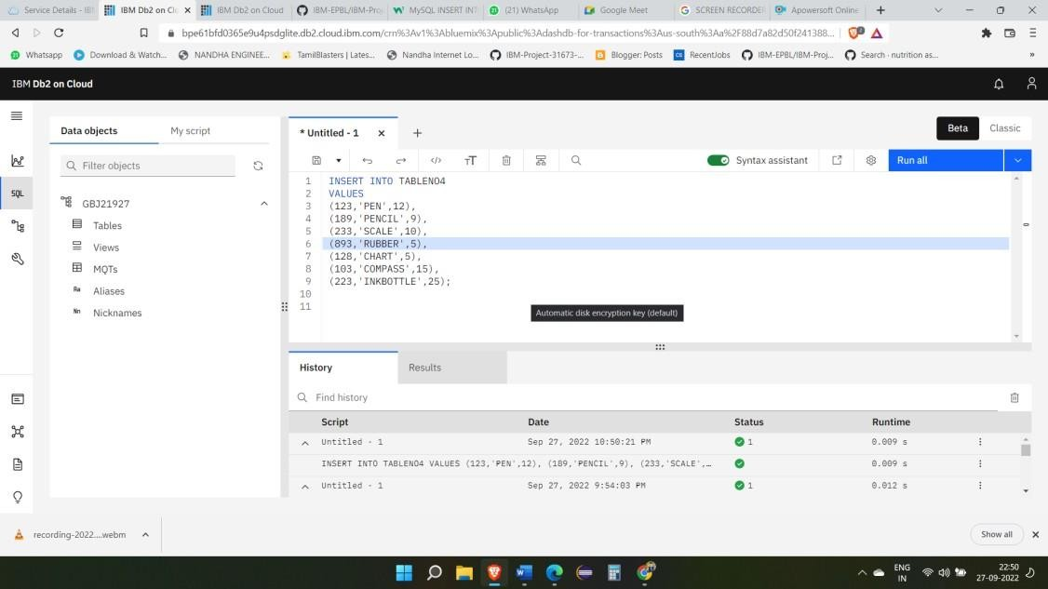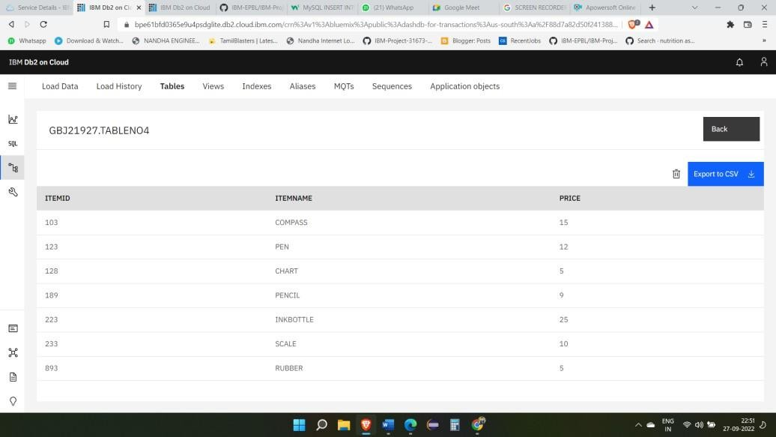

INSERT INTO TABLENO5 VALUES (23,'COCONUT',180,28),

(28,'CHICKEN',134,25),

(83,'MAKKAN',178,59),

(78,'NAAN',190,85),

(67,'PANEER',178,35);

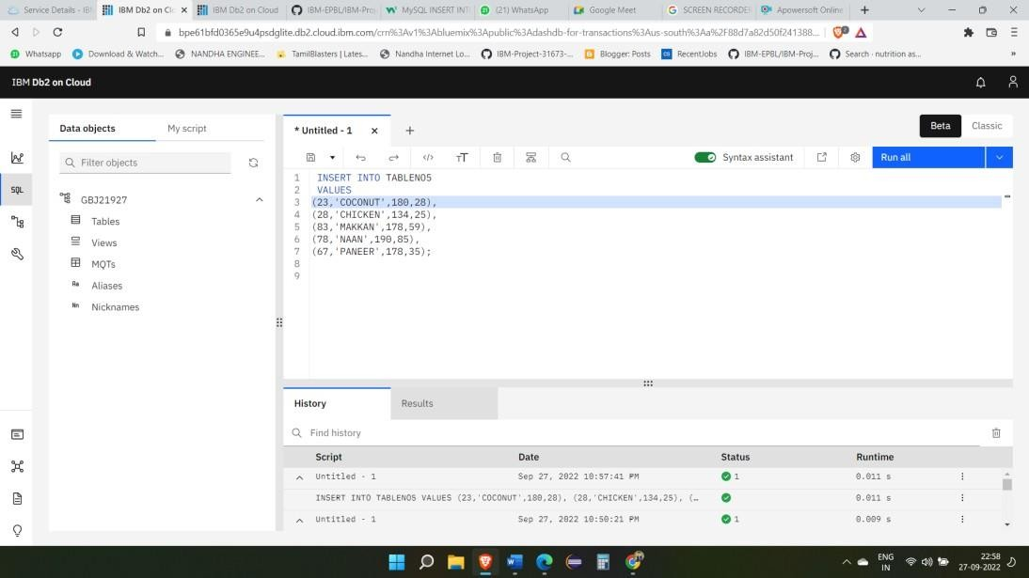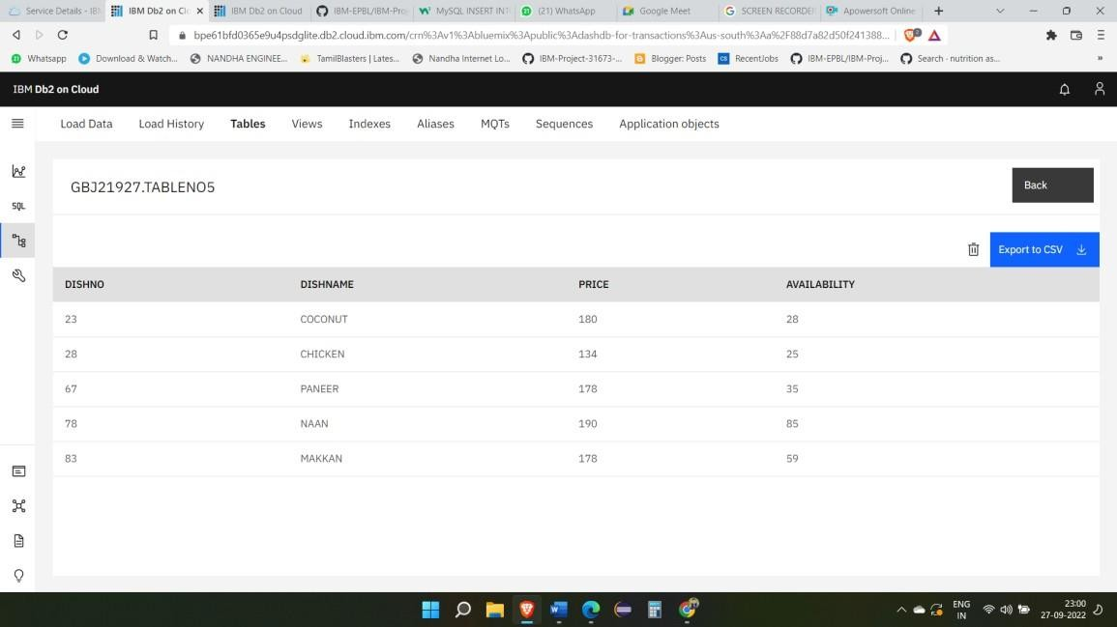

# ANSWER NO 2

**TABLE NO 1:** UPDATE TABLENO1 SET ENAME='SANJAY'

WHERE SALARY=88000;

DELETE FROM TABLENO1 WHERE ENAME='MRUNAL';

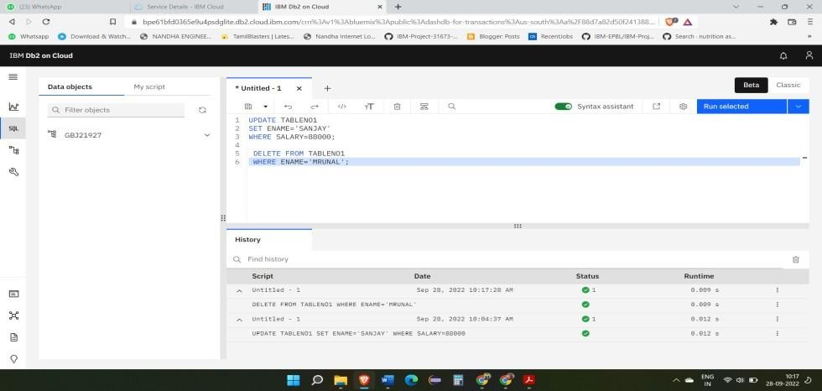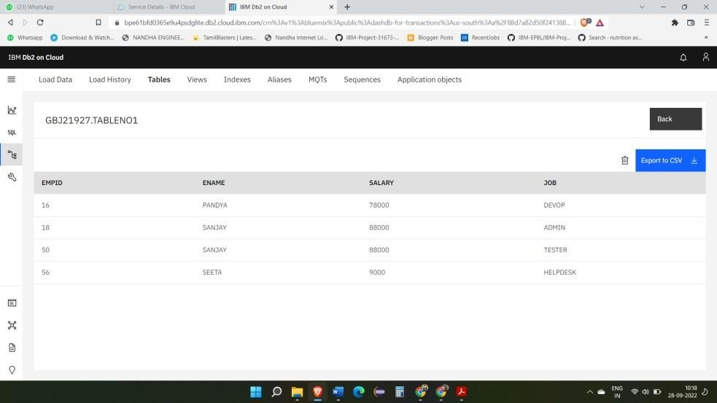

INSERT INTO TABLENO2 VALUES

('Saran',87,'Bangalore',0.13),

('Vijay',100,'Chennai',0.14),

('Bharath',78,'Mumbai',0.12),

('Ramya',99,'London',0.15),

('Lakshmi', 80,'Pune',0.19);

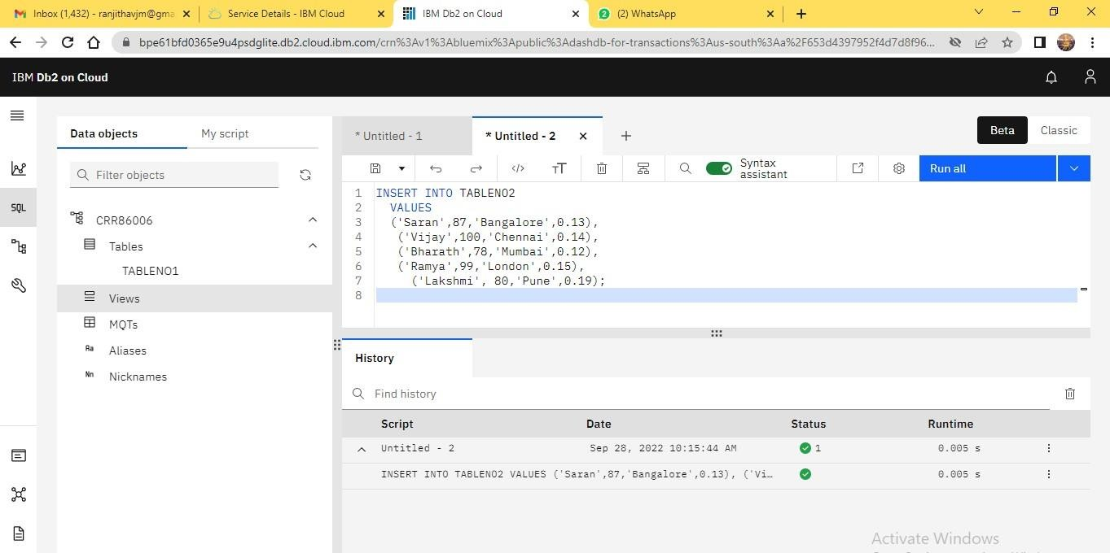

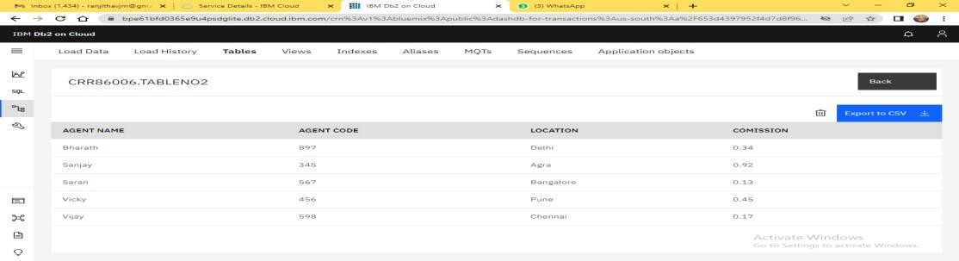

## TABLE NO 3:

INSERT INTO TABLENO3 VALUES ('APPLE',3456,180,134,45),

('ORANGE',3478,200,180,250),

('BANANA',3468,50,40,100),

('LEMON',3466,80,50,50),

('GRAPES',3489,90,60,300), ('WATERMELON',3456,100,80,250);

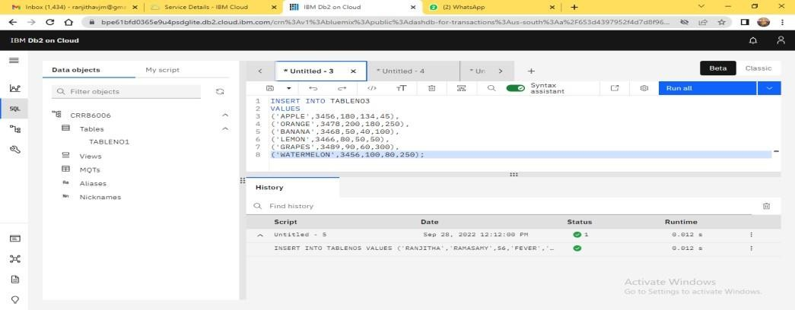

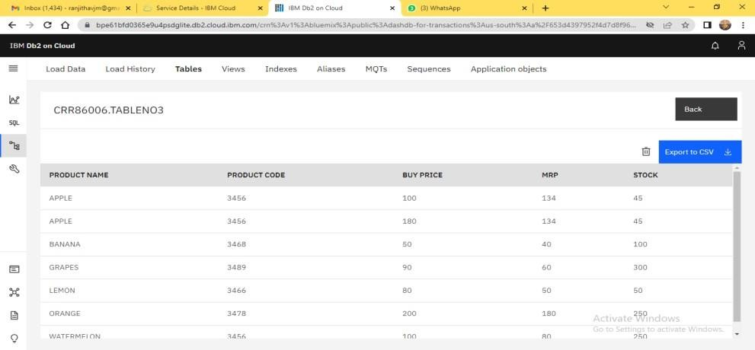

INSERT INTO TABLENO4 VALUES

(897,'BHARATH','RAJ','9976586134','NO'),

(888,'VIJAY','PRABU','6381095311','NO'),

(883,'VIGNESH','KUMAR','8838409020','NO'),

(881,'SHEELA','DEVI','9750048062','NO'),

(878,'PRANESH','RAJA','9942332237','N0');

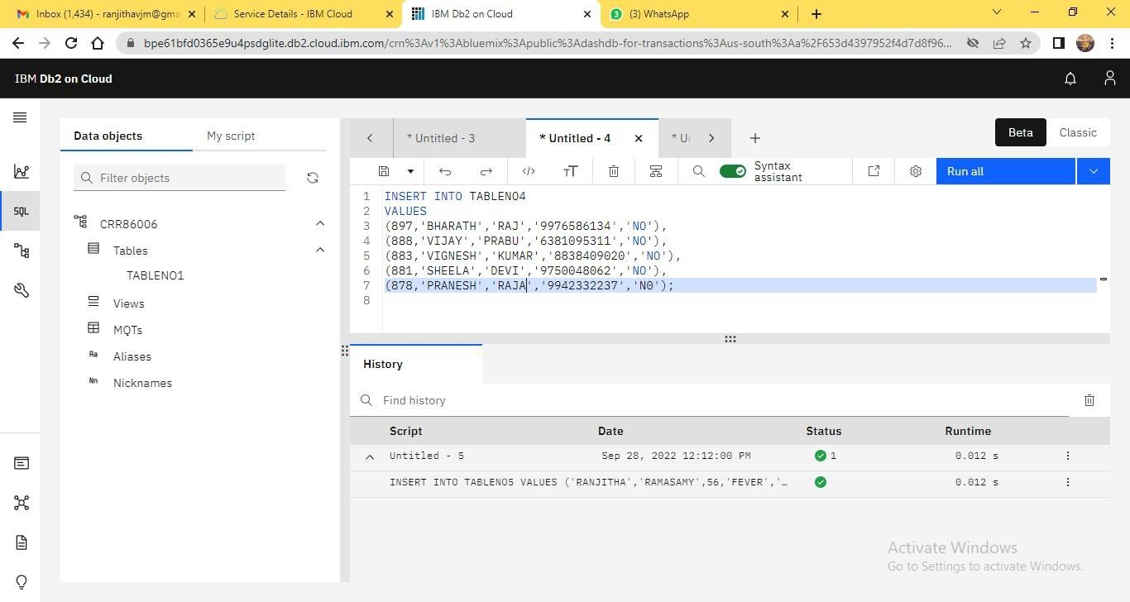

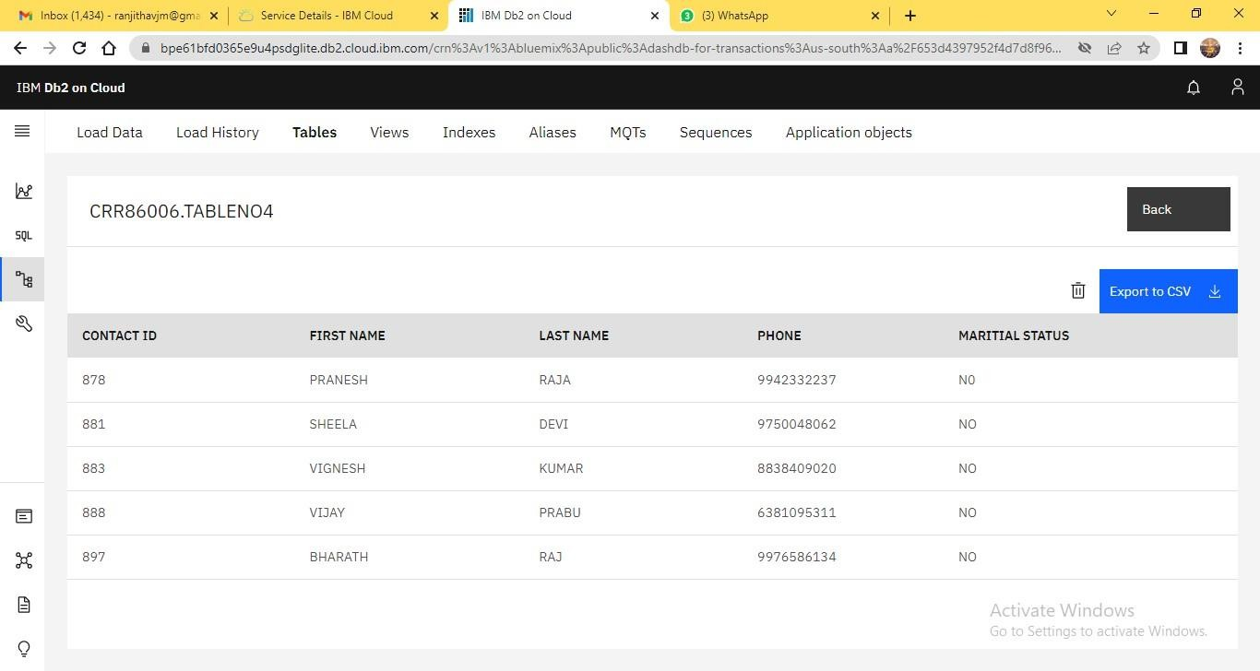

## TABLE NO 5:

INSERT INTO TABLENO5 VALUES

('RANJITHA','RAMASAMY',56,'FEVER','ONLINE'),

('SANDHYA','PALANISAMY',78,'COLD','OFFLINE'),

('KOWSALYA','SANJAY',98,'COUGH','ONLINE'),

('NITHYA','RAM',34,'HEADACHE','ONLINE');

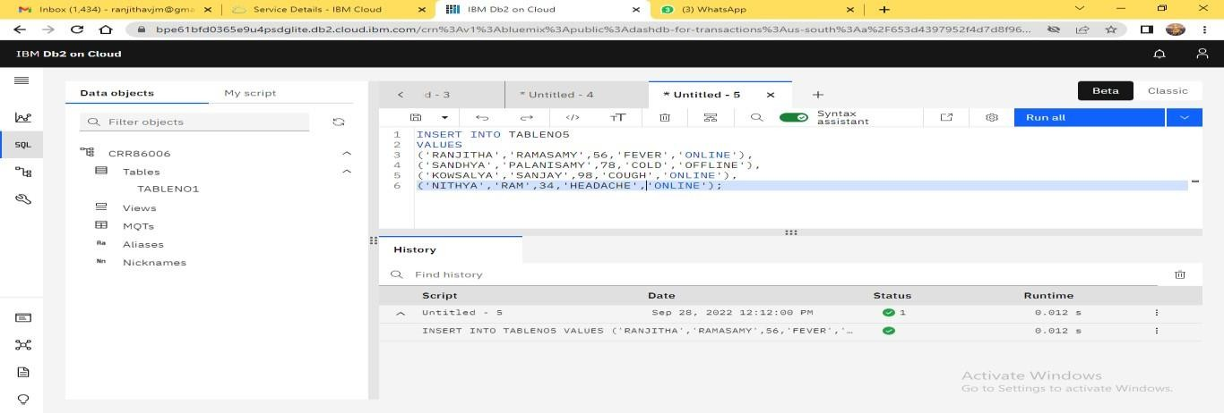

# ANSWER 3:

ANSWER NO 4

import ibm_db

hostname = '2f3279a5-73d1-4859-88f0- a6c3e6b4b907.c3n41cmd0nqnrk39u98g.databases.appdomain.cloud'

uid = 'gbj21927'

pwd = 'skRdfv9YUhrJjxeo'

driver = "{IBM DB2 ODBC DRIVER}"

db = 'bludb' port = '30756'

protocol = 'TCPIP' cert = 'CRT1.crt'

dsn = (

"DATABASE = {0};",

"HOSTNAME = {1};",

"PORT = {2};",

"UID = {3};", "SECURITY = SSL;",

"SSlServerCertificate = {4};",

"PWD = {5};"

).format(db, hostname, port, uid, cert, pwd) print(dsn)

try:

db2 = ibm_db.connect(dsn, " ", " ") print("connect to database")

except:

print("unable to connect ", ibm_db.conn_errormsg())

