**NAME: SREEKANTH.R**

ASSIGNMENT NO 4

**PROJECT: NUTRITION ASSISTANT APPLICATION PROJECT ID: PNT2022TMID51895**

# Create a Bucket in IBM object storage

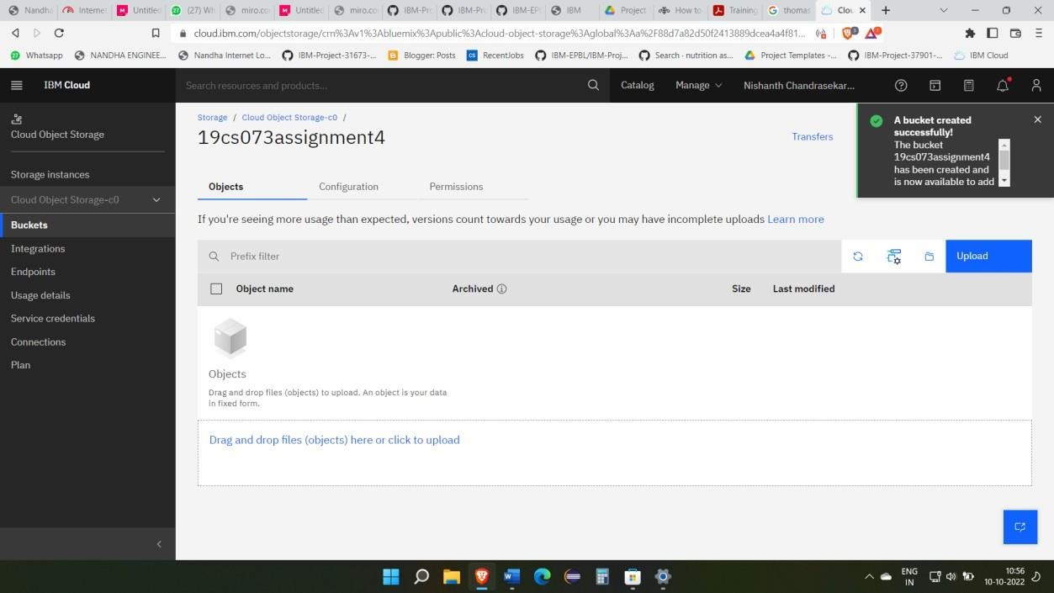

1. **Upload an 5 images to IBM Object storage and make it public. Write HTML code to display all the five images.**

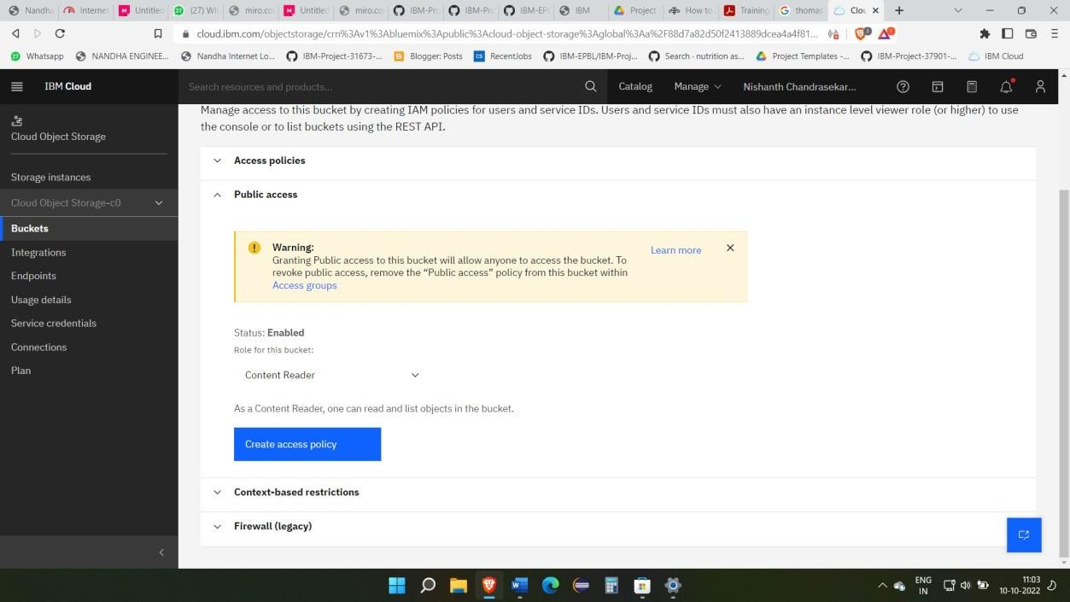

Write HTML code to display all the 5 images.

# Source code;

<!DOCTYPE html>

<html>

<head> WELCOME

<link rel="stylesheet" href="https://19cs073assignment4.s3.us-east.cloud-object- storage.appdomain.cloud/style.css">

</head>

<body>

<h2><B>ONLY HTML & CSS ARE USED</B></h2>

<div class="polaroid">

<img src="https://19cs073assignment4.s3.us-east.cloud-object-storage.appdomain.cloud/pic1.jpg" alt="5 Terre" style="width:100%">

<div class="container">

</div>

</div>

<div class="polaroid">

<img src="https://19cs073assignment4.s3.us-east.cloud-object-storage.appdomain.cloud/pic2.jpg" style="width:100%">

<div class="container">

</div>

</div>

<div class="polaroid">

<img src="https://19cs073assignment4.s3.us-east.cloud-object- storage.appdomain.cloud/pic3.jpg" alt="Norther Lights" style="width:100%">

<div class="container">

</div>

</div>

<div class="polaroid">

<img src="https://19cs073assignment4.s3.us-east.cloud-object- storage.appdomain.cloud/pic4.jpg" alt="Norther Lights" style="width:100%">

<div class="container">

</div>

</div>

<div class="polaroid">

<img src="https://19cs073assignment4.s3.us-east.cloud-object- storage.appdomain.cloud/pic5.jpg" alt="Norther Lights" style="width:100%">

<div class="container">

</div>

</div>

</body>

</html>

# IMAGE LINK NO 1:

<https://19cs073assignment4.s3.us-east.cloud-object-storage.appdomain.cloud/pic1.jpg>

# IMAGE LINK NO 2:

<https://19cs073assignment4.s3.us-east.cloud-object-storage.appdomain.cloud/pic2.jpg>

# IMAGE LINK NO 3:

<https://19cs073assignment4.s3.us-east.cloud-object-storage.appdomain.cloud/pic3.jpg>

# IMAGE LINK NO 4:

<https://19cs073assignment4.s3.us-east.cloud-object-storage.appdomain.cloud/pic4.jpg>

# IMAGE LINK NO 5:

<https://19cs073assignment4.s3.us-east.cloud-object-storage.appdomain.cloud/pic5.jpg>





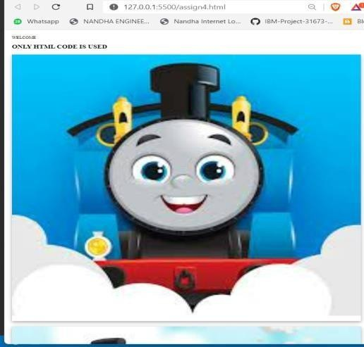

# Upload a CSS page to the object storage and use the same page int your HTML.

CSS CODE :

body {margin:25px;} div.polaroid {

width: 80%; background-color: white;

box-shadow: 0 4px 8px 0 rgba(0, 0, 0, 0.2), 0 6px 20px 0 rgba(0, 0, 0, 0.19); margin-bottom: 25px;

}

div.container { text-align: center;

padding: 10px 20px;

}

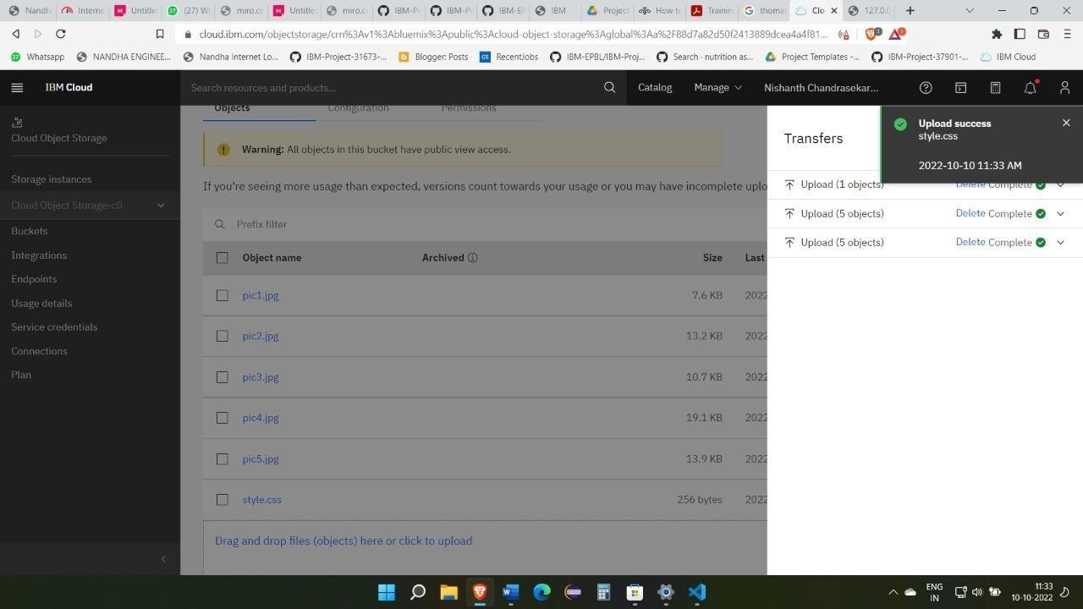

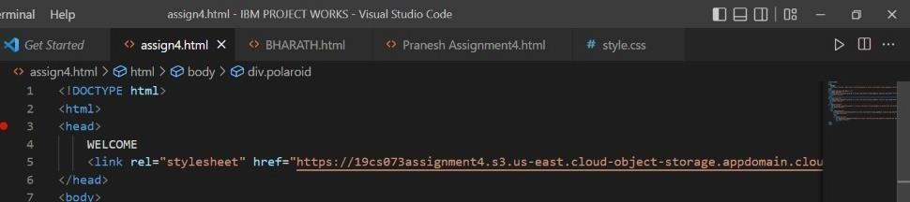

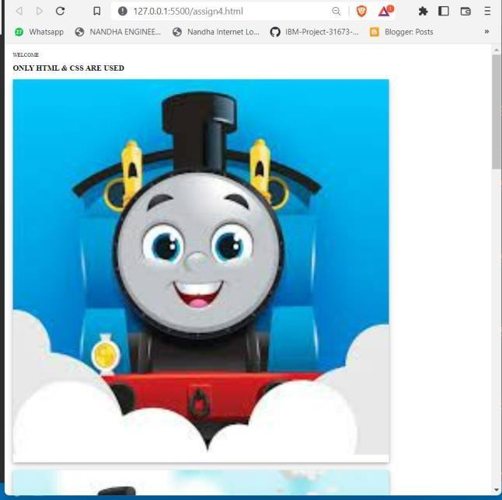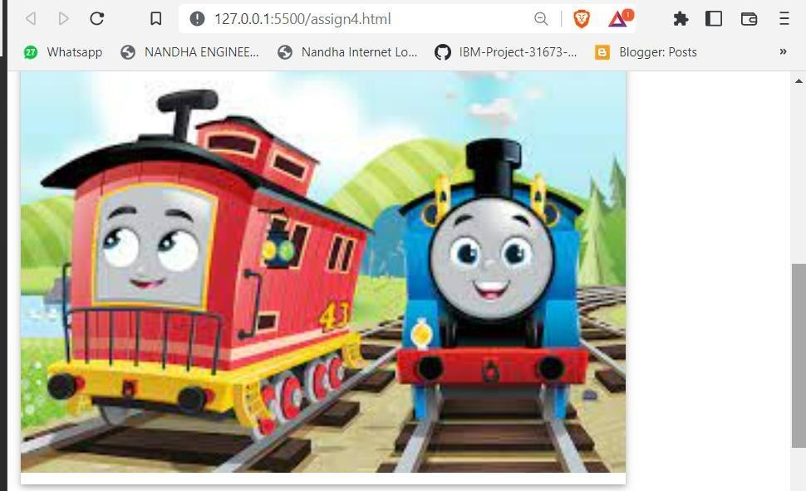

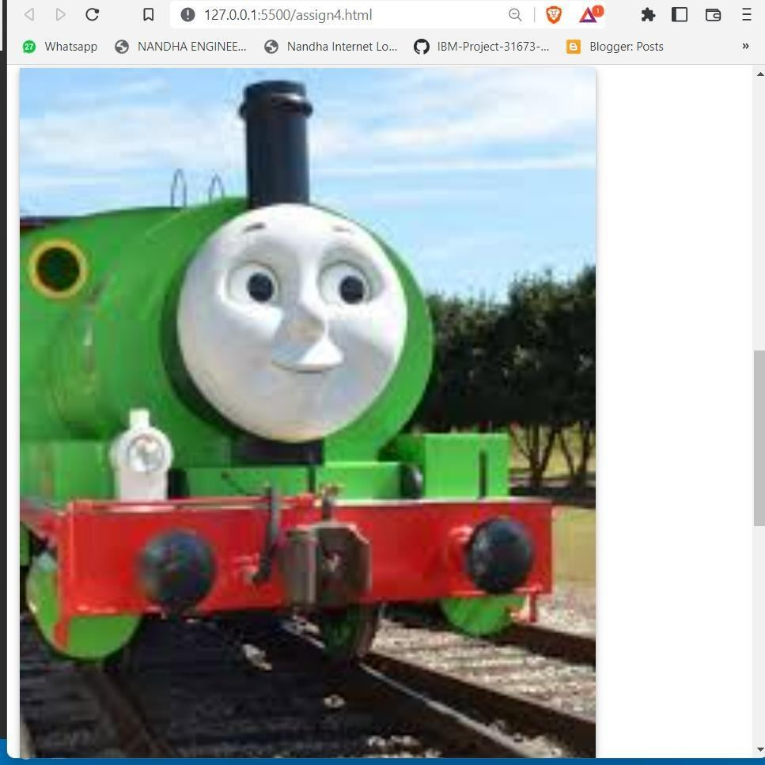

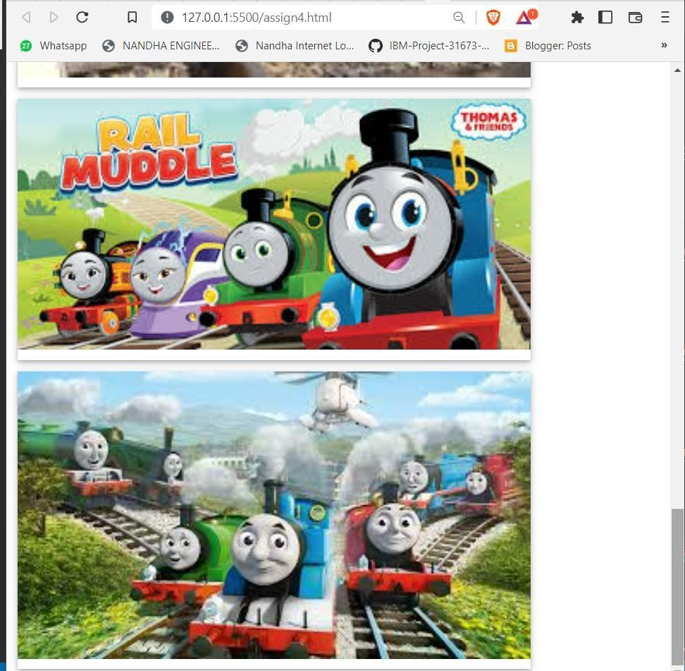

# Chatbot for Hospital:

LINK:

[https://web-](https://web-chat.global.assistant.watson.appdomain.cloud/preview.html?backgroundImageURL=https%3A%2F%2Fau-syd.assistant.watson.cloud.ibm.com%2Fpublic%2Fimages%2Fupx-cc3580bf-1448-4593-a58f-075ae1a72b58%3A%3A49974eb5-08b0-48d8-9a0c-223bdb0d1e5c&integrationID=6cc1a32d-3719-47b4-9a7a-3aa948861473&region=au-syd&serviceInstanceID=cc3580bf-1448-4593-a58f-075ae1a72b58) [chat.global.assistant.watson.appdomain.cloud/preview.html?backgroundImageURL=https%3A%2F%](https://web-chat.global.assistant.watson.appdomain.cloud/preview.html?backgroundImageURL=https%3A%2F%2Fau-syd.assistant.watson.cloud.ibm.com%2Fpublic%2Fimages%2Fupx-cc3580bf-1448-4593-a58f-075ae1a72b58%3A%3A49974eb5-08b0-48d8-9a0c-223bdb0d1e5c&integrationID=6cc1a32d-3719-47b4-9a7a-3aa948861473&region=au-syd&serviceInstanceID=cc3580bf-1448-4593-a58f-075ae1a72b58) [2Fau-syd.assistant.watson.cloud.ibm.com%2Fpublic%2Fimages%2Fupx-cc3580bf-1448-4593-a58f-](https://web-chat.global.assistant.watson.appdomain.cloud/preview.html?backgroundImageURL=https%3A%2F%2Fau-syd.assistant.watson.cloud.ibm.com%2Fpublic%2Fimages%2Fupx-cc3580bf-1448-4593-a58f-075ae1a72b58%3A%3A49974eb5-08b0-48d8-9a0c-223bdb0d1e5c&integrationID=6cc1a32d-3719-47b4-9a7a-3aa948861473&region=au-syd&serviceInstanceID=cc3580bf-1448-4593-a58f-075ae1a72b58) [075ae1a72b58%3A%3A49974eb5-08b0-48d8-9a0c-223bdb0d1e5c&integrationID=6cc1a32d-3719-](https://web-chat.global.assistant.watson.appdomain.cloud/preview.html?backgroundImageURL=https%3A%2F%2Fau-syd.assistant.watson.cloud.ibm.com%2Fpublic%2Fimages%2Fupx-cc3580bf-1448-4593-a58f-075ae1a72b58%3A%3A49974eb5-08b0-48d8-9a0c-223bdb0d1e5c&integrationID=6cc1a32d-3719-47b4-9a7a-3aa948861473&region=au-syd&serviceInstanceID=cc3580bf-1448-4593-a58f-075ae1a72b58) [47b4-9a7a-3aa948861473&region=au-syd&serviceInstanceID=cc3580bf-1448-4593-a58f-](https://web-chat.global.assistant.watson.appdomain.cloud/preview.html?backgroundImageURL=https%3A%2F%2Fau-syd.assistant.watson.cloud.ibm.com%2Fpublic%2Fimages%2Fupx-cc3580bf-1448-4593-a58f-075ae1a72b58%3A%3A49974eb5-08b0-48d8-9a0c-223bdb0d1e5c&integrationID=6cc1a32d-3719-47b4-9a7a-3aa948861473&region=au-syd&serviceInstanceID=cc3580bf-1448-4593-a58f-075ae1a72b58) [075ae1a72b58](https://web-chat.global.assistant.watson.appdomain.cloud/preview.html?backgroundImageURL=https%3A%2F%2Fau-syd.assistant.watson.cloud.ibm.com%2Fpublic%2Fimages%2Fupx-cc3580bf-1448-4593-a58f-075ae1a72b58%3A%3A49974eb5-08b0-48d8-9a0c-223bdb0d1e5c&integrationID=6cc1a32d-3719-47b4-9a7a-3aa948861473&region=au-syd&serviceInstanceID=cc3580bf-1448-4593-a58f-075ae1a72b58)

Image:

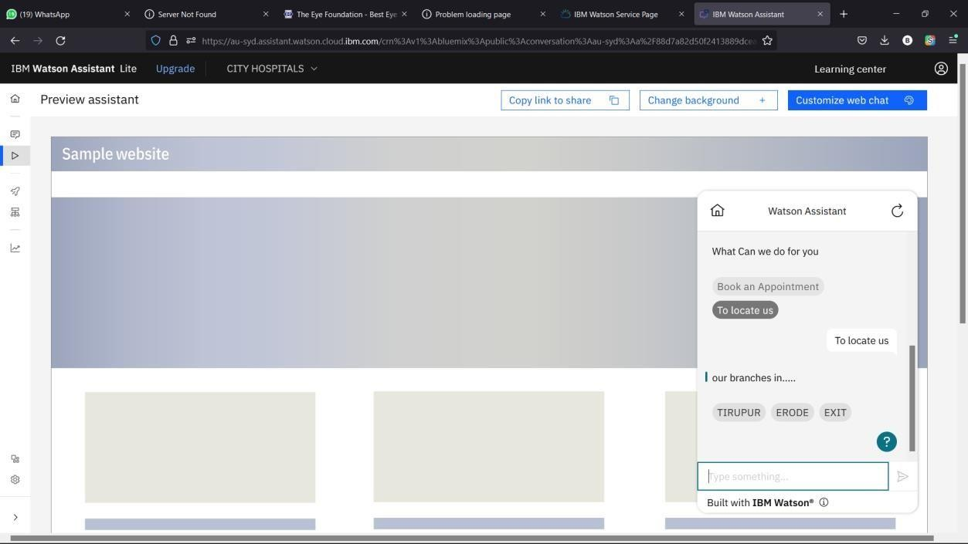

# Create Watson Assistant service with 10 steps and use 3 conditions in it and load that script in HTML page.

EMBEDED CODE:

<script> window.watsonAssistantChatOptions = {

integrationID: "6cc1a32d-3719-47b4-9a7a-3aa948861473", // The ID of this integration. region: "au-syd", // The region your integration is hosted in.

serviceInstanceID: "cc3580bf-1448-4593-a58f-075ae1a72b58", // The ID of your service instance. onLoad: function(instance) { instance.render(); }

};

setTimeout(function(){

const t=document.createElement('script');

t.src="https://web-chat.global.assistant.watson.appdomain.cloud/versions/" + (window.watsonAssistantChatOptions.clientVersion || 'latest') + "/WatsonAssistantChatEntry.js";

document.head.appendChild(t);

});

</script>

HTML Code:

<!DOCTYPE html>

<html lang="en">

<head>

<meta charset="UTF-8">

<meta http-equiv="X-UA-Compatible" content="IE=edge">

<meta name="viewport" content="width=device-width, initial-scale=1.0">

<title>CITY HOSPITAL | HOME</title>

<meta charset="UTF-8">

<!-- favicon -->

<!-- <link rel="shortcut icon" href="/assets/img/favicon.ico" type="image/x-icon"> -->

<!-- <link rel="icon" href="/assets/img/favicon.ico" type="image/x-icon"> -->

<link rel="icon" type="image/png" sizes="16x16" href="/assets/img/favicon-32x32.png">

<!-- bootstrap css cdn -->

<link rel="stylesheet" href="https://stackpath.bootstrapcdn.com/bootstrap/4.5.2/css/bootstrap.min.css" integrity="sha384-JcKb8q3iqJ61gNV9KGb8thSsNjpSL0n8PARn9HuZOnIxN0hoP+VmmDGMN5t9UJ0Z" crossorigin="anonymous">

<link rel="stylesheet" href="https://cdnjs.cloudflare.com/ajax/libs/font-awesome/4.7.0/css/font- awesome.css">

<!-- css stylesheet -->

<link rel="stylesheet" href="css/style.css">

<!-- font styles cdn -->

<link rel="preconnect" href="https://fonts.gstatic.com">

<link href="https://fonts.googleapis.com/css2?family=Alegreya&display=swap" rel="stylesheet">

<link href=["https:](https://fonts.googleapis.com/css2?family=Alegreya%3Awght%40600&display=swap)/[/fonts.googleapis.com/css2?family=Alegreya:wght@600&display=swap"](https://fonts.googleapis.com/css2?family=Alegreya%3Awght%40600&display=swap) rel="stylesheet">

</head>

<body>

<!-- bootstrap navbar -->

<nav class="navbar sticky-top navbar-expand-lg navbar-dark">

<div class="container-fluid">

<a class="main-logo-img mt-3" href="#"><img src="/static/img/smartinternz.png" alt="sheep-logo" height="50px" width="180px">

<!-- <a class="navbar-brand" href="index.html">KMCH</a> -->

</a>

<div class="row donate-sponsor">

<a type="button" class="btn btn-success mr-1" id="donate" href="mediaroom.html">MEDIA ROOM</a>

<a type="button" class="btn btn-warning mr-1" id="sponsor" href="photogallery.html">PHOTO GALLERY</a>

<a type="button" class="btn btn-primary mr-1" id="sponsor" href="viedogallery.html">VIEDO GALLERY</a>

</div>

</div>

</nav>

<!-- navbar ends -->

<!-- what we focus on -->

<section class="our-focus">

<div class="container">

<h2 class="text-center mt-3">About us</h2>

<div class="row ml-3 mt-3">

<div class="col-lg-3 mr-5" id="focus-first">

<div class="card" style="width: 19rem;">

<!-- <img src="assets/img/home kids.jpg" class="card-img-top" alt="..."> -->

<div class="card-body">

<h5 class="card-title">About</h5>

<p class="card-text">

The City Hospital has proved as one of the best multispeciality specialty hospital in all the major cities in south India and has a track reacord of nearly three decades, treating millions of patients through super specialty eye hospitals located in major cities.

</p>

</div>

</div>

</div>

<div class="col-lg-3 mr-5" id="focus-second">

<div class="card" style="width: 20rem;">

<!-- <img src="assets/img/friendship day.JPG" class="card-img-top" alt="..."> -->

<div class="card-body">

<h5 class="card-title">Vission</h5>

<p class="card-text">To be an Health Care Center par Exellence constantly striving to be a forntrunner. </p>

</div>

</div>

</div>

<div class="col-lg-3 ml-5" id="focus-third">

<div class="card" style="width: 20rem;">

<!-- <img src="assets/img/health camp.jpg" class="card-img-top" alt="..."> -->

<div class="card-body">

<h5 class="card-title">Mission</h5>

<p class="card-text">

The City Hospital is dedicated to provide quality health care with clinical exellennce and patient care of the highest order by constantly upgrading its knowledge and technology.</p>

</div>

</div>

</div>

</div>

</div>

</section>

<!-- focus section ends -->

<!-- footer starts -->

<!-- Site footer -->

<footer class="site-footer">

<div class="container mt-5">

<div class="row">

<div class="col-sm-12 col-md-6">

<h3>Over View</h3>

<p class="text-justify">A Health Care Provider of Western Approach with an Indian Touch. City Hospital is the most trusted Hospital in the Southern Indian Cities.

The relentless service in the past 15 years, taken health care to the most modern levels in the region catering to urban and rural population.</p>

</div>

<div class="col-xs-6 col-md-3">

<h4>contact us</h4>

<ul class="footer-links">

<li><a href="<mailto:test@gmail.com>">[contact@cityhospitals.com](mailto:contact@cityhospitals.com)</a></li>

<li><a href="">+ 91-9988453478</a></li>

</ul>

</div>

</div>

<hr>

</div>

</div>

</footer>

<script> window.watsonAssistantChatOptions = {

integrationID: "6cc1a32d-3719-47b4-9a7a-3aa948861473", // The ID of this integration. region: "au-syd", // The region your integration is hosted in.

serviceInstanceID: "cc3580bf-1448-4593-a58f-075ae1a72b58", // The ID of your service instance. onLoad: function(instance) { instance.render(); }

};

setTimeout(function(){

const t=document.createElement('script');

t.src="https://web-chat.global.assistant.watson.appdomain.cloud/versions/" + (window.watsonAssistantChatOptions.clientVersion || 'latest') + "/WatsonAssistantChatEntry.js";

document.head.appendChild(t);

});

</script>

</body>

</html>

