Ideation Phase

Define the Problem Statements

|  |  |
| --- | --- |
| Date | 04 November 2022 |
| Team ID | PNT2022TMID13624 |
| Project Name | Project – Analytics of Hospital Health-Care  Data |
| Maximum Marks | 2 Marks |

Reference: <https://miro.com/templates/customer-problem-statement/>

**Example :**

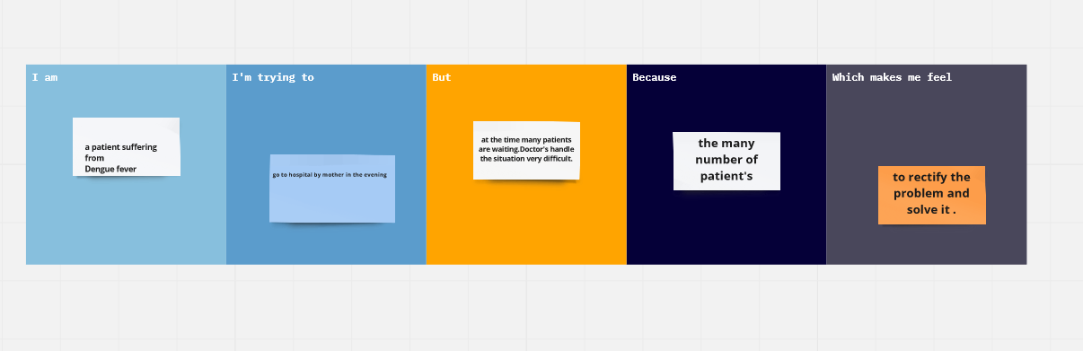

|  |  |  |  |  |  |
| --- | --- | --- | --- | --- | --- |
| **Problem Statement**  **(PS)** | **Iam (Customer)** | **I’m trying to** | **But** | **Because** | **Which makes me feel** |
| **PS-1** | **a patient suffering from the Dengue fever** | **Go to hospital by mother in the evening** | **At the time many patients are waiting.**  **Doctor’s handle the situation difficult.** | **The many number of patient’s** | **To rectify the problem and solve it.** |