PRE-REQUISITES

Software

|  |  |
| --- | --- |
| DATE | Nov 2022 |
| TEAM ID | PNT2022TMID49191 |
| PROJECT NAME | Real Time River WaterQuality Monitor And Control System |
| MAXIMUM MARKS | 2 Marks |

# Software:

Software is a set of instructions, data or programs used to operate computers and execute specific tasks. It is the opposite of hardware, which describes the physical aspects of a computer. Software is a generic term used to refer to applications, scripts and programs that runon a device.

# Software:

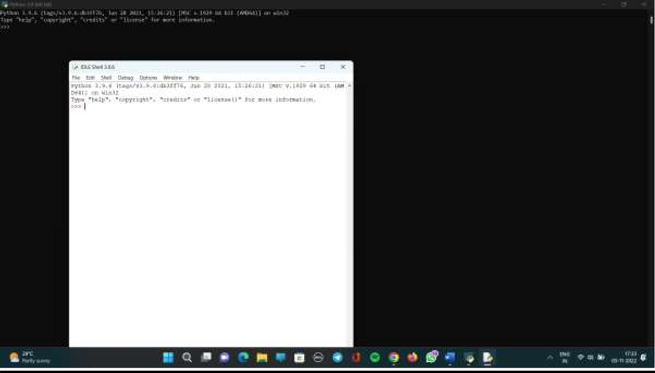**Python 3.7 and Python 3.7.0 shell has been created**

# Arduino IDE with AdafruitADS_1X15 LIBRARY

