PREREQUISITES:

TEAM ID: PNT2022TMID13481 IBM – CLOUD ACCOUNT CREATION:

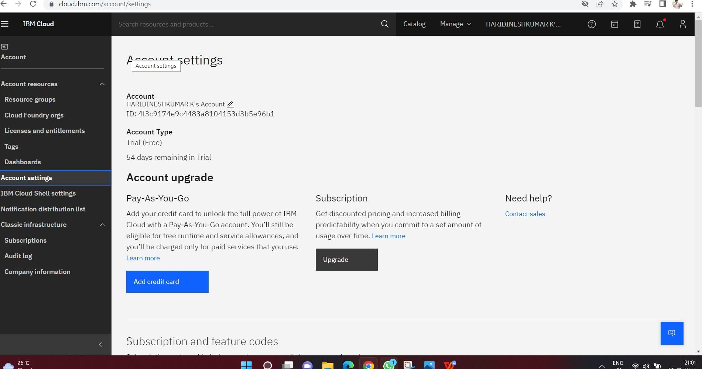

PYTHON INSTALLATION:

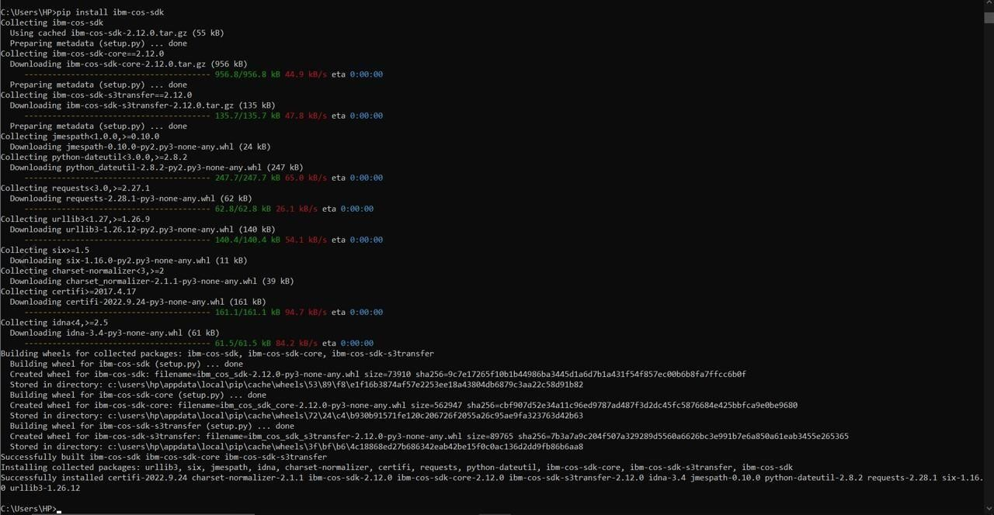

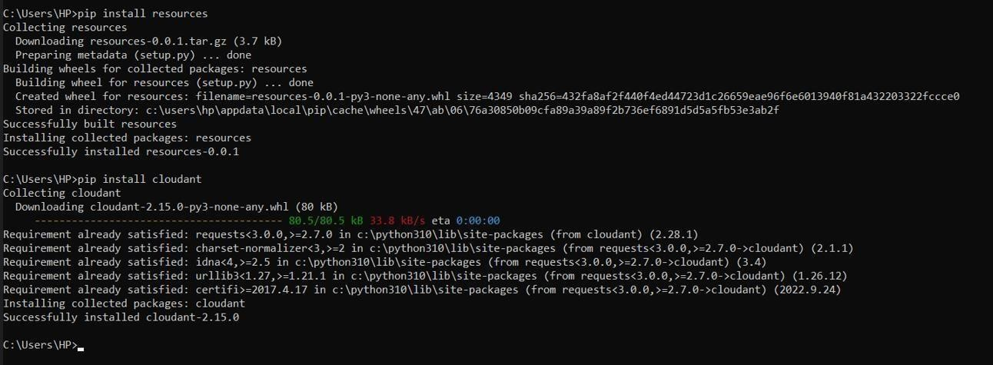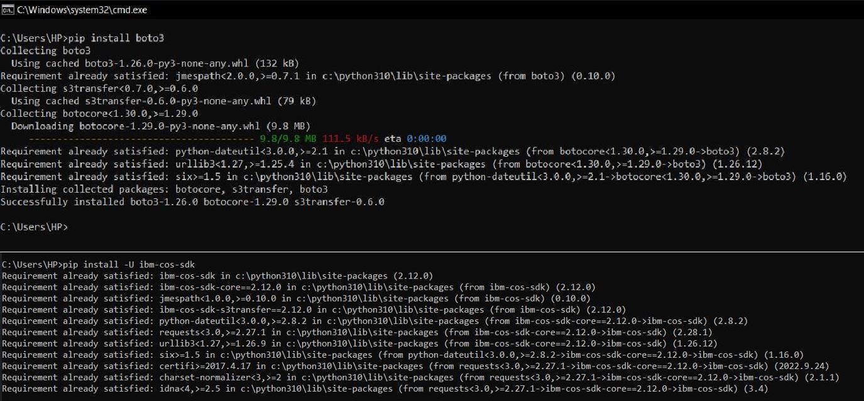

ACCOUNT CREATION IN CLARIFAI:

