# ASSIGNMENT-2

**PYTHON CODE FOR TEMPERATURE AND HUMIDTY MONITORING ALERT SYSTEM**

**CODE:**

import random

import time

while True:

temperature = random.randint(-15,100)

humidity = random.randint(1,100)

print(f"Checking Temperature: {temperature}"u'\N{DEGREE SIGN}'"C");

print(f"Checking Humidity: {humidity}%");

f = (temperature * 1.8 ) +32

print("Temperature in Fahrenheit is:",f)

if temperature >=37:

print(f"{temperature}"u'\N{DEGREE SIGN}'"C is a Hot Temperature\n Alarm is activated \n Notification is Notified")

elif temperature==37:

print(f"{temperature}"u'\N{DEGREE SIGN}'"C is a Normal Temperature")

if humidity >= 100:

print(f"{humidity}% it is a Humid humidity level")

elif 65<humidity<100 :

print(f"{humidity}% it is a Prefect humidity level")

else :

print(f"{humidity}% it is a Dry humidity level")

time.sleep(30)

# OUTPUT:

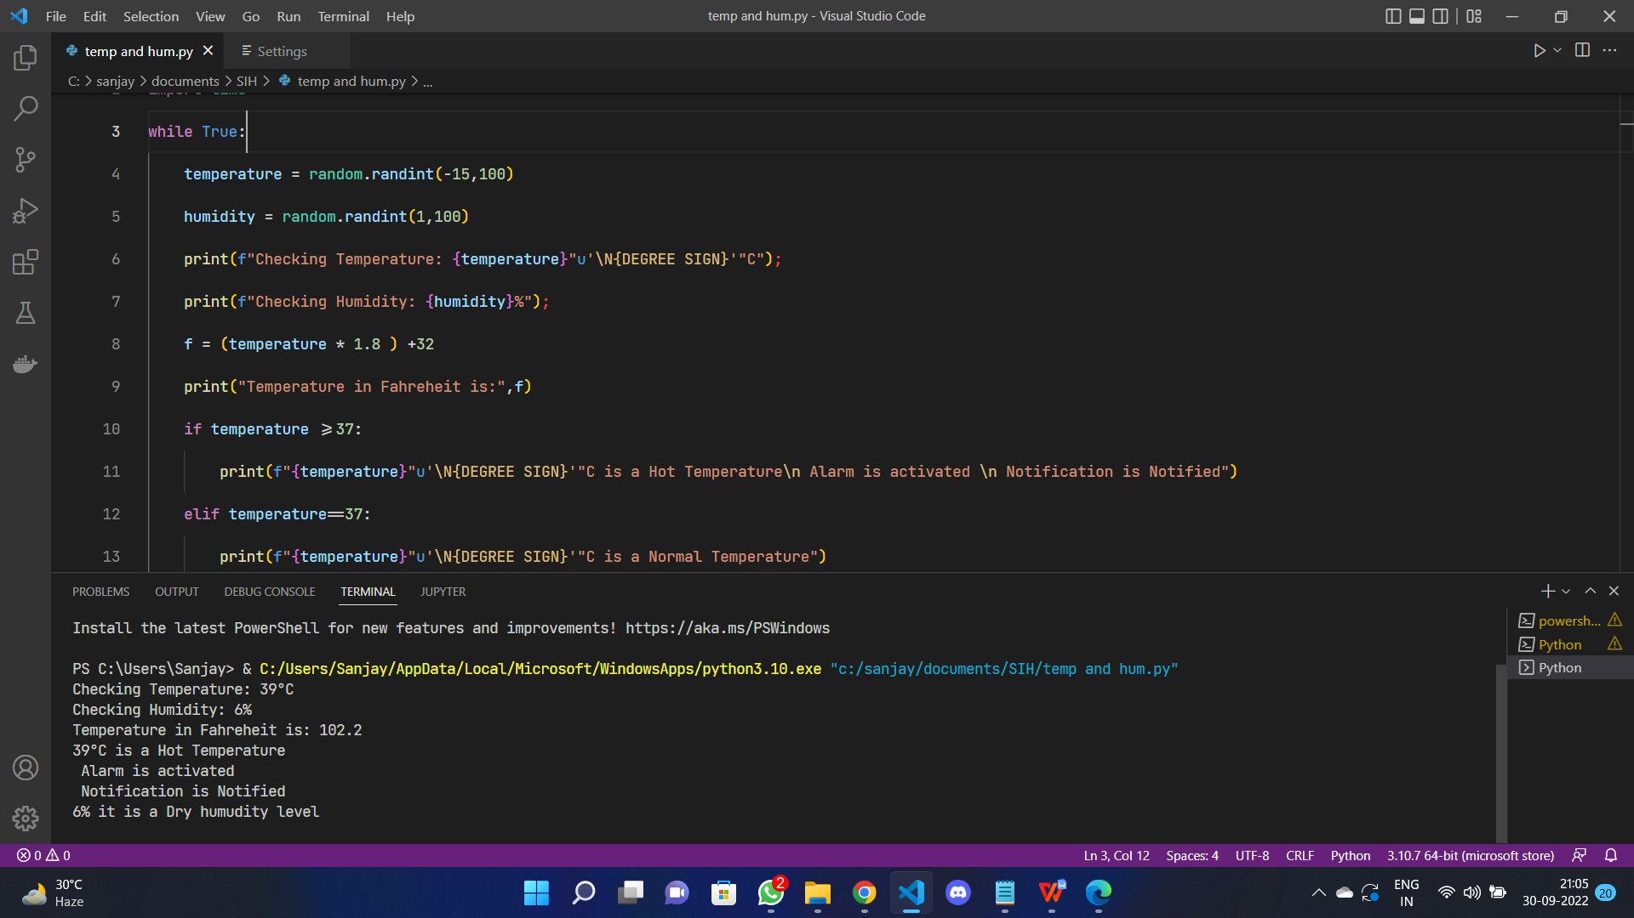

**OUTPUT:**

Checking Humidity: 56%

Temperature in Fahrenheit is: 111.2

44°C is a Hot Temperature

Alarm is activated

Notification is Notified

56% it is a Dry humidity level

Checking Temperature: 2°C

Checking Humidity: 43%

Temperature in Fahrenheit is: 35.6

43% it is a Dry humidity level

Checking Temperature: 62°C

Checking Humidity: 38%

Temperature in Fahrenheit is: 143.60000000000002

62°C is a Hot Temperature

Alarm is activated

Notification is Notified

38% it is a Dry humidity level

Checking Temperature: -12°C

Checking Humidity: 20%

Temperature in Fahrenheit is: 10.399999999999999

20% it is a Dry humidity level

Checking Temperature: 19°C

Checking Humidity: 12%

Temperature in Fahrenheit is: 66.2

12% it is a Dry humidity level