SMART FARMER – IoT ENABLED SMART FARMER APPLICATION ASSIGNMENT – 4

|  |  |
| --- | --- |
| **Team ID** | PNT2022TMID12810 |
| **Name** | TAMIL SELVAN S |
| **Roll No.** | 718020L419 |

**1. Write Code and connections in wokwi for ultrasonic sensor. Whenever distance is less than 100 centimetres send an *‘alert’* to the ibm cloud and display in device recent events.**

**Program:**

#define ECHO_PIN 2

#define TRIG_PIN 3

void setup() { **Serial**.begin(115200); pinMode(LED_BUILTIN, OUTPUT); pinMode(TRIG_PIN, OUTPUT); pinMode(ECHO_PIN, INPUT);

}

float readDistanceCM() { digitalWrite(TRIG_PIN, LOW); delayMicroseconds(2); digitalWrite(TRIG_PIN, HIGH); delayMicroseconds(10); digitalWrite(TRIG_PIN, LOW);

int duration = pulseIn(ECHO_PIN, HIGH); return duration * 0.034 / 2;

}

void loop() {

float distance = readDistanceCM(); if(distance<100)

{

**Serial**.println("Alert!!!!!!!!!");

}

**Serial**.print("Measured distance: ");

**Serial**.println(readDistanceCM());

delay(100);

}

**Wokwi Editor window:**



**Results:**

1. The measured distance is less than 100 centimetres, it gives alert message

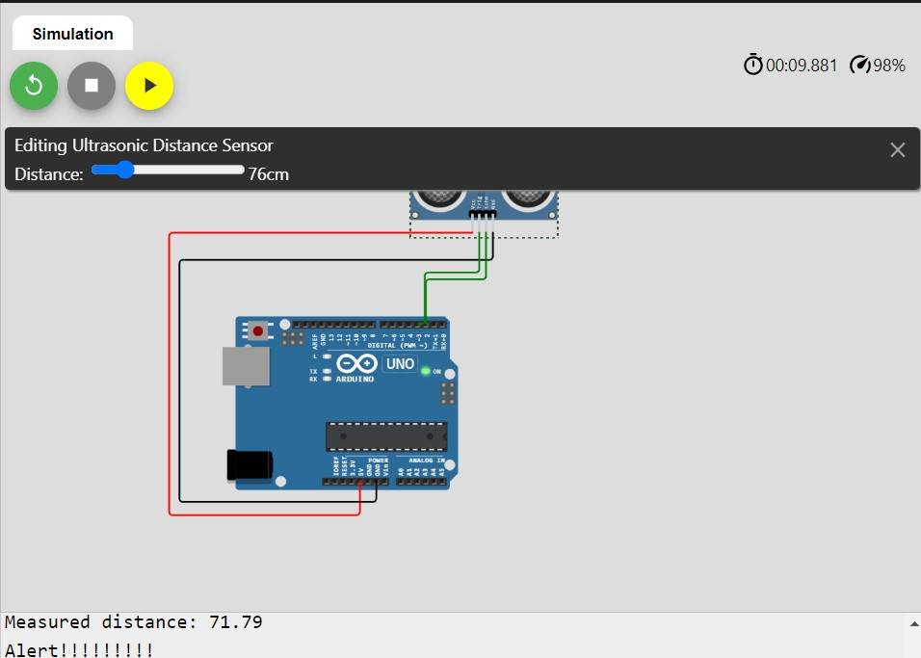

1. The measured distance is more than 100 centimetres, it will not give alert message

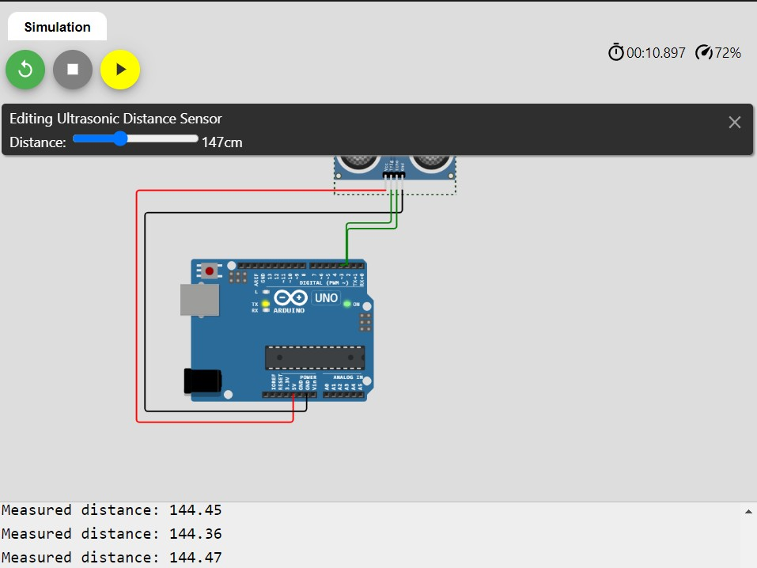

**Wokwi Link:** [**https://wokwi.com/projects/346951499588305491**](https://wokwi.com/projects/346951499588305491)