PREREQUISITES

Software

|  |  |
| --- | --- |
| Team ID | PNT2022TMID12755 |
| Project Name | Project: Signs with Smart Connectivity for Better Road Safety |

1. **Install Python IDE**

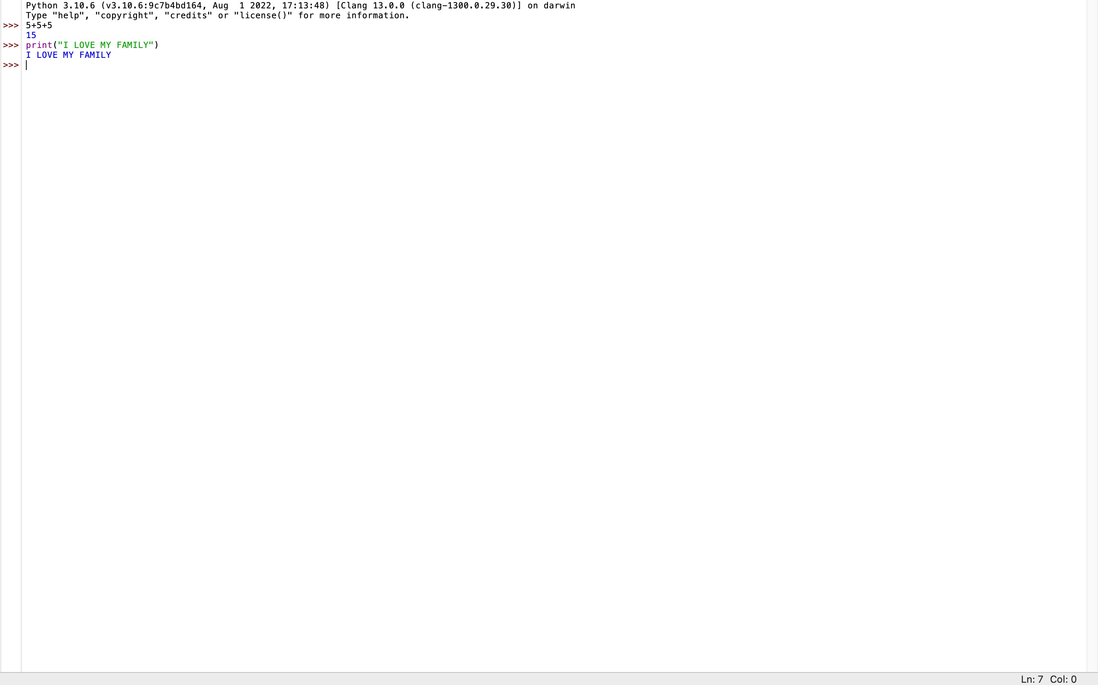

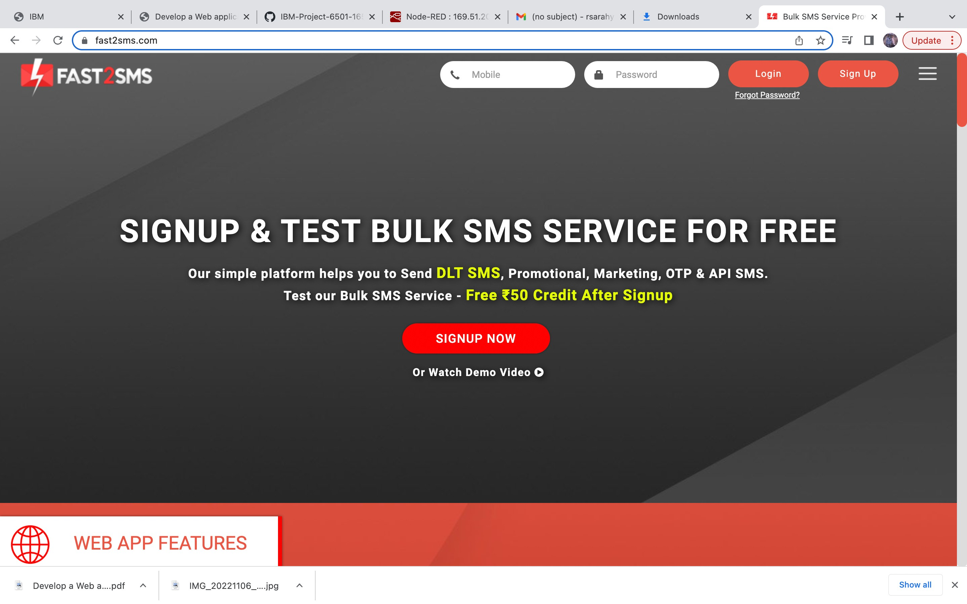

1. 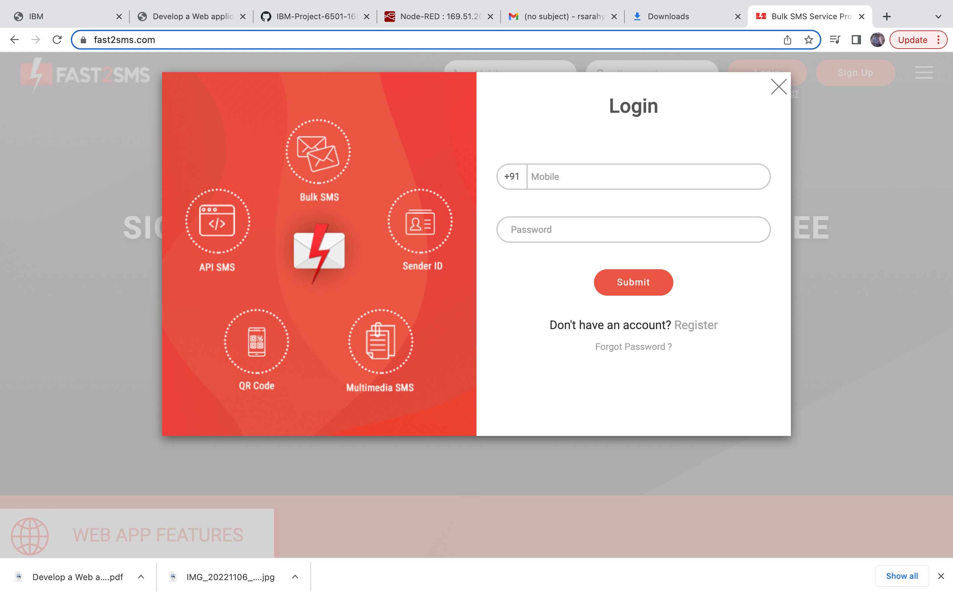**Fast SMS Service:**

