**Fertilizers Recommendation System For Disease Prediction**

## IBM PROJECT-NALAIYA THIRAN

***Submitted by***

**Team ID:** **PNT2022TMID26182**

|  |  |
| --- | --- |
| **HARENEE A S** | **(21151920505)** |
| **BHAVANI S** | **(211519205022)** |
| **RENNIE SHARON ROSE P** | **(211519205125)** |
| **JANANIPRIYAR** | **(211519205301)** |

***In partial fulfillment for the award of the degree of***

## BACHELOROF TECHNOLOGY

**In**

**INFORMATIONTECHNOLOGY**

## PANIMALAR INSTITUTE OF TECHNOLOGYANNAUNIVERSITY: CHENNAI-600025

**NOVMBER-2022**

# TABLEOFCONTENTS

|  |  |  |
| --- | --- | --- |
| **S.NO** | **CONTENT** | **PAGE.NO** |
| I | ABTRACT | iii |
| **1** | **INTRODUCTION** | **1** |
|  | 1.1 PROJECT OVERVIEW | 1 |
|  | 1.2 PURPOSE | 1 |
| **2** | **LITERATUREREVIEW** | **2** |
|  | 2.1 EXISTING PROBLEM |  |
|  | 2.2 REFERENCES |  |
|  | 2.3 PROBLEM STATEMENT DEFINITION |  |
| **3** | **IDEATION & PROPOSED SOLUTION** | **13** |
|  | 3.1 EMPATHY MAP CANVAS | 8 |
|  | 3.2 IDEATION & BRAINSTORMING | 9 |
|  | 3.3 PROPOSED SOLUTION | 9 |
|  | 3.4 PROBLEM SOLUTION FIT |  |
| **4** | **REQUIREMENT ANALYSIS** | **19** |
|  | 4.1 FUNCTIONAL REQUIREMENT | 12 |
|  | 4.2 NON-FUNCTIONAL REQUIREMENT | 12 |
|  |  |  |

1. PROJECT DESIGN 20
   1. DATA FLOW DIAGRAMS 15
   2. SOLUTION & TECHNICAL ARCHITECTURE 18
   3. USER STORIES 19
2. PROJECT PLANNING & SCHEDULING 23
   1. SPRINT PLANNING & ESTIMATION 24
   2. SPRINT DELIVERY SCHEDULE 24
   3. REPORTS FROM JIRA 26
3. CODING & SOLUTIONING 29
   1. FEATURE 1 27
   2. FEATURE 2 27
4. TESTING 31
   1. TEST CASES 33
   2. USER ACCEPTANCE TESTING 33
5. RESULTS 37
   1. PERFORMANCE METRICS 34
6. ADVANTAGES&DISADVANAGES 39
7. FUTUREWORK 40
8. REFERENCES 41
9. APPENDIX 42
   1. SOURCE CODE 48
   2. GitHub & Project Demo Link 50

# ABSTRACT

India is the largest agrarian economy in the world, with 54% of its total land area classified as arable. More over half of the world's gross domestic product is made up of agricultural production (GDP). It has been demonstrated that boosting agricultural output has a big influence on lowering poverty. Numerous variables might have an impact on the quantity of harvestable crops grown in a specific area. These three main categories of elements (climate, soil fertility, terrain, water quality, etc.) are made up of a combination of biological, technological, and environmental factors. over-fertilization-related soil infertility, as well as a The various variables that lead to low agricultural production include access issues and a lack of knowledge about modern farming techniques. The major goal of this research project is to create a recommendation system based on machine learning to boost agricultural output. In this work, sophisticated models were designed and developed to predict the crop, suggest fertiliser, and detect plant illness. Based on the regional soil nutrients and rainfall, the XGBoost model forecasts an appropriate crop. Rough Forest [RF] Based on the nutrients available in the soil, a model was utilised to suggest fertiliser and generate suggestions for boosting soil fertility. The plant illness is identified using NB Classifier and Support Vector Machine [SVM], which also offers a treatment. The suggested model offers a high level of accuracy in comparison to existing methods. Additionally, this article advises the farmer to boost crop output by entering input values and local soil conditions, where the model provides 99% accurate crop recommendations.

# CHAPTER 1

# INTRODUCTION

* 1. **PROJECT OVERVIEW**

Agriculture accounts for more than half of the world's gross domestic output (GDP). It has been established that increasing agricultural productivity has a significant impact on poverty reduction. A variety of factors can influence the amount of harvestable crops growing in a given location. These three major groups of components (climate, soil fertility, topography, water quality, and so on) are made up of biological, technical, and environmental aspects. A variety of factors impact agricultural practises. Fertilizers and insecticides were made more affordable to Bangladeshi farmers.That they might employ more of them, increasing agricultural output Phosphorus shortage was discovered in sugarcane crops A lime layer had developed in the subsurface, resulting in an uneven potassium/magnesium ratio. Planting too early, planting too close together, planting too deep, weeding too late, and selecting low-yielding cultivars will always result in lower yields.. soil infertility caused by over fertilization, as well as a Access concerns and a lack of understanding about contemporary farming practises are two of the many factors that contribute to low agricultural productivity. The primary purpose of this research project is to develop a machine learning-based recommendation system to increase agricultural productivity. In this study, sophisticated models were devised and developed to estimate crop yield, recommend fertilizer, and identify plant disease.

# PURPOSE

To Detect and recognize the plant diseases and to recommend fertilizer, it is necessary to provide symptoms in identifying the disease at its earliest. Hence the authors proposed and implemented new fertilizers Recommendation System for crop disease prediction.

# CHAPTER-2

**LITERATURE REVIEW**

**2.1** **EXISTING PROBLEM**

Adequate mineral nutrition is central to crop production. However, it can also exert considerable Influence on disease development. Fertilizer application can increase or decrease development of diseases caused by different pathogens, and the mechanisms responsible are complex, including effects of nutrients on plant growth, plant resistance mechanisms and direct effects on the pathogen. The effects of mineral nutrition on plant disease and the mechanisms responsible for those effects have been dealt with comprehensively elsewhere. In India, around 40% of land is kept and grown using reliable irrigation technologies, while the rest relies on the monsoon environment for water. Irrigation decreases reliance on the monsoon, increases food security, and boosts agricultural production.

Most research articles use humidity, moisture, and temperature sensors near the plant's root, with an external device handling all of the data provided by the sensors and transmitting it directly to an external display or an Android application. The application was created to measure the approximate values of temperature, humidity and moisture sensors that were programmed into a microcontroller to manage the amount of water.

**2.2 REFERANCE**

**Soil Fertilizer Recommendation System using Fuzzy Logic**

**J. J. I. Haban, J. C. V. Puno, A. A. Bandala, R. Kerwin Billones, E. P. Dadios and E.Sybingco, "Soil Fertilizer Recommendation System using Fuzzy Logic," 2020 IEEE REGION 10 CONFERENCE (TENCON), 2020, pp. 1171-1175, doi:10.1109/TENCON50793.2020.9293780.**

Soil nutrients and season have direct impact on the growth and yield of a crop.Deficiency on the nutrient level of the soil may result to plant disease while applying excessive amount of soil fertilizer on the other hand, may also cause negative results to the development of the crop. Nutrients on the soil also changes as the season changes from wet season to dry season. This study aims to develop a fuzzy logic-based program that will provide an appropriate amount of fertilizer to soil. The parameters such as season, nitrogen,phosphorus and potassium level are the inputs used on the fuzzy logic system

**ADVANTAGES:**

* Season, nitrogen, phosphorus and potassium level is used as input parameter of the fuzzy system.
* Different fertilizer combination is created depending on the range of input parameters used.

**DISADVANTAGES:**

* Used the recommended fertilizer to identify the accuracy of the result .
* Connect the program to a soil test analyzer.

# Farmer's Assistant: A Machine Learning Based Application for Agricultural Solutions

Shloka Gupta, Akshay Chopade, Nishit Jain, Aparna Bhonde,” Farmer's Assistant: A Machine Learning Based Application for Agricultural Solutions” arXiv:2204.11340 https://doi.org/10.48550/arXiv.2204.11340

Farmers face several challenges when growing crops like uncertain irrigation, poor soil quality, etc. Especially in India, a major fraction of farmers do not have the knowledge to select appropriate crops and fertilizers. Moreover, crop failure due to disease causes a significant loss to the farmers, as well as the consumers. While there have been recent developments in the automated detection of these diseases using Machine Learning techniques, the utilization of Deep Learning has not been fully explored. Additionally, such models are not easy to use because of the high-quality data used in their training, lack of computational power, and poor generalizability of the models. To this end, we create an open-source easy-to-use web application to address some of these issues which may help improve crop production.

# ADVANTAGES:

* 1. The user can provide the input using forms on our user interface and quickly get their results.

# DISADVANTAGES:

1. We can provide the availability of the same on the popular shopping websites, and possibly allow users to buy the crops and fertilizers directly from our application.
2. Unable to find data on various brands and items available based on the N,P,K values.
3. Unable to detect the correct class for any out-of-domain data.

# CNN based Leaf Disease Identification and Remedy Recommendation System

## Suma, R. A. Shetty, R. F. Tated, S. Rohan and T. S. Pujar, "CNN based Leaf Disease Identification and Remedy Recommendation System," 2019 3rd International conference on Electronics, Communication and Aerospace Technology (ICECA), 2019, pp. 395-399, doi: 10.1109/ICECA.2019.8821872.

Due to the improvement and development in technology where devices are smart enough to recognize and detect plant diseases. Recognizing illness can prompt faster treatment in order to lessen the negative impacts on harvest. This paper therefore focus upon plant disease detection using image processing approach This work utilizes an open dataset of 5000 pictures of unhealthy and solid plants, where convolution system and semi supervised techniques are used to characterize crop species and detect the sickness status of 4 distinct classes.

# ADVANTAGES:

* 1. The Network is trained using the images taken in the natural environment and achieved.

## DISADVANTAGES:

1. If there is any simple disease, it may predict it as a complex disease

# Crop Recommender System Using Machine Learning Approach

## S. M. PANDE, P. K. RAMESH, A. ANMOL, B. R. AISHWARYA, K. ROHILLA andK. SHAURYA, "Crop Recommender System Using Machine Learning Approach," 2021 5th International Conference on Computing Methodologies and Communication (ICCMC), 2021, pp. 1066-1071, doi: 10.1109/ICCMC51019.2021.9418351.

The proposed system provides connectivity to farmers via a mobile application. GPS helps to identify the user location. The user provides the area & soil type as input. Machine learning algorithms allow choosing the most profitable crop list or predicting the crop yield for a user-selected crop. To predict the crop yield, selected Machine Learning algorithms such as Support Vector Machine (SVM), Artificial Neural Network (ANN), Random Forest (RF), Multivariate Linear Regression (MLR), and K-Nearest Neighbour (KNN) are used. Among them, the Random Forest showed the best results with 95% accuracy. Additionally, the system also suggests the best time to use the fertilizers to boost up the yield.

# ADVANTAGES:

1. This paper highlighted the limitations of current systems and their practical usage on yield prediction

# DISADVANTAGES:

1. The future work will be focused on updating the datasets from time to time to produce accurate predictions, and the processes can be automated.
2. An analysis of available statistical data needs to be done.

# KRISHI RAKSHAN - A Machine Learning based New Recommendation System to the Farmer

## D. N. V. S. L. S. Indira, M. Sobhana, A. H. L. Swaroop and V. Phani Kumar, "KRISHI RAKSHAN - A Machine Learning based New Recommendation System to the Farmer," 2022 6th International Conference on Intelligent Computing and Control Systems (ICICCS), 2022, pp. 1798-1804, doi: 10.1109/ICICCS53718.2022.9788221.

The main purpose of this research work is to develop a machine learning-based recommendation system to increase agricultural productivity. A variety of datasets were used in this study to design and develop advanced models to estimate the crop, recommend fertiliser, and identify plant disease

# ADVANTAGES:

1. This system identifies the plant's ailment and presents the different treatment options.

# DISADVANTAGES:

1. Automation can be used for the data entries.
2. This system can be expanded to include additional features such as weather forecasting, drought conditions, and agricultural price forecasting depending on the season.

# Image-based Plant Diseases Detection using Deep Learning

## Panchal, S. C. Patel, K. Bagyalakshmi, P. Kumar, I. Raza Khan, M. Soni, “Image- based Plant Diseases Detection using Deep Learning”, Materials Today: Proceedings, 2021, ISSN 2214-7853, https://doi.org/10.1016/j.matpr.2021.07.281.

With the advance in Artificial Intelligence, there is a need to incorporate the facilities of the computer vision in the field of agriculture. Deep Learning rich libraries and user as well as developer friendly environment to work with, all these qualities make Deep Learning as the favorable method to get started with this problem. In this paper we have used Deep Learning because of the advantages it offers to work with images especially in image classification to get improvised results. The methodology includes taking leaves of infected crops and label them as per the disease pattern. The images of infected leaves are processed pixel based operations are applied to improve the information from the image.

# ADVANTAGES:

* 1. We trained a naïve network of slightly smaller size of varying number of layers and completely tuned parameter four recent models: Inception-v3, and ResNet50, VGG19, VGG16.
  2. Increased efficiency

# DISADVANTAGES:

1. Several diseases data collection for all stages can be done by using variety of sensors, like available in infrared camera also in multi camera.

# Soil Toxicity Prediction and Recommendation System Using Data Mining In Precision Agriculture

**M. Pawar and G. Chillarge, "Soil Toxicity Prediction and Recommendation System Using Data Mining In Precision Agriculture," 2018 3rd International Conference for Convergence in Technology (I2CT), 2018, pp. 1-5, doi: 10.1109/I2CT.2018.8529754.**

In this paper, the proposed system can help farmers by making them aware about their soil conditions. Farmers can maximize crops yield by knowing proportion of nutrients present in the soil. Soil toxicity affects the soil nutrients which indirectly affects crops health. The proposed system predicts the level of toxicity present in the soil and makes farmer aware about it. Many farmers are depending on rainfall which is the one of the factor for poor growth and decreases crops yield.

# ADVANTAGES:

1. The proposed system also informs farmers about toxicity level present in their soil as today the rate of pollution increasing very fast with industrialization.

# DISADVANTAGES:

1. If a single hardware fails, the total system halt.
2. Not able to reuse the hardware in the system

# Farmer’s Assistant: A Machine Learning Based Application for Agricultural Solutions

In this paper, we propose a user-friendly web application system based on machine learning and web-scraping called the ‘Farmer’s Assistant’. With our system, we are successfully able to provide several features - crop recommendation using Random Forest algorithm, fertilizer recommendation using a rule based classification system, and crop disease detection using Efficient Net model on leaf images. The user can provide the input using forms on our user interface and quickly get their results. In addition, we also use the LIME interpretability method to explain our predictions on the disease detection image, which can potentially help understand why our model predicts what it predicts, and improve the datasets and models using this information.

# ADVANTAGES:

1. For crop recommendation and fertilizer recommendation
2. we can provide the availability of the same on the popular shopping websites
3. And possibly allow users to buy the crops and fertilizers directly from our application.

# DISADVANTAGES:

1. To provide fine-grained segmentations of the diseased portion of the dataset.
2. This is not possible due to lack of such data.
3. However, in our application, we can integrate a segmentation annotation tool where the users might be able to help us with the lack.
4. Also, we can use some unsupervised algorithms to pin-point the diseased areas in the image.

# Intelligent insecticide and fertilizer recommendation system based on TPF- CNN for smart farming

It is necessary to control them to ensure healthy crop production. Many techniques are used to identify the pest, suggest medications, and do soil nutrient analysis techniques separately. This paper applies the dual operator, Transition Probability Function (TPF), and Convolution Neural Network (CNN the) to process pest's image discretely and continuously for applying the recommended insecticide. The mathematical model with the objective function is derived in this paper. The proposed system combines two major aspects in farming: pest identification and insecticide recommendation using machine.

vision and CNN. Secondly, the soil nutrient analysis uses a soil NPK sensor with the recommendation of fertilizers according to the obtained nutrient values. On-spot results are obtained, and the time required for insecticide recommendation is within 10 s, and for fertilizer recommendation, it is within 80 s.

# ADVANTAGE:

* 1. This system can be used anywhere as it is standalone and does not require an internet connection.
  2. Acquires 99.8 of accuracy.

# DISADVANTAGE:

1. It any hardware fail, the whole system may fail

**2.3 PROBLEM STATEMENT DEFINITION**

* The old traditional methods aren’t now suitable to the soil and the weather conditions, that are changing for the bad. In-fact they will have a negative impact on the soil.
* Sadly, even with the experience a farmer has, it is still not enough to judge about how the climatic conditions or the soil is going to affect the crop.
* Why? Because the NRT data of the soil is very low, if not zero.
* So we came up with a recommendation system for farmers that’ll help them in making Informed Decisions.

# CHAPTER-3

**IDEATION & PROPOSED SOLUTION**

**3.1 EMPATHY MAP CANVAS**

An empathy map is a simple, easy-to-digest visual that captures knowledge about a user’s behaviours and attitudes.

It is a useful tool to helps teams better understand their users.

Creating an effective solution requires understanding the true problem and the person who is experiencing it. The exercise of creating the map helps participants consider things from the user’s perspective along with his or her goals and challenges.

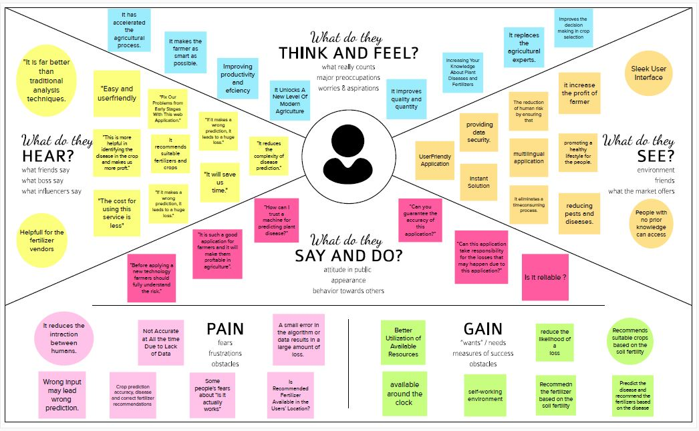

**3.2 Ideation & Brainstorming**

Brainstorming provides a free and open environment that encourages everyone within a team to participate in the creative thinking process that leads to problem solving. Prioritizing volume over value, out-of-the-box ideas are welcome and built upon, and all participants are encouraged to collaborate, helping each other develop a rich amount of creative solutions.

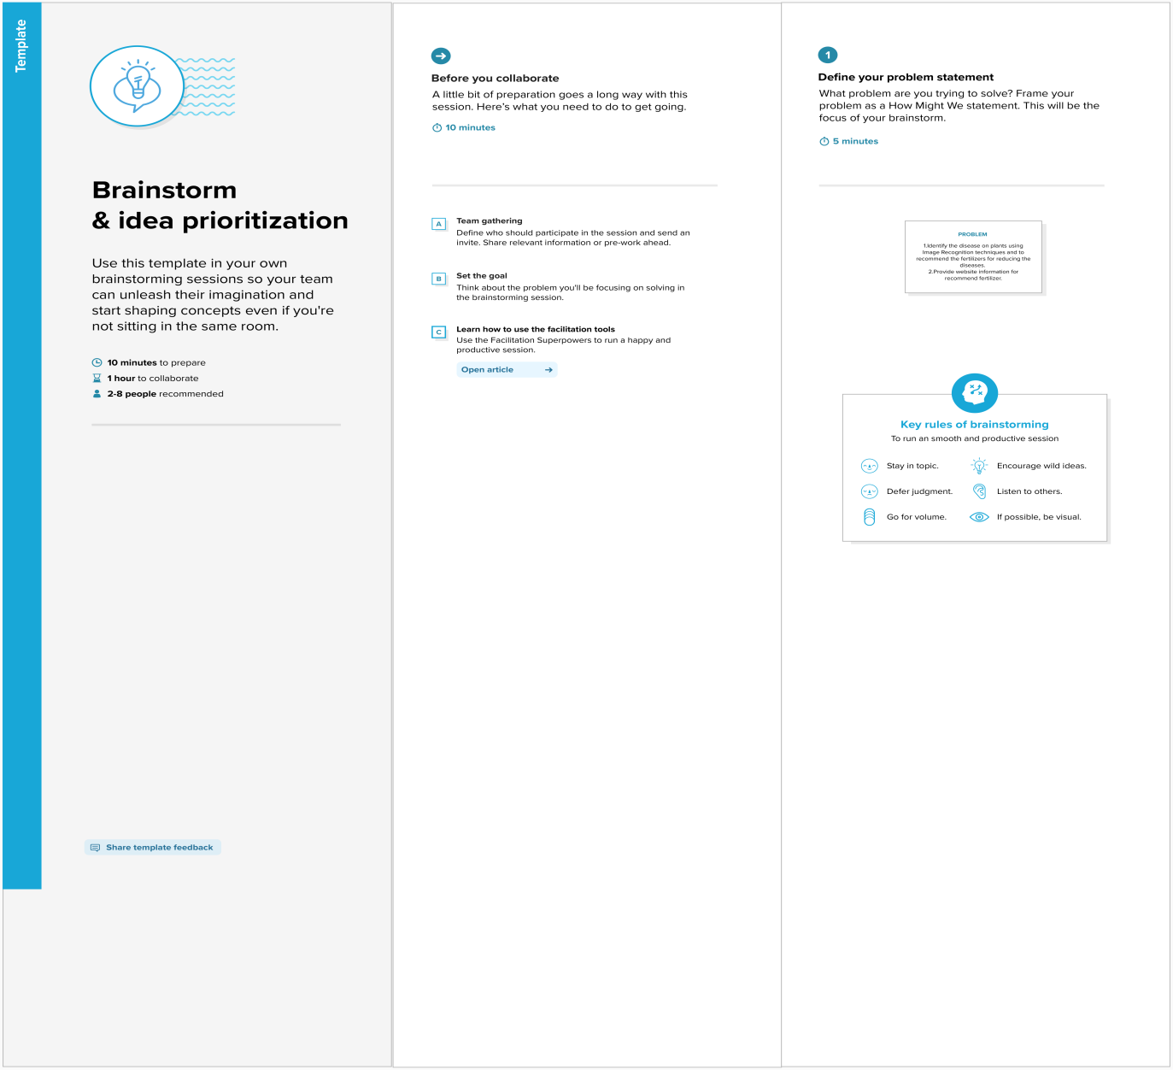

# Brainstorming (3).pngBrainstorming (4).png

# 3.3 PROPOSED SOLUTION

|  |  |  |
| --- | --- | --- |
| **S.No.** | **Parameter** | **Description** |
|  | Problem Statement (Problem to be solved) | How to identify the crop disease?  What are the fertilizers is used to cure the crop disease? |
|  | Idea / Solution description | 1. Ensure the correct prediction of crop disease to help the farmer to identify the crop disease priorly. 2. It reduces the loss and increase the profit |
|  | Novelty / Uniqueness | 1. Predicts the disease instantly 2. Predicting the crop baaed soil condition 3. Predicting the fertilizer based on the soil conditions and it tends to reduce the crop disease |
|  | Social Impact / Customer Satisfaction | Serves as farmer’s friend by helping them to take precautionary steps to minimize the economic losses. |
|  | Business Model (Revenue Model) | 1. Collaboration with fertilizer vendors. 2. Providing solutions for farmer’s problem. Increase in crop productivity |
|  | Scalability of the Solution | 1. Simplifying the model for everyone even the illiterate can use the system 2. To increase the profit, the fertilizer can sold directly to the farmers |

**3.4 PROBLEM SOLUTION FIT**

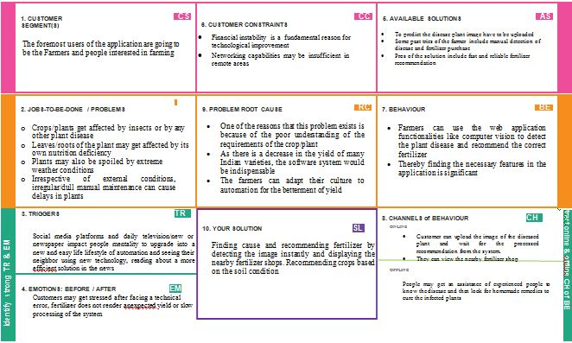

# CHAPTER-4 REQUIREMENT ANALYSIS

**4.1 FUNCTIONAL REQUIREMENT**

Following are the functional requirements of the proposed solution.

|  |  |  |
| --- | --- | --- |
| **FR No.** | **Functional Requirement (Epic)** | **Sub Requirement (Story / Sub-Task)** |
| FR-1 | User Registration | Registration through Form |
| FR-2 | User Confirmation | Confirmation via Email |
| FR-3 | User Profile | Filling the profile page after logging in |
| FR-4 | Uploading Dataset (Leaf) | Images of the leaves are to be uploaded |
| FR-5 | Requesting solution | Uploaded images is compared with the pre-defined Model and solution is generated |
| FR-6 | Downloading Solution | The Solution in pdf format which contains the recommendations of fertilizers and the possible diseases. |

**4.2 NON-FUNCTIONAL REQUIREMENTS**

Following are the non-functional requirements of the proposed solution.

|  |  |  |
| --- | --- | --- |
| **FR No.** | **Non-Functional Requirement** | **Description** |
| NFR-1 | **Usability** | The system allows the user to perform the tasks easily and efficiently and effectively. |
| NFR-2 | **Security** | Assuring all data inside the system or its part will be  protected against malware attacks or unauthorized access. |
| NFR-3 | **Reliability** | The website does not recover from failure quickly ,it  takes time as the application is running in single server |
| NFR-4 | **Performance** | Response Time and Net Processing Time is Fast |
| NFR-5 | **Availability** | The system will be available up to 95% of the time |
| NFR-6 | **Scalability** | The website is scalable |

# CHAPTER-5 PROJECT DESIGN

# DATA FLOW DIAGRAMS

A Data Flow Diagram (DFD) is a traditional visual representation of the information flows within a system. A neat and clear DFD can depict the right amount of the system requirement graphically. It shows how data enter and leaves the system, what changes the information, and where data is stored.

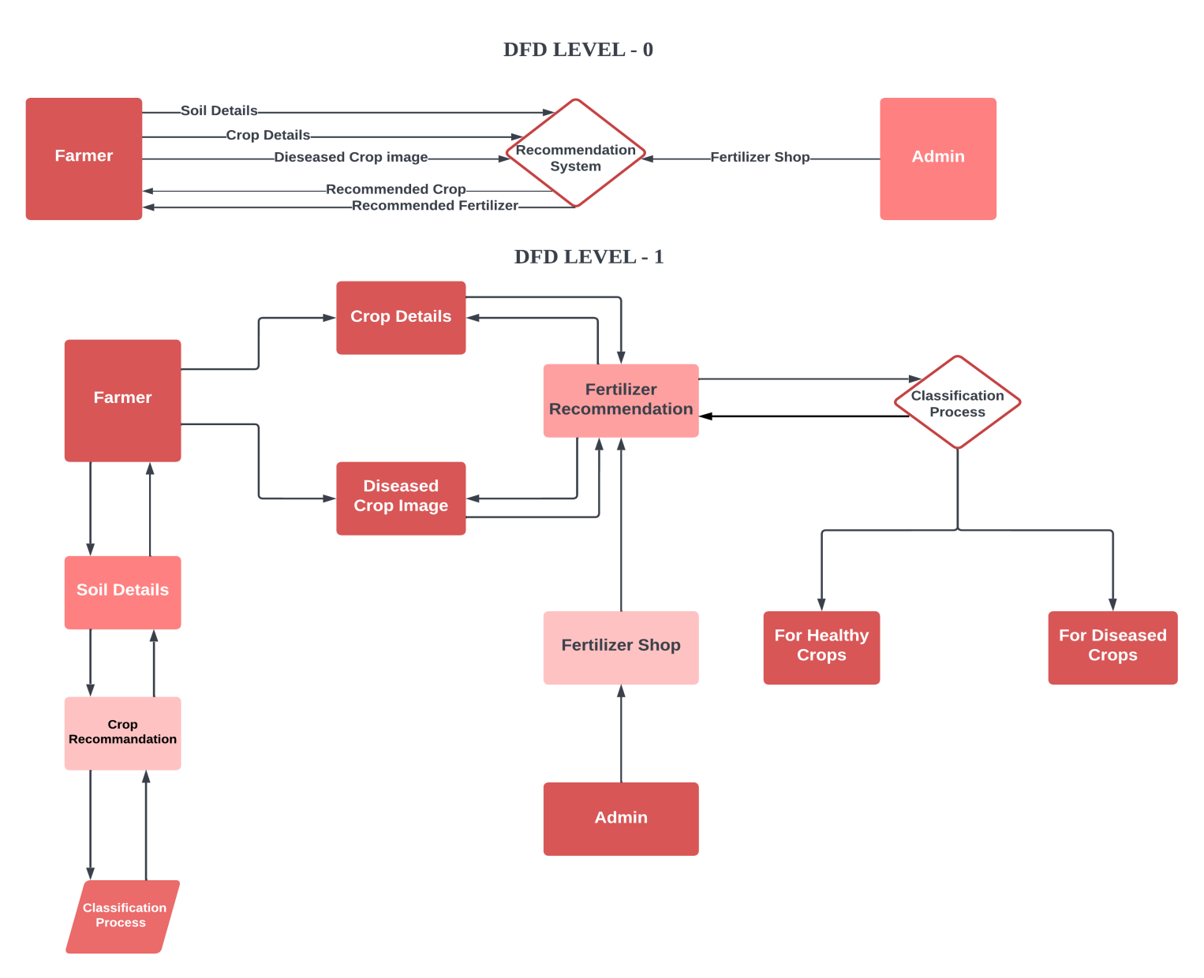

# Figure 5.1 DATA FLOW DIAGRAMS

* 1. **SOLUTION & TECHNICAL ARCHITECTURE**

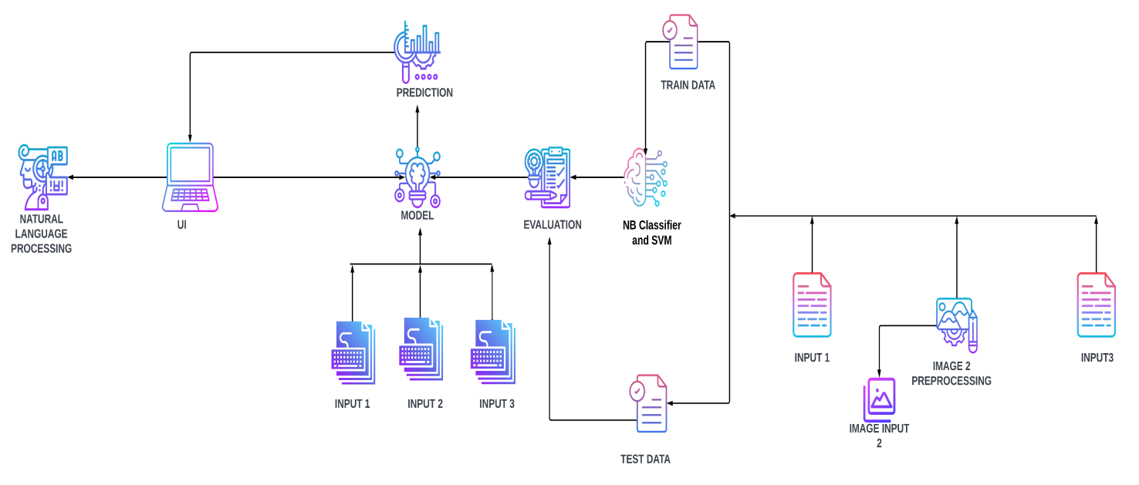

**5.3 User Stories:**

|  |  |  |  |  |  |  |
| --- | --- | --- | --- | --- | --- | --- |
| **User Type** | **Functional Requirement (Epic)** | **User Story Number** | **User Story / Task** | **Acceptance criteria** | **Priority** | **Release** |
| Customer  (Mobile user) | Registration | USN-1 | As a user, I can register for the application by entering my email, password, and confirming my password. | I can access my account /  dashboard | High | Sprint-1 |
|  | Login | USN-2 | As a user, I can log into the application by entering email &password | I can login using my E-mail ID accounts or user  credentials | High | Sprint-1 |
|  | Dashboard | USN-3 | As a user, I can view the page of the application where i can upload my images and the fertilizer should be recommended | I can access my account/ dashboard | High | Sprint-2 |
| Customer (Web user) | Registration | USN-4 | As a user, I can login to web dashboard just Like website dashboard | I can register using my username and  password | High | Sprint-3 |
|  | Login | USN-5 | As a user, I can login to my web dashboard with the login credentials | I can login using my User credentials | High | Sprint-3 |
|  | Dashboard | USN-6 | As a user, I can view the web application where i can upload my images and thefertilizer  should be recommended | I can access my account/dashboard | High | Sprint-4 |
|  |  | USN-7 | As a user, the fertilizer recommended to me should be of higher accuracy | I can access my  account/ dashboard | High | Sprint-4 |

# CHAPTER6

**PROJECT PLANNING & SCHEDULING**

* 1. **SPRINT PLANNING & ESTIMATION**

|  |  |  |  |  |  |  |
| --- | --- | --- | --- | --- | --- | --- |
| **Sprint** | **Functional Requirement**  **(Epic)** | **User Story**  **Number** | **User Story / Task** | **Story Points** | **Priority** | **Team**  **Members** |
| Sprint-1 | Image Processing | USN-1 | As a user, I can retrieve information about the image | 1 | Low |  |
| Sprint-2 | Model Building for Fruit Disease Prediction | USN-2 | As a user, I can predict the fruit disease using the model | 4 | Medium |  |
| Sprint-2 | Model Building for Vegetable Disease Prediction | USN-3 | As a user, I can predict the vegetable disease using the model | 4 | Medium |  |
| Sprint-3 | Disease Prediction in application | USN-4 | As a user, I can use the application to predict the disease | 4 | Medium |  |
| Sprint-3 | Crop Suggestion | USN-5 | As a user, I can use application to find a suitable crop for the soil | 1 | Low |  |
| Sprint-3 | Fertilizer Suggestion | USN-6 | As a user, I can use the application to find suitable fertilizer to grow healthy crop | 1 | Low |  |
| Sprint-4 | Train Model on IBM Cloud | USN-8 | As a user, I can save the information about Fertilizer and crops on IBM Cloud | 4 | High |  |

|  |  |  |  |  |  |  |
| --- | --- | --- | --- | --- | --- | --- |
| **Sprint** | **Total Story Points** | **Duration** | **Sprint Start Date** | **Sprint End Date (Planned)** | **Story Points Completed (as on Planned End Date)** | **Sprint Release Date (Actual)** |
| Sprint-1 | 20 | 6 Days | 24 Oct 2022 | 29 Oct 2022 | 1 |  |
| Sprint-2 | 20 | 6 Days | 31 Oct 2022 | 05 Nov 2022 | 8 |  |
| Sprint-3 | 20 | 6 Days | 07 Nov 2022 | 12 Nov 2022 | 7 |  |
| Sprint-4 | 20 | 6 Days | 14 Nov 2022 | 1. Nov 2022 | 4 |  |

**6.2 SPRINT DELIVERY SCHEDULE:**

**Project Tracker, Velocity & Burndown Chart:**

**Velocity:**

Imagine we have a 10-day sprint duration, and the velocity of the team is 20 (points per sprint). Let’s calculate the team’s average velocity (AV) per iteration unit (story points per day)

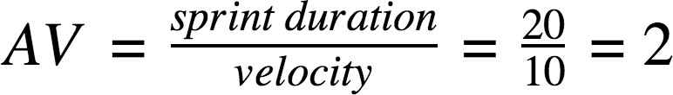

* 1. **Reports from JIRA:**

**PROJECT PROGRESS**

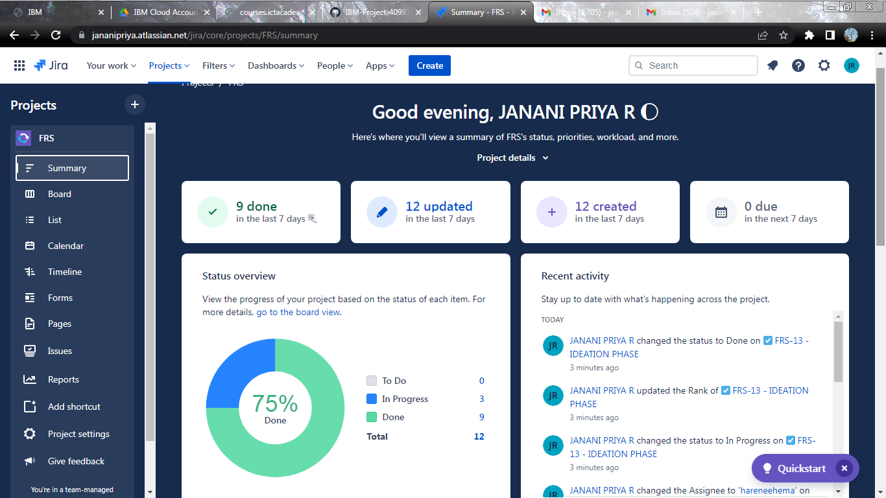

**BOARD**

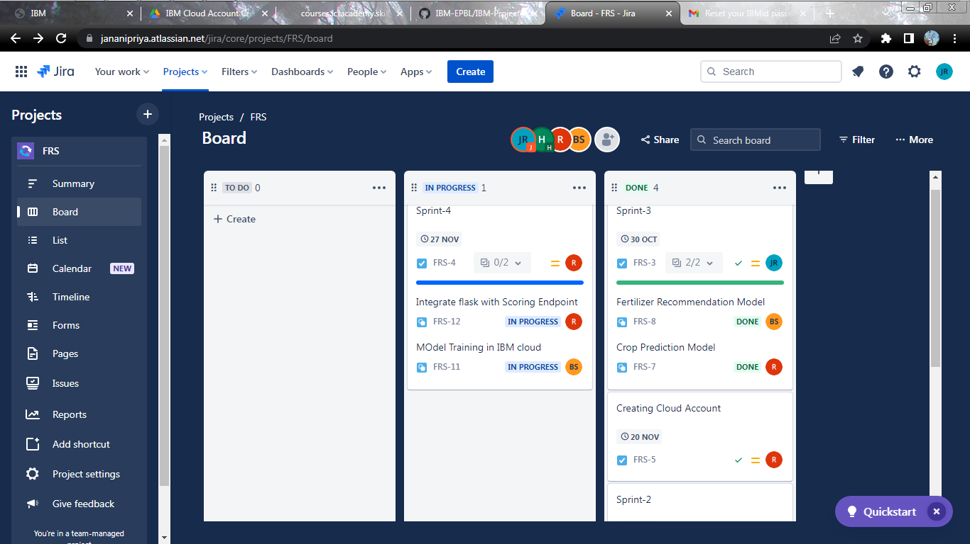

# 

# TIMELINE

# 

# CALENDER

# 

**ISSUES**

# 

# Burndown Chart:

# 

# CHAPTER 7

# CODING & SOLUTIONING

# FEATURE 1: CROP PREDICTION

# Crops are the money making factor of the farmers and the living factor to the human beings. Same crops cannot be harvested in a particular land all the time ,it would reduce particular minerals present in the soil that are required for the growth of the particular crop. Crop prediction is also determined by the pH value and the rainfall in the particular location. The pH value is varied based on the regions. Crop rotation is the best method to be followed to maintain the minerals balance in the soil. Our platform gets the minerals that are present in the soil from the users, pH of the soil and Rainfall in the locality and provides back the crop that needs to be planted in the soil for the season. It is done by the machine learning and artificial intelligence algorithms.

# FEATURE 2: FERTILIZER PREDICTION

# Fertilizers are the chemicals that are used to increase the crop yield and reduces the diseases and cure the disease present in the crops. Our platform gets the minerals that are present in the soil at the moment of requirement, rainfall in the locality and Ph of the soil and gives back the fertilizer that is recommended for the field and the amount that is needed for the amount of land. Our platform uses state of art machine learning and Naive bayes classifier algorithms to recommend the fertilizer required for the field.

# FEATURE 3: DISEASE PREDICTION

# Our platform uses the state of art algorithms like XGBOOST and decision tree to train the set of images and to get the output that the images has the particular disease. The images used are leaves in this case. The trained set of images act as reference to the input image given by the farmer. The farmer gives the input as the image and gets the output as the disease that is caused and recognizes the disease.

**CHAPTER-8**

* 1. **TEST CASES**

A test case is a specification of the inputs, execution conditions, testing procedure, and expected results that define a single test to be executed to achieve a specific software testing objective, such as exercising a specific programme path or verifying compliance with a specific requirement, in software engineering.   Test cases underpin deliberate rather than chaotic testing. To get the appropriate coverage of the programme being tested, a battery of test cases can be created. Formally stated test cases enable the same tests to be performed against consecutive versions of software, enabling effective and consistent regression testing.

**FORMAL TEST CASES**

To completely verify that all of an application's criteria are satisfied, there must be at least two test cases for each requirement: one positive test and one negative test. If a requirement is broken down into sub-requirements, each one must contain at least two test cases. A traceability matrix is widely used to keep track of the relationship between the requirement and the test. Written test cases should include a description of the functionality to be tested as well as the preparation needed to ensure that the test can be run.

**INFORMAL TESTING CASES**

Test cases for applications or systems that lack formal requirements might be built based on the acknowledged typical be haviour of program of a comparable class. In some testing schools, test cases are not written at all, but the activities and results are given after the exams are completed.

Hypothetical tales are used in scenario testing to assist the tester in thinking through a complicated problem or system. Typically, these circumstances are not documented in any depth.

**TEST CASES**

|  |  |  |  |  |  |  |  |  |  |  |  |  |  |
| --- | --- | --- | --- | --- | --- | --- | --- | --- | --- | --- | --- | --- | --- |
| **Test case ID** | **Feature Type** | **Component** | **Test Scenario** | **Pre-Requisite** | **Steps To Execute** | **Test Data** | **Expected Result** | **Actual Result** | **Status** | **Commnets** | **TC for Automation(Y/N)** | **BUG ID** | **Executed By** |
| HomePage_TC_OO1 | Functional | Home Page | Verify user is able to see the homepage or not. |  | 1. Enter URL and click go 2. verify whether the user is able to see the home page. | Enter URL and click go | User able to see the home page | Working as  expected | Pass | Nil | N | _ | Janani priya R |
| HomePage_TC_OO2 | UI | Home Page | Verify the UI elements in Home Page |  | 1. Enter URL and click go 2. Verify the UI elements in Home Page. | Enter URL and click go | Application should show below UI elements:  Home Tab & Predict Tab | Working as expected | pass | Nil | N | _ | Harenee A S |
| PredictPage_TC_OO 3 | Functional | Predict page | Verify user is able to redirect to predict page or not. |  | 1.Enter URL and click go 2.Click on Predict button  3.Verify whether the user to redirect to predict page or not. | Click the predict button in home page | User should navigate to Predict page | Working as expected | pass | Nil | N | _ | Bhavani S |
| Predict Page_TC_OO 4 | UI | Predict page | Verify the UI elements in Predict Page |  | 1. Enter URL and click go 2. Verify the UI elements in Predict Page. | Click the predict button and redirect to predict page | Application should show below UI elements:  Dropdown List , Upload file Button,  Predict button. | Working as expected | pass | Nil | N | _ | Rennie Sharon Rose P |
| Predict Page_TC_OO 5 | Functional | Predict page | Verify user is able to select the dropdown value or not. |  | 1.Enter URL and click go 2.Click on Predict button   1. Verify whether the user to redirect to predict page or not. 2. Verify user is able to select the dropdown value or not. | Fruit or Vegetable | Application should shows user to choose fruit or vegetable option in dropdown list. | Working as expected | pass | Nil | N | _ | Harenee A S |
| Predict Page_TC_OO 6 | Functional | Predict page | Verify user is able to upload the image or not. |  | 1.Enter URL and click go 2.Click on Predict button  3.Verify whether the user to redirect to predict page or not. 4.Verify user is able to select the dropdown value or not.  5.Verify user is able to upload the images or not | Images to be Uploaded | Application should shows the uploaded image. | Working as expected | pass | Nil | N | _ | Janani priya R |
| PredictPage_TC_OO 7 | Functional | Predict page | Verify whether the image is predicted correctly or not |  | 1.Enter URL and click go 2.Click on Predict button  3.Verify whether the user to redirect to predict page or not. 4.Verify user is able to select the dropdown value or not.   1. Verify user is able to upload the images or not 2. Verify whether the image is predicted correctly or not | Click the Predict Button | Application shows the predicted output | Working as expected | pass | Nil | N | _ | Rennie Sharon Rose P |

**8.2 USER ACCEPTANCE TESTING**

# Purpose of Document

The purpose of this document is to briefly explain the test coverage and open issues of the Fertilizers Recommendation System for Disease Prediction project at the time of the release to User Acceptance Testing (UAT).

# Defect Analysis

This report shows the number of resolved or closed bugs at each severity level, and how they were resolved

|  |  |  |  |  |  |
| --- | --- | --- | --- | --- | --- |
| **Resolution** | **Severity 1** | **Severity 2** | **Severity 3** | **Severity 4** | **Subtotal** |
| By Design | 0 | 0 | 1 | 0 | 1 |
| Duplicate | 1 | 3 | 2 | 2 | 8 |
| External | 2 | 3 | 0 | 0 | 5 |
| Fixed | 4 | 4 | 4 | 4 | 16 |
| Not Reproduced | 0 | 0 | 0 | 1 | 1 |
| Skipped | 0 | 0 | 0 | 0 | 0 |
| Won't Fix | 0 | 0 | 0 | 0 | 0 |
| Totals | 7 | 10 | 7 | 7 | 31 |

# Test Case Analysis

This report shows the number of test cases that have passed, failed, and untested

|  |  |  |  |  |
| --- | --- | --- | --- | --- |
| **Section** | **Total Cases** | **Not Tested** | **Fail** | **Pass** |
| Print Engine | 1 | 0 | 0 | 1 |
| Client Application | 1 | 0 | 0 | 1 |
| Security | 1 | 0 | 0 | 1 |
| Outsource Shipping | 1 | 0 | 0 | 1 |
| Exception Reporting | 1 | 0 | 0 | 1 |
| Final Report Output | 1 | 0 | 0 | 1 |
| Version Control | 1 | 0 | 0 | 1 |

**LOCUST REPORT**

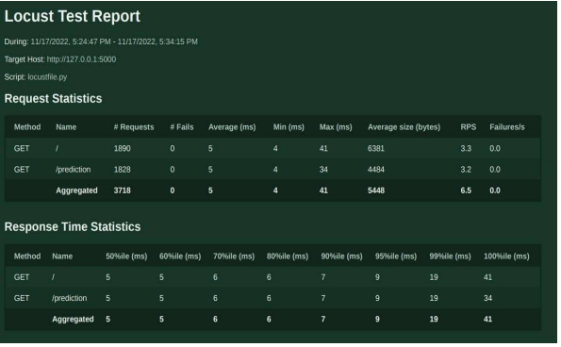

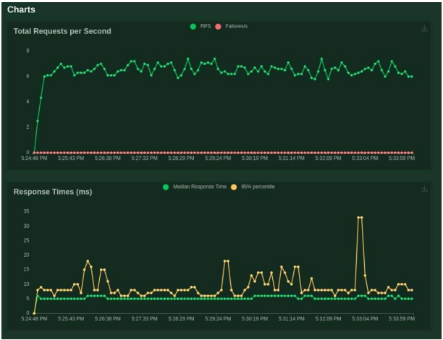

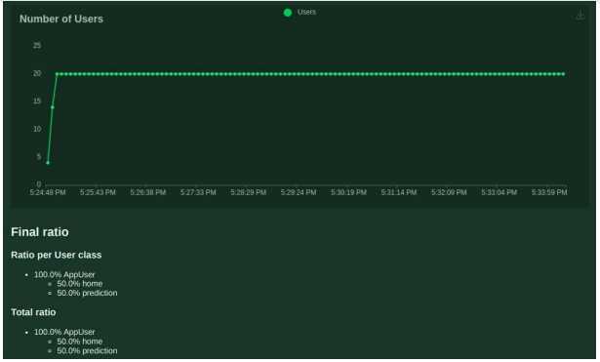

**CHAPTER-9**

**RESULTS**

* 1. **PERFORMANCE METRICS**

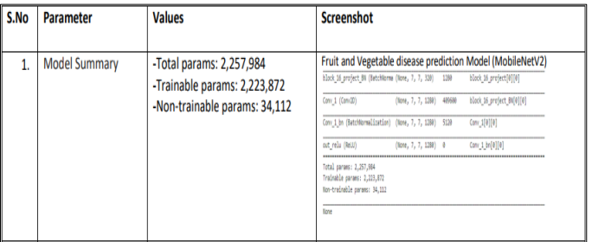

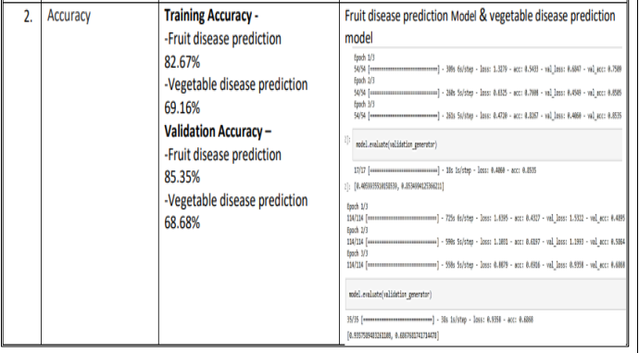

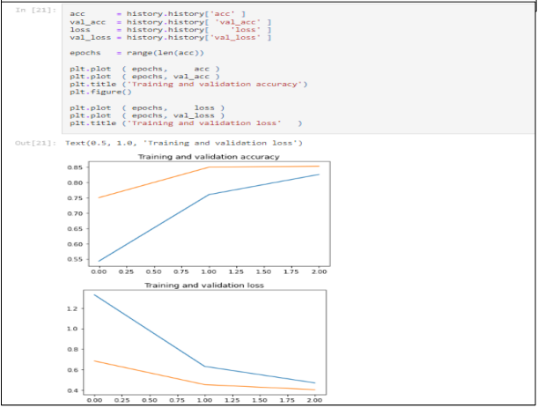 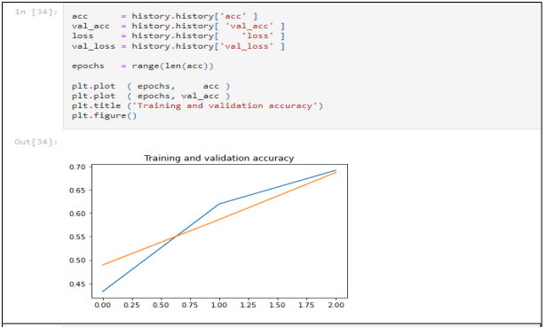

**CHAPTER-10**

**ADVANTAGES & DISADVANTAGES**

**ADVANTAGES:**

• The proposed model could predict the disease just from the image of a particular plant.

• Easy to use UI.

• Model has some good accuracy in detecting the plant just by taking the input (leaf).

**DISADVANTAGES**

* The machine can also make mistakes. The accuracy may not be a cent percent.

**CHAPTER-11**

**CONCLUSION**

Agriculture is the most significant industry in today's society. A vast range of bacterial and fungal diseases afflict the majority of plants. Plant diseases were a serious restraint on productivity and a big danger to food security. As a result, early and precise detection of plant diseases is critical to ensuring high production and quality.

The number of plant illnesses and the extent of damage inflicted have grown in recent years as a result of pathogen variety diversity, changes in cultivation practises, and inadequate plant protection systems. The use of such applications might assist farmers in taking the required safeguards to avoid loss.

**CHAPTER-12**

**FUTURE SCOPE**

As of now we have just built the web application which apparently takes the input as an image and then predict the out in the near future we can develop an application which computer vision and AI techniques to predict the infection once you keep the camera near the plant or leaf this could make our project even more usable.

This can be also done in Mobile applications like android, ios. It helps in many ways to improve the agriculture in cultivation of crops and predict the correct fertilizers to the crops.

**CHAPTER-13**

**APPENDIX**

# SOURCECODE

# Importing essential libraries and modules

from flask import Flask, render_template, request, Markup

import numpy as np

import pandas as pd

from utils.disease import disease_dic

from utils.fertilizer import fertilizer_dic

import requests

import config

import pickle

import io

import torch

from torchvision import transforms

from PIL import Image

from utils.model import ResNet9

# ==============================================================================================

# -------------------------LOADING THE TRAINED MODELS -----------------------------------------------

# Loading plant disease classification model

disease_classes = ['Apple___Apple_scab',

'Apple___Black_rot',

'Apple___Cedar_apple_rust',

'Apple___healthy',

'Blueberry___healthy',

'Cherry_(including_sour)___Powdery_mildew',

'Cherry_(including_sour)___healthy',

'Corn_(maize)___Cercospora_leaf_spotGray_leaf_spot',

'Corn_(maize)___Common_rust_',

'Corn_(maize)___Northern_Leaf_Blight',

'Corn_(maize)___healthy',

'Grape___Black_rot',

'Grape___Esca_(Black_Measles)',

'Grape___Leaf_blight_(Isariopsis_Leaf_Spot)',

'Grape___healthy',

'Orange___Haunglongbing_(Citrus_greening)',

'Peach___Bacterial_spot',

'Peach___healthy',

'Pepper,_bell___Bacterial_spot',

'Pepper,_bell___healthy',

'Potato___Early_blight',

'Potato___Late_blight',

'Potato___healthy',

'Raspberry___healthy',

'Soybean___healthy',

'Squash___Powdery_mildew',

'Strawberry___Leaf_scorch',

'Strawberry___healthy',

'Tomato___Bacterial_spot',

'Tomato___Early_blight',

'Tomato___Late_blight',

'Tomato___Leaf_Mold',

'Tomato___Septoria_leaf_spot',

'Tomato___Spider_mites Two-spotted_spider_mite',

'Tomato___Target_Spot',

'Tomato___Tomato_Yellow_Leaf_Curl_Virus',

'Tomato___Tomato_mosaic_virus',

'Tomato___healthy']

disease_model_path = 'models/plant_disease_model.pth'

disease_model = ResNet9(3, len(disease_classes))

disease_model.load_state_dict(torch.load(

disease_model_path, map_location=torch.device('cpu')))

disease_model.eval()

# Loading crop recommendation model

crop_recommendation_model_path = 'models/RandomForest.pkl'

crop_recommendation_model = pickle.load(

open(crop_recommendation_model_path, 'rb'))

# =========================================================================================

# Custom functions for calculations

def weather_fetch(city_name):

"""

Fetch and returns the temperature and humidity of a city

:params: city_name

:return: temperature, humidity

"""

api_key = config.weather_api_key

base_url = "http://api.openweathermap.org/data/2.5/weather?"

complete_url = base_url + "appid=" + api_key + "&q=" + city_name

response = requests.get(complete_url)

x = response.json()

if x["cod"] != "404":

y = x["main"]

temperature = round((y["temp"] - 273.15), 2)

humidity = y["humidity"]

return temperature, humidity

else:

return None

def predict_image(img, model=disease_model):

"""

Transforms image to tensor and predicts disease label

:params: image

:return: prediction (string)

"""

transform = transforms.Compose([

transforms.Resize(256),

transforms.ToTensor(),

])

image = Image.open(io.BytesIO(img))

img_t = transform(image)

img_u = torch.unsqueeze(img_t, 0)

# Get predictions from model

yb = model(img_u)

# Pick index with highest probability

_, preds = torch.max(yb, dim=1)

prediction = disease_classes[preds[0].item()]

# Retrieve the class label

return prediction

# ===============================================================================================

# ------------------------------------ FLASK APP -------------------------------------------------

app = Flask(__name__)

# render home page

@ app.route('/')

def home():

title = 'Agrofy - Home'

return render_template('index.html', title=title)

# render crop recommendation form page

@ app.route('/crop-recommend')

def crop_recommend():

title = 'Agrofy - Crop Recommendation'

return render_template('crop.html', title=title)

# render fertilizer recommendation form page

@ app.route('/fertilizer')

def fertilizer_recommendation():

title = 'Agrofy - Fertilizer Suggestion'

return render_template('fertilizer.html', title=title)

# render disease prediction input page

# ===============================================================================================

# RENDER PREDICTION PAGES

# render crop recommendation result page

@ app.route('/crop-predict', methods=['POST'])

def crop_prediction():

title = 'Agrofy - Crop Recommendation'

if request.method == 'POST':

N = int(request.form['nitrogen'])

P = int(request.form['phosphorous'])

K = int(request.form['pottasium'])

ph = float(request.form['ph'])

rainfall = float(request.form['rainfall'])

# state = request.form.get("stt")

city = request.form.get("city")

if weather_fetch(city) != None:

temperature, humidity = weather_fetch(city)

data = np.array([[N, P, K, temperature, humidity, ph, rainfall]])

my_prediction = crop_recommendation_model.predict(data)

final_prediction = my_prediction[0]

return render_template('crop-result.html', prediction=final_prediction, title=title)

else:

return render_template('try_again.html', title=title)

# render fertilizer recommendation result page

@ app.route('/fertilizer-predict', methods=['POST'])

def fert_recommend():

title = 'Agrofy - Fertilizer Suggestion'

crop_name = str(request.form['cropname'])

N = int(request.form['nitrogen'])

P = int(request.form['phosphorous'])

K = int(request.form['pottasium'])

# ph = float(request.form['ph'])

df = pd.read_csv('Data/fertilizer.csv')

nr = df[df['Crop'] == crop_name]['N'].iloc[0]

pr = df[df['Crop'] == crop_name]['P'].iloc[0]

kr = df[df['Crop'] == crop_name]['K'].iloc[0]

n = nr - N

p = pr - P

k = kr - K

temp = {abs(n): "N", abs(p): "P", abs(k): "K"}

max_value = temp[max(temp.keys())]

if max_value == "N":

if n < 0:

key = 'NHigh'

else:

key = "Nlow"

elifmax_value == "P":

if p < 0:

key = 'PHigh'

else:

key = "Plow"

else:

if k < 0:

key = 'KHigh'

else:

key = "Klow"

response = Markup(str(fertilizer_dic[key]))

return render_template('fertilizer-result.html', recommendation=response, title=title)

# render disease prediction result page

@app.route('/disease-predict', methods=['GET', 'POST'])

def disease_prediction():

title = 'Agrofy - Disease Detection'

if request.method == 'POST':

if 'file' not in request.files:

return redirect(request.url)

file = request.files.get('file')

if not file:

return render_template('disease.html', title=title)

try:

img = file.read()

prediction = predict_image(img)

prediction = Markup(str(disease_dic[prediction]))

return render_template('disease-result.html', prediction=prediction, title=title)

except:

pass

return render_template('disease.html', title=title)

# ===============================================================================================

if __name__ == '__main__':

app.run(debug=False)

**GIT REPOSITORY**

[IBM-EPBL](https://github.com/IBM-EPBL)/[**IBM-Project-3670-1658588290**](https://github.com/IBM-EPBL/IBM-Project-3670-1658588290)

DEMO-VIDEO LINK