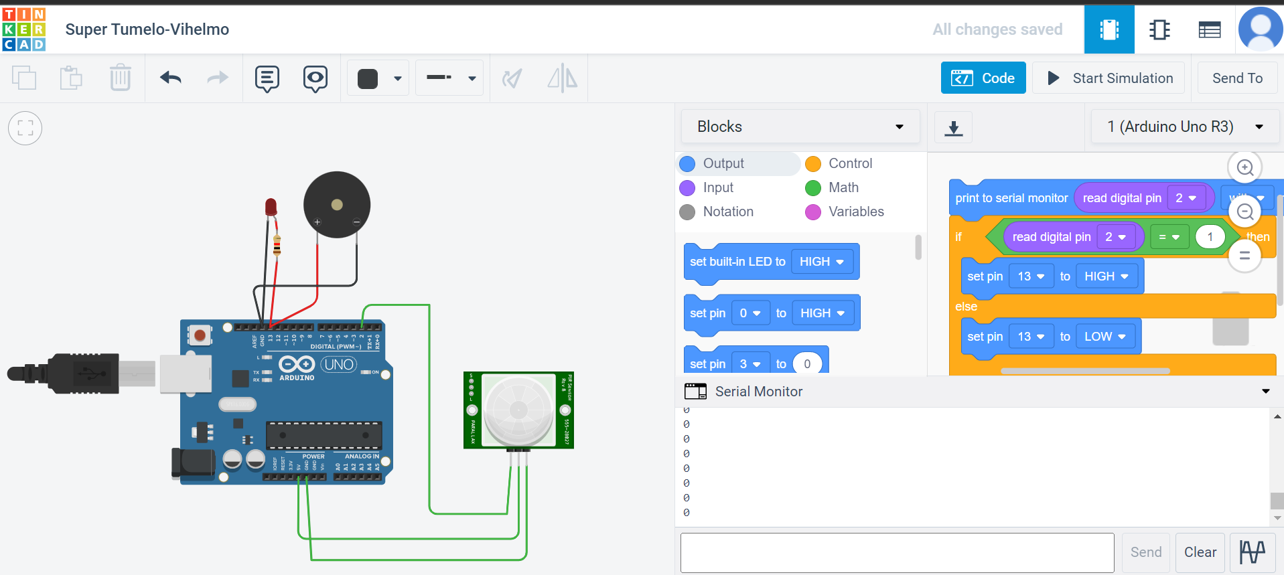

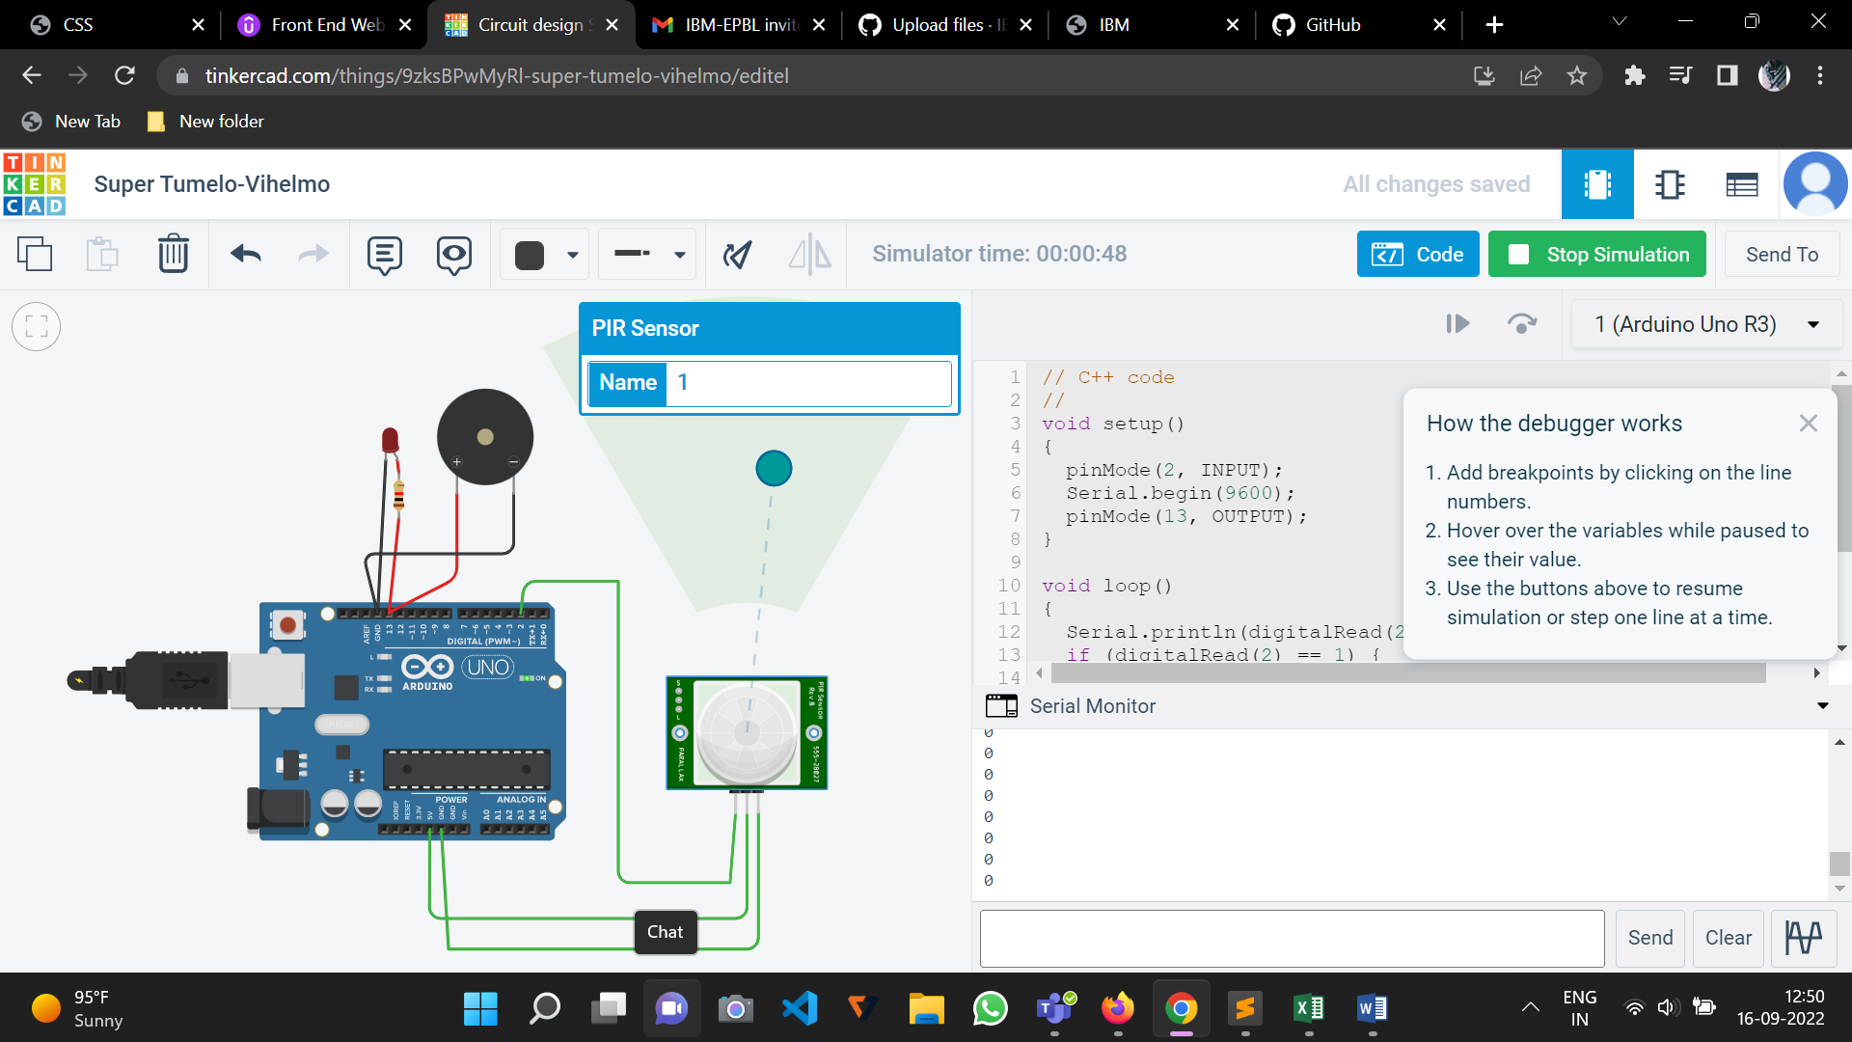

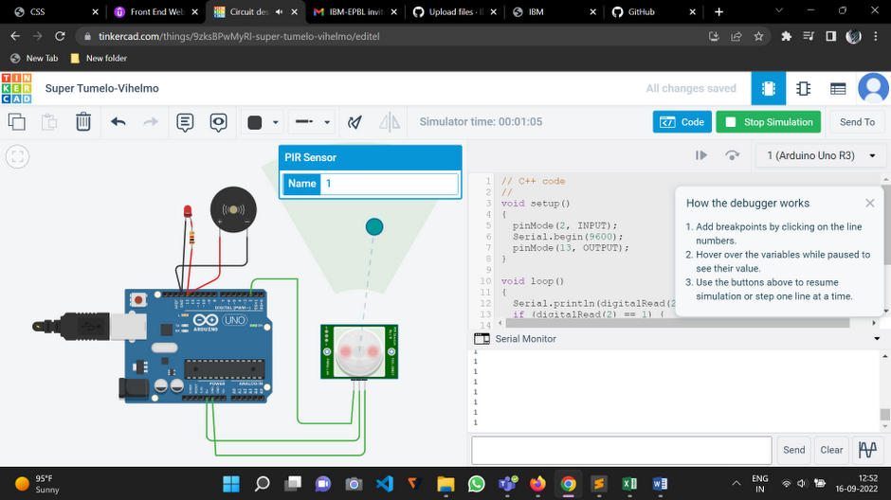

Project link: <https://www.tinkercad.com/things/9zksBPwMyRl-super-tumelo-vihelmo/editel?sharecode=O4-fb8Y-DZ-bxc8p9hZmOaVtjQY-l3kK6F0Nyth9598>