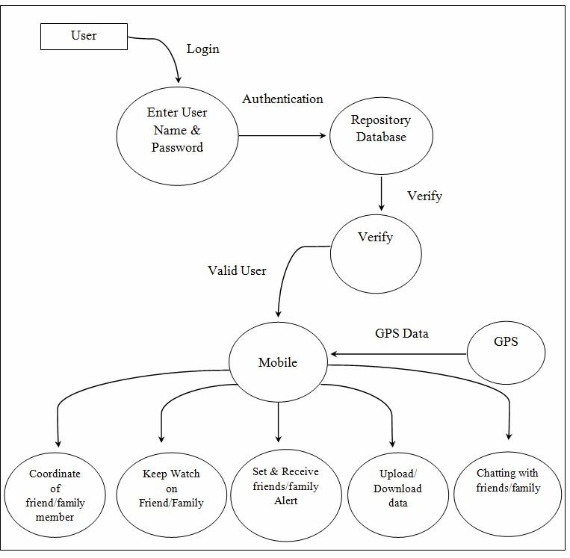**DATAFLOW DIAGRAM**