Name:C.Sathyajothi

# Module 3: Python Assignment

Consider a list (list = []). You can perform the following commands: insert i e: Insert integer at position.

print: Print the list.

remove e: Delete the first occurrence of integer. append e: Insert integer at the end of the list. sort: Sort the list.

pop: Pop the last element from the list. reverse: Reverse the list.

Initialize your list and read in the value of followed by lines of commands where each command will be of the types listed above. Iterate through each command in order and perform the corresponding operation on your list.

# Program:

n = int(input()) glist = []

for i in range(0,n): command = input().split()

if command[0] == "insert": glist.insert(int(command[1]),int(command[2]))

elif command[0] == "print": print(glist)

elif command[0] == "remove": glist.remove(int(command[1]))

elif command[0] == "append": glist.append(int(command[1]))

elif command[0] == "sort": glist.sort()

elif command[0] == "pop": glist.pop()

else:

glist.reverse()

# Output:

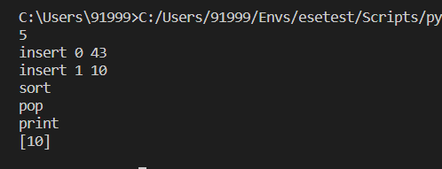

Write a Calculator program in Python?

# Program:

while(True): print("\nCalculator:\n1.Add\n2.Subtract\n3.Multiply\n4.Divide\n5.Exit") print("Enter your Choice by entering the number: ")

n=int(input()) if(n==5):

break

a=int(input("Enter the first number: ")) b=int(input("Enter the second number: ")) if(n==1):

print("Answer: ",a+b) elif(n==2):

print("Answer: ",a-b) elif(n==3):

print("Answer: ",a*b) elif(n==4):

print("Answer: ",a/b) else:

break

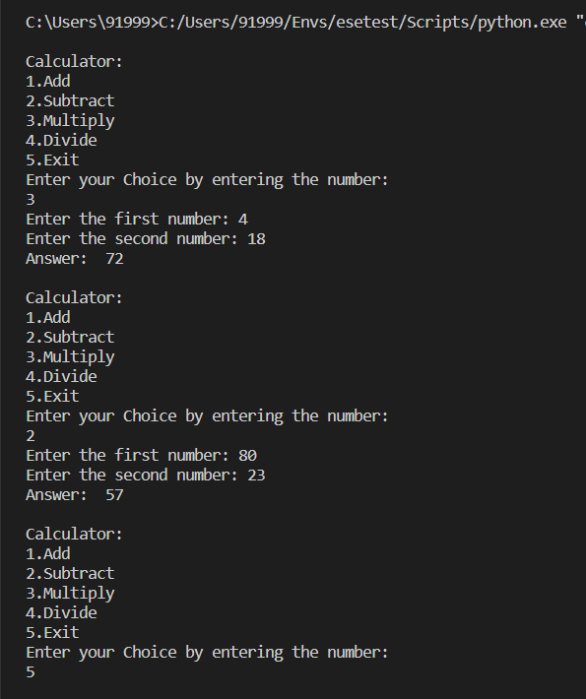

Write a program to concatenate, reverse and slice a string? a="gokul"

b="True" print("String-1: ",a)

print("String-2: ",b) print("Concatenate: ",a+b)

print("String Reverse: ",a[::-1])

print("String Slice: ",b[2:4])

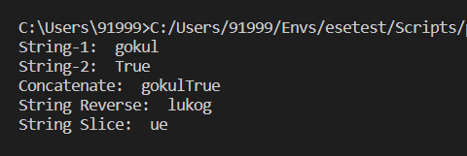

Why is Python a popular programming language?

* Python is easy to learn and use.
* Flexibility and Reliability
* Python offers versatile web-development solutions
* Python is well suited to data science and analytics

What are the other Frameworks that can be used with python?

Django, Dash, Flask, Pyramid, Sanic

Full form of WSGI?

WSGI - Web Server Gateway Interface